**Template version: 1.0**

test

MILANCE

type

**doc date**

**[[doc-company-url]]**

**Document Number: [[doc-id]]**

**Version: [[doc-version]]**

**Release Date: [[release-date]]**

Document History

Author Name: [[doc-author]]

Author Contact: [[doc-author-email]]

Document Revision

|  |  |  |  |  |
| --- | --- | --- | --- | --- |
| Version Number | Release Date | Status | Change Description | Author |
| [[doc-version]] | [[doc-release-date]] | Draft | [[change-description]] | [[doc-author-name]] |
|  |  |  |  |  |
|  |  |  |  |  |
|  |  |  |  |  |

Intellectual Property Rights

This document is exclusive property of doc date and all rights are reserved.

Table of Contents

Introduction 1

References 1

[test
1](#_Toc16245287525682196056605914)

[Just checking tables - heading 1
1](#_Toc16245287525889121179247099)

[Tables are under heading 2
1](#_Toc16245287526133579595139509)

Markdown1-2 1

[PUZZLES CLOUD MARKDOWN FILE HEADING 1
1](#_Toc16245287526603112295370127)

[Welcome to the puzzles cloud md file HEADING 2
1](#_Toc16245287526803379288058370)

[Let's start with stupid jokes HEADING 3
1](#_Toc1624528752700824299769388)

[Let me tell you stupid joke on German: HEADING4
1](#_Toc16245287527211738399293397)

[Let's switch to the Czech language HEADING 4
1](#_Toc16245287527427611807927284)

[Real Czech language HEADING 5
1](#_Toc16245287527631947581794326)

[Longest Serbian word he he HEADING 1
1](#_Toc1624528752783840326447066)

[Serbian literature HEADING 2
1](#_Toc16245287528059398288997680)

[It's enough, lets start with some smart things HEADING 1
1](#_Toc1624528752828103325575414)

[Just checking tables - heading 1
1](#_Toc16245287528508007731170095)

[Tables are under heading 2
1](#_Toc16245287528756991921806587)

Table of Tables

Table 1: Document references 1

# Introduction

## References

Referenced documents in creation of this document are listed in the Table 1.

|  |  |  |  |
| --- | --- | --- | --- |
| Document Reference | Document Title | Version | Filename |
| [1] | [[ reference-doc-title ]] |  | [[ reference-doc-filename ]] |
| [2] |  |  |  |
| [3] |  |  |  |
| [4] |  |  |  |
| [5] |  |  |  |
| [6] |  |  |  |
| [7] |  |  |  |
| [8] |  |  |  |

Table 1: Document references

# test

## Just checking tables - heading 1

### Tables are under heading 2

| field name | type | constrains | description | example |
| --- | --- | --- | --- | --- |
| id | UUID | globally unique | globally unique UUID | c91feaf3-5968-4b60-aa5b-62fe7fdd905c |
| type | string | n/a | type of request, must be "voucher-order", "voucher-order" |  |
| voucher-code | string | n/a | code of the voucher gathered from voucher list | "VODADE15" |
| payment-method | string | n/a | on of the allowed methods for the voucher, denoted in voucher list response | "Wirecard VISA" |
| notification-type | string | currently only "email" is supported | type of the notification target | "email" |
| notification-target | string | n/a | target adress | "[me@my-email.com](mailto:me@my-email.com)" |
| order-success-redirect-url | string | valid URL | Where the wirecard should redirect if payment was successfull | protect |
| order-failed-redirect-url | string | valid URL | Where the wirecard should redirect if payment fails | protect |
| order-canceled-redirect-url | string | valid URL | Where the wirecard should redirect if payment was canceled | protect |

| Option | Description |
| --- | --- |
| data | path to data files to supply the data that will be passed into templates. |
| engine | engine to be used for processing templates. Handlebars is the default. |
| ext | extension to be used for dest files. |

# Markdown1-2

## PUZZLES CLOUD MARKDOWN FILE HEADING 1

### Welcome to the puzzles cloud md file HEADING 2

#### Let's start with stupid jokes HEADING 3

##### **Let me tell you stupid joke on German: HEADING4**

* "Hey Philipp, wie war denn der Urlaub?"
* "Gräßlich! Im Hotel hatte ich Zimmernummer hundert. Und vom Türschild ist die Eins abgefallen!"

ÜÜÜÜÜÜ- that was stupid

##### Let's switch to the Czech language HEADING 4

* "Co rłńóobi trakłńótośźr u fśźryśźżzjera?"
* Warćękocze.

ąćęłńóśźż!!!!

Just kidding, that was Poland language u fool, let's switch to the Czech for real

###### Real Czech language HEADING 5

**ýžáčďéěíňóřšťúů**

* Jak říkáte albínskému muži z Prahy?
* Prázdný Čech.

## Longest Serbian word he he HEADING 1

Here you go: АБВГДЂЕЖЗИЈКЛЉМНЊОПРСТУФХЦЧЏШ

### Serbian literature HEADING 2

Весела песма
Из школе се враћа Стева
сав весео путем пева.
Уз пут среће бака Јелу:
„Ћирилицу знадем целу!"
Кући дође, па са врата:
„Ћирилицу знадем, тата!"
„Све сад, мајко, читам сам,
јер од данас и „ш" знам!"
Оком тражи и сестрицу:
„Сејо, знадем ћирилицу!"
Потом оде до икона,
па начини три поклона.
Хоће Стева да се јави
и захвали Светом Сави.
Свети Сава Стеву чује,
па се скупа с њим радује:
„Српство ми је од сад јаче
за још једно вредно ђаче!"

## It's enough, lets start with some smart things HEADING 1

1.

PLAY THIS VIDEO AND THANKS ME LATER!

**HIT THAT PLAY BUTTON** 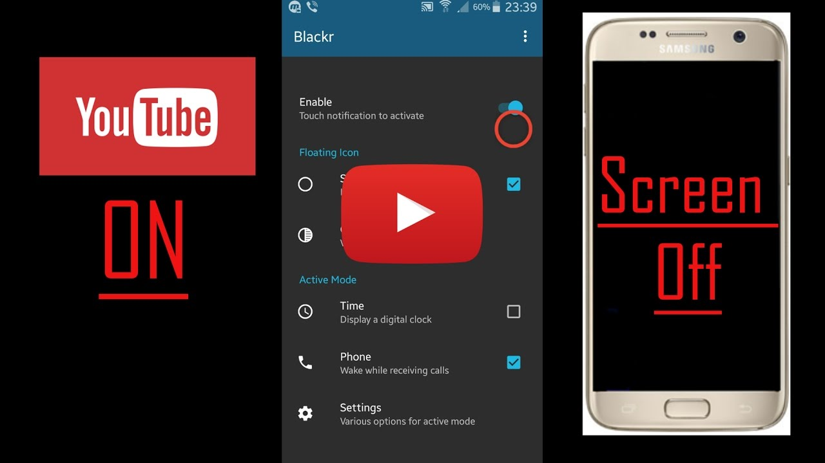

Yep, it's a picture, fool... lol
Here you go, CLICK IT:

# Just checking tables - heading 1

## Tables are under heading 2

| field name | type | constrains | description | example |
| --- | --- | --- | --- | --- |
| id | UUID | globally unique | globally unique UUID | c91feaf3-5968-4b60-aa5b-62fe7fdd905c |
| type | string | n/a | type of request, must be "voucher-order", "voucher-order" |  |
| voucher-code | string | n/a | code of the voucher gathered from voucher list | "VODADE15" |
| payment-method | string | n/a | on of the allowed methods for the voucher, denoted in voucher list response | "Wirecard VISA" |
| notification-type | string | currently only "email" is supported | type of the notification target | "email" |
| notification-target | string | n/a | target adress | "[me@my-email.com](mailto:me@my-email.com)" |
| order-success-redirect-url | string | valid URL | Where the wirecard should redirect if payment was successfull | protect |
| order-failed-redirect-url | string | valid URL | Where the wirecard should redirect if payment fails | protect |
| order-canceled-redirect-url | string | valid URL | Where the wirecard should redirect if payment was canceled | protect |

| Option | Description |
| --- | --- |
| data | path to data files to supply the data that will be passed into templates. |
| engine | engine to be used for processing templates. Handlebars is the default. |
| ext | extension to be used for dest files. |



Figure 1: Last Page