**Hello World Template version: 1.0**

Milica's Document

MS Word

**23.0**

**Release Date: 27.05.2022**

# Heding 1

## Backticks

### Backticks MD file

this is single line of backticks

Tis is text which contains text under backticks

this is backticks this is regular text

several text lines under single backticks several text lines under single backticks several text lines under single backticks several text lines under single backticks several text lines under single backticks several text lines under single backticks several text lines under single backticks several text lines under single backticks several text lines under single backticks several text lines under single backticks several text lines under single backticks several text lines under single backticks several text lines under single backticks

#### Backtickts in heading

test test test test test test test test test test test test test test test test test test test test test test test test test test test test test test

### End of file

test

# Heding 2

## JustTesting

### PUZZLES CLOUD MARKDOWN FILE

#### Welcome to the puzzles cloud md file

##### Let's start with stupid jokes

###### **Let me tell you stupid joke on German:**

* "Hey Philipp, wie war denn der Urlaub?"
* "Gräßlich! Im Hotel hatte ich Zimmernummer hundert. Und vom Türschild ist die Eins abgefallen!"

ÜÜÜÜÜÜ- that was stupid

###### Let's switch to the Czech language

* "Co robi traktor u fryzjera?"
* Warkocze.

ąćęłńóśźż!!!!

**Just kidding, that was Poland language u fool, let's switch to the Czech for real**

Real Czech language

**ýžáčďéěíňóřšťúů**

* Jak říkáte albínskému muži z Prahy?
* Prázdný Čech.

### Longest Serbian word he he

Here you go: АБВГДЂЕЖЗИЈКЛЉМНЊОПРСТУФХЦЧЏШ

#### Serbian literature

Весела песма  
 Из школе се враћа Стева  
 сав весео путем пева.  
   
 Уз пут среће бака Јелу:  
 „Ћирилицу знадем целу!"  
   
 Кући дође, па са врата:  
 „Ћирилицу знадем, тата!"  
   
 „Све сад, мајко, читам сам,  
 јер од данас и „ш" знам!"  
   
 Оком тражи и сестрицу:  
 „Сејо, знадем ћирилицу!"  
   
 Потом оде до икона,  
 па начини три поклона.  
   
 Хоће Стева да се јави  
 и захвали Светом Сави.  
   
 Свети Сава Стеву чује,  
 па се скупа с њим радује:  
   
 „Српство ми је од сад јаче  
 за још једно вредно ђаче!"

### It's enough, lets start with some smart things

1. PLAY THIS VIDEO AND THANKS ME LATER!

**HIT THAT PLAY BUTTON** 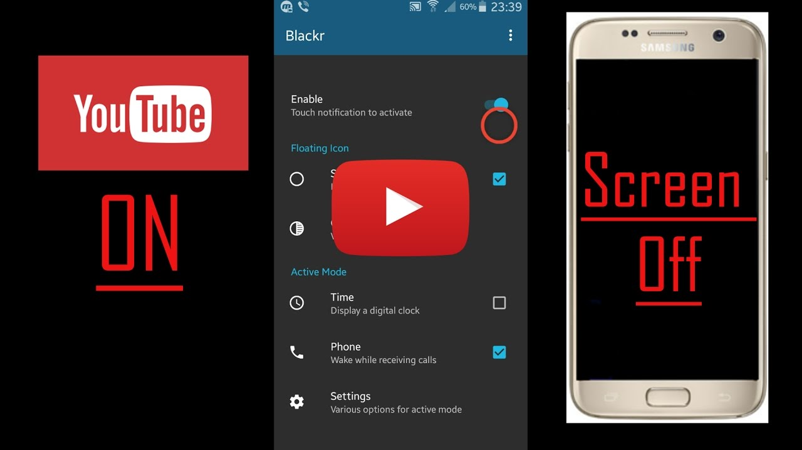

Yep, it's a picture, fool... lol Here you go, CLICK IT:

## blsh blsh



Figure : C:\puzzles-cloud-docs-site\images\logo.png