**Advanced Template version: 1.0**

[[doc-title]]

[[doc-subtitle]]

[[doc-type]]

**[[doc-company]]**

**[[doc-company-url]]**

**Document Number: [[doc-id]]**

**Version: [[doc-version]]**

**Release Date: [[doc-release-date]]**

Document History

Author Name: [[doc-author-name]]

Author Contact: [[doc-author-email]]

Document Revision

|  |  |  |  |  |
| --- | --- | --- | --- | --- |
| Version Number | Release Date | Status | Change Description | Author |
| [[doc-version]] | [[doc-release-date]] | Draft | [[doc-change-description]] | [[doc-author-name]] |
|  |  |  |  |  |
|  |  |  |  |  |
|  |  |  |  |  |

Intellectual Property Rights

This document is exclusive property of [[doc-company]] and all rights are reserved.

Table of Contents

1 Introduction 4

1.1 References 4

2 Markdown1 5

2.1 PUZZLES CLOUD MARKDOWN FILE HEADING 1 5

2.1.1 Welcome to the puzzles cloud md file HEADING 2 5

2.1.1.1 Let's start with stupid jokes HEADING 3 5

2.1.1.1.1 Let me tell you stupid joke on German: HEADING4 5

2.1.1.1.2 Let's switch to the Czech language HEADING 4 5

2.1.1.1.2.1 Real Czech language HEADING 5 5

2.2 Longest Serbian word he he HEADING 1 5

2.2.1 Serbian literature HEADING 2 5

2.3 It's enough, lets start with some smart things HEADING 1 6

Table of Tables

Table 1: Document references 4

Table of Figures

# Introduction

## References

Referenced documents in creation of this document are listed in the Table 1.

|  |  |  |  |
| --- | --- | --- | --- |
| Document Reference | Document Title | Version | Filename |
| [1] | [[ reference-doc-title ]] |  | [[ reference-doc-filename ]] |
| [2] |  |  |  |
| [3] |  |  |  |
| [4] |  |  |  |
| [5] |  |  |  |
| [6] |  |  |  |
| [7] |  |  |  |
| [8] |  |  |  |

Table 1: Document references

# Markdown1

## PUZZLES CLOUD MARKDOWN FILE HEADING 1

### Welcome to the puzzles cloud md file HEADING 2

#### Let's start with stupid jokes HEADING 3

##### **Let me tell you stupid joke on German: HEADING4**

* "Hey Philipp, wie war denn der Urlaub?"
* "Gräßlich! Im Hotel hatte ich Zimmernummer hundert. Und vom Türschild ist die Eins abgefallen!"

ÜÜÜÜÜÜ- that was stupid

##### Let's switch to the Czech language HEADING 4

* "Co rłńóobi trakłńótośźr u fśźryśźżzjera?"
* Warćękocze.

ąćęłńóśźż!!!!

**Just kidding, that was Poland language u fool, let's switch to the Czech for real**

###### Real Czech language HEADING 5

**ýžáčďéěíňóřšťúů**

* Jak říkáte albínskému muži z Prahy?
* Prázdný Čech.

## Longest Serbian word he he HEADING 1

Here you go: АБВГДЂЕЖЗИЈКЛЉМНЊОПРСТУФХЦЧЏШ

### Serbian literature HEADING 2

Весела песма  
 Из школе се враћа Стева  
 сав весео путем пева.  
   
 Уз пут среће бака Јелу:  
 „Ћирилицу знадем целу!"  
   
 Кући дође, па са врата:  
 „Ћирилицу знадем, тата!"  
   
 „Све сад, мајко, читам сам,  
 јер од данас и „ш" знам!"  
   
 Оком тражи и сестрицу:  
 „Сејо, знадем ћирилицу!"  
   
 Потом оде до икона,  
 па начини три поклона.  
   
 Хоће Стева да се јави  
 и захвали Светом Сави.  
   
 Свети Сава Стеву чује,  
 па се скупа с њим радује:  
   
 „Српство ми је од сад јаче  
 за још једно вредно ђаче!"

## It's enough, lets start with some smart things HEADING 1

1. PLAY THIS VIDEO AND THANKS ME LATER!

**HIT THAT PLAY BUTTON** 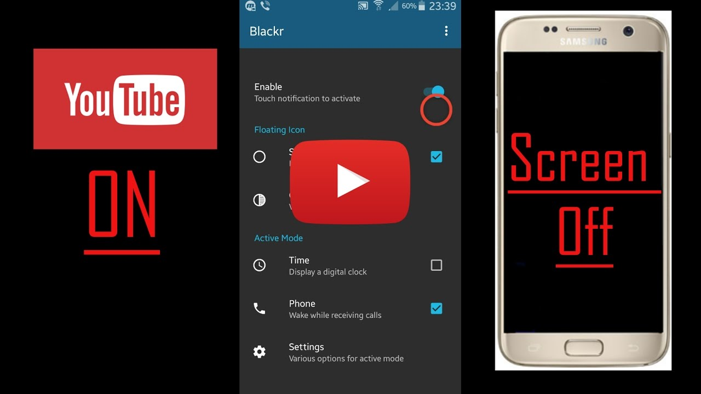

Yep, it's a picture, fool... lol Here you go, CLICK IT:



Figure 1: Last Page