**Template version: 1.0**

[[doc-title]]

[[doc-subtitle]]

[[doc-type]]

**[[doc-company]]**

**[[doc-company-url]]**

**Document Number: [[doc-id]]**

**Version: [[doc-version]]**

**Release Date: [[release-date]]**

Document History

Author Name: [[doc-author]]

Author Contact: [[doc-author-email]]

Document Revision

|  |  |  |  |  |
| --- | --- | --- | --- | --- |
| Version Number | Release Date | Status | Change Description | Author |
| [[doc-version]] | [[doc-release-date]] | Draft | [[change-description]] | [[doc-author-name]] |
|  |  |  |  |  |
|  |  |  |  |  |
|  |  |  |  |  |

Intellectual Property Rights

This document is exclusive property of [[doc-company]] and all rights are reserved.

Table of Contents

Introduction 1

References 1

JustTesting 1

[PUZZLES CLOUD MARKDOWN FILE
1](#_Toc1629295545127514040369556)

[Welcome to the puzzles cloud md file
1](#_Toc16292955451471474890840243)

[Let's start with stupid jokes
1](#_Toc16292955451683684867585177)

[Let me tell you stupid joke on German:
1](#_Toc16292955451886876734757635)

[Let's switch to the Czech language
1](#_Toc16292955452092406934285224)

[Real Czech language
1](#_Toc16292955452306016454662337)

[Longest Serbian word he he
1](#_Toc16292955452528170006964262)

[Serbian literature
1](#_Toc16292955452723552101918291)

[It's enough, lets start with some smart things
1](#_Toc16292955452956263515932451)

Table of Tables

Table 1: Document references 1

# Introduction

## References

Referenced documents in creation of this document are listed in the Table 1.

|  |  |  |  |
| --- | --- | --- | --- |
| Document Reference | Document Title | Version | Filename |
| [1] | [[ reference-doc-title ]] |  | [[ reference-doc-filename ]] |
| [2] |  |  |  |
| [3] |  |  |  |
| [4] |  |  |  |
| [5] |  |  |  |
| [6] |  |  |  |
| [7] |  |  |  |
| [8] |  |  |  |

Table 1: Document references

# JustTesting

## PUZZLES CLOUD MARKDOWN FILE

### Welcome to the puzzles cloud md file

#### Let's start with stupid jokes

##### **Let me tell you stupid joke on German:**

* "Hey Philipp, wie war denn der Urlaub?"
* "Gräßlich! Im Hotel hatte ich Zimmernummer hundert. Und vom Türschild ist die Eins abgefallen!"

ÜÜÜÜÜÜ- that was stupid

##### Let's switch to the Czech language

* "Co robi traktor u fryzjera?"
* Warkocze.

ąćęłńóśźż!!!!

Just kidding, that was Poland language u fool, let's switch to the Czech for real

###### Real Czech language

**ýžáčďéěíňóřšťúů**

* Jak říkáte albínskému muži z Prahy?
* Prázdný Čech.

## Longest Serbian word he he

Here you go: АБВГДЂЕЖЗИЈКЛЉМНЊОПРСТУФХЦЧЏШ

### Serbian literature

Весела песма
Из школе се враћа Стева
сав весео путем пева.
Уз пут среће бака Јелу:
„Ћирилицу знадем целу!"
Кући дође, па са врата:
„Ћирилицу знадем, тата!"
„Све сад, мајко, читам сам,
јер од данас и „ш" знам!"
Оком тражи и сестрицу:
„Сејо, знадем ћирилицу!"
Потом оде до икона,
па начини три поклона.
Хоће Стева да се јави
и захвали Светом Сави.
Свети Сава Стеву чује,
па се скупа с њим радује:
„Српство ми је од сад јаче
за још једно вредно ђаче!"

## It's enough, lets start with some smart things

1.

PLAY THIS VIDEO AND THANKS ME LATER!

**HIT THAT PLAY BUTTON** 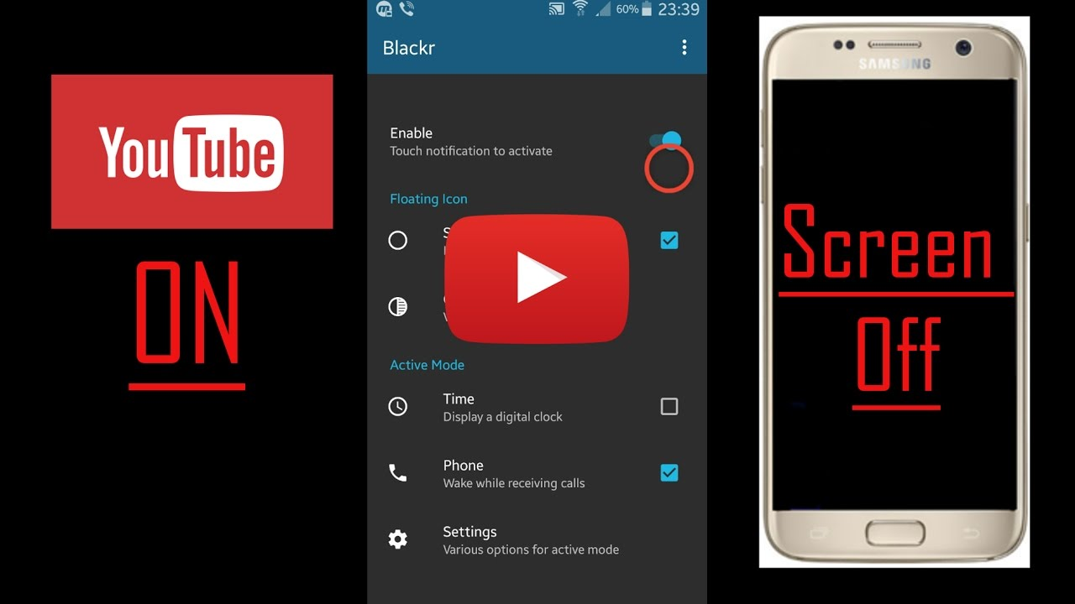

Yep, it's a picture, fool... lol
Here you go, CLICK IT:



Figure 1: Last Page