**Advanced Template version: 1.0**

[[doc-title]]

[[doc-subtitle]]

[[doc-type]]

**[[doc-company]]**

**[[doc-company-url]]**

**Document Number: [[doc-id]]**

**Version: [[doc-version]]**

**Release Date: [[doc-release-date]]**

Document History

Author Name: [[doc-author-name]]

Author Contact: [[doc-author-email]]

Document Revision

|  |  |  |  |  |
| --- | --- | --- | --- | --- |
| Version Number | Release Date | Status | Change Description | Author |
| [[doc-version]] | [[doc-release-date]] | Draft | [[doc-change-description]] | [[doc-author-name]] |
|  |  |  |  |  |
|  |  |  |  |  |
|  |  |  |  |  |

Intellectual Property Rights

This document is exclusive property of [[doc-company]] and all rights are reserved.

Table of Contents

Introduction 1

References 1

Markdown2 1

[Formatted Text Examples
1](#_Toc16292176679633013587911831)

[Font buttons:
1](#_Toc16292176679854073244599810)

[Text Format:
1](#_Toc16292176680129832241567010)

[Text Justification:
1](#_Toc1629217668037890234884687)

[Useful markdown links:
1](#_Toc16292176680604025370057498)

[I just have to store some code here, if you don't mind
1](#_Toc16292176680848472393097167)

[I'll put it here
1](#_Toc16292176681091858155280219)

[And also here
1](#_Toc16292176681314843004110086)

[You know the process...
1](#_Toc16292176681534199596904520)

Markdown2-3 1

[Formatted Text Examples
1](#_Toc16292176681954695458133306)

[Font buttons:
1](#_Toc162921766821631677784028)

[Text Format:
1](#_Toc16292176682386014831861905)

[Text Justification:
1](#_Toc16292176682601010863731556)

[Useful markdown links:
1](#_Toc16292176682828145457261777)

[I just have to store some code here, if you don't mind
1](#_Toc16292176683059770109247272)

[I'll put it here
1](#_Toc16292176683279452290698265)

[And also here
1](#_Toc16292176683482451177661312)

[You know the process...
1](#_Toc16292176683696255933466166)

Markdown1-2 1

[PUZZLES CLOUD MARKDOWN FILE HEADING 1
1](#_Toc16292176684112696201489197)

[Welcome to the puzzles cloud md file HEADING 2
1](#_Toc16292176684335331067593015)

[Let's start with stupid jokes HEADING 3
1](#_Toc16292176684542445152546704)

[Let me tell you stupid joke on German: HEADING4
1](#_Toc16292176684763777725080395)

[Let's switch to the Czech language HEADING 4
1](#_Toc16292176685022900201495588)

[Real Czech language HEADING 5
1](#_Toc16292176685246940112864877)

[Longest Serbian word he he HEADING 1
1](#_Toc16292176685451457832952504)

[Serbian literature HEADING 2
1](#_Toc16292176685656614670632575)

[It's enough, lets start with some smart things HEADING 1
1](#_Toc1629217668588632379848663)

Table of Tables

Table 1: Document references 1

Table of Figures

Figure 1: Last Page 1

# Introduction

## References

Referenced documents in creation of this document are listed in the Table 1.

|  |  |  |  |
| --- | --- | --- | --- |
| Document Reference | Document Title | Version | Filename |
| [1] | [[ reference-doc-title ]] |  | [[ reference-doc-filename ]] |
| [2] |  |  |  |
| [3] |  |  |  |
| [4] |  |  |  |
| [5] |  |  |  |
| [6] |  |  |  |
| [7] |  |  |  |
| [8] |  |  |  |

Table 1: Document references

# Markdown2

## Formatted Text Examples

Below is an illustration of the Format toolbar used to format text:

Here are some examples of the effects different options have on text:

### Font buttons:

As well as the standard Font drop down box showing a list of all the fonts on your system and the **Point** size box that allows you to set the font size,
two shortcut buttons have been added that allow you to increase the selected text or group of text objects at the press of a button:

1 Will increase the font size by 2 points every time you press the button.

2 Will decrease the font size by 2 points every time you press the button.

### Text Format:

**The standard text format options are also available for text i.e. bold, italic, underline and outline:**

3 

4 

5 

6 

Note:
**You can combine any of these formats together, as in the last example above which is a combination of the bold, underline and outline formats.**

### Text Justification:

* Text can be aligned to the
  1. left,
  2. right,
  3. centre
* or one of the three full justifications: Full Justification, Density Justification and Aspect Justification.

Note:
The Full justification spreads the words across the page but does not change the size of them. The Density Justification also spreads the words and does not change their size but puts spaces between the characters in a word. The Aspect Justification spreads the words but stretches the words to fill the space as well.

The Density and Aspect methods can provide some visually interesting effects.

Go back to the top

## Useful markdown links:

* [Link 1](https://guides.github.com/features/mastering-markdown/)
  1. This is link 1
* [Link 2](https://markdown-it.github.io/)
  1. This is link 2
* [Link 3](https://confluence.atlassian.com/bitbucketserver/markdown-syntax-guide-776639995.html)
  1. This is link 3
     + [Link 4](https://github.com/luong-komorebi/Markdown-Tutorial/blob/master/README.md)
       - This is link 4 ordered under link 3

### I just have to store some code here, if you don't mind

#### I'll put it here

**LoGiC** iS **rEaL** !!!

if(a == 0){
a = 0;
}

#### And also here

**It's getting better**

if (false == true) {
// log some message
}

#### You know the process...

I'll just assert and finish this...

public void justAssert(){
boolean checkTrue = true;
Assert.assertTrue(checkTrue);
}
//let me return true he he
public boolean trueStatement(){
return true;
}

# Markdown2-3

## Formatted Text Examples

Below is an illustration of the Format toolbar used to format text:

Here are some examples of the effects different options have on text:

### Font buttons:

As well as the standard Font drop down box showing a list of all the fonts on your system and the **Point** size box that allows you to set the font size,
two shortcut buttons have been added that allow you to increase the selected text or group of text objects at the press of a button:

1 Will increase the font size by 2 points every time you press the button.

2 Will decrease the font size by 2 points every time you press the button.

### Text Format:

**The standard text format options are also available for text i.e. bold, italic, underline and outline:**

3 

4 

5 

6 

Note:
**You can combine any of these formats together, as in the last example above which is a combination of the bold, underline and outline formats.**

### Text Justification:

* Text can be aligned to the
  1. left,
  2. right,
  3. centre
* or one of the three full justifications: Full Justification, Density Justification and Aspect Justification.

Note:
The Full justification spreads the words across the page but does not change the size of them. The Density Justification also spreads the words and does not change their size but puts spaces between the characters in a word. The Aspect Justification spreads the words but stretches the words to fill the space as well.

The Density and Aspect methods can provide some visually interesting effects.

Go back to the top

## Useful markdown links:

* [Link 1](https://guides.github.com/features/mastering-markdown/)
  1. This is link 1
* [Link 2](https://markdown-it.github.io/)
  1. This is link 2
* [Link 3](https://confluence.atlassian.com/bitbucketserver/markdown-syntax-guide-776639995.html)
  1. This is link 3
     + [Link 4](https://github.com/luong-komorebi/Markdown-Tutorial/blob/master/README.md)
       - This is link 4 ordered under link 3

### I just have to store some code here, if you don't mind

#### I'll put it here

**LoGiC** iS **rEaL** !!!

if(a == 0){
a = 0;
}

#### And also here

**It's getting better**

if (false == true) {
// log some message
}

#### You know the process...

I'll just assert and finish this...

public void justAssert(){
boolean checkTrue = true;
Assert.assertTrue(checkTrue);
}
//let me return true he he
public boolean trueStatement(){
return true;
}

# Markdown1-2

## PUZZLES CLOUD MARKDOWN FILE HEADING 1

### Welcome to the puzzles cloud md file HEADING 2

#### Let's start with stupid jokes HEADING 3

##### **Let me tell you stupid joke on German: HEADING4**

* "Hey Philipp, wie war denn der Urlaub?"
* "Gräßlich! Im Hotel hatte ich Zimmernummer hundert. Und vom Türschild ist die Eins abgefallen!"

ÜÜÜÜÜÜ- that was stupid

##### Let's switch to the Czech language HEADING 4

* "Co rłńóobi trakłńótośźr u fśźryśźżzjera?"
* Warćękocze.

ąćęłńóśźż!!!!

Just kidding, that was Poland language u fool, let's switch to the Czech for real

###### Real Czech language HEADING 5

**ýžáčďéěíňóřšťúů**

* Jak říkáte albínskému muži z Prahy?
* Prázdný Čech.

## Longest Serbian word he he HEADING 1

Here you go: АБВГДЂЕЖЗИЈКЛЉМНЊОПРСТУФХЦЧЏШ

### Serbian literature HEADING 2

Весела песма
Из школе се враћа Стева
сав весео путем пева.
Уз пут среће бака Јелу:
„Ћирилицу знадем целу!"
Кући дође, па са врата:
„Ћирилицу знадем, тата!"
„Све сад, мајко, читам сам,
јер од данас и „ш" знам!"
Оком тражи и сестрицу:
„Сејо, знадем ћирилицу!"
Потом оде до икона,
па начини три поклона.
Хоће Стева да се јави
и захвали Светом Сави.
Свети Сава Стеву чује,
па се скупа с њим радује:
„Српство ми је од сад јаче
за још једно вредно ђаче!"

## It's enough, lets start with some smart things HEADING 1

1.

PLAY THIS VIDEO AND THANKS ME LATER!

**HIT THAT PLAY BUTTON** 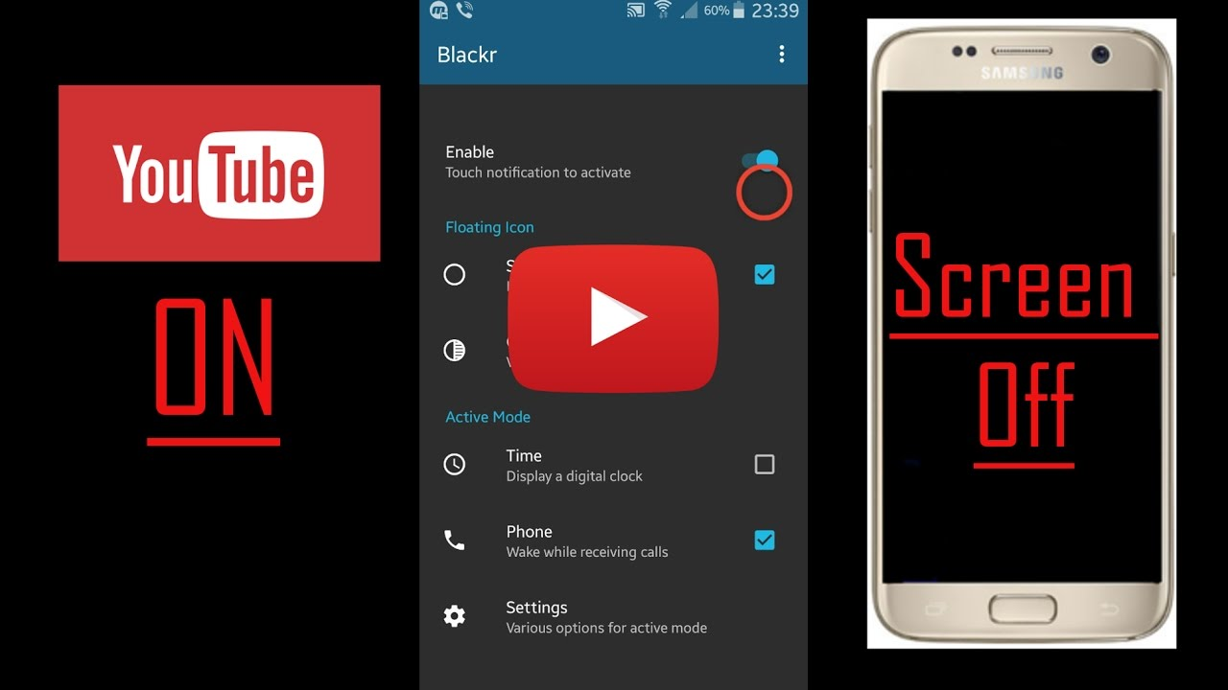

Yep, it's a picture, fool... lol
Here you go, CLICK IT:



Figure 1: Last Page