**Advanced Template version: 1.0**

[[doc-title]]

[[doc-subtitle]]

[[doc-type]]

**[[doc-company]]**

**[[doc-company-url]]**

**Document Number: [[doc-id]]**

**Version: [[doc-version]]**

**Release Date: [[doc-release-date]]**

Document History

Author Name: [[doc-author-name]]

Author Contact: [[doc-author-email]]

Document Revision

|  |  |  |  |  |
| --- | --- | --- | --- | --- |
| Version Number | Release Date | Status | Change Description | Author |
| [[doc-version]] | [[doc-release-date]] | Draft | [[doc-change-description]] | [[doc-author-name]] |
|  |  |  |  |  |
|  |  |  |  |  |
|  |  |  |  |  |

Intellectual Property Rights

This document is exclusive property of [[doc-company]] and all rights are reserved.

Table of Contents

1 Introduction 5

1.1 References 5

2 UC1 Work in GIT and Produce DOCX & PDF 6

3 h1 Heading 8-) 7

3.1 h2 Heading 7

3.1.1 h3 Heading 7

3.1.1.1 h4 Heading 7

3.1.1.1.1 h5 Heading 7

3.1.1.1.1.1 h6 Heading 7

3.2 Horizontal Rules 7

3.3 Typographic replacements 7

3.4 Emphasis 7

3.5 Blockquotes 7

3.6 Lists 8

3.7 Code 9

3.8 Tables 9

3.9 Links 9

3.10 Images 11

3.11 Plugins 14

3.11.1 Emojies 14

3.11.2 Subscript / Superscript 15

3.11.3 <ins> 15

3.11.4 <mark> 15

3.11.5 Footnotes 15

3.11.6 Definition lists 15

3.11.7 Abbreviations 16

3.11.8 Custom containers 16

4 Just checking tables - heading 1 17

4.1 Tables are under heading 2 17

5 Images 19

6 Markdown1-2 21

6.1 PUZZLES CLOUD MARKDOWN FILE HEADING 1 21

6.1.1 Welcome to the puzzles cloud md file HEADING 2 21

6.1.1.1 Let's start with stupid jokes HEADING 3 21

6.1.1.1.1 Let me tell you stupid joke on German: HEADING4 21

6.1.1.1.2 Let's switch to the Czech language HEADING 4 21

6.1.1.1.2.1 Real Czech language HEADING 5 21

6.2 Longest Serbian word he he HEADING 1 21

6.2.1 Serbian literature HEADING 2 21

6.3 It's enough, lets start with some smart things HEADING 1 22

Table of Tables

Table 1: Document references 5

Table 2 this is caption of the first table 17

Table 3 caption of the second table 18

Table of Figures

Figure 1 The Stormtroopocat 13

Figure 2 The Dojocat 14

Figure 3 Hooooover GIIIIT LAAAB 20

Figure 4 earth 20

Figure 5 This is a Title 2 20

# Introduction

## References

Referenced documents in creation of this document are listed in the Table 1.

|  |  |  |  |
| --- | --- | --- | --- |
| Document Reference | Document Title | Version | Filename |
| [1] | [[ reference-doc-title ]] |  | [[ reference-doc-filename ]] |
| [2] |  |  |  |
| [3] |  |  |  |
| [4] |  |  |  |
| [5] |  |  |  |
| [6] |  |  |  |
| [7] |  |  |  |
| [8] |  |  |  |

Table 1: Document references

# UC1 Work in GIT and Produce DOCX & PDF

* Do you work in Git?
* Do you like current DOCX editors?
* Do you need to produce high quality DOCX?

If answers are: **yes, no, yes** respectively, you are at the right place.

In this section we will explain the workflow on how you can work in Git and still produce high quality DOCX and PDF using our solution (very convenient for DevOps and Agile teams). This concept is known as docs-as-code, or we like to call it docx-as-code. The workflow is outlined in the following UML diagram:

1. Register (if not already done) and login to our application
2. Import a Git project where you have MarkDown based documentation.
3. Our application will connect to your repo and import it.
4. Upload your DOCX corporate template. For more details how to do it please check [Create docx Template](create-docx-template).
5. Start a new doc in our application.
6. Create manually the structure (Table of Content) of the new document, based on MarkDown docs in your Git repo.
7. Save your new doc in our application and push it to your Git repo.
8. Our App will push to your Git project uploaded DOCX template.
9. Our App will push to your Git project created DOCX structure (Table of Content).
10. Our App will push to your Git project new updated DOCX and PDF documents.
11. **[If Updating the Content]** You can update the content and commit the change to your repo.
12. Your repo through webhook service will notify our App about the change.
13. Our App will generate updated DOCX and PDF.
14. Our App will push to your Git project new updated DOCX and PDF documents.
15. **[If Changing DOCX Template]** You can update the DOCX Template and commit the change to your repo.
16. Your repo through webhook service will notify our App about the new Template.
17. Our App will generate updated DOCX and PDF.
18. Our App will push to your Git project new updated DOCX and PDF documents.
19. **[If Changing Table of Content]** You can update the Table of Content and commit the change to your repo. There are different possibilities: add/remove chapters/ .md docs, change order/heading level
20. Your repo through webhook service will notify our App about the new Table of Content.
21. Our App will generate updated DOCX and PDF.
22. Our App will push to your Git project new updated DOCX and PDF documents.

**If using PuzzlesCloud for Updates**

This option is still in development, coming soon.

# h1 Heading 8-)

## h2 Heading

### h3 Heading

#### h4 Heading

##### h5 Heading

###### h6 Heading

## Horizontal Rules

## Typographic replacements

Enable typographer option to see result.

(c) (C) (r) (R) (tm) (TM) (p) (P) +-

test.. test... test..... test?..... test!....

!!!!!! ???? ,, -- ---

"Smartypants, double quotes" and 'single quotes'

## Emphasis

**This is bold text**

**This is bold text**

This is italic text

This is italic text

Strikethrough

## Blockquotes

Blockquotes can also be nested...

...by using additional greater-than signs right next to each other...

...or with spaces between arrows.

## Lists

Unordered

* Create a list by starting a line with +, -, or *
* Sub-lists are made by indenting 2 spaces:
  1. Marker character change forces new list start:
     + Ac tristique libero volutpat at
     + Facilisis in pretium nisl aliquet
     + Nulla volutpat aliquam velit
* Very easy!

Ordered

1. Lorem ipsum dolor sit amet
2. Consectetur adipiscing elit
3. Integer molestie lorem at massa
4. You can use sequential numbers...
5. ...or keep all the numbers as 1.

asghdkaskdhkasjdhasddasdh khasdhas dhas asghdkaskdhkasjdhasddasdh khasdhas dhasasghdkaskdhkasjdhasddasdh khasdhas dhasasghdkaskdhkasjdhasddasdh khasdhas dhasasghdkaskdhkasjdhasddasdh khasdhas dhas

asghdkaskdhkasjdhasddasdh khasdhas dhasasghdkaskdhkasjdhasddasdh khasdhas dhasasghdkaskdhkasjdhasddasdh khasdhas dhasasghdkaskdhkasjdhasddasdh khasdhas dhasasghdkaskdhkasjdhasddasdh khasdhas dhasasghdkaskdhkasjdhasddasdh khasdhas dhas

asghdkaskdhkasjdhasddasdh khasdhas dhasasghdkaskdhkasjdhasddasdh khasdhas dhasasghdkaskdhkasjdhasddasdh khasdhas dhasasghdkaskdhkasjdhasddasdh khasdhas dhas

1. Lorem ipsum dolor sit amet
2. Consectetur adipiscing elit
3. Integer molestie lorem at massa
4. You can use sequential numbers...
5. ...or keep all the numbers as 1.

asdasdasdsa

1. Lorem ipsum dolor sit amet
2. Consectetur adipiscing elit
3. Integer molestie lorem at massa
4. You can use sequential numbers...
5. ...or keep all the numbers as 1.

Start numbering with offset:

1. foo
2. bar

## Code

Inline code

Indented code

// Some comments  
 line 1 of code  
 line 2 of code  
 line 3 of code

Block code "fences"

Sample text here...

Syntax highlighting

var foo = function (bar) {  
 return bar++;  
 };  
   
 console.log(foo(5));

## Tables

| Option | Description |
| --- | --- |
| data | path to data files to supply the data that will be passed into templates. |
| engine | engine to be used for processing templates. Handlebars is the default. |
| ext | extension to be used for dest files. |

Right aligned columns

| Option | Description |
| --- | --- |
| data | path to data files to supply the data that will be passed into templates. |
| engine | engine to be used for processing templates. Handlebars is the default. |
| ext | extension to be used for dest files. |

## Links

[link text](http://dev.nodeca.com/)

[link with title](http://nodeca.github.io/pica/demo/)

Autoconverted link <https://github.com/nodeca/pica> (enable linkify to see)

## Images

 

Figure 1 The Stormtroopocat

Like links, Images also have a footnote style syntax



Figure 2 The Dojocat

With a reference later in the document defining the URL location:

## Plugins

The killer feature of markdown-it is very effective support of [syntax plugins](https://www.npmjs.org/browse/keyword/markdown-it-plugin).

### [Emojies](https://github.com/markdown-it/markdown-it-emoji)

Classic markup: :wink: :crush: :cry: :tear: :laughing: :yum:

Shortcuts (emoticons): :-) :-( 8-) ;)

see [how to change output](https://github.com/markdown-it/markdown-it-emoji" \l "change-output) with twemoji.

### [Subscript](https://github.com/markdown-it/markdown-it-sub) / [Superscript](https://github.com/markdown-it/markdown-it-sup)

* 19th
* H2O

### [<ins>](https://github.com/markdown-it/markdown-it-ins)

Inserted text

### [<mark>](https://github.com/markdown-it/markdown-it-mark)

==Marked text==

### [Footnotes](https://github.com/markdown-it/markdown-it-footnote)

Footnote 1 link1.

Footnote 2 link2.

Inline footnote^[Text of inline footnote] definition.

Duplicated footnote reference2.

### [Definition lists](https://github.com/markdown-it/markdown-it-deflist)

Term 1

Definition 1 with lazy continuation.

Term 2 with inline markup

Definition 2

{ some code, part of Definition 2 }

Third paragraph of definition 2.

Compact style:

Term 1 ~ Definition 1

Term 2 ~ Definition 2a ~ Definition 2b

### [Abbreviations](https://github.com/markdown-it/markdown-it-abbr)

This is HTML abbreviation example.

It converts "HTML", but keep intact partial entries like "xxxHTMLyyy" and so on.

*[HTML]: Hyper Text Markup Language

### [Custom containers](https://github.com/markdown-it/markdown-it-container)

::: warning here be dragons :::

1. Footnote **can have markup**

and multiple paragraphs. ↩

1. Footnote text.

↩

# Just checking tables - heading 1

## Tables are under heading 2

| field name | type | constrains | description | example |
| --- | --- | --- | --- | --- |
| id | UUID | globally unique | globally unique UUID | c91feaf3-5968-4b60-aa5b-62fe7fdd905c |
| type | string | n/a | type of request, must be "voucher-order", "voucher-order" |  |
| voucher-code | string | n/a | code of the voucher gathered from voucher list | "VODADE15" |
| payment-method | string | n/a | on of the allowed methods for the voucher, denoted in voucher list response | "Wirecard VISA" |
| notification-type | string | currently only "email" is supported | type of the notification target | "email" |
| notification-target | string | n/a | target adress | "[me@my-email.com](mailto:me@my-email.com)" |
| order-success-redirect-url | string | valid URL | Where the wirecard should redirect if payment was successfull | protect |
| order-failed-redirect-url | string | valid URL | Where the wirecard should redirect if payment fails | protect |
| order-canceled-redirect-url | string | valid URL | Where the wirecard should redirect if payment was canceled | protect |

Table 2 this is caption of the first table

| Option | Description |
| --- | --- |
| data | path to data files to supply the data that will be passed into templates. |
| engine | engine to be used for processing templates. Handlebars is the default. |
| ext | extension to be used for dest files. |

Table 3 caption of the second table

# Images

This section is related to the rendering of the syntax of IMAGES elements

Casual image



Image with the title



Figure 3 Hooooover GIIIIT LAAAB

This is an footnote style sintax with defined id later in the document



Figure 4 earth

My alt attribute goes here!

Figure 5 This is a Title 2

# Markdown1-2

## PUZZLES CLOUD MARKDOWN FILE HEADING 1

### Welcome to the puzzles cloud md file HEADING 2

#### Let's start with stupid jokes HEADING 3

##### **Let me tell you stupid joke on German: HEADING4**

* "Hey Philipp, wie war denn der Urlaub?"
* "Gräßlich! Im Hotel hatte ich Zimmernummer hundert. Und vom Türschild ist die Eins abgefallen!"

ÜÜÜÜÜÜ- that was stupid

##### Let's switch to the Czech language HEADING 4

* "Co rłńóobi trakłńótośźr u fśźryśźżzjera?"
* Warćękocze.

ąćęłńóśźż!!!!

**Just kidding, that was Poland language u fool, let's switch to the Czech for real**

###### Real Czech language HEADING 5

**ýžáčďéěíňóřšťúů**

* Jak říkáte albínskému muži z Prahy?
* Prázdný Čech.

## Longest Serbian word he he HEADING 1

Here you go: АБВГДЂЕЖЗИЈКЛЉМНЊОПРСТУФХЦЧЏШ

### Serbian literature HEADING 2

Весела песма  
 Из школе се враћа Стева  
 сав весео путем пева.  
   
 Уз пут среће бака Јелу:  
 „Ћирилицу знадем целу!"  
   
 Кући дође, па са врата:  
 „Ћирилицу знадем, тата!"  
   
 „Све сад, мајко, читам сам,  
 јер од данас и „ш" знам!"  
   
 Оком тражи и сестрицу:  
 „Сејо, знадем ћирилицу!"  
   
 Потом оде до икона,  
 па начини три поклона.  
   
 Хоће Стева да се јави  
 и захвали Светом Сави.  
   
 Свети Сава Стеву чује,  
 па се скупа с њим радује:  
   
 „Српство ми је од сад јаче  
 за још једно вредно ђаче!"

## It's enough, lets start with some smart things HEADING 1

1. PLAY THIS VIDEO AND THANKS ME LATER!

**HIT THAT PLAY BUTTON** 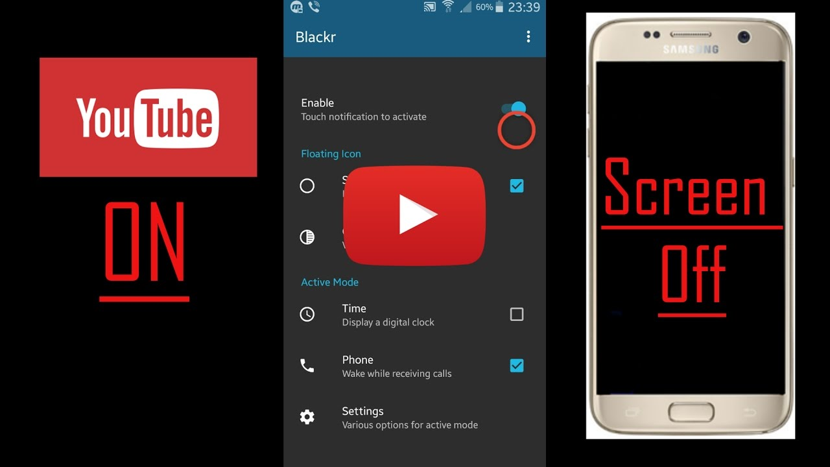

Yep, it's a picture, fool... lol Here you go, CLICK IT:



Figure 1: Last Page