**Advanced Template version: 1.0**

[[doc-title]]

[[doc-subtitle]]

[[doc-type]]

**[[doc-company]]**

**[[doc-company-url]]**

**Document Number: [[doc-id]]**

**Version: [[doc-version]]**

**Release Date: [[doc-release-date]]**

Document History

Author Name: [[doc-author-name]]

Author Contact: [[doc-author-email]]

Document Revision

|  |  |  |  |  |
| --- | --- | --- | --- | --- |
| Version Number | Release Date | Status | Change Description | Author |
| [[doc-version]] | [[doc-release-date]] | Draft | [[doc-change-description]] | [[doc-author-name]] |
|  |  |  |  |  |
|  |  |  |  |  |
|  |  |  |  |  |

Intellectual Property Rights

This document is exclusive property of [[doc-company]] and all rights are reserved.

Table of Contents

Introduction 1

References 1

Backticks 1

[Backticks MD file
1](#_Toc16293621084201260728056062)

[Backtickts in heading
1](#_Toc16293621084415800401584393)

[End of file
1](#_Toc16293621084623085612992124)

Markdown1 1

[PUZZLES CLOUD MARKDOWN FILE HEADING 1
1](#_Toc16293621085967963639008268)

[Welcome to the puzzles cloud md file HEADING 2
1](#_Toc16293621086175556181501424)

[Let's start with stupid jokes HEADING 3
1](#_Toc16293621086373922516961195)

[Let me tell you stupid joke on German: HEADING4
1](#_Toc16293621086587806897644418)

[Let's switch to the Czech language HEADING 4
1](#_Toc16293621086787674500087632)

[Longest Serbian word he he HEADING 1
1](#_Toc16293621087197973945049982)

[Serbian literature HEADING 2
1](#_Toc16293621087402959524824139)

[It's enough, lets start with some smart things HEADING 1
1](#_Toc16293621087622819210340342)

SameHeadingsTest 1

[Heading 2
1](#_Toc16293621088029169616003947)

[Heading 2 (text1)
1](#_Toc16293621088239611384124012)

[Heading 2 (text2)
1](#_Toc1629362108843467096025815)

[Heading 1
1](#_Toc1629362108863243452717619)

[Heading 2
1](#_Toc16293621088837391797291148)

[Heading 3
1](#_Toc16293621089031375683927487)

JustTesting 1

[PUZZLES CLOUD MARKDOWN FILE
1](#_Toc16293621089436761901458637)

[Welcome to the puzzles cloud md file
1](#_Toc16293621089637912372705893)

[Let's start with stupid jokes
1](#_Toc16293621089834288281194658)

[Let me tell you stupid joke on German:
1](#_Toc16293621090034426012792718)

[Let's switch to the Czech language
1](#_Toc16293621090245511819202740)

[Real Czech language
1](#_Toc16293621090452111558653156)

[Longest Serbian word he he
1](#_Toc1629362109065904490509692)

[Serbian literature
1](#_Toc16293621090858354595491995)

[It's enough, lets start with some smart things
1](#_Toc1629362109107279788976830)

SameHeadingsTest 1

[Heading 2
1](#_Toc16293621092413307854333678)

[Heading 2 (text1)
1](#_Toc16293621092601644948034950)

[Heading 2 (text2)
1](#_Toc16293621092816558152051702)

[Heading 1
1](#_Toc16293621093016428918657984)

[Heading 2
1](#_Toc16293621093229992385219286)

[Heading 3
1](#_Toc1629362109342576217249252)

Table of Tables

Table 1: Document references 1

Table of Figures

Figure 1: Last Page 1

# Introduction

## References

Referenced documents in creation of this document are listed in the Table 1.

|  |  |  |  |
| --- | --- | --- | --- |
| Document Reference | Document Title | Version | Filename |
| [1] | [[ reference-doc-title ]] |  | [[ reference-doc-filename ]] |
| [2] |  |  |  |
| [3] |  |  |  |
| [4] |  |  |  |
| [5] |  |  |  |
| [6] |  |  |  |
| [7] |  |  |  |
| [8] |  |  |  |

Table 1: Document references

# testing_folder

## Backticks

### Backticks MD file

this is single line of backticks

Tis is text which contains text under backticks

this is backticks this is regular text

several text lines under single backticks several text lines under single backticks several text lines under single backticks several text lines under single backticks several text lines under single backticks several text lines under single backticks several text lines under single backticks several text lines under single backticks several text lines under single backticks several text lines under single backticks several text lines under single backticks several text lines under single backticks several text lines under single backticks

#### Backtickts in heading

test test test test test test test test test test test test test test test test test test test test test test test test test test test test test test

### End of file

test

## testing folder

### testing subFolder

#### no files folder

##### Markdown1

###### PUZZLES CLOUD MARKDOWN FILE HEADING 1

Welcome to the puzzles cloud md file HEADING 2

Let's start with stupid jokes HEADING 3

**Let me tell you stupid joke on German: HEADING4**

* "Hey Philipp, wie war denn der Urlaub?"
* "Gräßlich! Im Hotel hatte ich Zimmernummer hundert. Und vom Türschild ist die Eins abgefallen!"

ÜÜÜÜÜÜ- that was stupid

Let's switch to the Czech language HEADING 4

* "Co rłńóobi trakłńótośźr u fśźryśźżzjera?"
* Warćękocze.

ąćęłńóśźż!!!!

Just kidding, that was Poland language u fool, let's switch to the Czech for real

Real Czech language HEADING 5

**ýžáčďéěíňóřšťúů**

* Jak říkáte albínskému muži z Prahy?
* Prázdný Čech.

###### Longest Serbian word he he HEADING 1

Here you go: АБВГДЂЕЖЗИЈКЛЉМНЊОПРСТУФХЦЧЏШ

Serbian literature HEADING 2

Весела песма
Из школе се враћа Стева
сав весео путем пева.
Уз пут среће бака Јелу:
„Ћирилицу знадем целу!"
Кући дође, па са врата:
„Ћирилицу знадем, тата!"
„Све сад, мајко, читам сам,
јер од данас и „ш" знам!"
Оком тражи и сестрицу:
„Сејо, знадем ћирилицу!"
Потом оде до икона,
па начини три поклона.
Хоће Стева да се јави
и захвали Светом Сави.
Свети Сава Стеву чује,
па се скупа с њим радује:
„Српство ми је од сад јаче
за још једно вредно ђаче!"

###### It's enough, lets start with some smart things HEADING 1

1.

PLAY THIS VIDEO AND THANKS ME LATER!

**HIT THAT PLAY BUTTON** 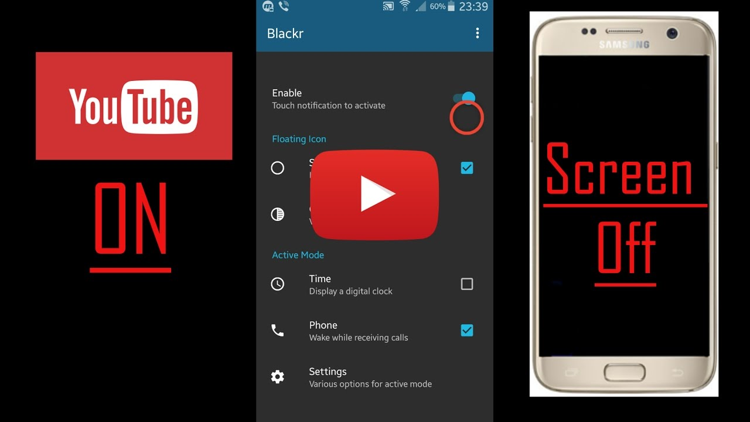

Yep, it's a picture, fool... lol
Here you go, CLICK IT:

#### SameHeadingsTest

##### Heading 2

##### Heading 2 (text1)

##### Heading 2 (text2)

### Heading 1

#### Heading 2

##### Heading 3

# JustTesting

## PUZZLES CLOUD MARKDOWN FILE

### Welcome to the puzzles cloud md file

#### Let's start with stupid jokes

##### **Let me tell you stupid joke on German:**

* "Hey Philipp, wie war denn der Urlaub?"
* "Gräßlich! Im Hotel hatte ich Zimmernummer hundert. Und vom Türschild ist die Eins abgefallen!"

ÜÜÜÜÜÜ- that was stupid

##### Let's switch to the Czech language

* "Co robi traktor u fryzjera?"
* Warkocze.

ąćęłńóśźż!!!!

Just kidding, that was Poland language u fool, let's switch to the Czech for real

###### Real Czech language

**ýžáčďéěíňóřšťúů**

* Jak říkáte albínskému muži z Prahy?
* Prázdný Čech.

## Longest Serbian word he he

Here you go: АБВГДЂЕЖЗИЈКЛЉМНЊОПРСТУФХЦЧЏШ

### Serbian literature

Весела песма
Из школе се враћа Стева
сав весео путем пева.
Уз пут среће бака Јелу:
„Ћирилицу знадем целу!"
Кући дође, па са врата:
„Ћирилицу знадем, тата!"
„Све сад, мајко, читам сам,
јер од данас и „ш" знам!"
Оком тражи и сестрицу:
„Сејо, знадем ћирилицу!"
Потом оде до икона,
па начини три поклона.
Хоће Стева да се јави
и захвали Светом Сави.
Свети Сава Стеву чује,
па се скупа с њим радује:
„Српство ми је од сад јаче
за још једно вредно ђаче!"

## It's enough, lets start with some smart things

1.

PLAY THIS VIDEO AND THANKS ME LATER!

**HIT THAT PLAY BUTTON** 

Yep, it's a picture, fool... lol
Here you go, CLICK IT:

# testing_folder

## testing folder

### testing subFolder

#### no files folder

#### SameHeadingsTest

##### Heading 2

##### Heading 2 (text1)

##### Heading 2 (text2)

### Heading 1

#### Heading 2

##### Heading 3



Figure 1: Last Page