1. Overview
This architecture represents an AI-assisted Performance Testing (PT) platform that integrates LLMs, MCP (Model Context Protocol), k6 performance scripts, and monitoring tools into a single, extensible system.
The goal is to: - Simplify performance test creation and execution - Enable intelligent orchestration using LLMs - Support multiple test types (Load, Stress, Spike, Soak) - Plug in different monitoring tools - Provide automated insights, summaries, and reports.

Diagram :
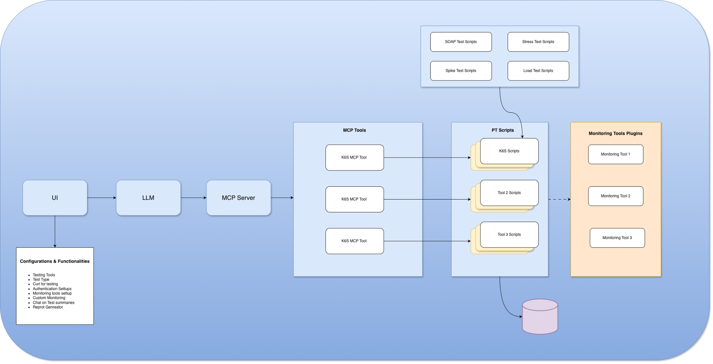

2. High-Level Flow

UI → LLM → MCP Server → MCP Tools → PT Scripts → Monitoring Tools → Reports & Insights
- User configures and triggers tests via the UI
- LLM interprets intent and converts it into structured actions
- MCP Server routes actions to the appropriate MCP tools
- MCP tools generate/execute PT scripts (k6, others)
- Scripts push metrics to monitoring tools
- Results are stored, analyzed, summarized, and reported

3. Component Breakdown

3.1 User Interface (UI)
The UI acts as the control plane for the entire system.
Responsibilities: - Select testing tool (k6, future tools) - Choose test type (Load, Stress, Spike, Soak) - Configure: - VUs, duration, ramp-up/down - Curl / API definitions - Authentication (JWT, OAuth, API keys) - Monitoring tool setup - Trigger test execution - Chat with AI for: - Test summaries - Failure analysis - Capacity insights - Generate downloadable reports

3.2 LLM (Large Language Model)
The LLM acts as the intelligent brain of the platform.
Responsibilities: - Understand user intent (natural language or UI input) - Convert intent into structured MCP commands - Assist in: - Script generation - Test optimization suggestions - Root cause analysis - Human-readable summaries
The LLM does not execute tests directly; it delegates execution via MCP.

3.3 MCP Server
The MCP Server is the orchestration and routing layer.
Responsibilities: - Acts as a bridge between LLM and execution tools - Enforces standard MCP contracts - Routes requests to correct MCP tools - Manages tool lifecycle and permissions
This layer ensures: - Tool abstraction - Vendor/tool independence - Easy extensibility

3.4 MCP Tools
MCP Tools are tool-specific adapters.
In this design, multiple k6 MCP Tools are shown, representing: - Different test profiles - Different environments - Different execution backends
Responsibilities: - Translate MCP instructions into executable scripts - Validate test configuration - Trigger PT script execution - Collect raw results and metadata
Future tools (e.g., JMeter, Locust) can be added without changing the LLM.

3.5 PT Scripts Layer
This layer contains the actual performance test scripts.
Script Types: - k6 Scripts - Tool 2 Scripts (future) - Tool 3 Scripts (future)
Test Categories Supported: - Load Test - Stress Test - Spike Test - Soak Test
Responsibilities: - Execute workload against target systems - Emit metrics (latency, TPS, errors) - Push metrics to monitoring tools - Persist results to storage

3.6 Monitoring Tools Plugins
This layer provides observability integrations.
Examples: - Prometheus - Grafana - Elastic (APM, Metrics) - Cloud-native monitoring tools
Responsibilities: - Receive metrics from PT scripts - Correlate system-level and application-level metrics - Enable dashboards and alerts
The plugin-based design allows adding/removing monitoring tools easily.

3.7 Results Storage
A centralized data store for: - Test execution metadata - Raw metrics - Aggregated KPIs - Historical trends
Used by: - Report generator - AI analysis - Regression comparison

4. Script Management & Test Types
The Test Scripts block represents reusable templates: - Load Test Scripts - Stress Test Scripts - Spike Test Scripts - Soak Test Scripts
These templates are: - Parameterized by the LLM - Version-controlled - Reused across environments

5. Key Design Advantages

5.1 AI-Driven Automation
- No manual script writing for common cases
- Intelligent test tuning
- Automated insights

5.2 Tool-Agnostic Architecture
- MCP abstracts execution tools
- Easy to add new PT tools

5.3 Observability-First Design
- Tight integration with monitoring systems
- Correlated infra + app metrics

5.4 Scalability & Extensibility
- Multiple MCP tools
- Plugin-based monitoring
- Supports enterprise-scale testing

6. Example End-to-End Scenario
- User selects Stress Test, 300 VUs, 10 mins
- UI sends configuration to LLM
- LLM generates MCP instructions
- MCP Server routes to the k6 MCP Tool
- k6 scripts execute test
- Metrics flow to Prometheus & Elastic
- Results stored
- LLM generates:
  - TPS
  - Error analysis
  - Capacity recommendation
- Report is generated and shared

7. Future Enhancements
- Multi-region test execution
- Chaos engineering integration
- Auto-scaling validation
- Cost-aware load testing
- CI/CD pipeline integration

8. Conclusion
This architecture provides a modern, AI-powered, extensible performance testing platform that reduces manual effort, improves insight quality, and scales with system complexity.It is well-suited for enterprise-grade performance engineering and continuous testing pipelines.

