

# **Professor Lee Chuk Munn**

**EXAM MANAGEMENT SYSTEM**

**FULLTIME TEAM - 4**

|  |  |
| --- | --- |
| Milan D Ashara | A0120041J |
| Nisith Singh | A0119941B |
| Li ke |  |
| Abhinav Gupta |  |

**Instructions to configure Connection Pool**

Open Domain Admin Console from Glassfish under Servers inside Services tab

URL : Jdbc:mysql://localhost:3306/ems

Database name: ems

Server name: localhost

Port: 3306

Username: root

Password: root

Datasource: jdbc/ems

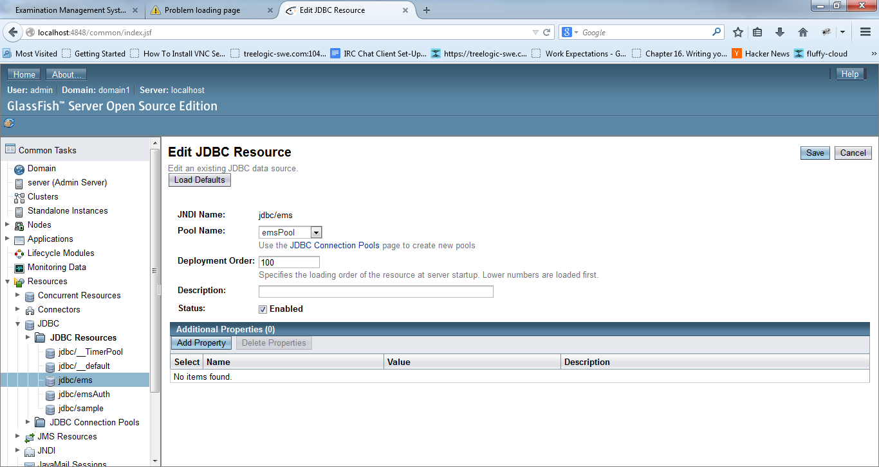

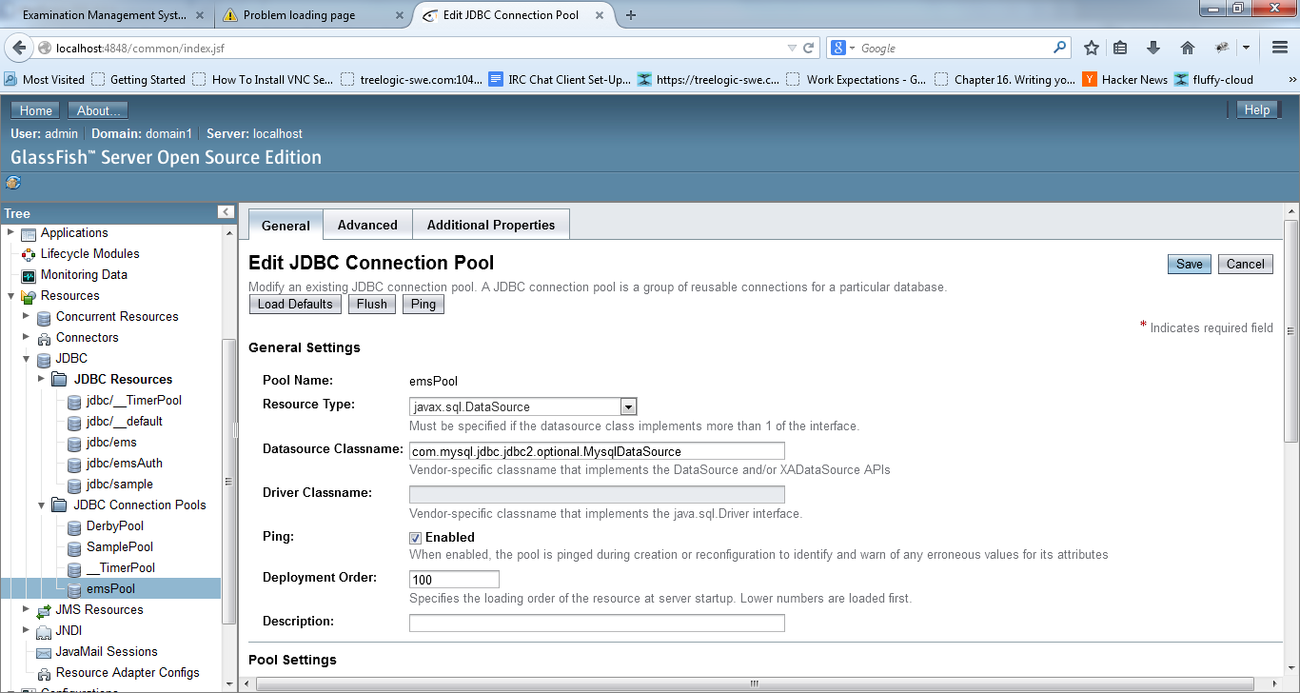

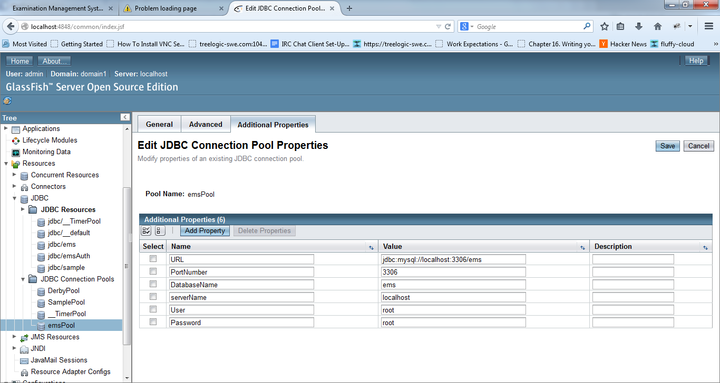

**Security Configuration for Authentication and Authorization**

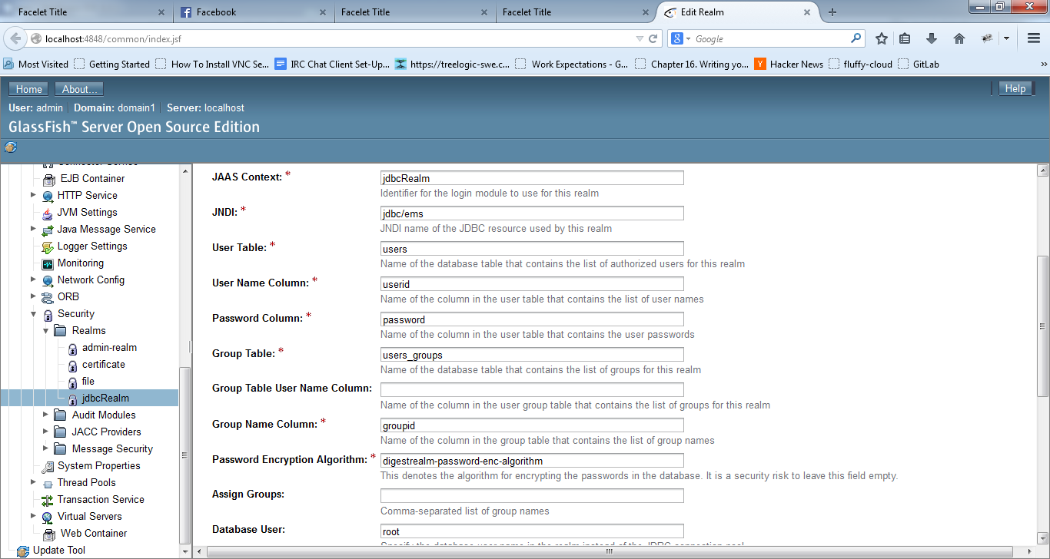

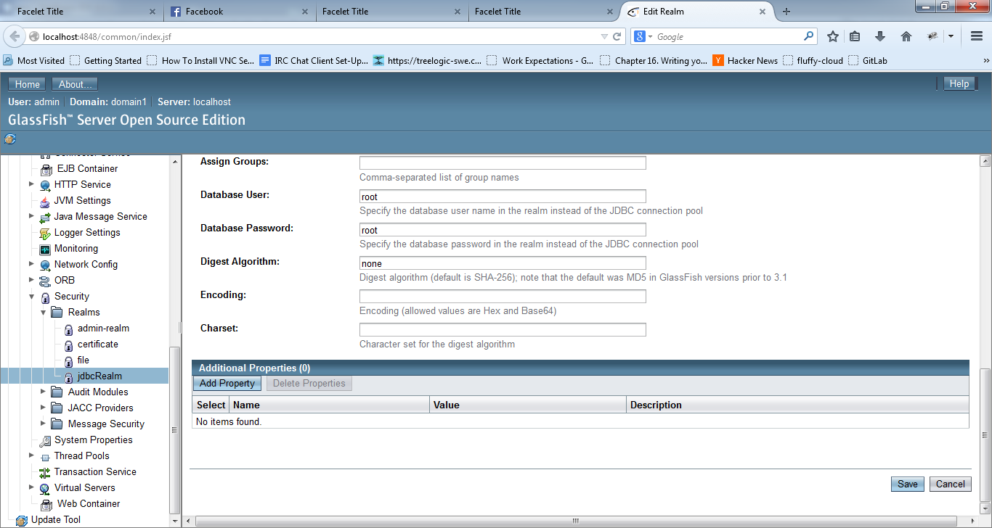

**Additional Information**

**Populate Data in mysql**

“ems/doc/script/init_data_v6**.sql**”

**The Class diagrams** “ems/doc/entity_diagram.jpa”

The project can also be found on : <https://github.com/milandashara/EMS>