E-commerce Sales Analytics Dashboard
A Project Report Submitted in the partial fulfillment of the requirements for the award of the degree of
BACHELOR OF TECHNOLOGY
In
DEPARTMENT OF COMPUTER SCIENCE
By
Milan Jain - 2420030789
N Nikhil Reddy - 2420030768
T Varun - 2420030039

Under the Esteemed Guidance of
Dr N Sunanda
Associate Professor
Department of COMPUTER SCIENCE
AY-2026-2027
Semester: 3rd year Odd Sem



K L (Deemed to be) University
DEPARTMENT OF COMPUTER SCIENCE
Declaration
The Project Report entitled “ E-commerce Sales Analytics Dashboard is a record of Bonafide work of N Nikhil Reddy – 2420030768, Milan Jain – 2420030789, T Varun – 2420030039 submitted in partial fulfillment for the award of B. Tech in CSE to the K L University. The results embodied in this report have not been copied from any other departments/University/Institute.

N Nikhil Reddy – 2420030768
Milan Jain – 2420030789
T Varun – 2420030039

K L (Deemed to be) University
DEPARTMENT OF CSE
CERTIFICATE
This is certify that the mini project based report entitled “E-commerce Sales Analytics Dashboard” is a bonafide work done and submitted by N Nikhil Reddy– 2420030768, Milan Jain – 2420030789, T Varun – 2420030039 in partial fulfillment of the requirements for the award of the degree of BACHELOR OF TECHNOLOGY in Department of CSE, K L (Deemed to be University), during the academic year 2026-2027.

Signature of Guide
Dr.N.Sunanda
Associate Professor
Department of CSE

Signature of the Course Coordinator Signature of the HOD Dr.P.Venkateswara Rao
CSE-HOD
Dr.N.Sunanda
Associate Professor
Department of CSE

ACKNOWLEDGEMENT
The success in this project would not have been possible but for the timely help and guidance rendered by many people. Our wish to express my sincere thanks to all those who has assisted us in one way or the other for the completion of my project.
Our greatest appreciation to my Course Coordinator and my guide Dr N Sunanda, Department of CSE which cannot be expressed in words for his/her tremendous support, encouragement and guidance for this project.
We express our gratitude to Dr P.Venkateshwar Rao, Head of the Department for CSE for providing us with adequate facilities, ways and means by which we are able to complete this project-based Lab.
We thank all the members of teaching and non-teaching staff members, and also who have assisted me directly or indirectly for successful completion of this project. Finally, I sincerely thank my parents, friends and classmates for their kind help and cooperation during my work.

N Nikhil Reddy – 2420030768
Milan Jain – 2420030789
T Varun – 2420030039

Abstract
With the explosive growth of modern digital commerce, online retail businesses face mounting challenges in aggregating, processing, and deriving actionable insights from high-velocity, multi-dimensional sales data. Conventional transactional databases and static spreadsheets often fail to provide the responsiveness and clarity required for agile commercial decision-making. This project presents the development of Kartwise, an E-commerce Sales Analytics Dashboard, designed to bridge the gap between raw order records and day-to-day business decisions.
The dashboard is built as a responsive single-page web application using HTML, CSS and JavaScript, with all charts drawn as scalable vector graphics (SVG) and no external charting library. It computes and presents core retail metrics including revenue, order volume, average order value (AOV) and conversion rate, together with a revenue-and-orders trend chart, a category-wise revenue share, top-selling products, and region-wise sales across India. Users can switch the reporting window between 7 days, 30 days and 12 months, browse the product catalogue, search and filter recent orders by customer, product or status, export the orders as a CSV file, and switch between light and dark themes. The platform reduces time-to-insight and equips business stakeholders with clear, data-driven intelligence for sales planning and revenue optimization.

Index
S. No. | Chapters | Topics | Page.no
 |  | Acknowledgement
 |  | Abstract
1 | Introduction | 1.1 Background of the project  1.2 Problem statement  1.3 Scope of the project  1.4 Objective(s)  1.5 Importance of the application  1.6 Target users/audience | 1-10
2 | System Requirements | 2.1 Hardware requirements  2.2 Software requirements  2.3 Development tools and frameworks | 11-20
3 | Technology Stack | 3.1 Front-end (e.g., React.js, Angular, HTML/CSS)  3.2 Back-end (e.g., Node.js, Django, Spring Boot)  3.3 Database (e.g., MongoDB, MySQL, PostgreSQL)  3.4 Version Control (e.g., Git, GitHub)  3.5 APIs or External services (e.g., Firebase, Stripe) | 21-30
4 | System Architecture | 4.1 High-level architecture diagram  4.2 Description of each layer (frontend, backend, database)  4.3 Deployment architecture (e.g., cloud, local, CI/CD pipelines) | 31-35
5 | Design | 5.1 Wireframes or mockups  5.2 ER Diagram / Database schema | 36-42
6 | Implementation | 6.1 Module-wise implementation  6.2 Front-end logic (UI rendering, state management)  6.3 Backend logic (routes, controllers, business logic)  6.4 Database connectivity  6.5 API integration  6.6 Authentication & Authorization | 43-55
7 | Features | 7.1 List of main features  7.2 How each feature works (user perspective + technical description) | 56-60
8 | Testing | 8.1 Postman testing (frontend/backend)  8.2 Integration testing  8.3 Tools used for testing  8.4 Test cases and results | 61-67
9 | Deployment | 9.1 Steps to deploy  9.2 Environment configuration  9.3 Hosting of frontend and backend | 68-73
10 | Challenges & Limitations | 10.1 Issues faced during development  10.2 Solutions applied  10.3 Current limitations or known bugs | 74-80
11 | Future Enhancements | 11.1 Planned features  11.2 Possible integrations or optimizations | 81-88
12 | Conclusion | 12.1 Summary of the project  12.2 What was achieved  12.3 Skills learned during development | 89-100
13 | References | - Books, tutorials, APIs, documentation sites used
14 | Appendices | - Screenshots of the app  - Sample code snippets  - Installation/setup instructions  - User manual or guide  -certifications

CHAPTER 1

Introduction

1.1 Motivation
The E-commerce Sales Analytics Dashboard (Kartwise) provides an interactive platform to transform raw transactional data into real-time business intelligence. It enables stakeholders to monitor key metrics like revenue, order volume, and customer trends to make fast, data-driven decisions that optimize sales and inventory performance.

1.2 Objective
The primary objective of the E-commerce Sales Analytics Dashboard is to provide business stakeholders and managers with an interactive platform for monitoring and analyzing commercial performance. By converting raw transactional records into real-time business intelligence, the system tracks vital metrics such as revenue growth, order volume, average order value, conversion rate and product performance. Ultimately, it eliminates data silos and reporting delays, enabling fast, data-driven decisions that optimize sales strategies and operational efficiency.

1.3 What is Web Development?
Web development is the work involved in developing a web site for the Internet (World Wide Web) or an intranet (a private network). Web development can range from developing a simple single static page of plain text to complex web-based internet applications (web apps), electronic businesses, and social network services. A more comprehensive list of tasks to which web development commonly refers, may include web engineering, web design, web content development, client liaison, client-side/server-side scripting, web server and network configuration.
Among web professionals, "web development" usually refers to the main non-design aspects of building web sites: writing markup and coding. Web development may use content management systems (CMS) to make content changes easier and available with basic technical skills.
For larger organizations and businesses, web development teams can consist of hundreds of people (web developers) and follow standard methods like Agile methodologies while developing websites. Smaller organizations may only require a single permanent or contracting developer, or secondary assignment to related job positions such as a graphic designer or information systems technician. Web development may be a collaborative effort between departments rather than the domain of a designated department. There are three kinds of web developer specialization: front-end developer, back-end developer, and full-stack developer.

1.4 What is Website?
A website or web site is a collection of related network web resources, such as web pages, multimedia content, which are typically identified with a common domain name, and published on at least one web server. Notable examples are wikipedia.org, google.com, and amazon.com.
Websites can be accessed via a public Internet Protocol (IP) network, such as the Internet, or a private local area network (LAN), by a uniform resource locator (URL) that identifies the site.
Websites can have many functions and can be used in various fashions; a website can be a personal website, a corporate website for a company, a government website, an organization website, etc. Websites are typically dedicated to a particular topic or purpose, ranging from entertainment and social networking to providing news and education. All publicly accessible websites collectively constitute the World Wide Web, while private websites, such as a company's website for its employees, are typically part of an intranet.

1.5 What is Webpage?
A web page is a document that is suitable to act as a web resource on the World Wide Web. In order to graphically display a web page, a web browser is needed. This is a type of software that can retrieve web pages from the Internet. When accessed by a web browser it may be displayed as a web page on a monitor or mobile device. Typical web pages are hypertext documents which contain hyperlinks, often referred to as links, for browsing to other web pages.
The term web page usually refers to what is visible, but may also refer to the contents of the source code itself, which is usually a text file containing hypertext written in HTML or a comparable markup language. Most current web browsers include the ability to view the source code. Web browsers will frequently have to access multiple web resource elements, such as style sheets, scripts, and images, while presenting each web page.

CHAPTER 2

Software Requirement

2.1 Problem Statement
In today's competitive e-commerce industry, businesses generate large amounts of sales data every day. However, analyzing this data manually is difficult, time-consuming, and may lead to errors. Businesses often face challenges in understanding customer purchasing behavior, identifying best-selling products, tracking sales performance, and monitoring overall revenue.

2.2 Technologies used
1. HTML: Hypertext Markup Language (HTML) is the standard markup language for documents designed to be displayed in a web browser. It can be assisted by technologies such as Cascading Style Sheets (CSS) and scripting languages such as JavaScript. In Kartwise, HTML defines the sidebar navigation, the three views (Overview, Products and Orders), the KPI containers, the orders table and the SVG canvases for the charts.
General Syntax of HTML:
1. <!DOCTYPE html>
2. <html>
3. <head>
4. <title>Page Title</title>
5. </head>
6. <body>
7. <h1>My First Heading</h1>
8. <p>My first paragraph.</p>
9. </body>
10. </html>
2. CSS: Cascading Style Sheets (CSS) is a style-sheet language used to describe the presentation of a document written in HTML or XML (including XML dialects such as SVG, MathML or XHTML). CSS describes how elements should be rendered on screen, on paper, in speech, or on other media.
CSS is one of the core languages of the open Web and is standardized across Web browsers according to the W3C specification. Developed in levels, CSS1 is now obsolete, CSS2.1 is a recommendation, and CSS3, now split into smaller modules, is progressing on the standardization track. Kartwise uses CSS custom properties (variables), CSS Grid and Flexbox, media queries and keyframe animations to build the layout, the light and dark themes and the motion effects.
Types of CSS:
2.1 Inline CSS: It will affect only single elements. In HTML we require that various HTML tag's views are different so then we use inline Cascading Style Sheets. There are disadvantage of inline Cascading Style Sheets. It must be specified on every HTML tag. There is a lot of time consumed by that and it is not the best practice for a good programmer and the code will be quite large and very complex.
2.2 Internal CSS: In internal CSS the style of CSS is specified in the <head> section. This is internal CSS, it affects all the elements in the body section. Internal CSS is used in the condition when we want a style to be used in the complete HTML body. For that we can use style in the head tag. Kartwise uses internal CSS, so the whole dashboard is delivered as a single self-contained HTML file.
2.3 External CSS: In External CSS we create a .css file and use it in our HTML page as per our requirements. Generally external Cascading Style Sheets are used whenever we have many HTML attributes and we can use them as required; there is no need to rewrite the CSS style again and again in a complete body of HTML that inherits the property of the CSS file.
3. JavaScript: JavaScript is a high-level, interpreted programming language that runs in every modern web browser and makes web pages interactive. In Kartwise, plain (vanilla) JavaScript is used to generate the sample sales data, calculate the KPIs, draw the SVG line chart, donut chart and bars, animate the number counters, filter the orders table, switch views and themes, and export the orders as a CSV file. No framework or library is required.
4. SVG (Scalable Vector Graphics): SVG is an XML-based markup language for describing two-dimensional vector graphics. It stays sharp at any screen size and can be styled with CSS and animated. All charts of the dashboard (revenue-and-orders chart, category donut and the hero cart illustration) are generated as inline SVG.
5. Google Fonts: The typefaces Bricolage Grotesque (headings and numbers) and DM Sans (body text) are loaded from Google Fonts, with system fonts as a fallback.

2.3 Software Used
2.3.1 Code Editor: A source code editor is used for writing the HTML, CSS and JavaScript of the project. Modern editors provide syntax highlighting, auto-completion and live preview, which speed up front-end development.
2.3.2 Web Browser: A modern web browser such as Google Chrome is used to run and test the dashboard. Its developer tools help in inspecting the DOM, debugging JavaScript and checking the responsive layout on different screen sizes.

2.4 Hardware Requirements
- Processor: Any modern dual-core processor
- RAM: 4 GB or more
- Display: 1280 × 720 or higher recommended (the layout also adapts to mobile screens)
- Storage: Less than 1 MB for the project file

CHAPTER 3

Software Design

3.1 DFD
A data-flow diagram (DFD) is a way of representing a flow of a data of a process or a system (usually an information system). The DFD also provides information about the outputs and inputs of each entity and the process itself. A data-flow diagram has no control flow, there are no decision rules and no loops. Specific operations based on the data can be represented by a flowchart.
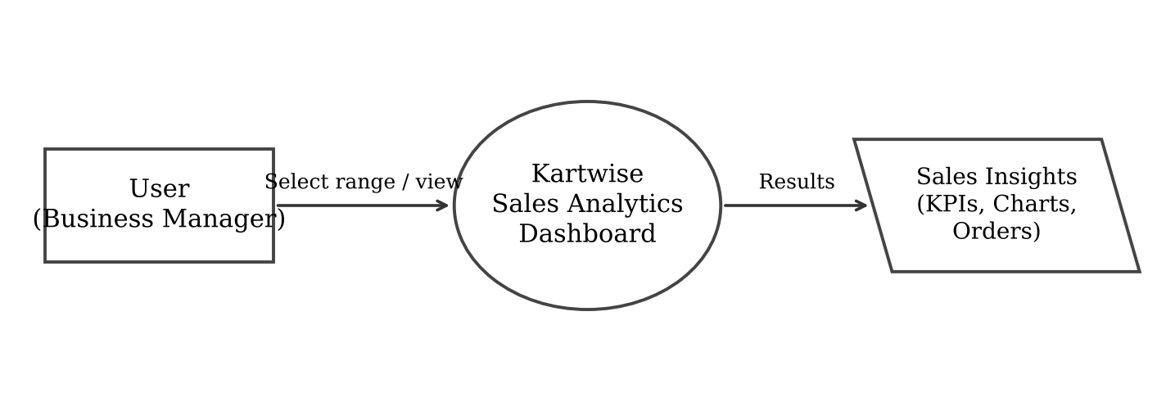
Fig No. 3.1 DFD LEVEL-0
At Level-0 the whole system is shown as a single process. The user (business manager) selects a time range or a view, and the Kartwise dashboard returns the sales insights in the form of KPIs, charts, product lists and the orders table.
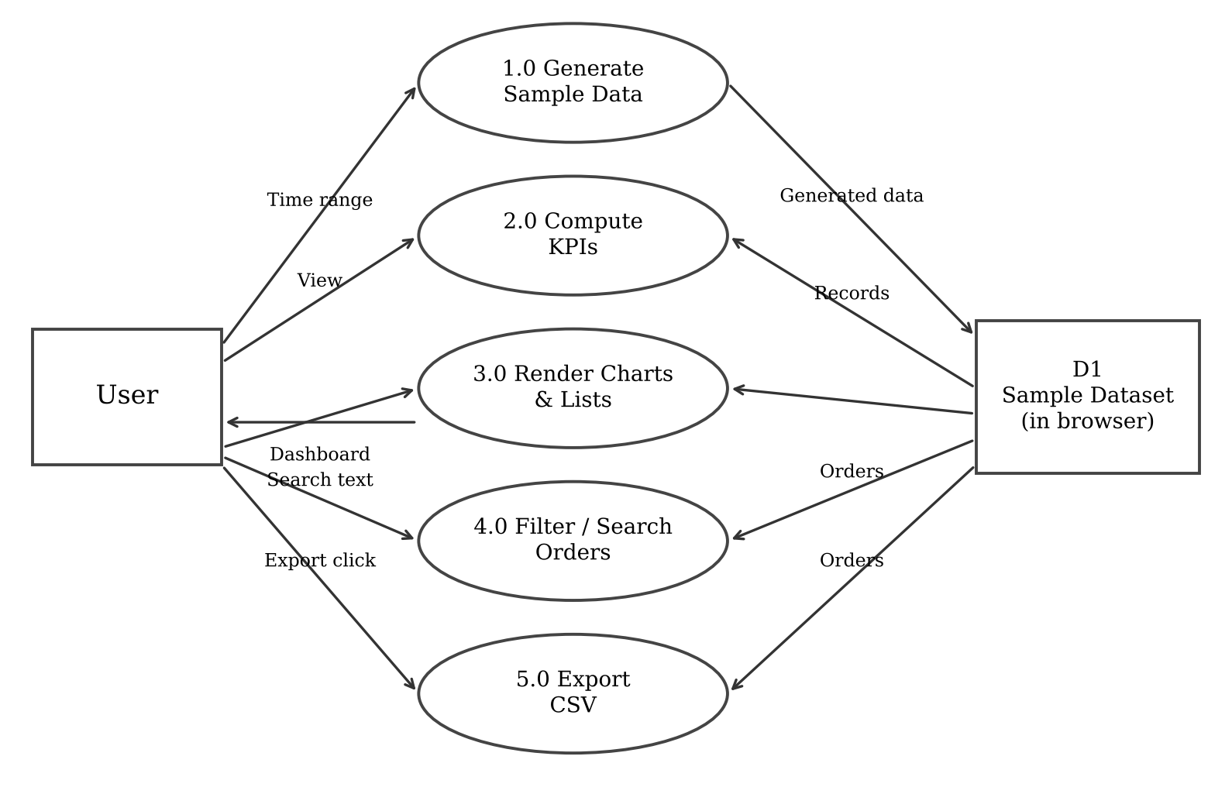
Fig No. 3.2 DFD LEVEL-1
At Level-1 the system is divided into five processes: generating the sample data, computing the KPIs, rendering the charts and lists, filtering the orders, and exporting the orders as a CSV file. All processes read from the in-browser sample dataset.
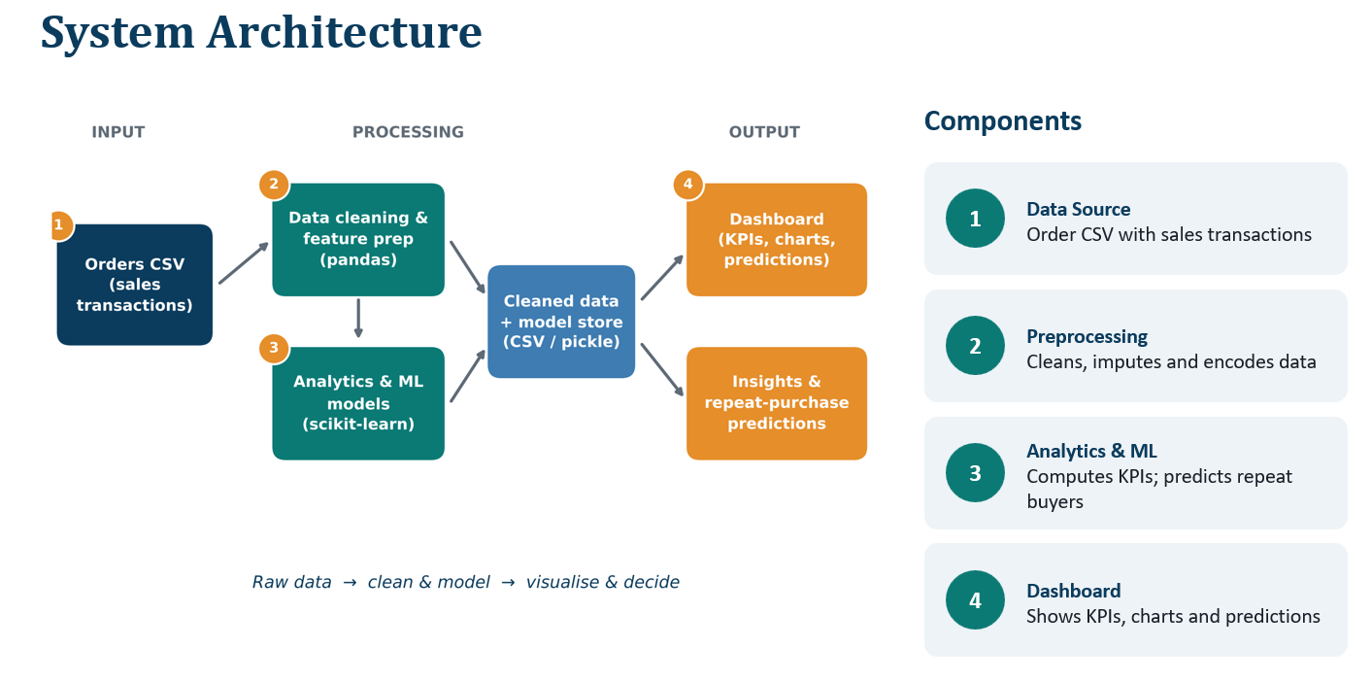

CHAPTER 4

Implementation and User Interface

4.1 Web Page Details
- Overview Page
- Products Page
- Orders Page
- Dark Theme and Time Range Filters

4.2 Detailed Description of Pages
1. Overview Page: The home screen is the Sales overview page. It shows a hero banner with the total revenue earned in the selected period, four animated KPI cards (Revenue, Orders, Average order value and Conversion rate) each with its change against the previous period, a combined revenue line chart and orders bar chart that shows a tooltip on hover, a donut chart for the share of revenue by category, a ranked list of top products, and the revenue split by region across India. A segmented control at the top lets the user switch between 7 days, 30 days and 12 months.
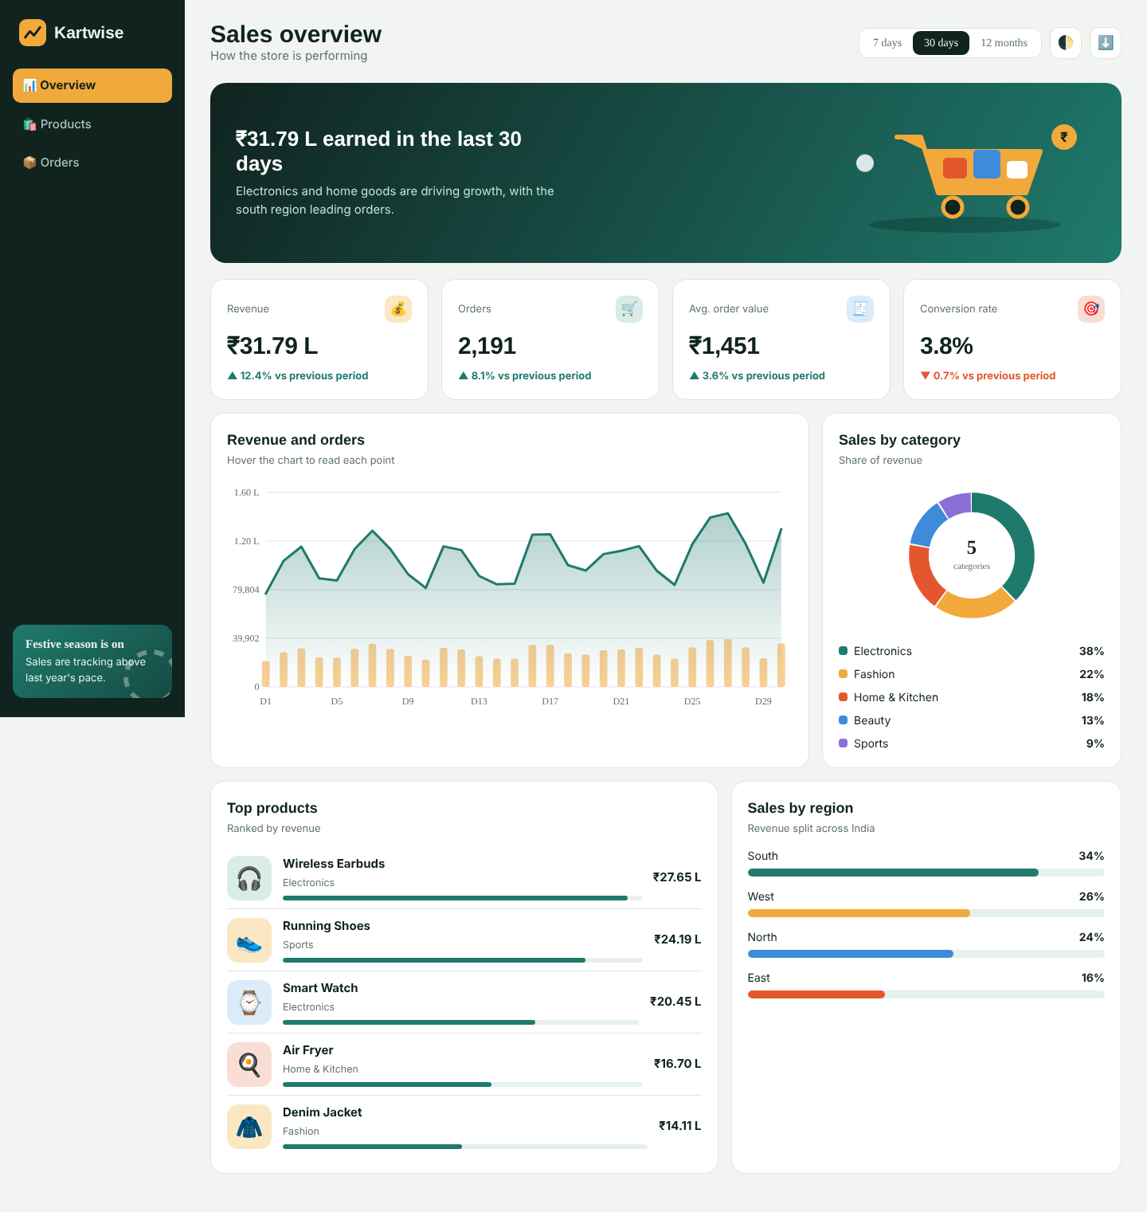
Fig No. 4.1 Overview Page
2. Products Page: This screen shows the product catalogue as cards. Each card has the product icon, name, category, price and the number of units sold this month. The cards lift slightly when the pointer moves over them.
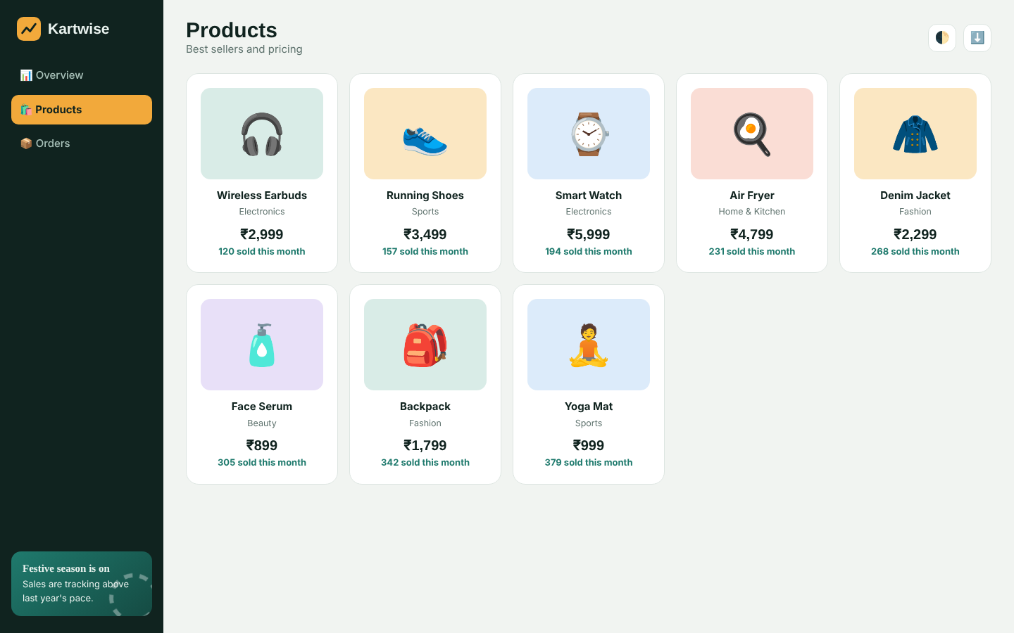
Fig No. 4.2 Products Page
3. Orders Page: The Orders page lists recent orders with the order number, customer, product, amount and a coloured status label (Delivered, Shipped, Processing or Refunded). A search box filters the table instantly by customer name, product, status or order number. The download button in the top bar exports the orders as a CSV file.
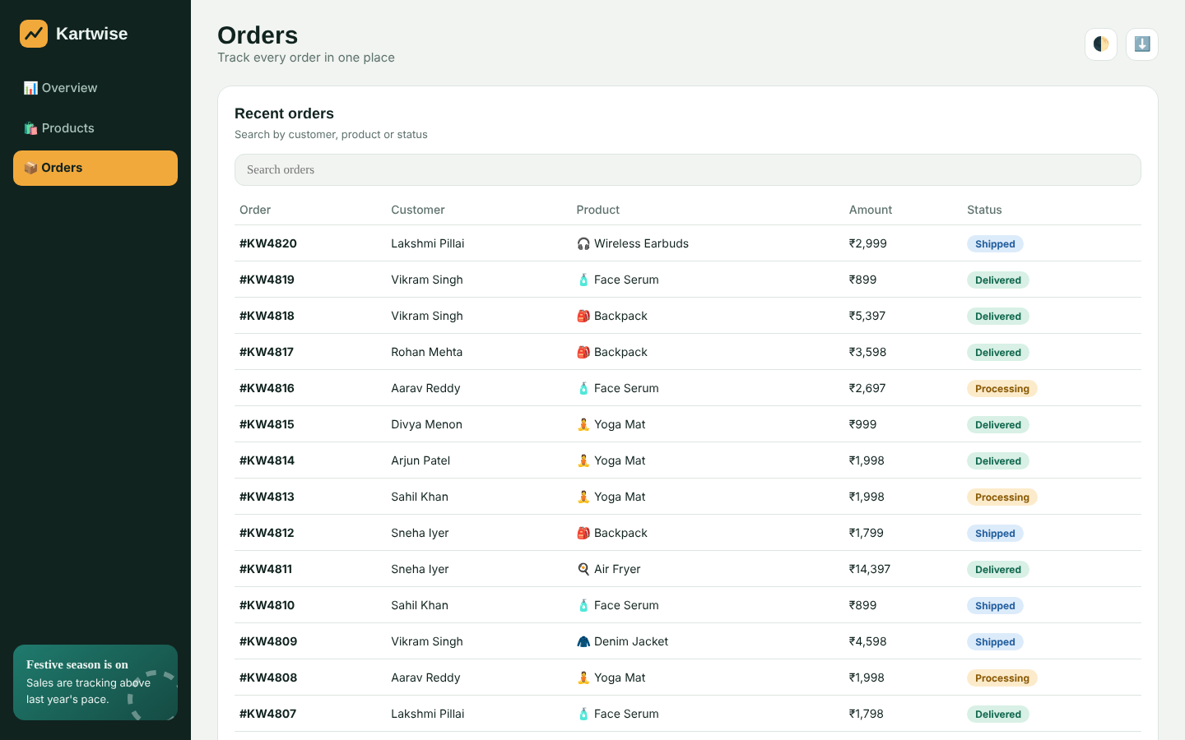
Fig No. 4.3 Orders Page
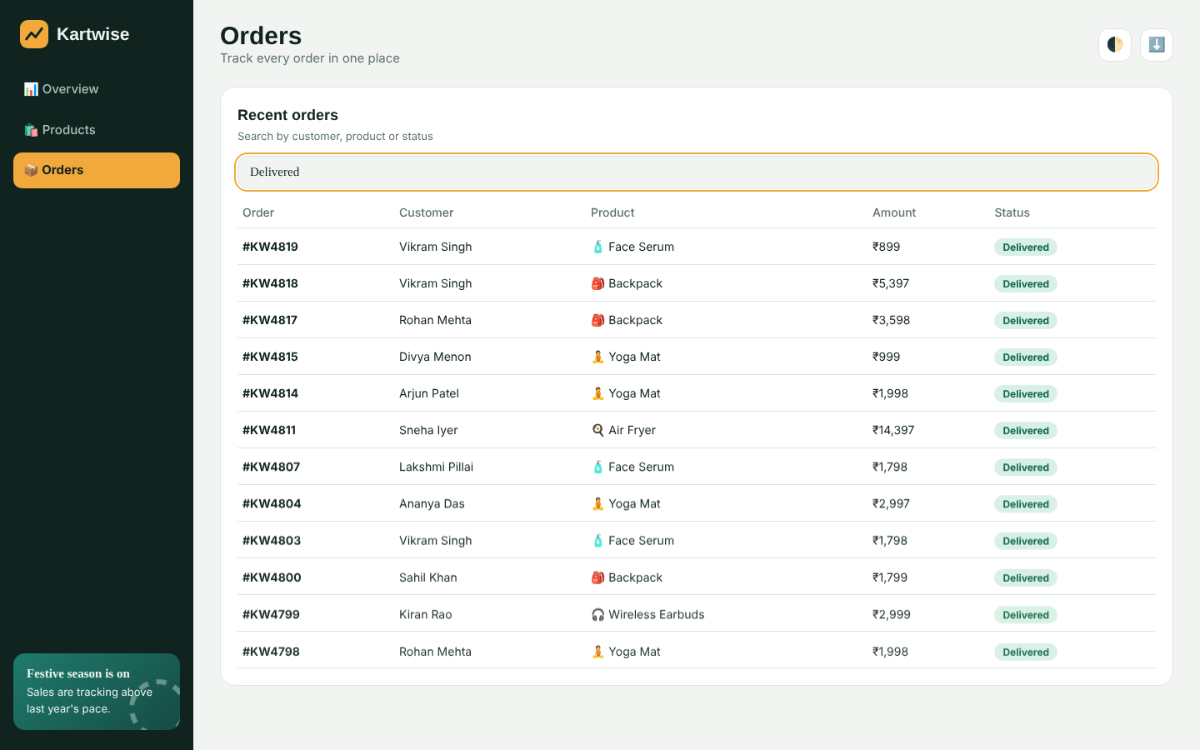
Fig No. 4.4 Orders Page with search filter applied
4. Dark Theme and 7-Day View: The theme button switches the dashboard between light and dark colour schemes, and the dashboard also follows the operating system preference. Figure 4.5 shows the Overview page in dark theme with the 7 days range selected.
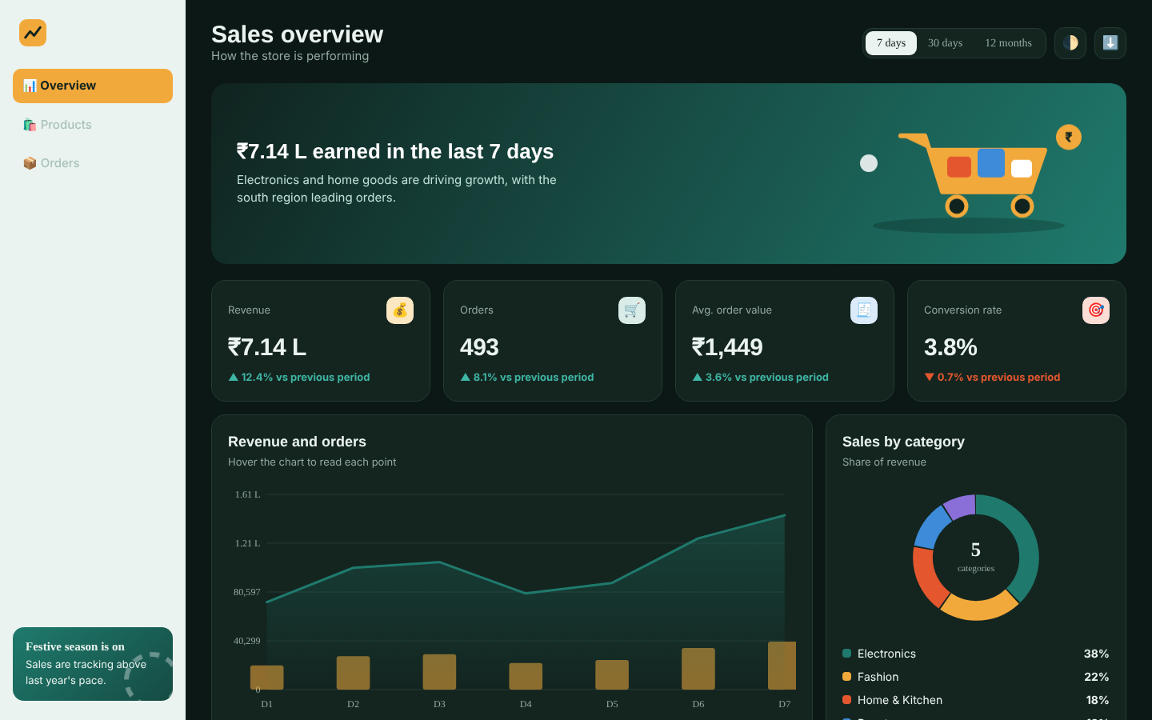
Fig No. 4.5 Overview Page in Dark Theme (7 days)

CHAPTER 5

Conclusion and Future Aspects

5.1 Conclusion
We have successfully implemented the website “Kartwise – E-commerce Sales Analytics Dashboard”. With the help of HTML, CSS, JavaScript and SVG, we have been able to provide a fast, responsive dashboard that converts sales data into easy-to-read KPIs, charts, product rankings, regional sales and an order tracker, without needing any server or external library. We have been successful in our attempt to take care of the needs of business managers who need quick answers about revenue, orders and customer buying behaviour. Finally we hope that this will go a long way in helping online businesses take faster, data-driven decisions.

5.2 Future Aspects
- We can connect the dashboard to a real database (such as MySQL or MongoDB) through a back-end API so that live store data is shown instead of sample data.
- We can add login and role-based access so that managers, analysts and sellers see only the data meant for them.
- We can add date-range pickers, more filters (category, region, status) and drill-down charts.
- We can add sales forecasting and anomaly alerts using machine learning.
- We can add export of reports as PDF and Excel and scheduled e-mail summaries.

CHAPTER 6

Bibliography
- https://www.w3schools.com/html/default.asp
- https://www.w3schools.com/css/default.asp
- https://www.w3schools.com/js/default.asp
- https://www.w3schools.com/graphics/svg_intro.asp
- https://developer.mozilla.org/en-US/docs/Web/SVG
- https://fonts.google.com

CHAPTER 7

Appendices

7.1 CSS – Theme, Layout and Navigation
1. :root{--bg:#F1F4F1;--card:#fff;--ink:#10231F;--mute:#5E726D;--line:#DDE5E1;--teal:#1F7A6D;--saffron:#F2A93B;--coral:#E4572E;--sky:#3D8BD9;--soft:#E6F0EC;box-sizing:border-box;padding-top:env(safe-area-inset-top,0px);padding-bottom:env(safe-area-inset-bottom,0px)}
2. :root[data-theme="dark"]{--bg:#0C1815;--card:#142520;--ink:#EAF3EF;--mute:#93A9A2;--line:#243A34;--soft:#1B332D;--teal:#3FB5A3}
3. body{background:var(--bg);color:var(--ink);font:15px/1.5 "DM Sans",system-ui,sans-serif;display:flex;min-height:100vh;transition:background .3s,color .3s}
4. aside{width:232px;background:var(--ink);color:#EAF3EF;padding:24px 16px;position:sticky;top:0;height:100vh;display:flex;flex-direction:column;gap:6px;flex-shrink:0}
5. aside a{display:flex;align-items:center;gap:12px;padding:10px 12px;border-radius:10px;color:#A9C2BA;text-decoration:none;font-weight:500;cursor:pointer;transition:.2s}
6. aside a.on{background:var(--saffron);color:#10231F;font-weight:700}
7. .promo{margin-top:auto;border-radius:14px;background:linear-gradient(140deg,#1F7A6D,#154B43);padding:16px;font-size:13px;position:relative;overflow:hidden}
8. main{flex:1;min-width:0;padding:26px 32px 48px}
9. main{padding:18px 14px 100px}.hero svg{display:none}.top h1{font-size:24px}}
1. .hero{border-radius:20px;padding:28px 32px;margin-bottom:20px;color:#fff;background:linear-gradient(120deg,#10231F 0%,#1F7A6D 100%);display:flex;justify-content:space-between;align-items:center;gap:20px;overflow:hidden;position:relative;animation:rise .9s cubic-bezier(.2,.8,.2,1) both}
2. .grid{display:grid;gap:16px}
3. .kpis{grid-template-columns:repeat(4,1fr);margin-bottom:16px}
4. .card{background:var(--card);border:1px solid var(--line);border-radius:18px;padding:20px;transition:background .3s}
5. .kpi{display:flex;flex-direction:column;gap:6px;transition:transform .25s,box-shadow .25s}
6. .kpi .num{font-size:30px;font-weight:800;letter-spacing:-.5px}
7. .up{color:var(--teal)}.dn{color:var(--coral)}
8. .row{display:grid;grid-template-columns:2fr 1fr;gap:16px;margin-bottom:16px}
9. .row2{display:grid;grid-template-columns:1.3fr 1fr;gap:16px}
10. .bar{height:6px;background:var(--soft);border-radius:6px;margin-top:6px;overflow:hidden}
11. .bar i{display:block;height:100%;width:0;border-radius:6px;background:var(--teal);transition:width 1.1s cubic-bezier(.2,.8,.2,1)}
12. .pill{padding:3px 10px;border-radius:20px;font-size:12px;font-weight:700}
13. .Delivered{background:#D8F0E5;color:#12684F}.Shipped{background:#DCEBFA;color:#245F9E}.Processing{background:#FCEBCB;color:#8A5A06}.Refunded{background:#FADDD5;color:#A23516}
14. .view{display:none}.view.on{display:block;animation:rise .5s both}
1. @media(max-width:1020px){.kpis{grid-template-columns:repeat(2,1fr)}.row,.row2{grid-template-columns:1fr}}
2. @media(max-width:760px){aside{position:fixed;bottom:0;top:auto;left:0;right:0;width:auto;height:auto;flex-direction:row;padding:8px 8px calc(8px + env(safe-area-inset-bottom,0px));z-index:10;justify-content:space-around}
3. @media(prefers-reduced-motion:reduce){*{animation:none!important;transition:none!important}}

7.2 HEAD
1. <!DOCTYPE html>
2. <html lang="en">
3. <head>
4. <meta charset="UTF-8">
5. <meta name="viewport" content="width=device-width, initial-scale=1, viewport-fit=cover">
6. <title>Kartwise – E-commerce Sales Analytics</title>
7. <link rel="stylesheet" href="https://fonts.googleapis.com/css2?family=Bricolage+Grotesque:wght@500;700;800&family=DM+Sans:wght@400;500;700&display=swap">

7.3 Navigation Bar (Sidebar)
1. <aside>
2. <div class="logo"><svg viewBox="0 0 40 40"><rect width="40" height="40" rx="11" fill="#F2A93B"/><path d="M9 27l7-9 6 6 9-12" fill="none" stroke="#10231F" stroke-width="3.4" stroke-linecap="round" stroke-linejoin="round"/></svg>Kartwise</div>
3. <a class="on" data-v="overview" tabindex="0">📊 Overview</a>
4. <a data-v="products" tabindex="0">🛍️ Products</a>
5. <a data-v="orders" tabindex="0">📦 Orders</a>
6. <div class="promo"><b>Festive season is on</b>Sales are tracking above last year's pace.<svg viewBox="0 0 40 40"><circle cx="20" cy="20" r="16" fill="none" stroke="#fff" stroke-width="3" stroke-dasharray="6 5"/></svg></div>
7. </aside>

7.4 Sample Data (Categories, Products, Regions and Orders)
1. let seed=7;const rnd=()=>(seed=(seed*16807)%2147483647)/2147483647;
2. const fmt=n=>'₹'+(n>=1e7?(n/1e7).toFixed(2)+' Cr':n>=1e5?(n/1e5).toFixed(2)+' L':Math.round(n).toLocaleString('en-IN'));
3. const CATS=[['Electronics','#1F7A6D'],['Fashion','#F2A93B'],['Home & Kitchen','#E4572E'],['Beauty','#3D8BD9'],['Sports','#8A6FD8']];
4. const PRODS=[['Wireless Earbuds','🎧',0,'#D9ECE7',2999],['Running Shoes','👟',4,'#FBE7C2',3499],['Smart Watch','⌚',0,'#DCEBFA',5999],['Air Fryer','🍳',2,'#FADDD5',4799],['Denim Jacket','🧥',1,'#FBE7C2',2299],['Face Serum','🧴',3,'#E8E0F8',899],['Backpack','🎒',1,'#D9ECE7',1799],['Yoga Mat','🧘',4,'#DCEBFA',999]];
5. const REG=[['South',34],['West',26],['North',24],['East',16]];
6. const NAMES=['Aarav Reddy','Priya Sharma','Rohan Mehta','Sneha Iyer','Kiran Rao','Ananya Das','Vikram Singh','Meera Nair','Arjun Patel','Divya Menon','Sahil Khan','Lakshmi Pillai'];
7. const ST=['Delivered','Shipped','Processing','Delivered','Delivered','Refunded'];
8. const orders=Array.from({length:30},(_,i)=>{const p=PRODS[Math.floor(rnd()*8)];return{id:'#KW'+(4820-i),c:NAMES[Math.floor(rnd()*12)],p:p[0],e:p[1],a:p[4]*(1+Math.floor(rnd()*3)),s:ST[Math.floor(rnd()*6)]}});

7.5 Time-series Data Generator
1. function series(r){const n=r==12?12:+r,out=[];const M=['Jan','Feb','Mar','Apr','May','Jun','Jul','Aug','Sep','Oct','Nov','Dec'];
2. for(let i=0;i<n;i++){const t=1+i/n*.35,w=1+.18*Math.sin(i*1.3),base=r==12?2.6e6:r==30?9e4:8.5e4;const rev=base*t*w*(.85+rnd()*.3);out.push({l:r==12?M[(i+0)%12]:'D'+(i+1),rev,ord:Math.round(rev/1450)})}return out}

7.6 KPI Cards and Rendering
1. function render(){
2. seed=11+ +range;data=series(range);
3. const rev=data.reduce((a,d)=>a+d.rev,0),ord=data.reduce((a,d)=>a+d.ord,0);
4. const kp=[['Revenue',rev,fmt,'💰','#FBE7C2',12.4],['Orders',ord,n=>Math.round(n).toLocaleString('en-IN'),'🛒','#D9ECE7',8.1],['Avg. order value',rev/ord,fmt,'🧾','#DCEBFA',3.6],['Conversion rate',3.8,n=>n.toFixed(1)+'%','🎯','#FADDD5',-0.7]];
5. $('#kpis').innerHTML=kp.map((k,i)=>`<div class="card kpi" style="animation:rise .7s ${i*.08+.2}s both"><div class="lab">${k[0]}<span class="bub" style="background:${k[4]}">${k[3]}</span></div><div class="num" data-i="${i}">0</div><div class="chg ${k[5]>=0?'up':'dn'}">${k[5]>=0?'▲':'▼'} ${Math.abs(k[5])}% vs previous period</div></div>`).join('');
6. $$('.kpi .num').forEach(el=>{const k=kp[el.dataset.i];count(el,k[1],k[2])});
7. $('#heroT').textContent=fmt(rev)+' earned in '+(range==12?'the last 12 months':'the last '+range+' days');
8. chart();donut();tops();regions();
9. }

7.7 Donut Chart – Sales by Category
1. function donut(){
2. const vals=[38,22,18,13,9],tot=100,R=70,C=2*Math.PI*R;let off=0,s='';
3. vals.forEach((v,i)=>{const len=v/tot*C;s+=`<circle cx="100" cy="100" r="${R}" fill="none" stroke="${CATS[i][1]}" stroke-width="26" stroke-dasharray="0 ${C}" stroke-dashoffset="${-off}" transform="rotate(-90 100 100)"><animate attributeName="stroke-dasharray" from="0 ${C}" to="${len-2} ${C-len+2}" dur="1s" begin="${i*.15}s" fill="freeze"/></circle>`;off+=len});
4. $('#donut').innerHTML=s+`<text x="100" y="98" text-anchor="middle" style="font:800 26px 'Bricolage Grotesque';fill:var(--ink)">5</text><text x="100" y="118" text-anchor="middle">categories</text>`;
5. $('#leg').innerHTML=CATS.map((c,i)=>`<div><i style="background:${c[1]}"></i><span>${c[0]}</span><span>${vals[i]}%</span></div>`).join('');
6. }

7.8 Top Products and Sales by Region
1. function tops(){
2. const w=[96,84,71,58,49];const sc=range==12?1:range==30?.09:.02;
3. $('#top').innerHTML=PRODS.slice(0,5).map((p,i)=>`<div class="prod"><div class="thumb" style="background:${p[3]}">${p[1]}</div><div class="meta"><b>${p[0]}</b><small>${CATS[p[2]][0]}</small><div class="bar"><i data-w="${w[i]}"></i></div></div><div class="val">${fmt(w[i]*sc*3.2e5)}</div></div>`).join('');
4. setTimeout(()=>$$('#top .bar i').forEach(b=>b.style.width=b.dataset.w+'%'),80);
5. }
6. function regions(){
7. const cols=['#1F7A6D','#F2A93B','#3D8BD9','#E4572E'];
8. $('#regions').innerHTML=REG.map((r,i)=>`<div class="region"><div class="h"><span>${r[0]}</span><b>${r[1]}%</b></div><div class="bar" style="height:10px"><i data-w="${r[1]*2.4}" style="background:${cols[i]}"></i></div></div>`).join('');
9. setTimeout(()=>$$('#regions .bar i').forEach(b=>b.style.width=b.dataset.w+'%'),120);
10. }

7.9 Orders Table with Search
1. function ordersTbl(q=''){
2. const f=orders.filter(o=>(o.c+o.p+o.s+o.id).toLowerCase().includes(q.toLowerCase()));
3. $('#ob').innerHTML=f.length?f.map((o,i)=>`<tr style="animation-delay:${i*.025}s"><td><b>${o.id}</b></td><td>${o.c}</td><td>${o.e} ${o.p}</td><td>${fmt(o.a)}</td><td><span class="pill ${o.s}">${o.s}</span></td></tr>`).join(''):'<tr><td colspan="5" style="text-align:center;color:var(--mute);padding:28px">No orders match. Try a different name, product or status.</td></tr>';
4. }

7.10 View Switching, Theme Toggle and CSV Export
1. $$('#range button').forEach(b=>b.onclick=()=>{$$('#range button').forEach(x=>x.classList.remove('on'));b.classList.add('on');range=b.dataset.r;render();toast('Showing '+b.textContent)});
2. const T={overview:['Sales overview','How the store is performing'],products:['Products','Best sellers and pricing'],orders:['Orders','Track every order in one place']};
3. $$('aside a').forEach(a=>{const go=()=>{$$('aside a').forEach(x=>x.classList.remove('on'));a.classList.add('on');$$('.view').forEach(v=>v.classList.remove('on'));$('#v-'+a.dataset.v).classList.add('on');$('#title').textContent=T[a.dataset.v][0];$('#subtitle').textContent=T[a.dataset.v][1];$('#range').style.display=a.dataset.v=='overview'?'flex':'none';if(a.dataset.v=='overview')render()};a.onclick=go;a.onkeydown=e=>{if(e.key=='Enter'||e.key==' ')go()}});
4. $('#q').oninput=e=>ordersTbl(e.target.value);
5. $('#theme').onclick=()=>{const d=document.documentElement,dark=getComputedStyle(d).getPropertyValue('--bg').trim()=='#0C1815';d.dataset.theme=dark?'light':'dark'};
6. $('#export').onclick=()=>{const csv='Order,Customer,Product,Amount,Status\n'+orders.map(o=>[o.id,o.c,o.p,o.a,o.s].join(',')).join('\n');const a=document.createElement('a');a.href='data:text/csv;charset=utf-8,'+encodeURIComponent(csv);a.download='kartwise-orders.csv';a.click();toast('Orders exported as CSV')};

