**BREATH ACETONE-BASED NON-INVASIVE DETECTION OF**

**BLOOD GLUCOSE LEVELS**

Abstract- There has been a constant demand for the development of non-invasive, sensitive glucose sensor system that offers fast and real-time electronic readout of blood glucose levels. Here, we propose a new system for detecting blood glucose levels by estimating the concentration of acetone in the exhaled breath. A TGS822 tin oxide (SnO2) sensor has been used to detect the concentration of acetone in the exhaled air. Acetone in exhaled breath showed a correlation with the blood glucose levels. Effects of pressure, temperature and humidity have been considered. Artificial Neural Network (ANN) has been used to extract features from the output waveform of the sensors. The system has been trained and tested with patient data in the blood glucose ranges from 80 mg/dl to 180 mg/dl. Using the proposed system, the blood glucose concentration has been estimated within an error limit of ±7.5 mg/dl.

Index terms: acetone sensor, exhaled breath, glucose, artificial neural network.

1. INTRODUCTION

Non-invasive diagnosis technique is becoming more prominent in diagnosing diseases due to their pain free and simple monitoring methods. Non-invasive detection of blood hemoglobin was already reported by our group in the earlier work. Lieschnegg et al. have developed a sensor to detect failures and material imperfections in total joint prosthesis based on acceleration measurement non-invasively. Diabetes can also be detected using non-invasive methods. Diabetes mellitus is a major health problem worldwide. This health condition arises from many complex metabolic disorders leading to high glucose levels in a person. High glucose levels can lead to many health disorders such as kidney failure, blindness, heart diseases and even premature death. Frequent testing and accurate determination of glucose levels is essential for diagnosis, effective management and treatment of diabetes mellitus. Therefore, there have been constant efforts to develop efficient and sensitive techniques for the determination of blood glucose levels. A number of invasive enzymatic and non-enzymatic methods and systems have been reported for the detection of glucose.

Conventionally, glucose level is determined from a small volume of blood sample collected by finger pricking. Though the test may not pose any risk to a healthy adult who goes for the diabetes checkup in every 2 to 3 months, but it is very painful to the diabetic patients because every time they have to prick the finger. The current invasive method is based on the enzymatic catalysis principle where a thin needle is used to prick the finger of the patient to minimize the discomfort. To avoid such painful diagnosis, extensive research has been devoted towards developing non-invasive techniques that measure blood glucose levels without taking the blood sample. Other non-invasive techniques used are electrical impedance, NIR spectroscopy, breath analysis, ultrasound and thermal spectroscopy. However, none of these methods seems to achieve the desired accuracy due to varying environmental conditions and physical movements and therefore none of them led to any accurate and safe commercial device. Further, compared to the breath analyzer other techniques appear to be expensive due to the sensor components involved.

In this work, we report a non-invasive system for the determination of blood glucose levels from the detection of the breath acetone. Acetone is one of the volatile organic compounds (VOCs) present in the exhaled breath. The acetone present in the exhaled breath is a metabolic product of the body fat-burning. The breakdown of excess acetyl-CoA from fatty acid metabolism in diabetic patients leads to increase in the levels of acetone in the blood. This acetone reaches lungs and exhaled or is excreted through urine. Therefore, the breath acetone levels could be a measure of the blood glucose levels of a person. The breath acetone concentration ranging from 1.7 ppm to 3.7 ppm can be detected in diabetic patients, whereas it varies between 0.3 and 0.9 ppm for healthy humans. Over 1000 VOC’s have been detected to date in the ppmv (parts per million by volume) to pptv (parts per trillion by volume) concentrations. A number of metal oxide nanomaterials have shown excellent gas sensing properties because large surface area and nanoscale surface features of such nanomaterials result in increased sensitivity towards gases. With the newly emerging semiconductor technologies it is possible to design and fabricate nanoparticle gas sensors that can detect sub-ppm VOC concentration in the breath. The basic principle of operation of these gas sensors is the change in their conductivities due to interactions with oxidizing and reducing gas molecules. However, in addition to the quantity of the gas, natures of both the gas and the metal oxide determine the degree of response of the sensor.

Tin oxide (SnO2) based nanowire sensors had been widely used in the gas sensing applications due to their unique gas detection properties. Here we have used the TGS SnO2 particle system as acetone sensor. The resistance of this sensor varies depending on the quantity of acetone present and can be detected by potential divider circuit. Several other parameters such as the breath chamber temperature, humidity and pressure have been taken into consideration in the estimation of acetone because these parameters affect the quantity of acetone sensed by the sensor. Further, the acetone concentration in the breath chamber will not be the same for the same person every time due to different flow rates, because all humans can’t blow at the same rate into the mouth piece/breath chamber. This can result in wrong diagnosis. Therefore, we specified the time duration for breathing into the mouth piece. Finally, we have used the artificial neural network to calculate the glucose levels.

1. PROPOSED SYSTEM

For analysis of glucose levels from the breath, we considered a total of five parameters from three different sensors: Voltage and resistance from acetone sensor (Figaro TGS822), pressure from Digital barometric pressure sensor (BMP180) and temperature & humidity from DHT11 sensor. A 215 cm3 mouth piece was designed and three sensors were placed inside the mouth piece for analysis. Due to the presence of sensors inside the mouth piece the volume of this test chamber is taken to be approximately 200 cm3. All the three sensors data were given to the controller board (Arduino Uno R3) shown in the Figure 1.

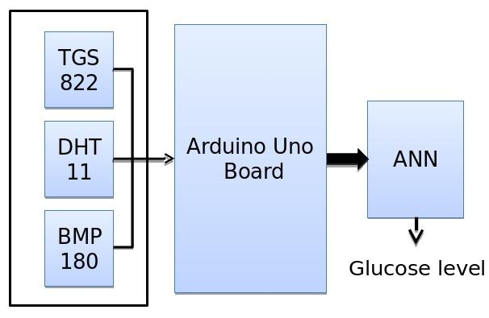

Figure 1. Block Diagram of the System

a. Sensing of Acetone using Figaro TGS822 gas sensor

Figaro TGS822 is a gas sensor having good sensitivity towards acetone and ethanol gases. The acetone sensing application is used when the ethanol is absent in the breath. The acetone sensing relies on the changes in electrical conductivity due to the change in the sensor surface arising from the reactions between ionosorbed surface oxygen and acetone gas. In the presence of a

deoxidizing gas, the surface density of the negatively charged oxygen decreases. This results in the decrease of the barrier height in the grain boundary and hence decrease of sensor resistance.

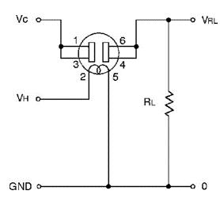

Figure 2. Figaro TGS822 Acetone Sensor circuit

VC - Sensor input voltage,

VH - Micro heater voltage,

RL - Load resistor.

VC = 5 V; VH = 5 V; RL = 100 K Ω

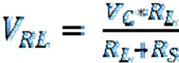

(1)

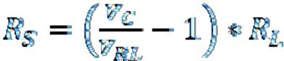

(2)

Voltage VRL and RS are calculated from the above Figure 2 for analysis. The sensor accuracy, especially at low analyte concentrations, shows nonlinear characteristics of the response and depends on the temperature and relative humidity in addition to the nature of the gas. As mentioned earlier, the test can’t be conducted when alcohol vapor is present in the breath. A voltage detecting method was used to calculate the sensitivity (*S*) of the sensor:

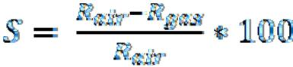

(3)

where, Rair and Rgas are the sensor resistances in normal air and under gas [32**].**

b. DHT11 and BMP180 sensors

Flow rate and volume of breath blow into the mouth piece can’t be controlled and are different for each person. To compensate this, the effects of pressure, temperature and humidity levels have been considered for each and every person apart from the actual parameters (voltage and resistance) detected from the acetone sensor.

DHT11 is a Digital Temperature and Humidity sensor. It measures humidity, ranges from 20-90% with a resolution of 1% at an accuracy of ±5 RH (Relative Humidity) and temperature from 0-50o C with a resolution of 1 at accuracy of ±2oC. The sensor is operated at 5V DC supply. DHT11 sensor sends 40bit data on a single data-line which includes 16 bit Relative Humidity (8bit integer RH data + 8bit decimal RH data), 16 bit Temperature (8bit integer temperature data + 8bit decimal temperature data) and 8bit checksum. The 40bit single data-line is connected to the microcontroller board to read the Relative Humidity and Temperatures.

BMP180 is a Barometric pressure sensor. It measures atmospheric pressure ranges from 300-1100 hPa (hectopascal) with a resolution of 0.01 hPa under 0-65oC temperature conditions. The sensor is operated at 3.3V DC supply. The data is transferred via I2C bus. Sensor is connected to the microcontroller board via SCL and SDA lines to read data from I2C bus. Microcontroller board reads the data from all the three sensors and sends back to the artificial neural network model via serial port.

c. Neural Network Modeling

Breath samples have been collected from 30 persons. Each person was advised to blow into the mouth piece for 5 seconds continuously with the same flow rate. Sensor data was recorded on MATLAB tool. In each of five parameters maximum and minimum values were taken in the specified time duration.

To analyze and get the relation between the recorded parameters and glucose levels Neural Network Tool in MATLAB has been used.

Figure 3 shows the modeled neural network block diagram. The network is selected to have 30 hidden layer neurons and 1 output layer neuron with 5 inputs and a single output. In hidden layer, the neurons have the sigmoid transfer function at the output, and in the output layer neurons have a linear function at the output.

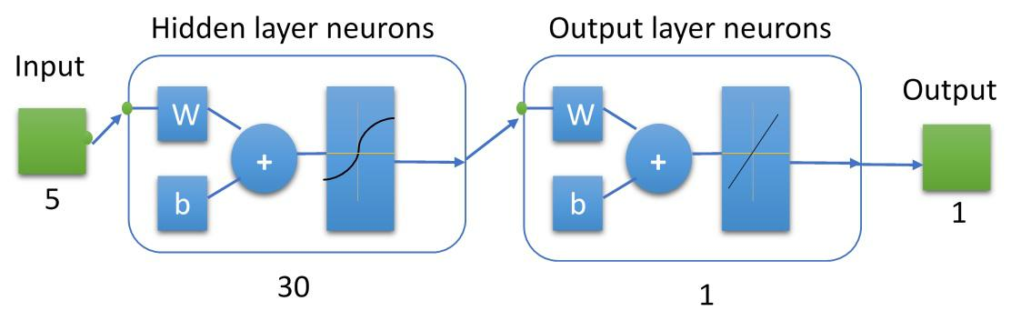

Figure 3. Artificial Neural Network block diagram

A single neuron model is shown in Figure 4 with a sigmoid transfer function at the output.

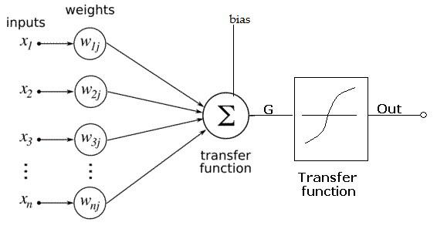

Figure 4. Artificial Neuron model

Here the transfer function is



(4)

Output of neuron is given to the sigmoid function

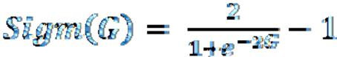

(5)

For a hidden layer neuron, output = G which is the same as the sum of all the inputs to the neuron. Figure 5 shows the complete neural network model with 5 inputs and 30 hidden layer neurons and one output layer neuron. 30 samples of each 5 elements (V, R, P, H and T) have been given as the input matrix to the network with a target output array of 30 Glucose samples, are given below.

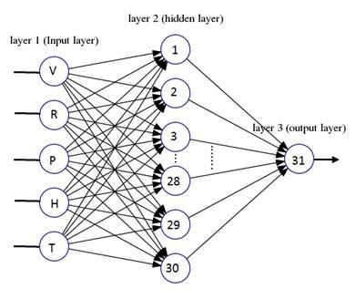

Figure 5. Artificial Neural Network with 30 hidden neurons

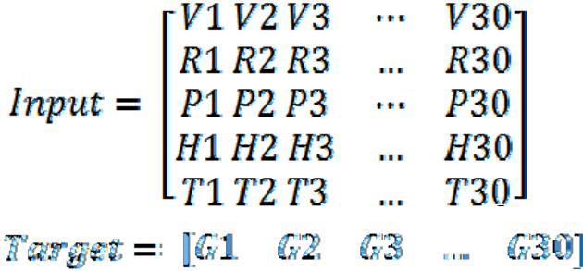

1. ACETONE CHARACTERISTICS OF TGS822 SENSOR

Acetone concentration detection is done in ~200 cm3 test chamber. To create required concentration inside the chamber we injected liquid acetone into the chamber. Acetone has a molecular weight of MW = 50.08 g/mol and density δ= 0.791 g/cm3. The gas density of acetone is given by [33]



(6)

Where δ = the density of the gas of acetone in g/L,

P = the standard Atmospheric Pressure (1 atm)

MW= Molecular Weight in g/mol

R= Universal gas constant in atm/mol.K (equal to 0.821 atm/mol.K), T= temperature in Kelvin.

Thus, one gets 2.36g/L gas density for acetone.

100 ppm acetone stock solution was prepared for testing. For 1 ppm acetone gas concentration inside the 200 cm3 test chamber required volume is

(7)



x= 2 cm3.

(8)



where Vgas is the volume occupied by the gas of acetone which is equal to 2 cm3, δ is the density of the gas of acetone as calculated before, ρ is the constant density of liquid acetone. Therefore,



(9)

From the eq. (9) one can calculate the liquid acetone required. Thus one gets Vliquid = 6 µL for 2 cm3 acetone gas that gives 1 ppm acetone concentration in the mouth piece. Therefore, for a concentration of ’n’ ppm acetone inside the chamber ‘n*6 µL’ liquid acetone is required.

IV. RESULTS AND DISCUSSION

Acetone concentrations have been studied in 1ppm - 10ppm levels with and without humidity effect. First, Figaro TGS822 acetone sensor is tested under normal atmospheric conditions.

Humidity effect has been calculated for acetone sensor under 85-90%RH, created inside the chamber. The test results are shown in Figure 6. It is observed that there is an increase of 0.2V in high humidity sensing compared to the low humidity sensing. Artificial neural network was used to compensate these effects.

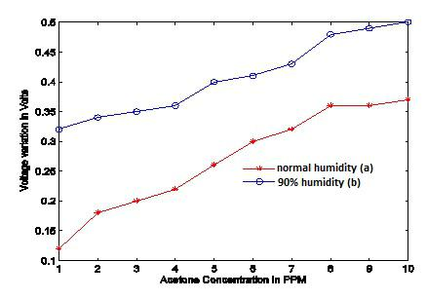

Figure 6. Acetone detection a). Under normal humidity b). Humidity=90% inside the chamber

The network is trained such that the MSE (Mean Square Error) is very low and Regression reaches 1. The trained network knowledge is stored in terms of weights and biases. The network is fixed with 180 I/O layer weights and 31 neuron biases. The trained network MSE is 2.75 x e-27 and the total regression ratio is 0.9962 as shown in Figure 7. The relation between the acetone concentration and sensor response with humidity effect is already explained and is modeled in ANN tool.

From the collected samples it is observed that different values of voltage, resistance, pressure, humidity and temperature have been recorded for every person depending on their glucose levels and flow rate.

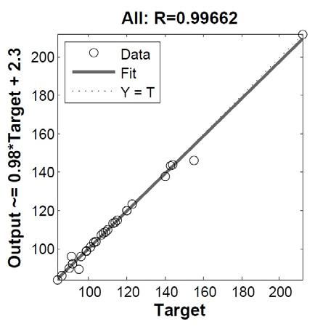

Figure 7. Network with R=0.99662

Figure 8 shows the network trained with regression coefficient R=1. Validation and Test results also show regression coefficient R=1 as shown in Figures 9 and 10. After training the network it has been tested with different breath inputs and the results compare closely with the actual glucose levels.

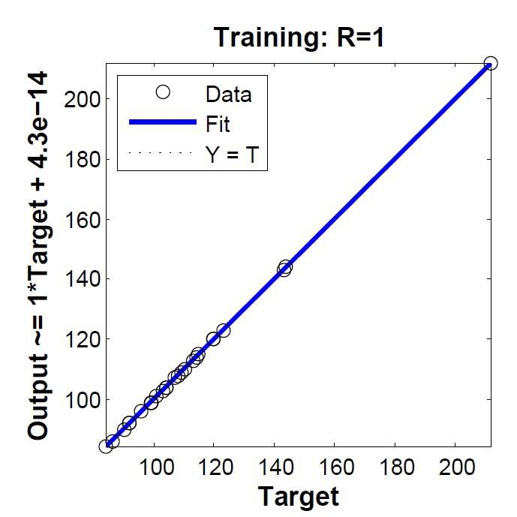

Figure 8. Trained network regression R=1

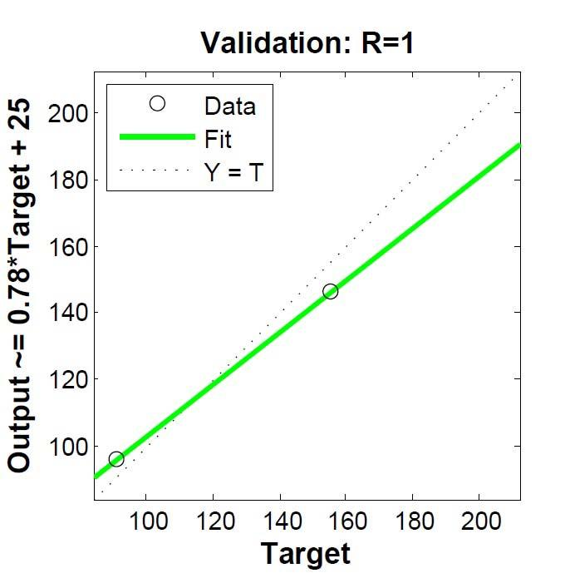

Figure 9. Network under validation R=1

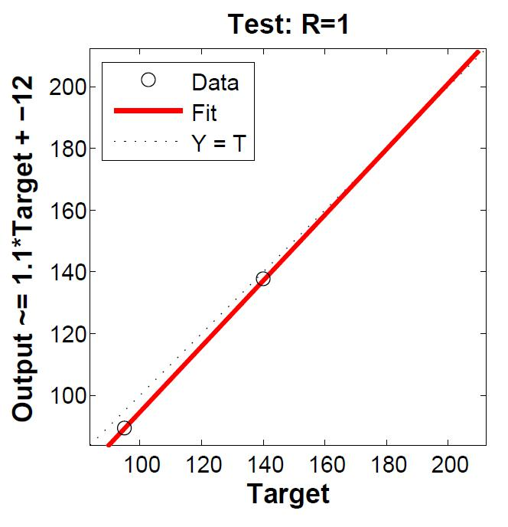

Figure 10. Network under test R=1

From the results it is observed that the voltage and resistance are playing important roles in measuring the glucose level non-invasively whereas the other parameters affect the measurements very little. The temperature effect is more compared to other two parameters, the relative humidity and pressure. The training data is collected from non-diabetic patients with glucose

levels in between 80 mg/dL and 140 mg/dL and a few pre-diabetic patients with glucose levels in between 140 mg/dL and 180 mg/dL. Figure11 (a) shows the variation in concentration of actual blood glucose levels of a patient over time. Figures 11b to 11f show the variation in different parameters during the non-invasive monitoring of blood glucose over time.

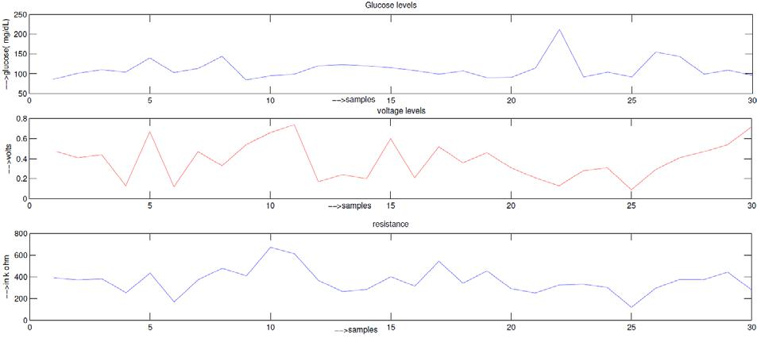

(a)

(b)

(c)

|  |  |  |  |  |  |  |
| --- | --- | --- | --- | --- | --- | --- |
| hPa | 0.8 |  |  |  |  |  |
| 0.6 |  |  |  |  |  |
| in |  |  |  |  |  |
|  |  |  |  |  |  |
| −−>pressure | 0.4 |  |  |  |  |  |
|  |  |  |  |  |  |
|  | 0.2 |  |  |  |  |  |
|  |  |  |  |  |
|  | 0 |  |  |  |  |  |
|  |  |  |  |  |
|  | 0 | | |  |  |  |
| % | 30 |  |  |  |  |  |
| 20 |  |  |  |  |  |
|  |  |  |  |
| −−>H in | 10 |  |  |  |  |  |
|  |  |  |  |
|  | 0 |  |  |  |  |  |
|  |  |  |  |  |
|  | 0 | | |  |  |  |
|  | 3 |  |  |  |  |  |
| −−>in dC | 2 |  |  |  |  |  |
|  |  |  |  |  |
| 1 |  |  |  |  |  |
|  |  |  |  |  |  |
|  | 0 |  |  |  |  |  |
|  |  |  |  |  |  |
|  | 0 | | |  |  |  |

pressure

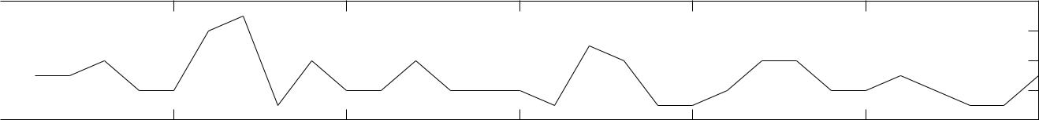

(d)

|  |  |  |  |  |  |  |  |
| --- | --- | --- | --- | --- | --- | --- | --- |
| 5 | 10 | −−>samples | 15 | 20 | 25 | 30 |  |
|  |  | Humidity |  |  |  |  |
|  |  |  |  |  |  |  |

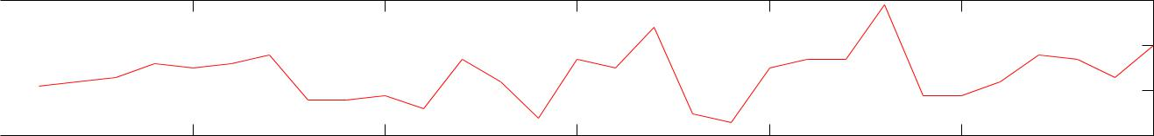

(e)

5 10 −−>samples 15 20 25 30

Temperature levels

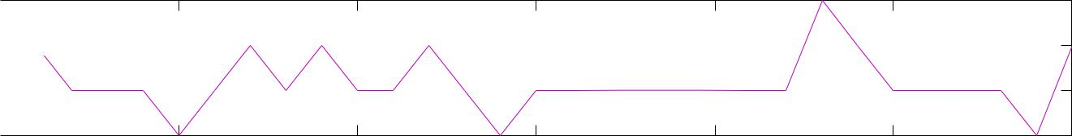

(f)

5 10 −−>samples 15 20 25 30

Figure 11. Variations in various parameters during monitoring of blood glucose levels over time:

1. actual concentration of blood glucose levels of a patient over time during invasive measurement; (b) voltage levels, (c) resistance, (d) pressure, (e) humidity and (f) temperature during non-invasive monitoring of blood glucose.

From the Figures 11 (a) to (f) it can be observed that if the glucose levels are high at some point the voltage will also be high and the resistance will go down and the other parameters are moderate. In some cases, albeit the glucose levels are high, voltage levels are low because of considerably low pressure, humidity and temperature levels, which indicate the person did not blow correctly into the mouth piece. These effects are minimized with the help of neural network tool.

1. CONCLUSIONS

In this study, the applicability of the breath acetone sensing method to the determination of glucose in human blood is demonstrated. We used acetone sensor for monitoring acetone levels in the exhaled breath and compared with actual blood glucose levels. We also considered the effects of the pressure, temperature and humidity parameters on the acetone sensing. This test involved studies of non-diabetic and pre-diabetic persons. We have also used Artificial Neural Network model for analyzing the data. The test results show that it is possible to measure the blood glucose levels via breath acetone sensing. The accuracy of the system can be improved with a large set of data.