Assignment1

# Activity 1: DATA COLLECTION (2.1)

# STEP 7: Student writing task
print("Write 4–5 sentences describing:")
print("- Number of rows and columns")
print("- Data types of each column")
print("- Any unusual or missing data you observe")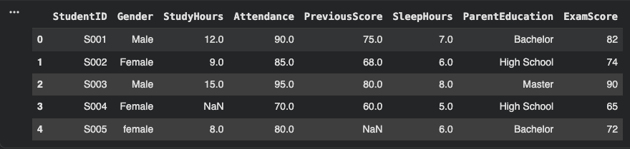

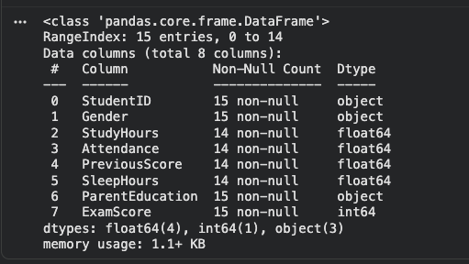

Ans: Here there are 5 rows and 8 columns
The columns StudentID, Gender, and ParentEducation are stored as object type, while StudyHours,Attendance,PreviousScore,SleepHours,and ExamScore are float datatype. 2 values missing studyHours of student with studentID S004 and PreviousScore of student with studentID S005.

# =====================
# Activity 2: DATA CLEANING (2.2)
# =====================

# STEP 6: Student writing task
print("Write 5–6 sentences describing:")
print("- Missing values count")
print("- How you handled them")
print("- Outliers in StudyHours or ExamScore")

Ans: first missing values were counted using isna() method, then then the rows with missing values were either removed using dropna or filled missing numeric values with mean value using fillna.After that fixed inconsistent categorical values using capitalize and title. Outliers are detected using IQR if there is any it is removed in this case there were no outliers.

# =====================
# Activity 3: DATA MANIPULATION (2.3)
# =====================

# STEP 7: Student writing task
print("Write 4–6 sentences explaining:")
print("- One example each of filtering, grouping, encoding, feature creation")

Ans: Filtering example: students with high scores can be filtered using the exam score where students with exam scores greater than 85 are the highest scoring students.
Grouping example: grouping the students by parental education with mean of examScore can show how parental education can affect exam score.
Encoding: here changing the gender values from object datatype to numeric datatypes can make it useful in analysis
Feature creation: we can calculate the study efficiency by dividing studyHours by attendance and create a new feature called study_efficiency.

# =====================
# Activity 4: DATA MODELING (2.4)
# =====================

# STEP 5: Student writing task
print("Write 6–8 sentences describing:")
print("- Correlated numeric variables")
print("- Patterns/trends")
print("- Which graph helped most")

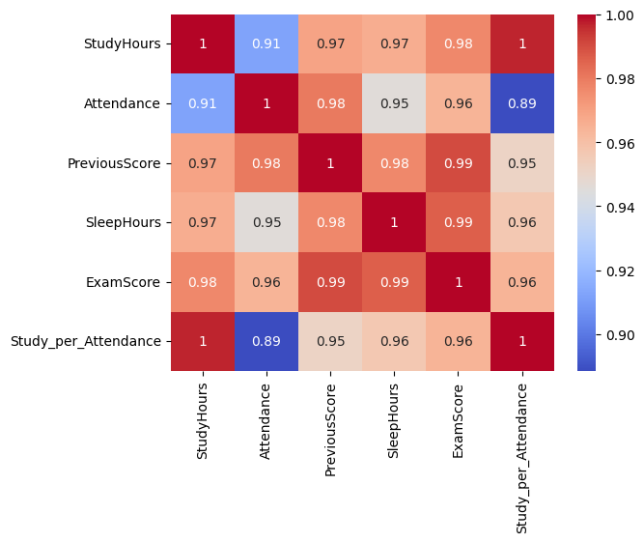

Ans: The correlation matrix shows that StudyHours has a positive correlation with ExamScore, indicating that students who study more tend to achieve higher scores. Attendance also appears positively correlated with ExamScore, suggesting consistent class participation contributes to better performance. In contrast, variables such as SleepHours show a weaker relationship with exam results.
StudyHours and ExamScore reveals an upward trend. The histogram of ExamScore indicates that most students score within a central range with fewer students at the extreme high or low ends.

# =====================
# Activity 5: DATA PREPARATION (2.5)
# =====================

# STEP 5: Student writing task
print("Write 5–6 sentences:")
print("- Why do we split data?")
print("- Why is scaling important?")
print("- Difference between StandardScaler and MinMaxScaler")

Ans: we split data into training data and testing data. Training data is used to train the model into identifying patterns and testing data is used to measure how well the model identifies in other words testing the performance of the model.
Scaling is important because machine learning algorithms are sensitive to the scale of features and unscaled data can cause large discrepancies in the output.
Standard Scaler transforms features, so they have mean of 0 and a standard deviation of 1. While MinMaxScaler rescales features into a fixed scale from 0 to 1 maintaining the relative distance.

