**ADS ASSIGNMENT – 2**

**STATISTICS AND TRENDS – REPORT**

**NAME:** Milan katrodiya

**ABSTRACT:**

The following report indicate the relationship between four various factors which are

Air pollution, GHG-emissions, Agricultural Land, Forest Area. The reason why I selected

These type of areas is because it will show the exact correlation between different sector to give a meaningful evolution that how the total air pollution affects different other major sectors and to evaluate meaningful output from it.

**REPOSITORY LINK:**

<https://github.com/milankatrodiya/ADS-Assignment2.git>

**CLIMATE CHANGE ANALYSIS BASED ON WORLD BANK DATA**

Initially, there are total 8 countries that are taken into consideration in different areas which are interrelated and change in any factor also varies the other ones and ultimately leads to climate change. These factors are air pollution, GHG emission, agricultural land and forest area which are observed in different time series and found meaningful insights.

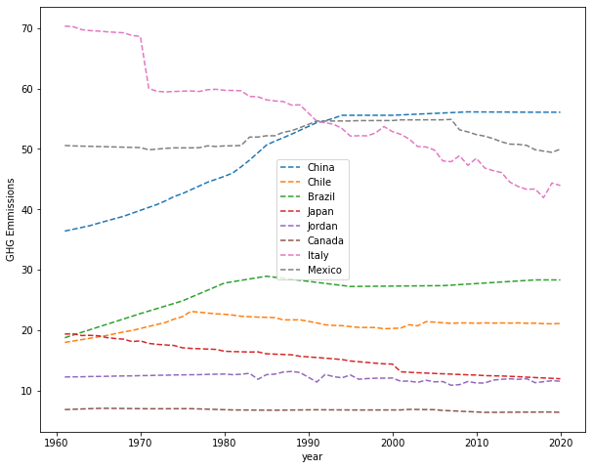

Figure 1: GHG EMISSION

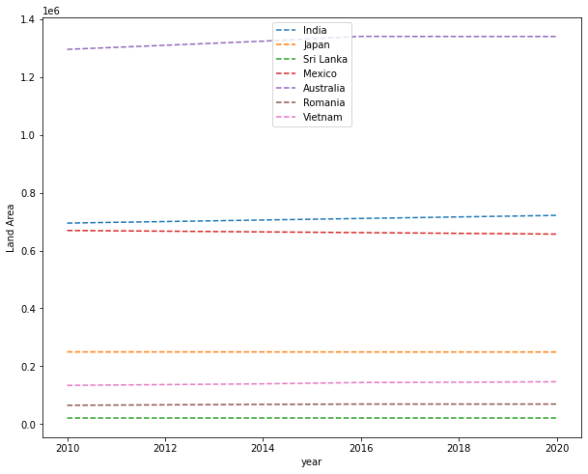

Figure 2: LAND AREA

The “Greenhouse Gas Emission” and “Land Area” charts also show that Japan and Mexico have similar trends in land area which is constant at the world level. The greenhouse gas different of all country. Because, when the greenhouse gas is increase then its effect on the globally in land area of the world.

The Japan and Mexico have different effect of the greenhouse gas which is like, with japan the GHG Emission is completely downwards of the trend and with Mexico, the greenhouse

The line graph indicate the Total GHG emission from the different countries which was from the year 1960 to 2020.Apprently, Mexico has a constant trend of GHG emission expect minor downfall in year 2020.where as japan has continuous low emission from the year 1960 to 2020 which is directly affected by Land area as japan and Mexico show more land area in every year.so the having more land area is resulting to less emission.

Gas is going straight.

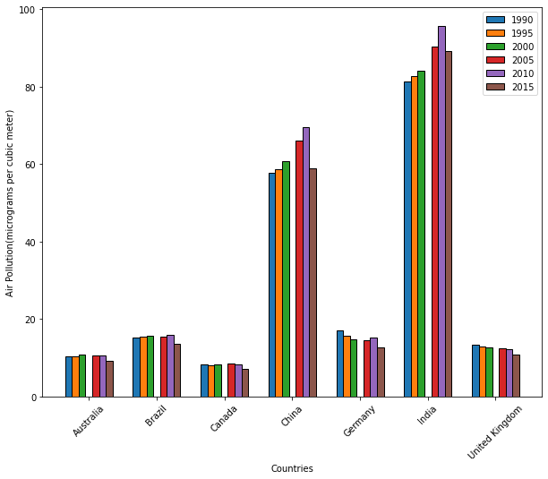

Figure 3: Total air pollution

The above bar chart illustrate the air pollution of the world of different country and with six different year from 1990 to 2015. Which also show the five year gap from every different country. So apparently from the bar India top in air pollution compare to all other countries as it has highest air pollution every year from 1990 to 2015. Whereas, Canada has the least air pollution in every given year. Brazil, Germany and United kingdom has almost similar trend at every year in air pollution.so it is very obvious from the GHG emission chart that it has correlation with air pollution as is show effect on given year for different country.

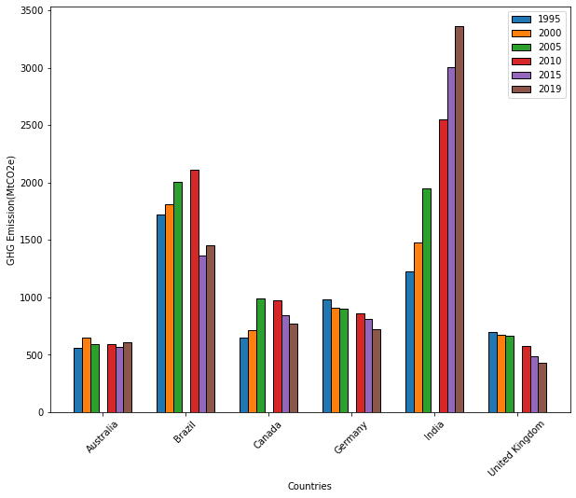

Figure 4: GHG emission

This bar chart indicate the total greenhouse gas emission for six different countries from the year 1995 to 2019 with the year gap for every country.

It can be seen that India was the only country where GHG emission is increased every given year which was also been seen in the air pollution graph.

Moreover, Germany and United Kingdom has similar downward trend as greenhouse gas emission was decreased from 1995 to 2019. While, Australia, Brazil and Canada show fluctuation in GHG emission for every given year.