**Brainstorm & Idea Prioritization Template**

**Date:** 14 October 2025  
**Team ID:** SWUID20250199287

**Project Name:**Social Media App(MERN)

**Purpose:**  
Brainstorming encourages free and open creativity, allowing all team members to contribute ideas for your social media app. Prioritization helps identify the most impactful features to implement first, ensuring development is focused on user value and feasibility. 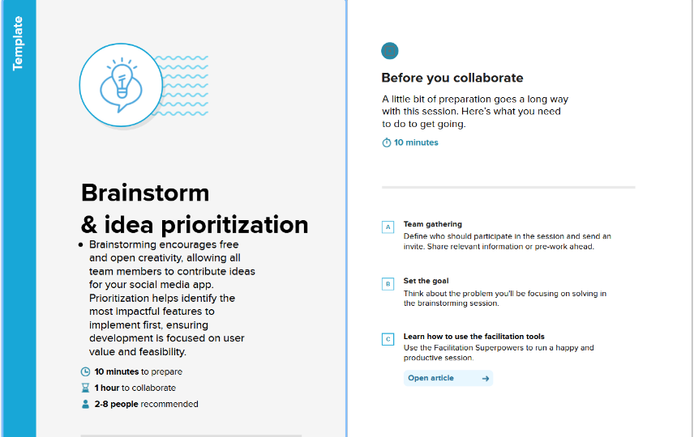

**Step 1: Team Gathering, Collaboration, and Select the Problem Statement**

**Objective:** "Users today want a social media platform that not only connects them with friends and communities but also keeps them engaged with personalized content, ensures privacy and security of their data, and provides innovative ways to interact and share experiences. Existing platforms often lack a balance between meaningful engagement, privacy, and creative features, leaving users looking for a more interactive, safe, and enjoyable social networking experience."

**Example Problem Statements for SocialConnect:**

* How can we make connecting with friends more interactive and engaging?
* How can users discover trending topics effortlessly?
* How can we ensure privacy and secure data sharing for all users?

**Action:**

* Gather team members for a brainstorming session.
* Choose one or two main problem statements to focus on for idea generation.
* 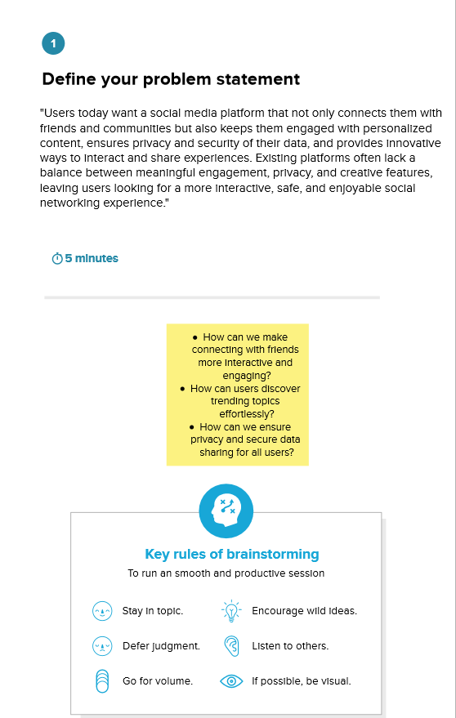

**Step 2: Brainstorm, Idea Listing, and Grouping**

**Objective:** Generate as many creative ideas as possible without filtering them.

**Brainstorming Ideas for SocialConnect:**

1. AI-based content recommendations
2. Stories and reels with augmented reality filters
3. Topic-based chat rooms and communities
4. In-app event creation and RSVPs
5. Post scheduling and analytics for influencers
6. Enhanced privacy controls and user data encryption
7. Gamified engagement (badges, rewards, levels)
8. Voice and video chat options
9. Marketplace for users to sell or exchange items
10. Real-time trending topic dashboard

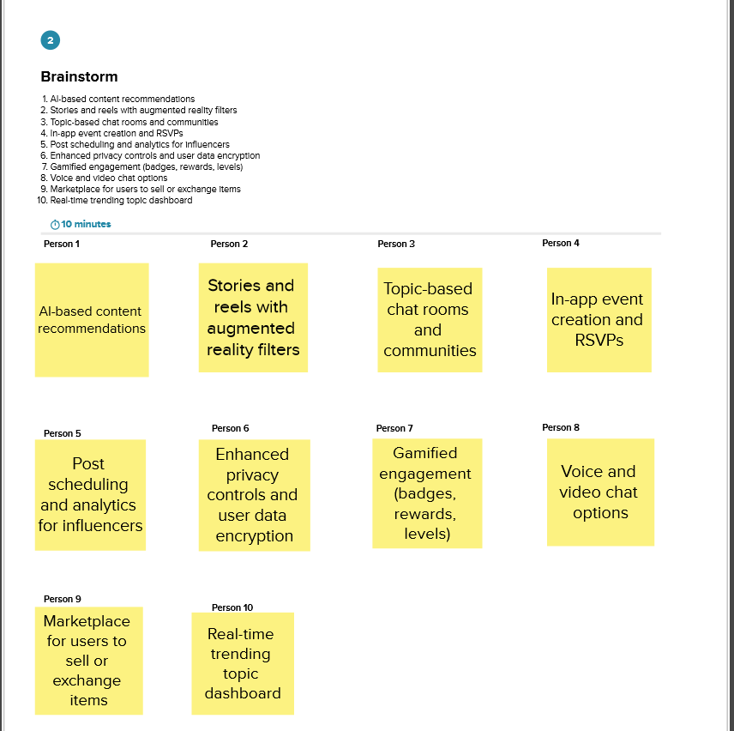

**Grouping Ideas:**

* **Engagement Features:** Stories, reels, gamification
* **Privacy & Security:** Encryption, privacy controls
* **Community Features:** Chat rooms, events
* **Content Features:** AI recommendations, trending topics
* **Monetization Features:** Marketplace, influencer tools

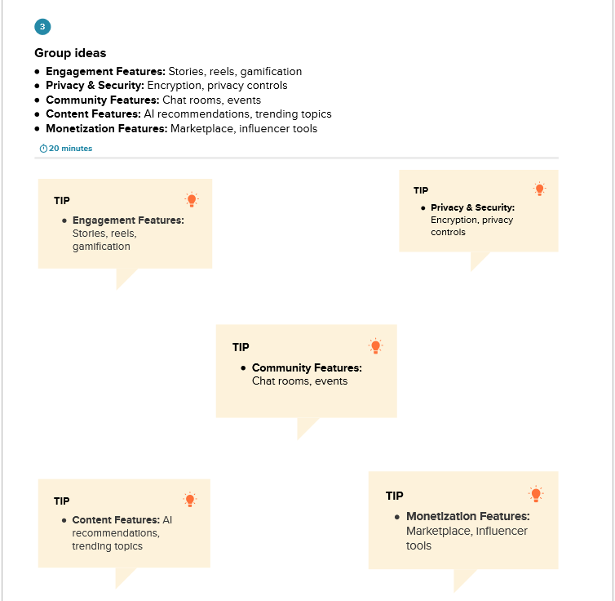

**Step 3: Idea Prioritization**

**Objective:** Decide which ideas to develop first based on impact and feasibility.

**Prioritization Criteria:**

* **Impact:** How much value does this feature provide to users?
* **Feasibility:** How easy is it to implement given resources and time?

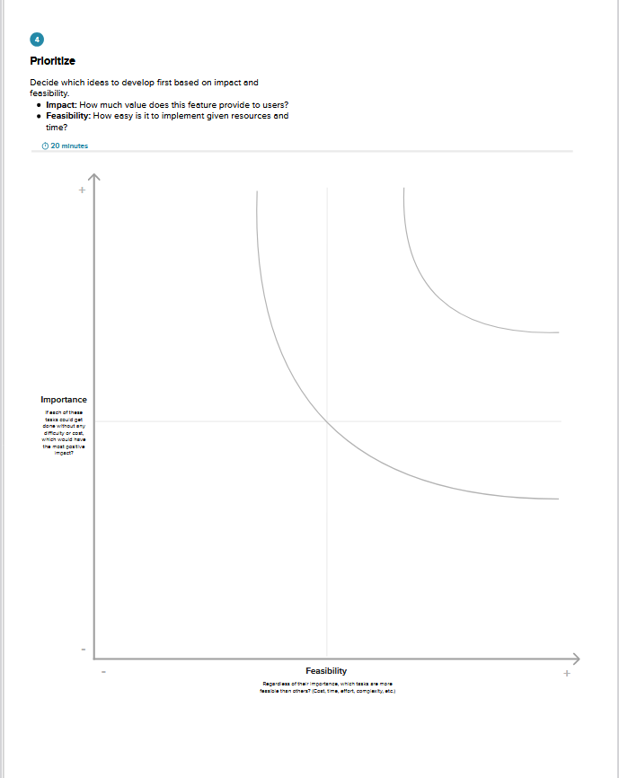

**Prioritization Table Example:**

| **Idea** | **Impact (High/Medium/Low)** | **Feasibility (High/Medium/Low)** | **Priority (High/Medium/Low)** |
| --- | --- | --- | --- |
| AI-based content recommendations | High | Medium | High |
| Stories and reels with AR filters | High | Medium | High |
| Enhanced privacy controls | High | High | High |
| Gamified engagement | Medium | Medium | Medium |
| Marketplace | Medium | Low | Low |
| Topic-based chat rooms | Medium | High | Medium |

**Action:**

* Focus development on **high priority features** first.
* Reassess medium and low priority ideas in future iterations.