**Ideation Phase**  
**Define the Problem Statements**

| Date | 10 OCTOBER 2025 |
| --- | --- |
| Team ID | SWUID20250199287 |
| Project Name | Social Media App(MERN) |

**Customer Problem Statement Template:**  
To define the core problems social media users face while interacting, sharing content, and building connections online, and use those insights to guide the development of SocialConnect.

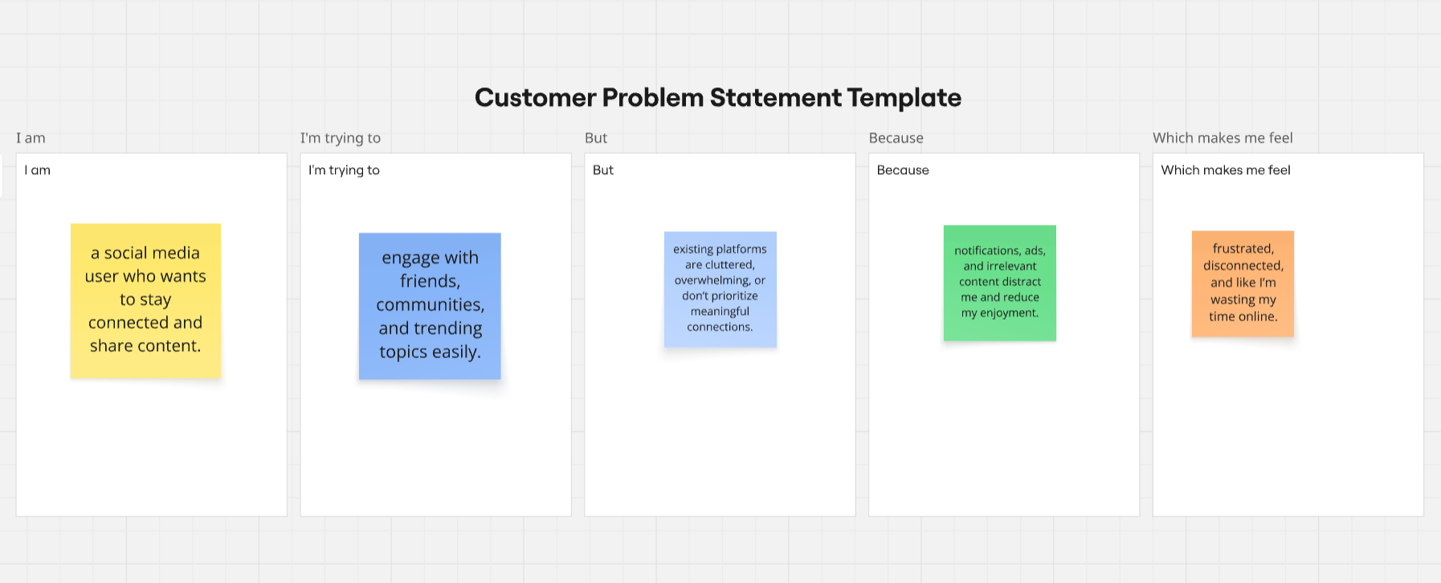

|  |  |  |  |  |  |
| --- | --- | --- | --- | --- | --- |
| **Problem Statement (PS)** | **I am (Customer)** | **I’m trying to** | **But** | **Because** | **Which makes me feel** |
| PS-1 | Social media user | stay connected with friends and communities | current platforms overwhelm me with irrelevant content | content isn’t personalized and engagement is shallow | frustrated and disengaged |
| PS-2 | Content creator | showcase my posts and grow followers effectively | existing tools limit visibility and engagement | algorithms favor only popular creators | demotivated and unnoticed |
| PS-3 | Privacy-conscious user | share updates without compromising privacy | platforms often track my data and show ads | privacy settings are complex and inconsistent | unsafe and anxious |