**Project Design Phase-II**

**Data Flow Diagram & User Stories**

| Date | 10-10-2025 |
| --- | --- |
| Team ID | SWUID20250199287 |
| Project Name | Social Media App |

**Data Flow Diagrams (DFD) – Social Media App**

A Data Flow Diagram (DFD) illustrates how data moves within the social media platform. It captures how users (content creators, followers, and admins) interact with the system, how information flows between different components, and where the data is stored.

**Key components:**

* **Users:** Content creators, followers, and admins.
* **Content:** Posts, comments, likes, messages, and media uploads.
* **System Modules:** Feed, Profile, Messaging, Notifications, Analytics, Admin Dashboard.
* **Data Stores:** User database, Content database, Interaction logs, Analytics data.
* **Data Flows:** Users create content → Content stored in database → Followers see content in feed → Users interact (like, comment, share) → Interactions recorded in logs → Notifications sent → Analytics updated.

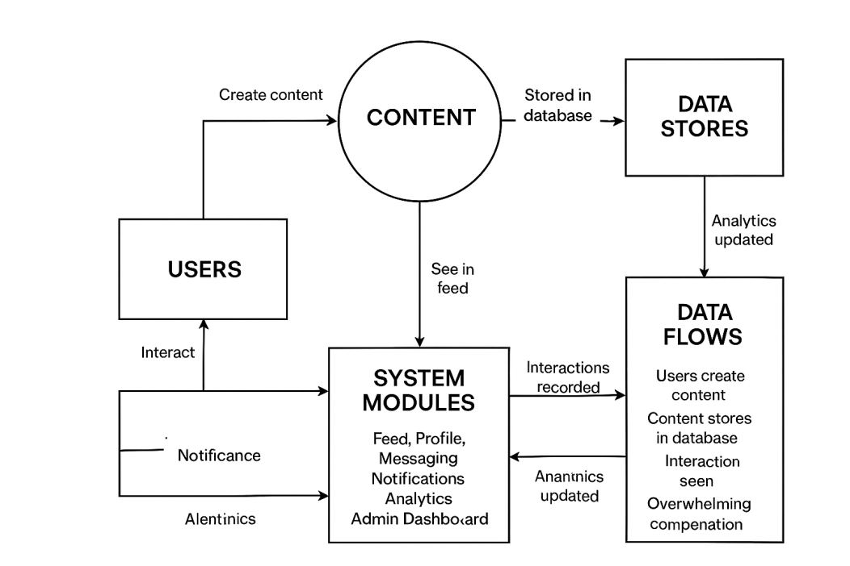

**User Stories Table – Social Media App**

|  |  |  |  |  |  |
| --- | --- | --- | --- | --- | --- |
| **User Type** | **Functional Requirement (Epic)** | **User Story / Task** | **Acceptance Criteria** | **Priority** | **Release** |
| Content Creator | Content Posting | As a content creator, I can post new content (text, images, videos). | Content appears in feed and on my profile. | High | Sprint-1 |
| User | Feed Browsing | As a user, I can browse and filter content in my feed. | Filter returns relevant posts based on interests. | Medium | Sprint-2 |
| Content Creator | Interaction | As a user, I can receive likes, comments, and shares on my posts. | Notifications appear instantly; engagement recorded. | High | Sprint-1 |
| User | Messaging | As a user, I can chat with other users in real-time. | Messages appear instantly. | Medium | Sprint-2 |
| Content Creator | Profile Management | As a user, I can update my profile and bio. | Changes are saved successfully and reflected in feed. | High | Sprint-2 |
| User | Payment / Subscriptions | As a user, I can make payments for premium features or subscriptions. | Payment recorded and shown in transaction history. | High | Sprint-2 |
| User | Review / Feedback | As a user, I can leave feedback on content or users. | Feedback appears publicly or privately as intended. | Medium | Sprint-2 |
| Admin | User Moderation | As an admin, I can review reported content/users and take action. | Reports and actions logged and reflected in moderation dashboard. | High | Sprint-1 |