Speech To Text Application

Overview
Speech To Text Application is a full-stack AI-powered web application that converts audio recordings into text transcripts using the Deepgram Speech Recognition API.
The application provides secure authentication, audio upload, voice recording, transcript history management, transcript downloads, and user-specific data access.

Features

Authentication
- User Registration
- User Login
- JWT Authentication
- Password Encryption using BCrypt
- Protected Routes

Speech Processing
- Audio File Upload
- Microphone Recording
- Deepgram AI Integration
- Automatic Speech-to-Text Conversion

Transcript Management
- View Transcript History
- Download Transcript
- Delete Transcript
- User-Specific Transcript Storage

User Experience
- Modern Dark UI
- Responsive Design
- Dashboard Interface
- History Management Page

Technology Stack

Frontend
- React
- Vite
- Tailwind CSS
- React Router DOM
- Axios

Backend
- Spring Boot
- Spring Security
- Spring Data JPA
- Maven

Database
- PostgreSQL

AI Integration
- Deepgram Speech Recognition API

Authentication
- JWT (JSON Web Token)

System Architecture
React Frontend
↓
Axios + JWT
↓
Spring Boot REST API
↓
PostgreSQL Database
↓
Deepgram API
↓
Speech To Text Conversion

Project Structure

Backend
src/main/java/com/sttapp
├── controller
├── service
├── repository
├── model
├── dto
├── security
└── config

Frontend
src
├── pages
├── components
├── hooks
├── services
└── utils

Database Schema

users
Field | Type
id | BIGINT
name | VARCHAR
email | VARCHAR
password | VARCHAR

transcriptions
Field | Type
id | BIGINT
audio_file | VARCHAR
transcript | TEXT
created_at | TIMESTAMP
user_id | BIGINT

Installation

Backend
Navigate to backend
cd backend
Install dependencies
mvn clean install
Run application
mvn spring-boot:run
Backend URL
http://localhost:8080

Frontend
Navigate to frontend
cd frontend
Install dependencies
npm install
Run application
npm run dev
Frontend URL
http://localhost:5173

API Endpoints

Authentication
POST /api/auth/register
POST /api/auth/login

Speech Processing
POST /api/speech/upload
GET /api/speech/history
GET /api/speech/{id}
DELETE /api/speech/{id}
GET /api/speech/download/{id}

Security
- JWT Authentication
- BCrypt Password Hashing
- Protected REST APIs
- User-Specific Transcript Access
- Authorization Filter Validation

Future Enhancements
- Real-Time Streaming Transcription
- Multi-Language Support
- Speaker Identification
- Transcript Export to PDF
- Cloud Storage Integration
- Transcript Search Functionality

Screenshots
Add screenshots in the following sections:

Login Page

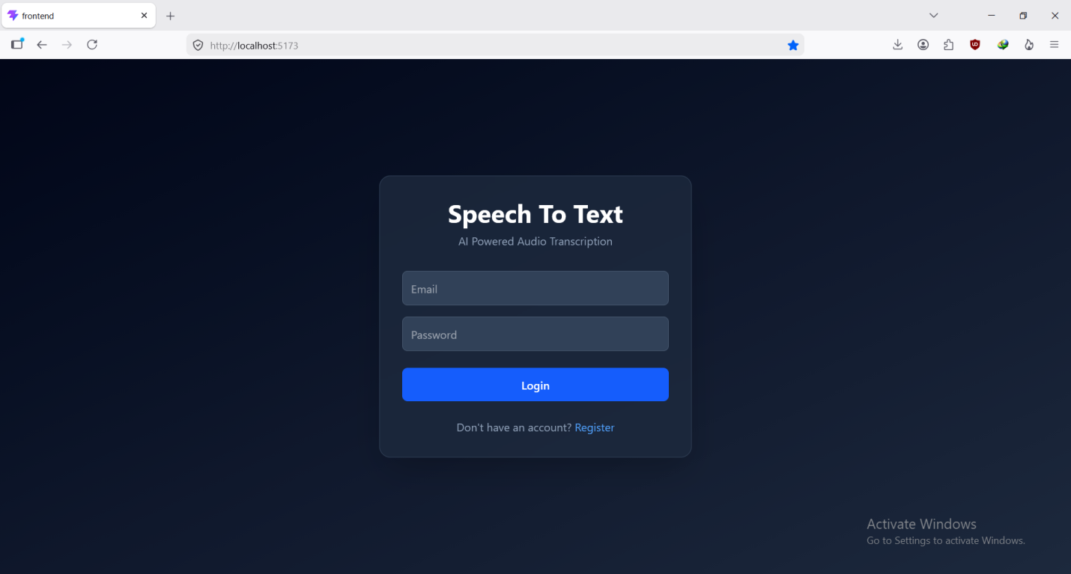

Register Page

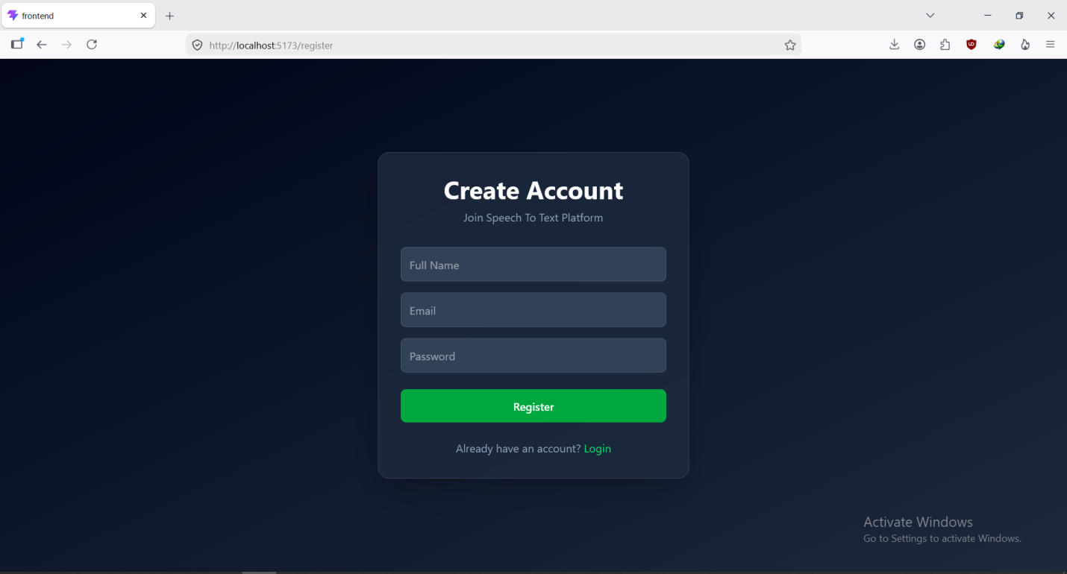

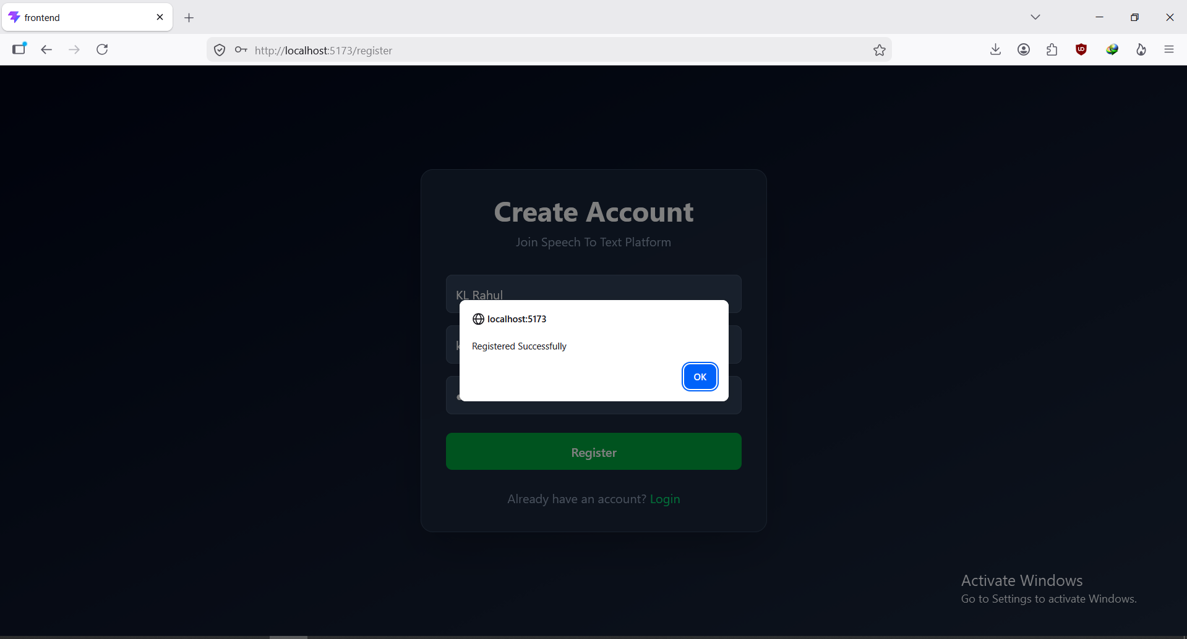

Dashboard

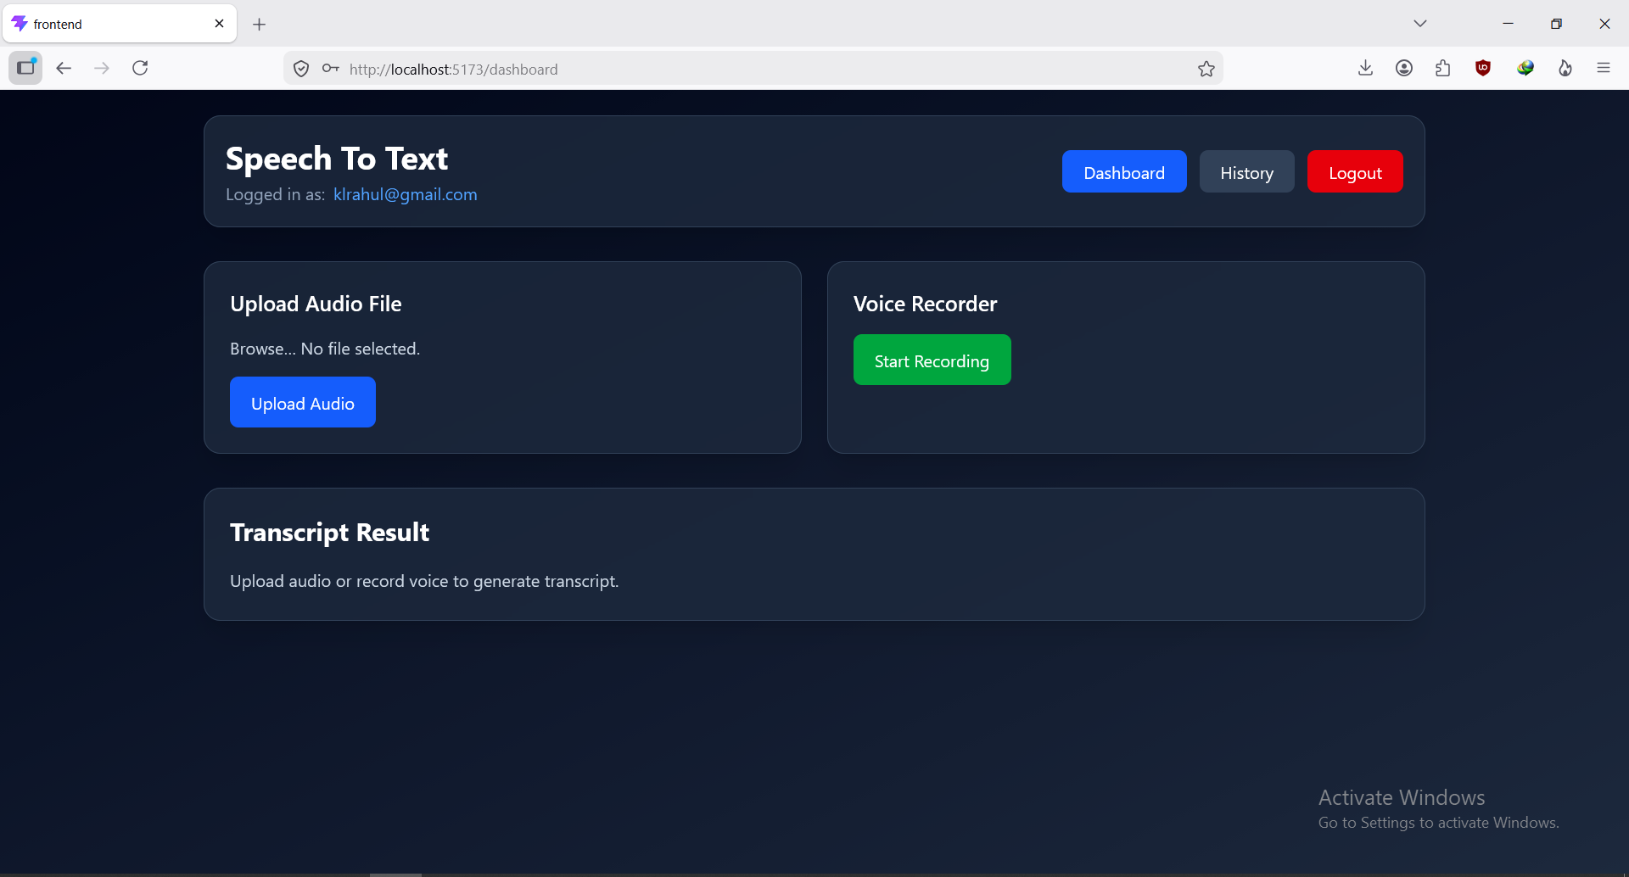

Audio Upload & Transcript Generation

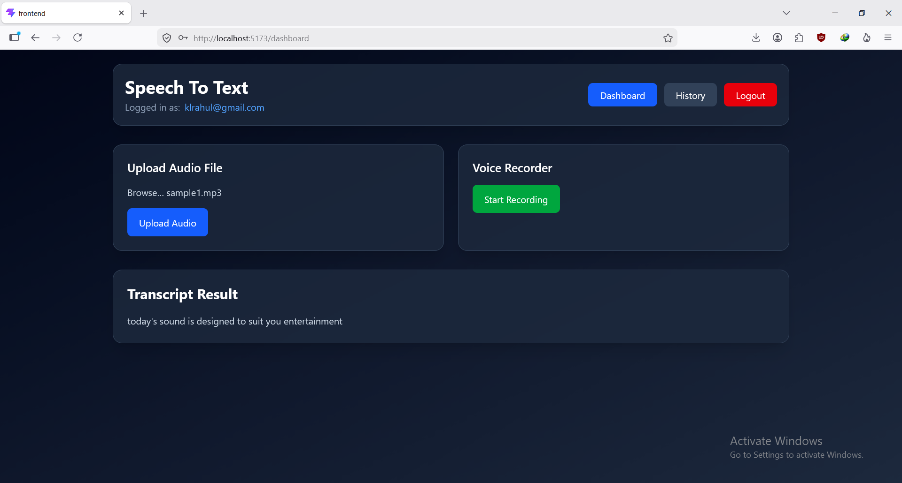

Transcript History

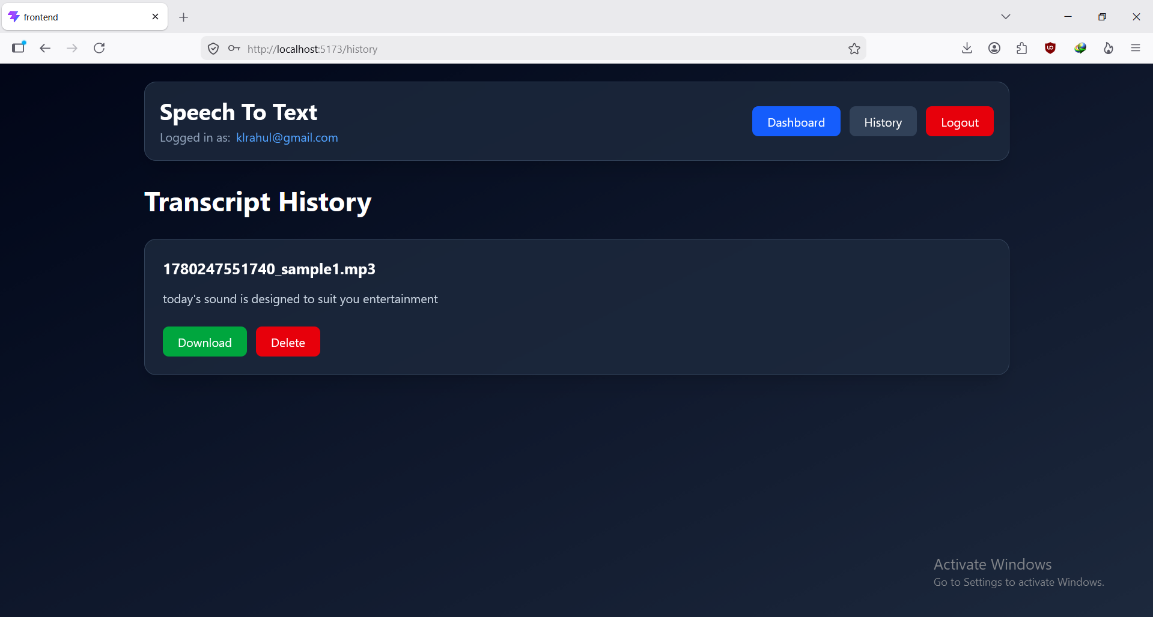

Database Tables

Users:

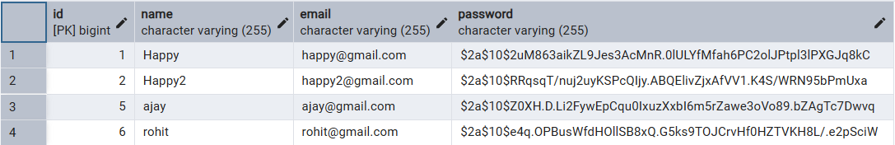

Transcriptions

