Java Social Media Platform (Reddit Clone) - Full Project Documentation

1. Project Overview
The Reddit Clone MVP is a full-stack web application that enables users to create communities, share posts, vote, and comment using a Java-based backend and modern frontend technologies. The project focuses on building a scalable, production-ready MVP within a short development cycle.

2. Objectives
• Build RESTful backend using Java (Spring Boot)
• Implement secure authentication & authorization using JWT
• Design relational database with proper entity mapping
• Integrate frontend with backend APIs
• Deliver deployable full-stack application

3. Tech Stack
Backend: Spring Boot, Spring Security, Hibernate (JPA), Maven
Frontend: Next.js / React.js, Tailwind CSS
Database: PostgreSQL

4. System Architecture
Frontend (Next.js/React)
↓
REST API (Spring Boot)
↓
Service Layer (Business Logic)
↓
Repository Layer (JPA/Hibernate)
↓
PostgreSQL Database

5. Core Features (MVP)
• User Authentication (JWT-based login/signup)
• Communities (create & browse subreddits)
• Posts (create, view, filter by community)
• Voting System (upvote/downvote)
• Comments (add & display comments)
• Sorting

6. Database Design (Entities)
Entities:
User, Community, Post, Comment, Vote
Key Relationships:
User → Posts (OneToMany)
Community → Posts (OneToMany)
Post → Comments (OneToMany)
User → Votes (OneToMany)

7. API Design
Auth:
POST /api/auth/signup
POST /api/auth/login

8. Development Plan (2 Weeks)
Week 1:
Day 1: Setup Spring Boot + PostgreSQL
Day 2: Entities & Repositories
Day 3: JWT Authentication
Day 4: Community APIs
Day 5: Post APIs
Day 6: Voting Logic
Day 7: Comments
Week 2:
Day 8: Frontend Setup
Day 9: Community UI
Day 10: Post UI
Day 11: Voting & Comments UI
Day 12: Auth Integration
Day 13: Testing
Day 14: Deployment

9. Security Considerations
• JWT-based authentication
• Password encryption using BCrypt
• Spring Security endpoint protection
• Input validation for all APIs

10. UI Guidelines
• Clean Reddit-like interface
• Responsive design
• Clear voting & interaction buttons
• Proper loading & empty states
11.UI Screenshots
Login page:
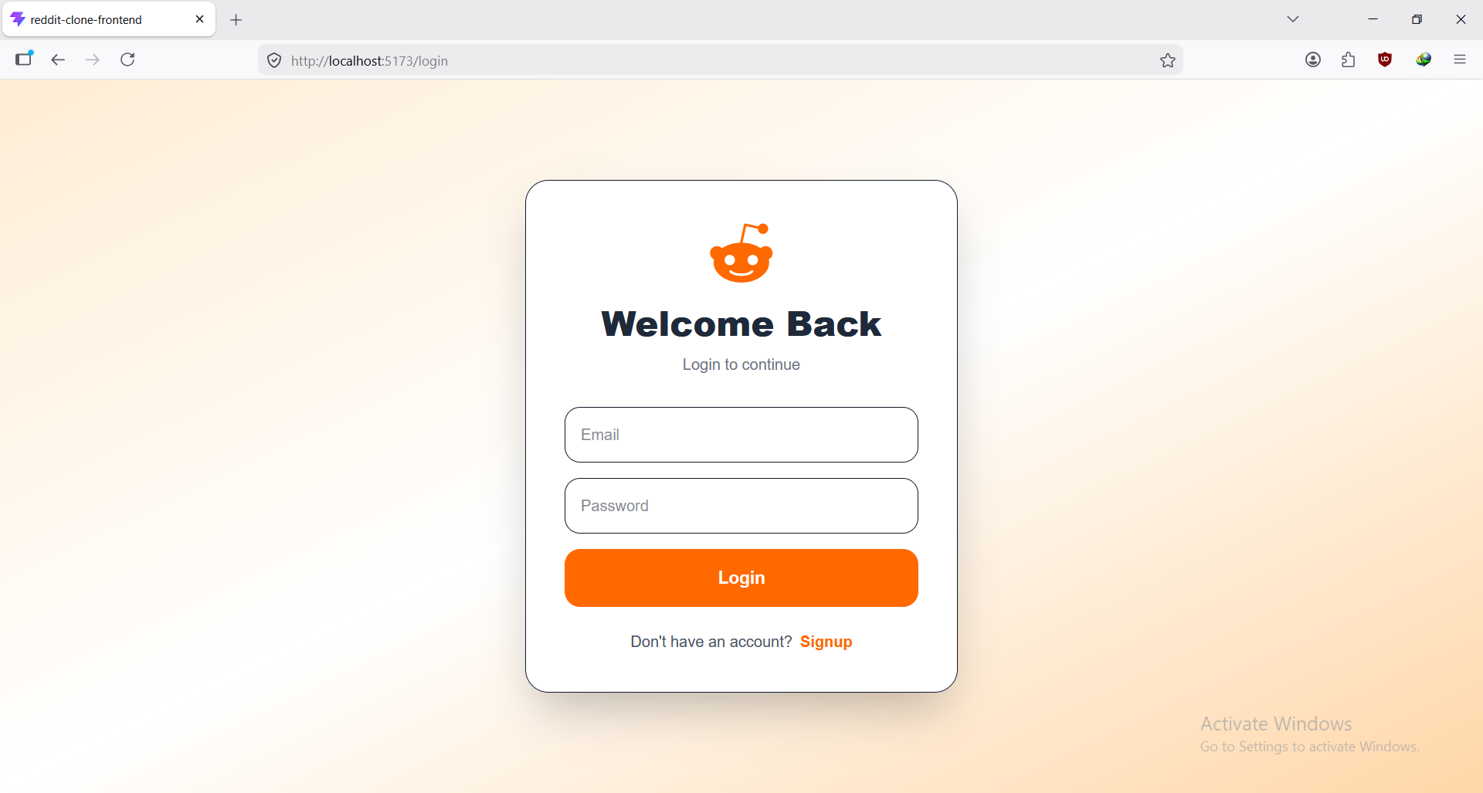

Signup page:
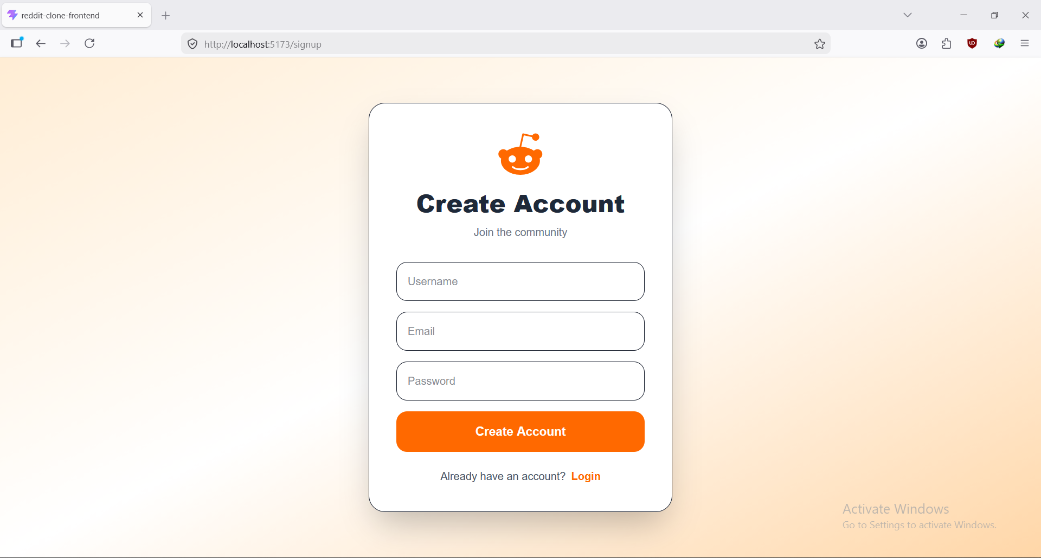
Home feed:

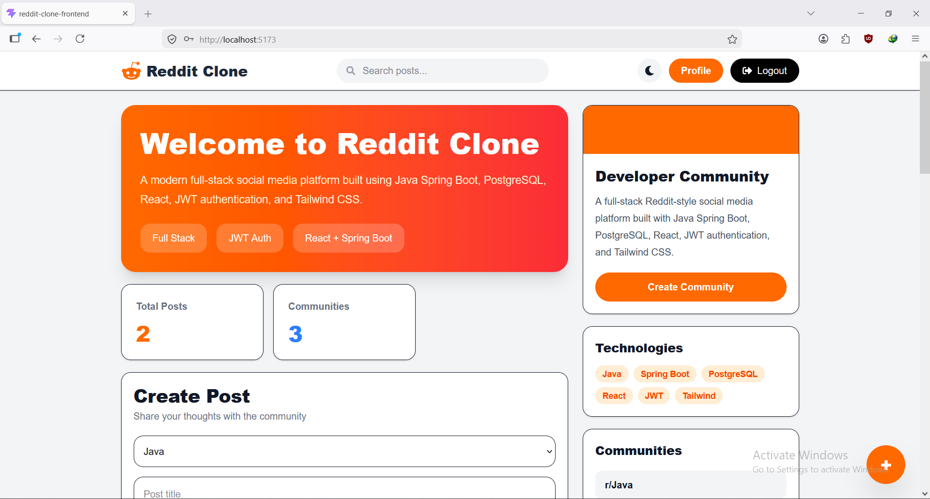
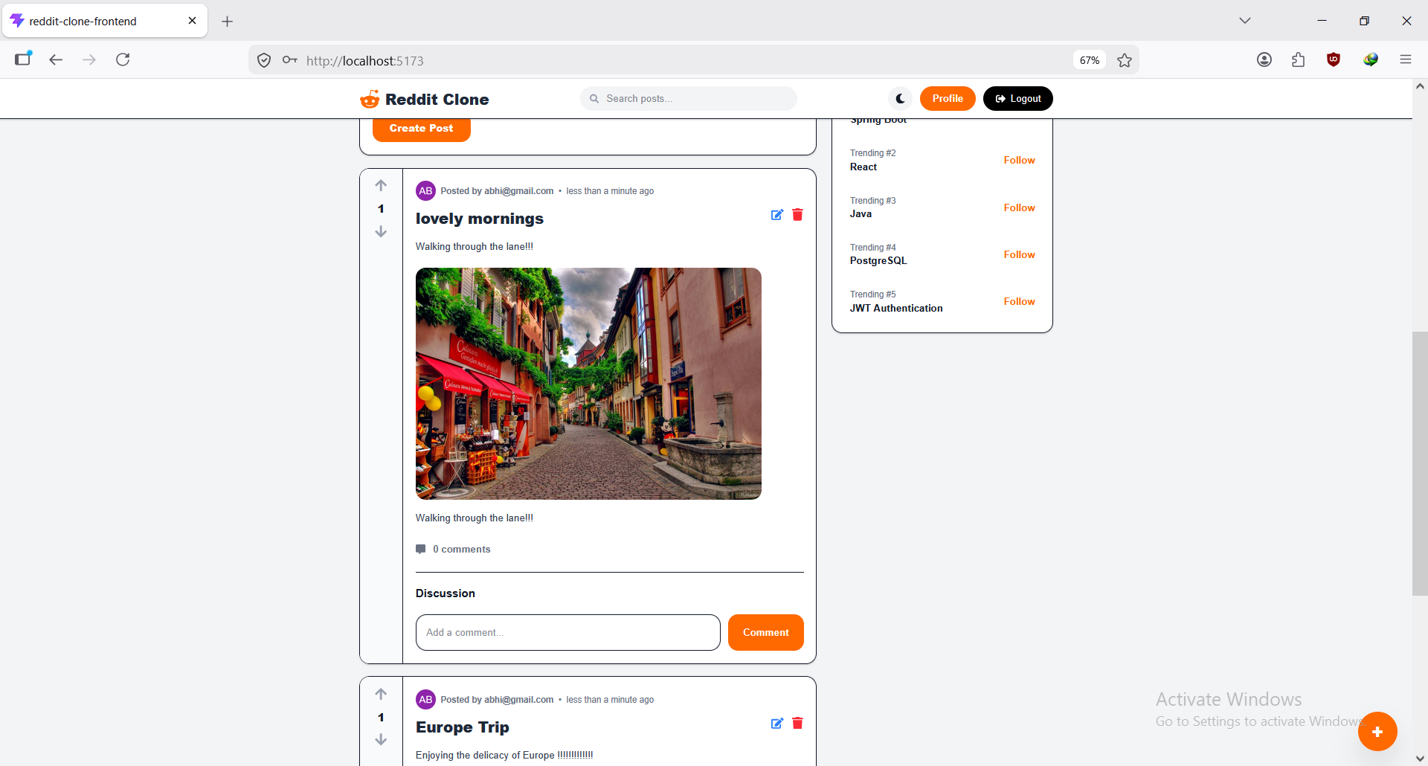

Creating new post:
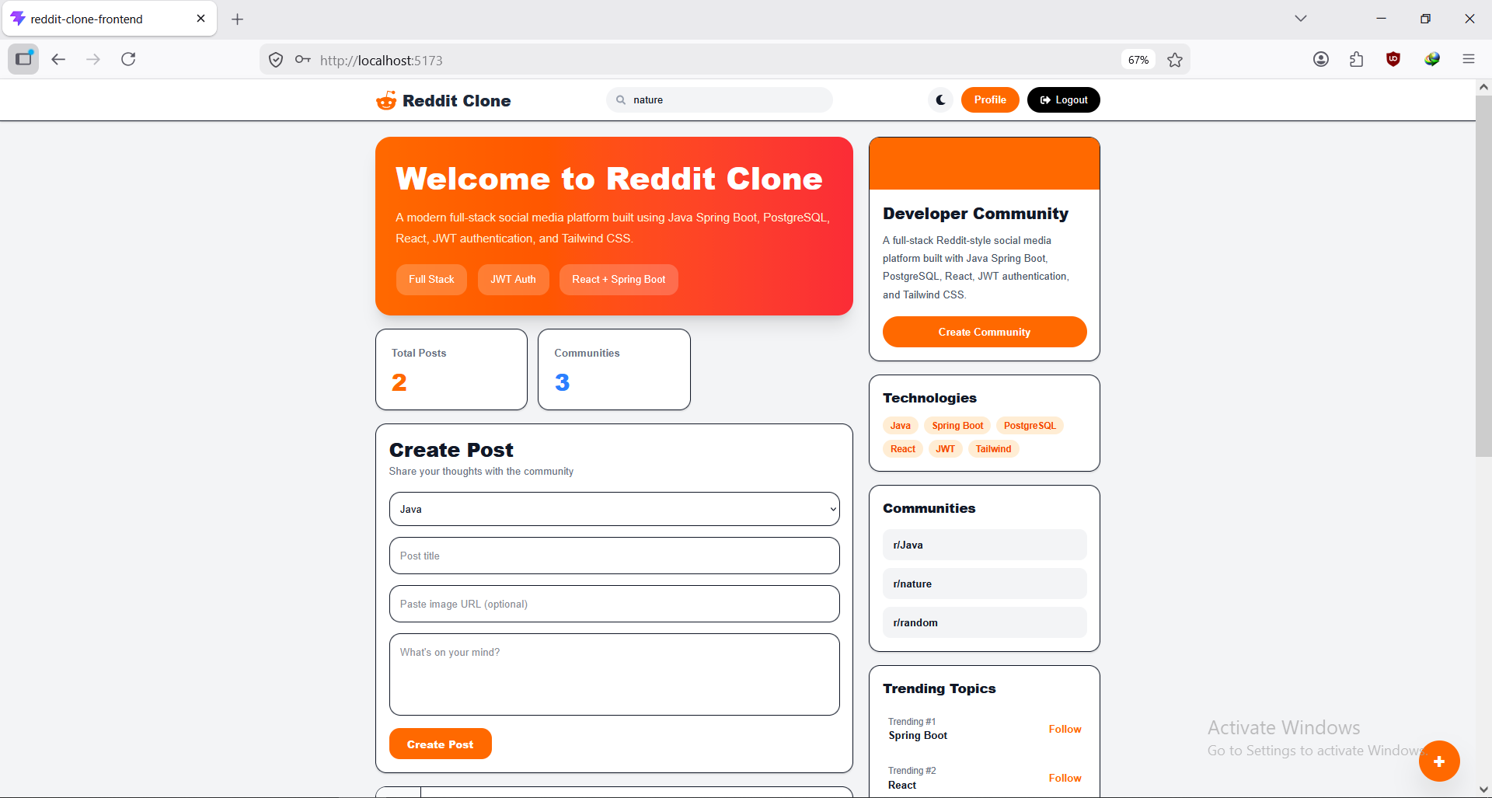

Commenting on post:
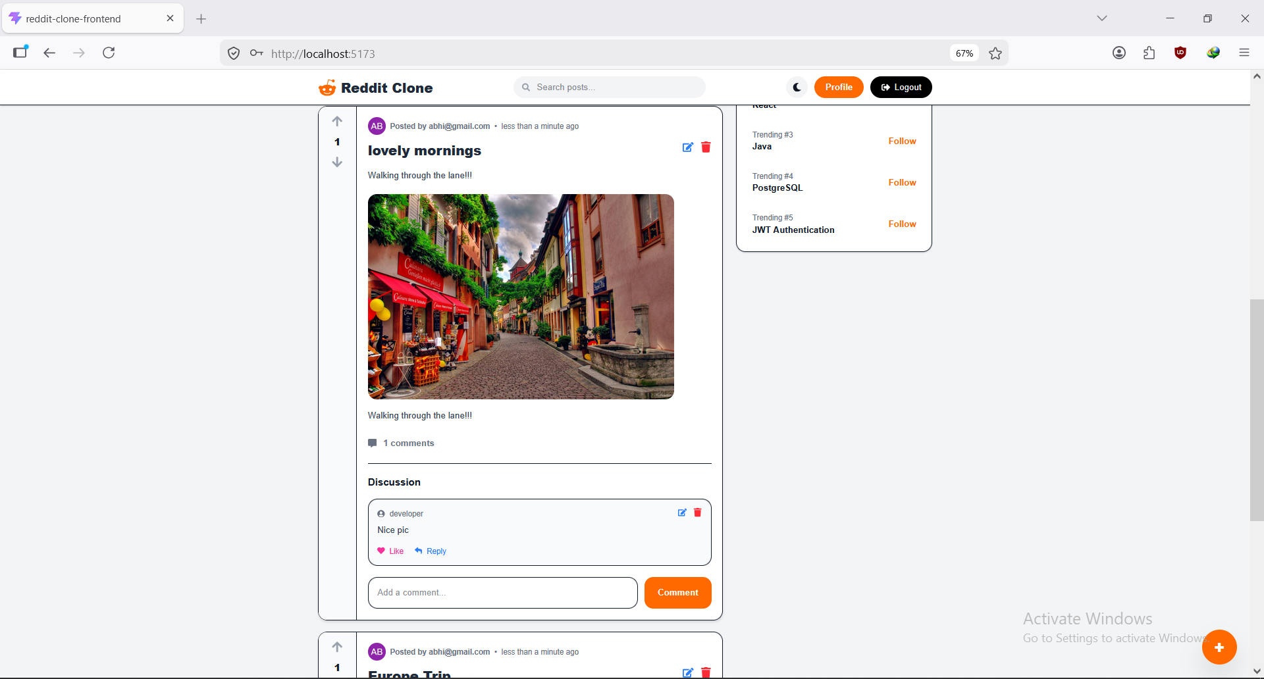

Editing, replying and deleting comment:
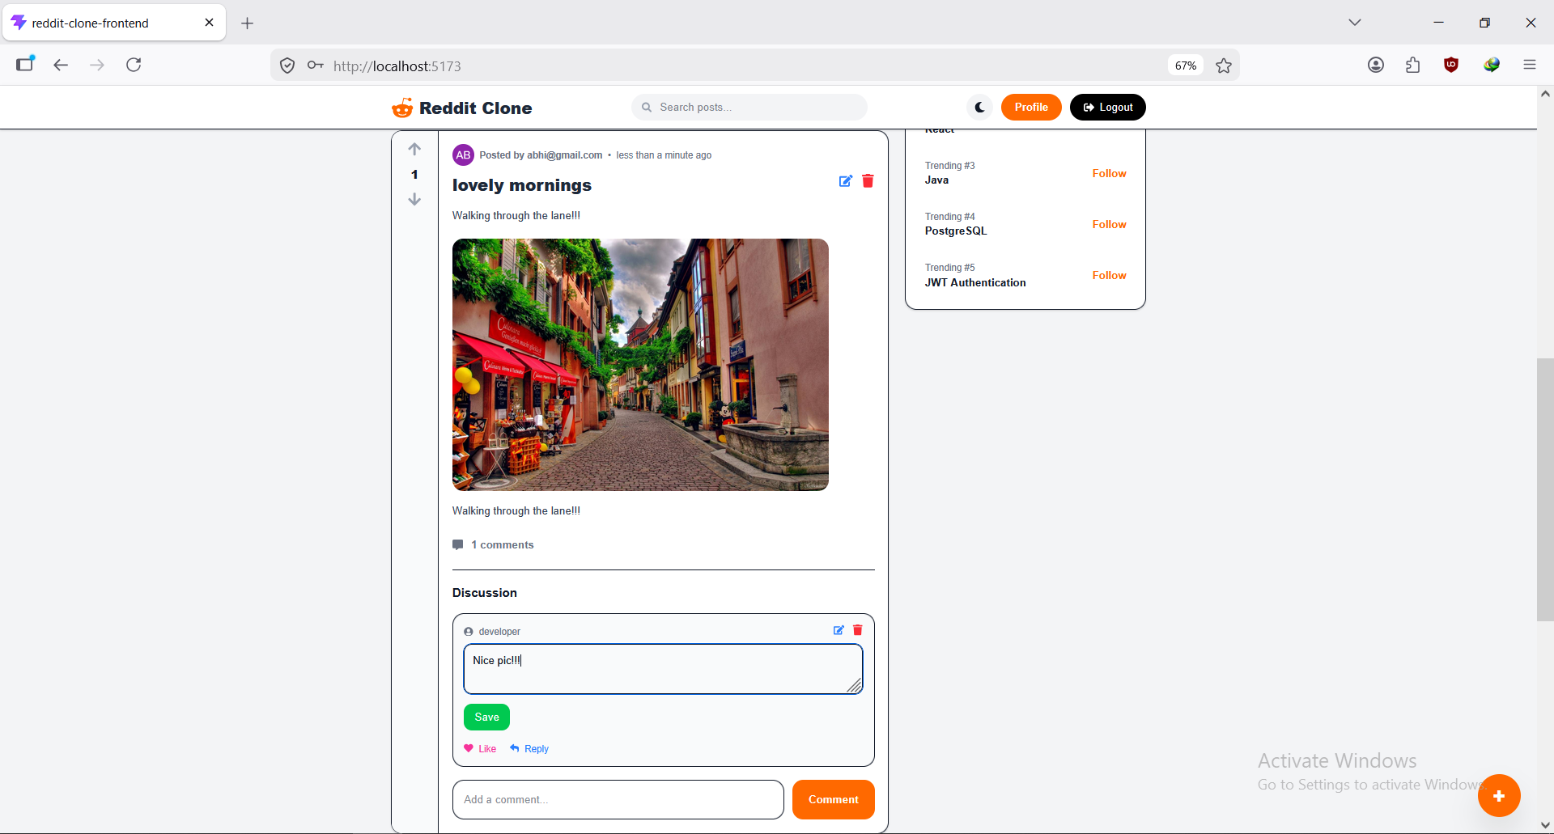

Editing and deleting post:
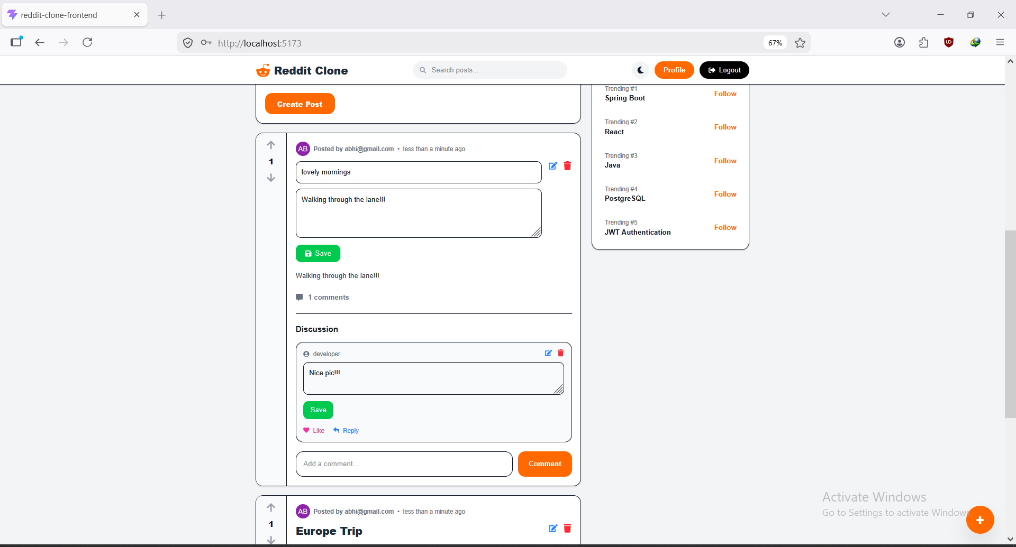
Browsing communities and sorting post:
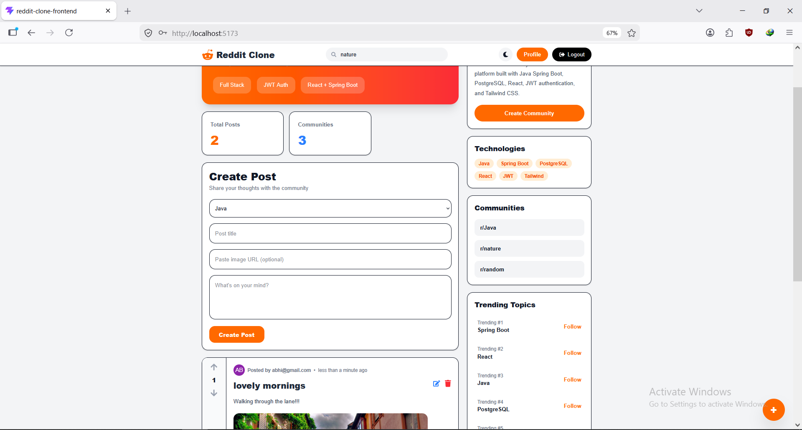
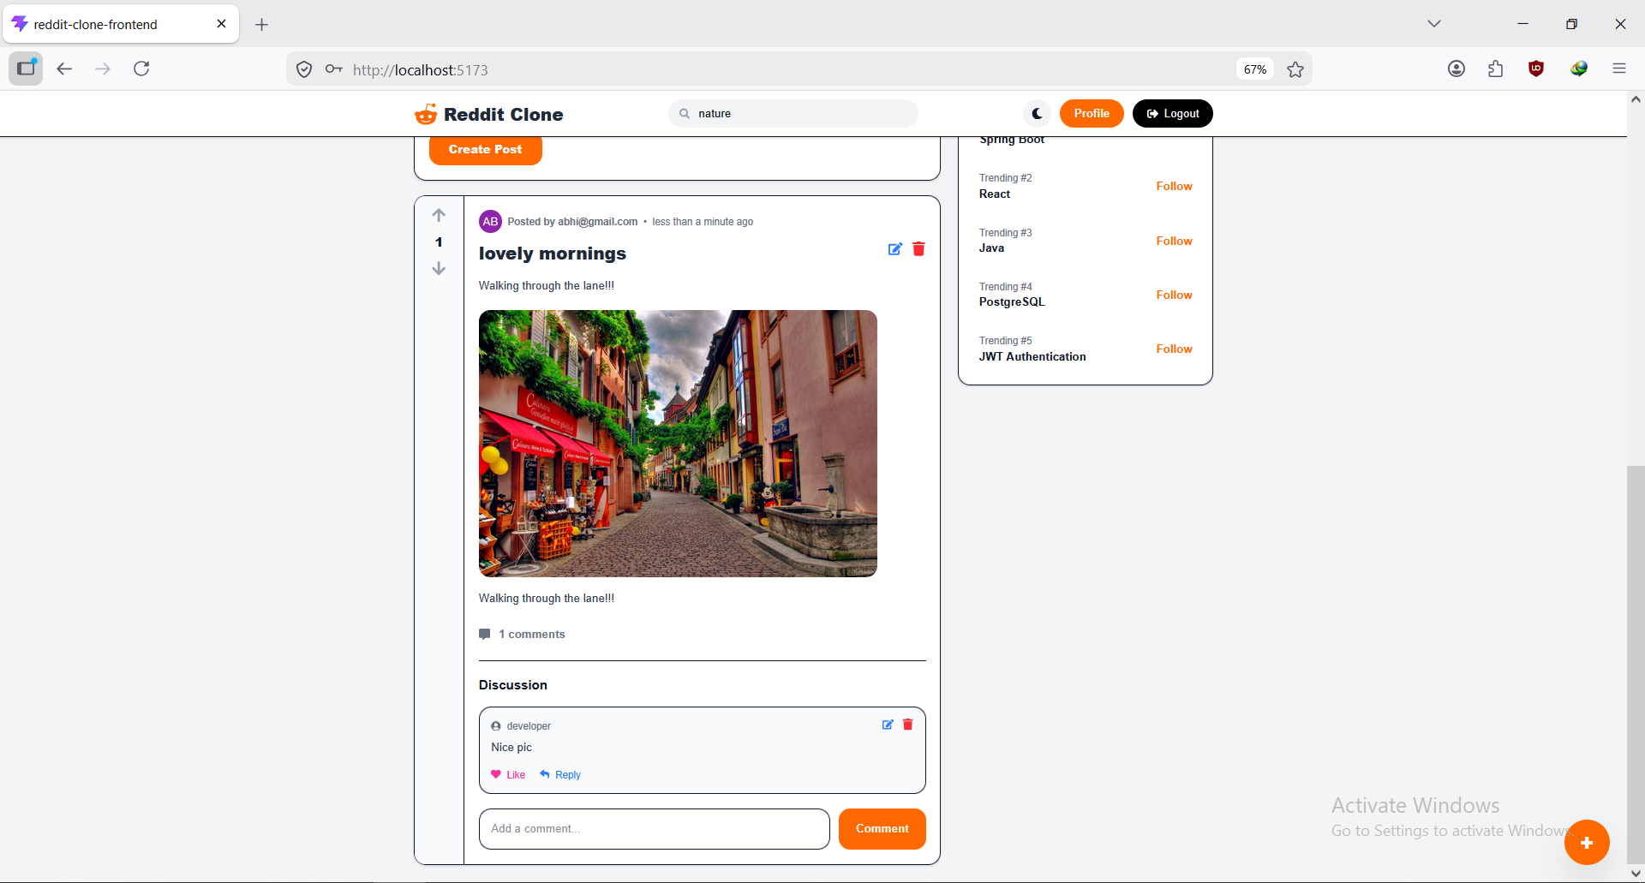
Profile page:
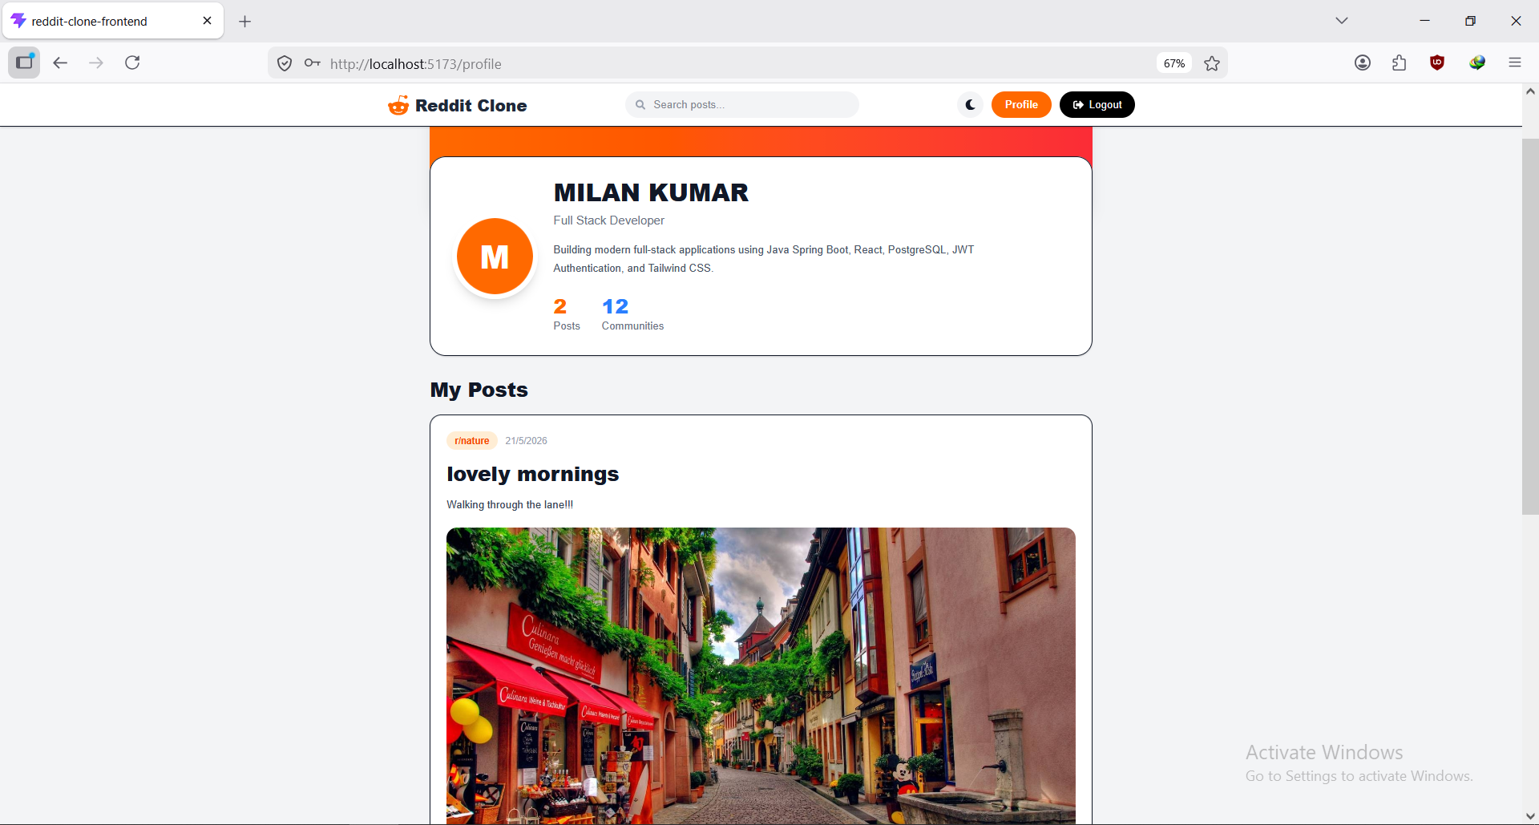

12. Future Enhancements
• Nested comments
• Notifications system
• Real-time updates (WebSockets)
• Admin moderation

13. Learning Resources
Backend: Spring Boot Docs, Spring Security Docs, Hibernate Docs
Frontend: Next.js Docs, Tailwind CSS Docs
Database: PostgreSQL Docs
APIs: REST API best practices

14. Conclusion
This project demonstrates strong backend development using Java, API design, database modeling, and full-stack integration. It is a high-impact portfolio project suitable for Java Backend and Full Stack Developer roles.

