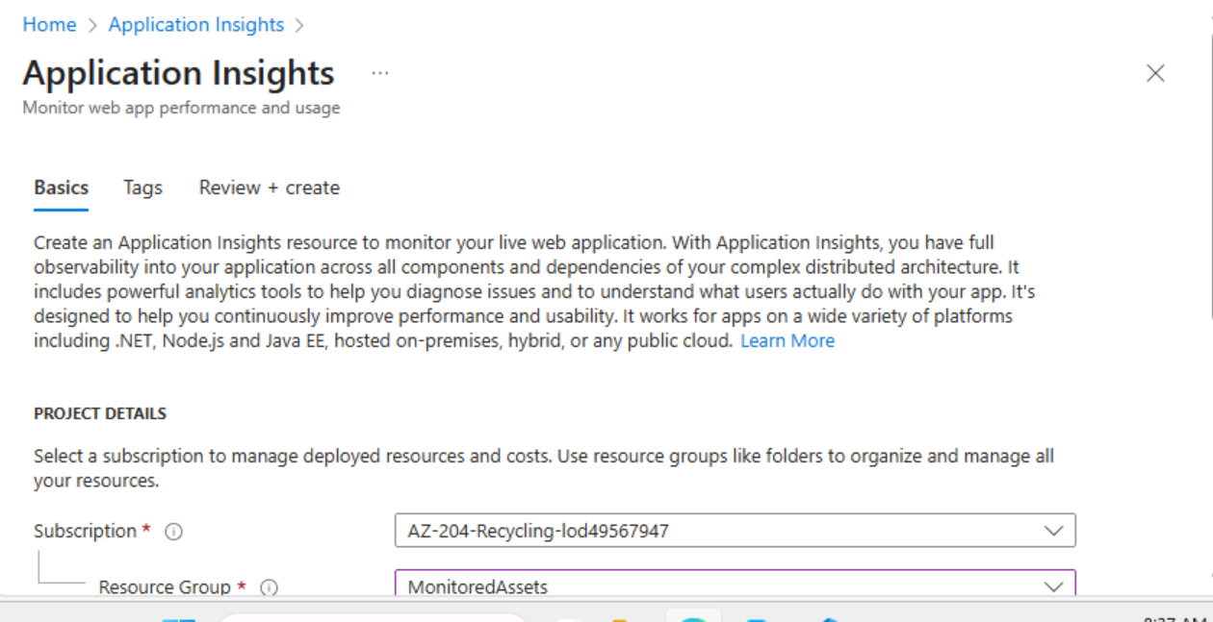

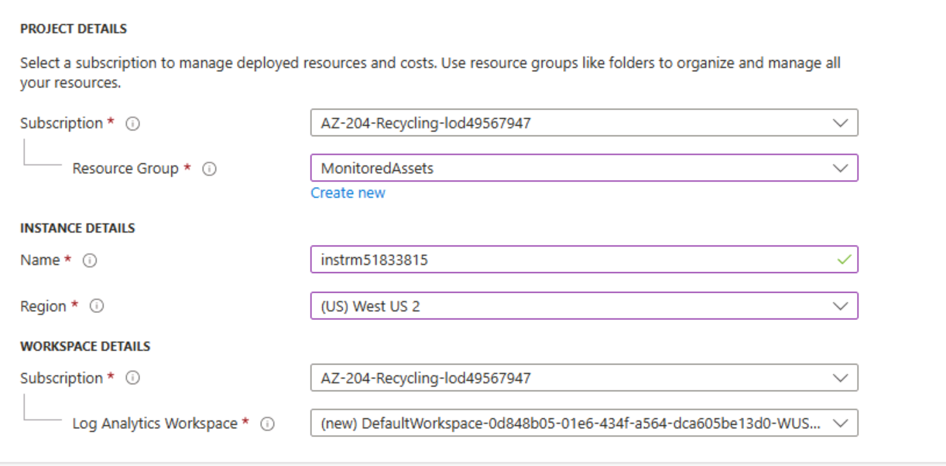

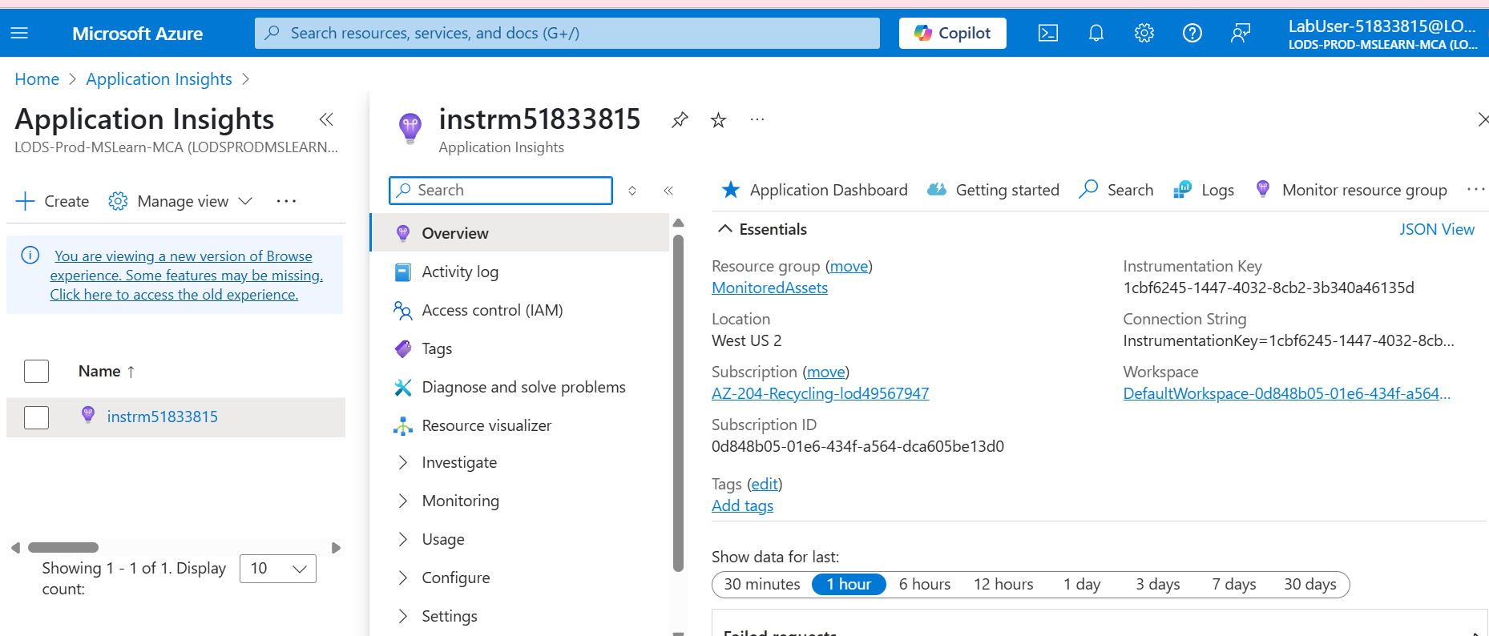

Instrumentation Key

1cbf6245-1447-4032-8cb2-3b340a46135d

Connection String

InstrumentationKey=1cbf6245-1447-4032-8cb2-3b340a46135d;IngestionEndpoint=https://westus2-2.in.applicationinsights.azure.com/;LiveEndpoint=https://westus2.livediagnostics.monitor.azure.com/;ApplicationId=b5ffcc8c-1dc9-4f4f-b86b-7bee72da3071

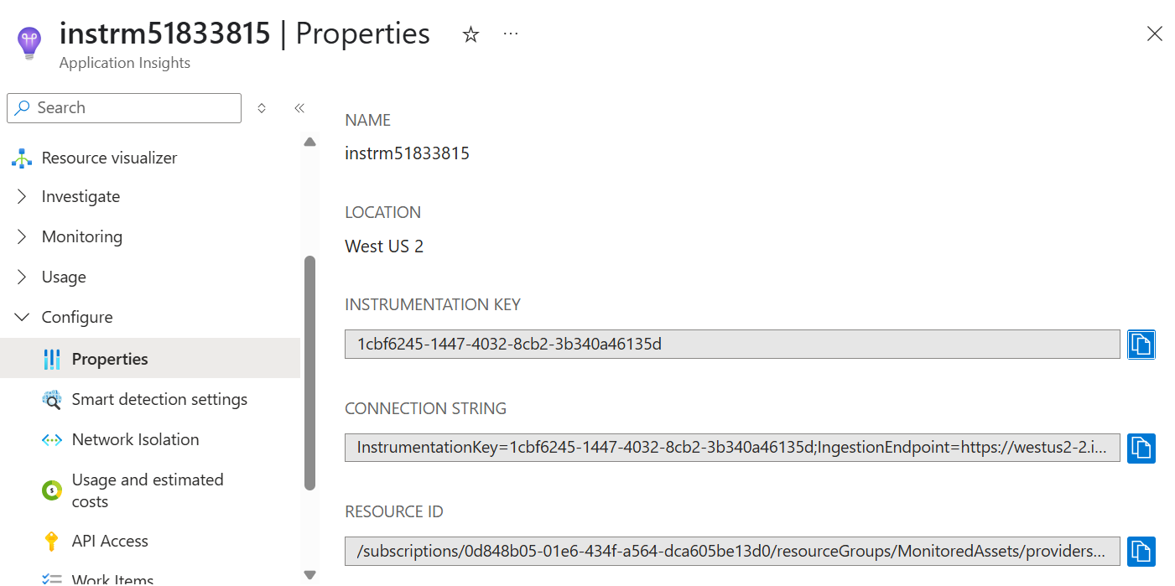

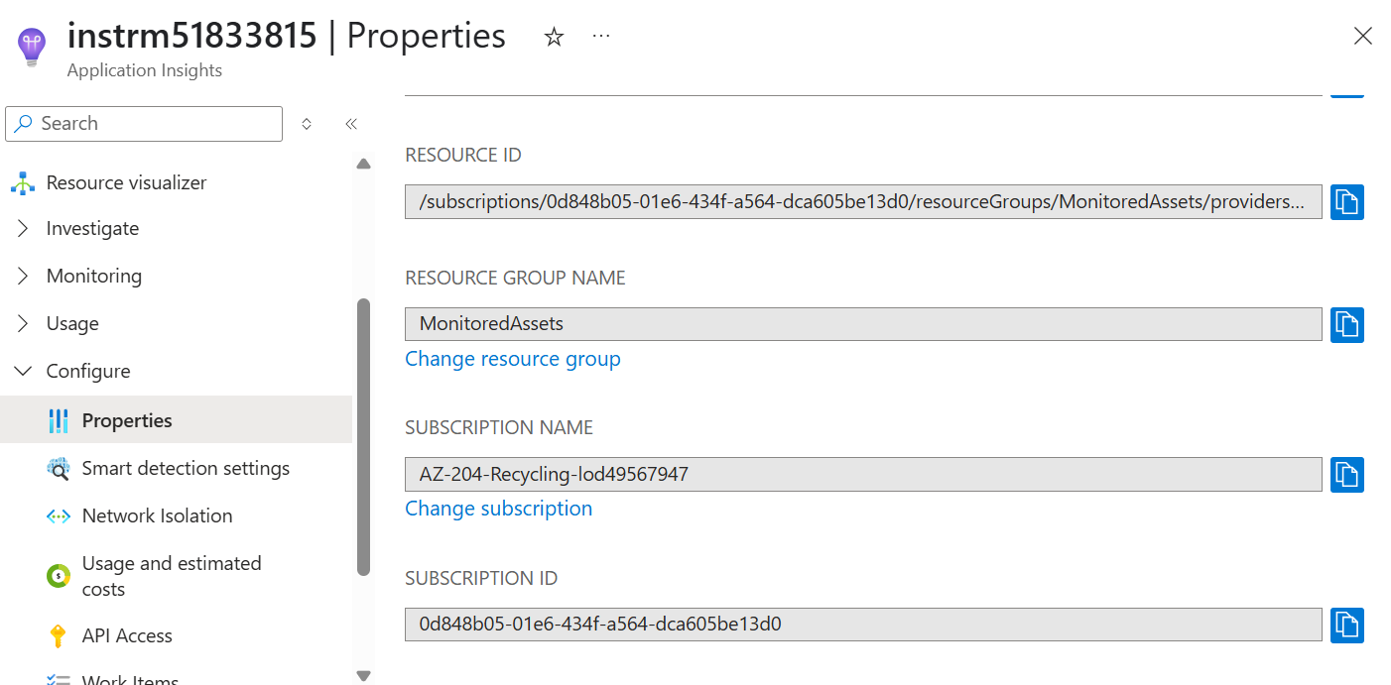

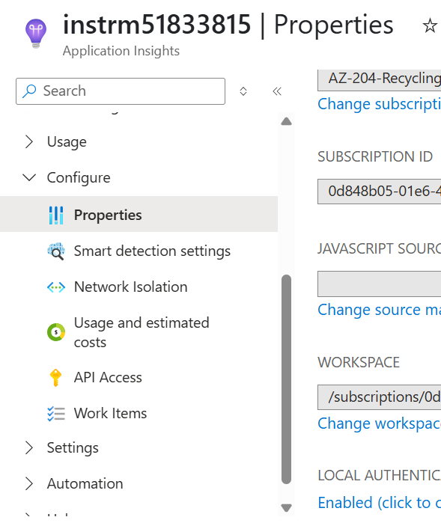

1cbf6245-1447-4032-8cb2-3b340a46135d

InstrumentationKey=1cbf6245-1447-4032-8cb2-3b340a46135d;IngestionEndpoint=https://westus2-2.in.applicationinsights.azure.com/;LiveEndpoint=https://westus2.livediagnostics.monitor.azure.com/;ApplicationId=b5ffcc8c-1dc9-4f4f-b86b-7bee72da3071

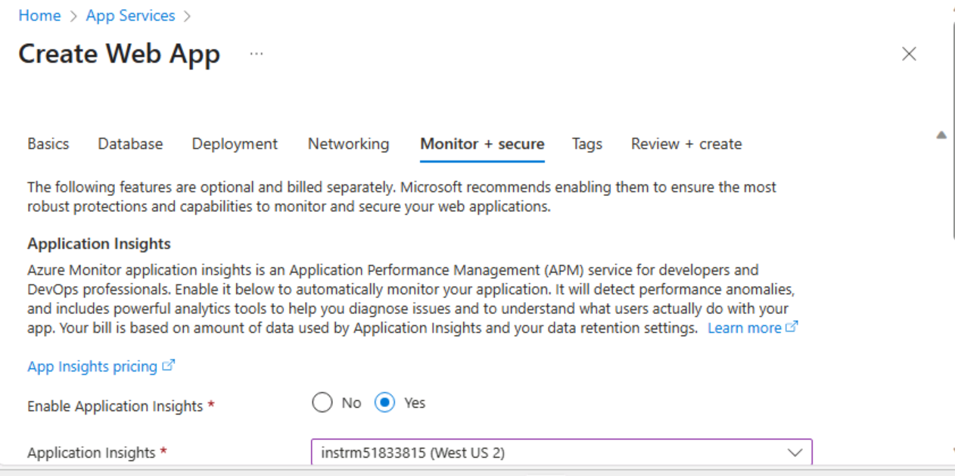

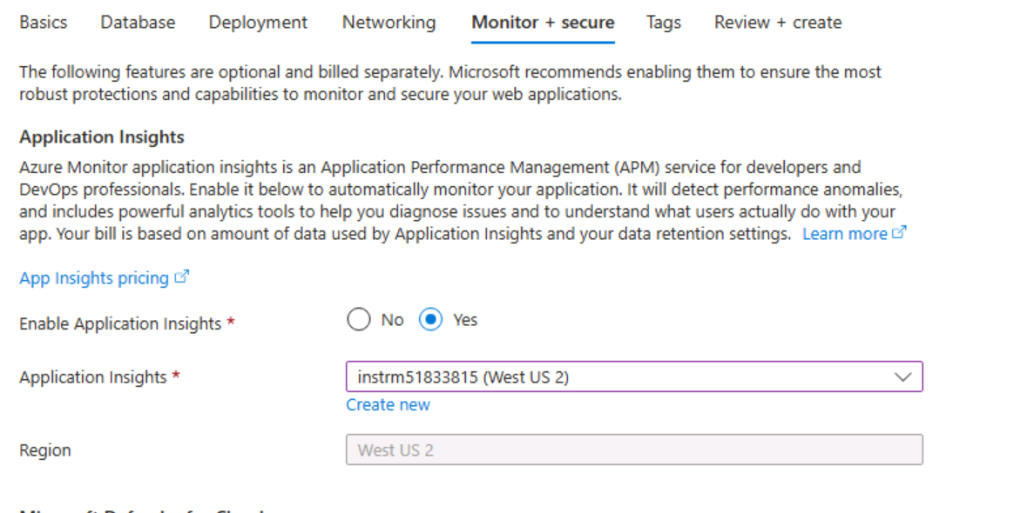

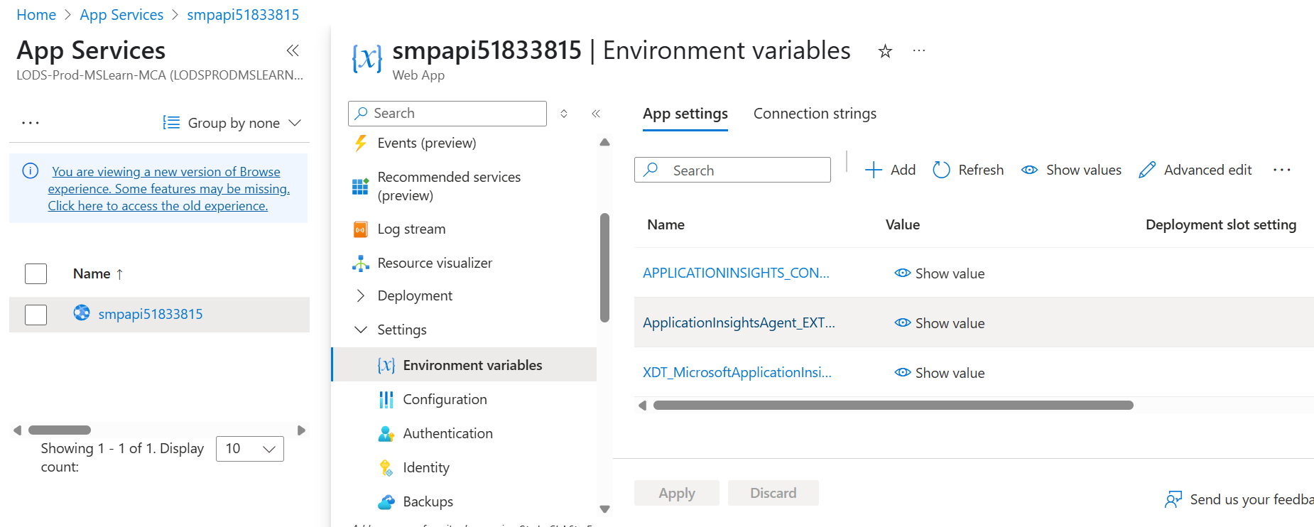

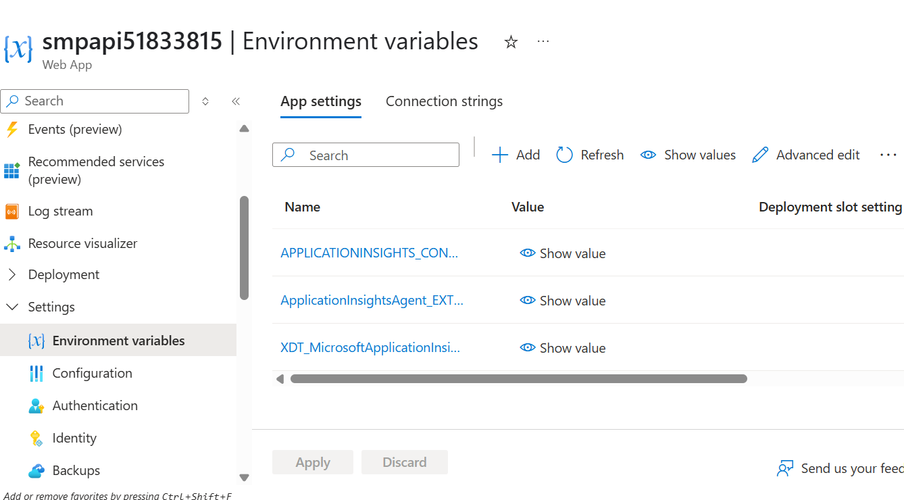

Below will be generated automatically.

1. On the **App Service** blade, in the **Settings** section, select the **Environment Variables** link.
2. In the **Environment Variables** section, perform the following actions:
   1. On the **App settings** tab, select **Show values** to display secrets associated with your web API.
   2. Note the value representing the **APPLICATIONINSIGHTS_CONNECTION_STRING** key. This value was set automatically when you built the web API resource.

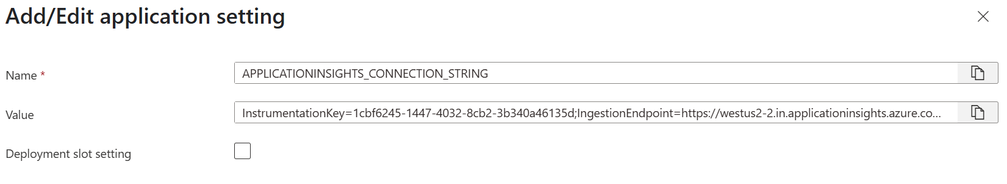

Default domain of web service

smpapi51833815-b8c2b4fcfsbre9ey.westus2-01.azurewebsites.net

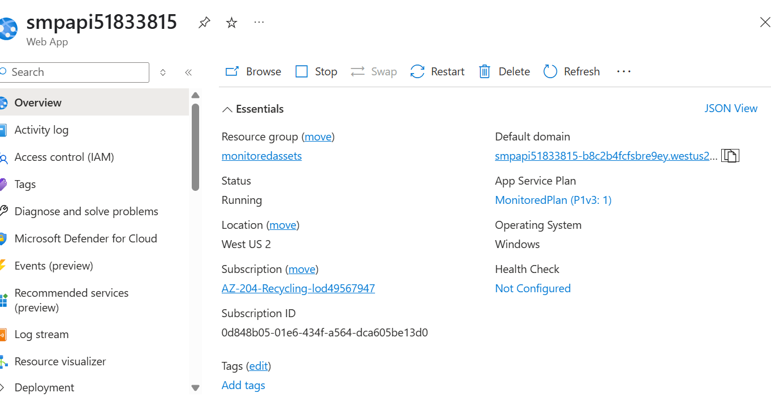

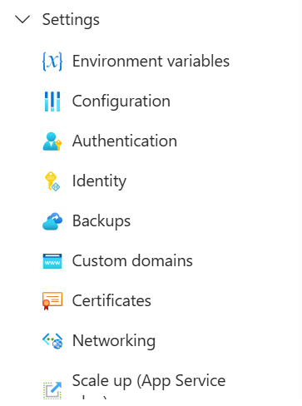

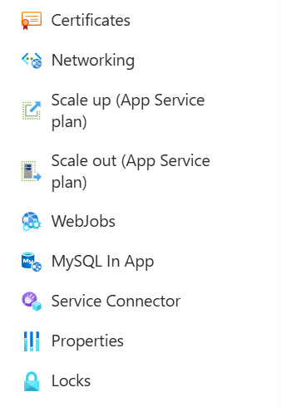

In Azure App Service, "scale up" refers to increasing the resources available to a single App Service instance by upgrading to a more powerful plan, while "scale out" means adding more instances of your application to distribute the workload.

Scale Up (Vertical Scaling):

* **Definition:** You increase the resources (CPU, memory, storage) of a single App Service instance by changing to a higher pricing tier.
* **Benefit:** Provides a single, more powerful server for your application.
* **Use Cases:** Suitable for applications with bursty loads, or those that need to handle more data at once.
* **Example:** Moving from a "Basic" App Service plan to a "Standard" plan.

Scale Out (Horizontal Scaling):

* **Definition:**

You add more instances of your App Service application to handle the load across multiple servers.

* **Benefit:**

Distributes the load across multiple servers, improving scalability and availability.

* **Use Cases:**

Ideal for applications that handle a large volume of concurrent requests, or those that benefit from distributed processing.

* **Example:**

Running your application on multiple instances within a "Basic", "Standard", or "Premium" App Service plan, allowing you to handle more traffic without downtime.

Key Differences:

|  |  |  |
| --- | --- | --- |
| **Feature** | **Scale Up (Vertical)** | **Scale Out (Horizontal)** |
| Action | Increase resources on a single instance | Add more instances |
| Resource Use | Single server | Multiple servers |
| Ideal for | Single-server workloads, bursty loads | Parallel tasks, high traffic |
| Scalability | Limited by single-server capacity | Can scale indefinitely |
| Complexity | Simpler to manage | Requires more management |
| Cost | Higher upfront costs for powerful servers | Can be more cost-effective |

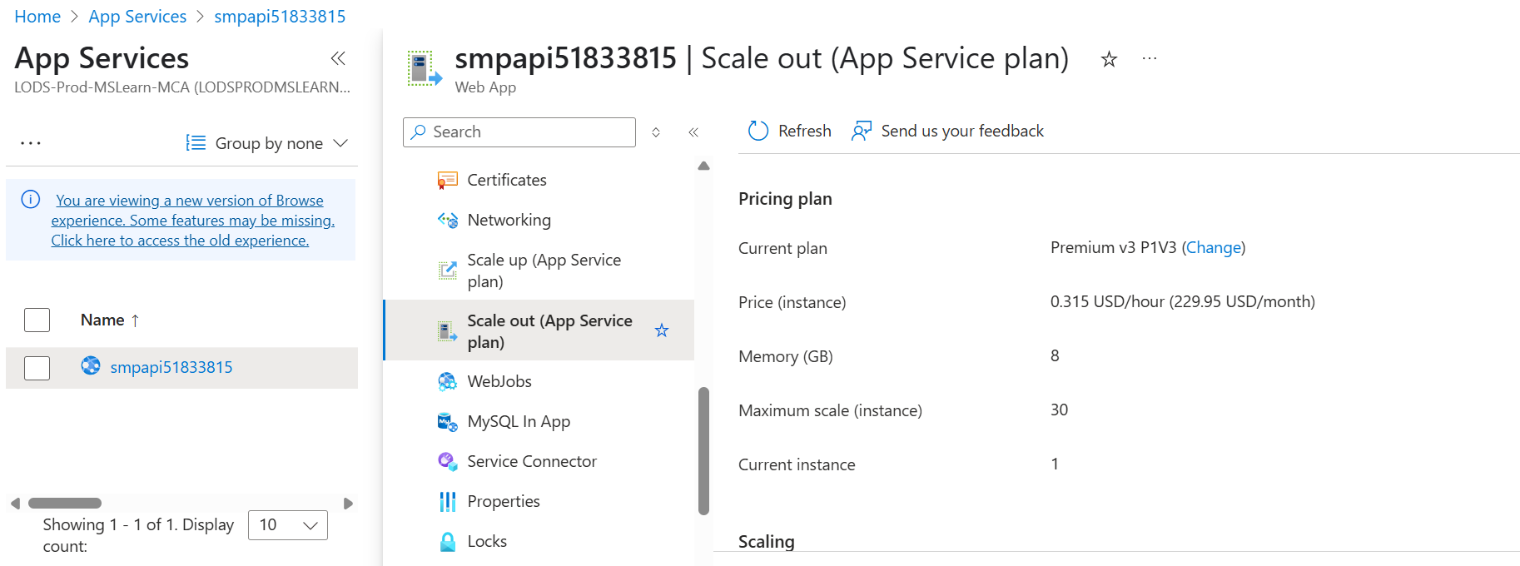

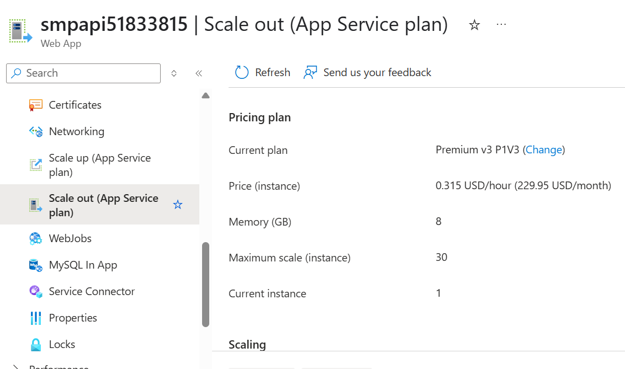

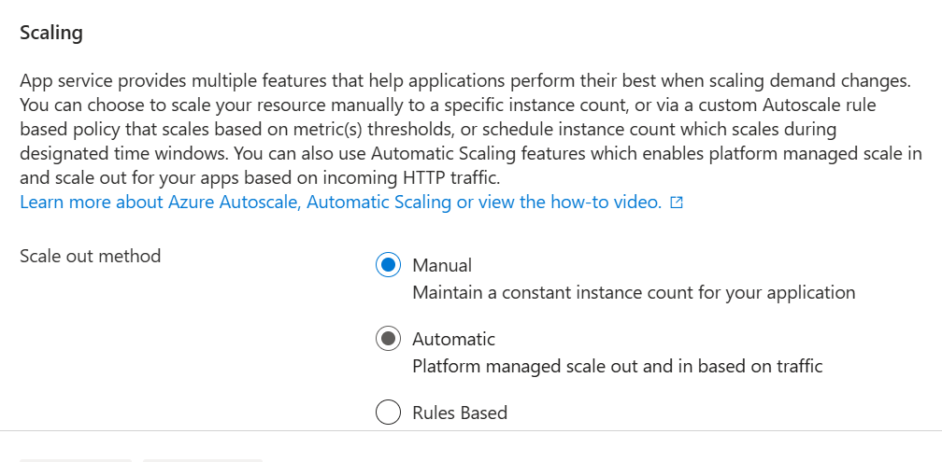

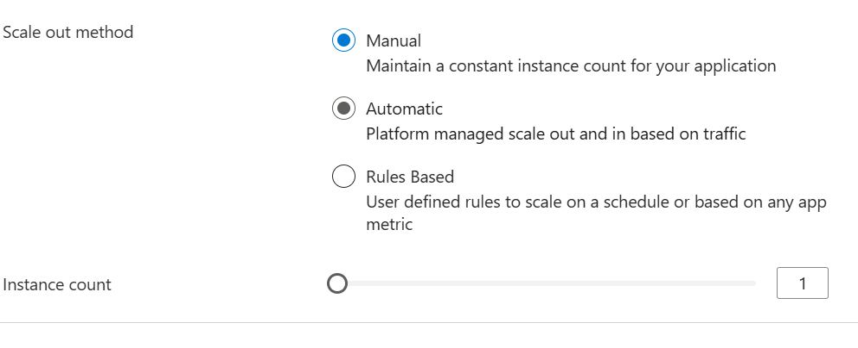

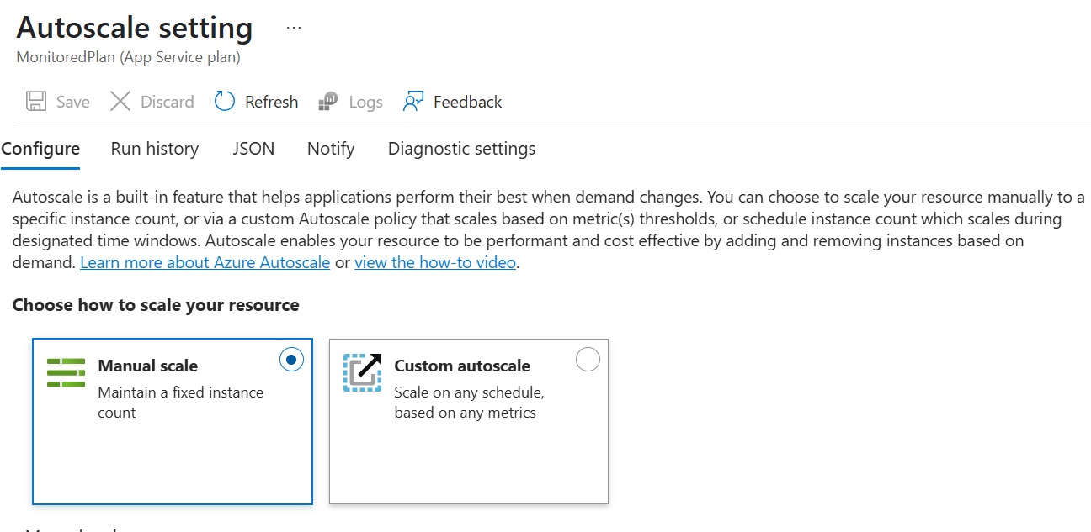

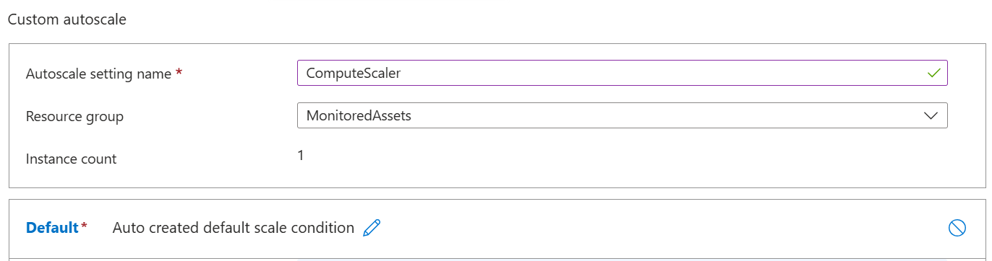

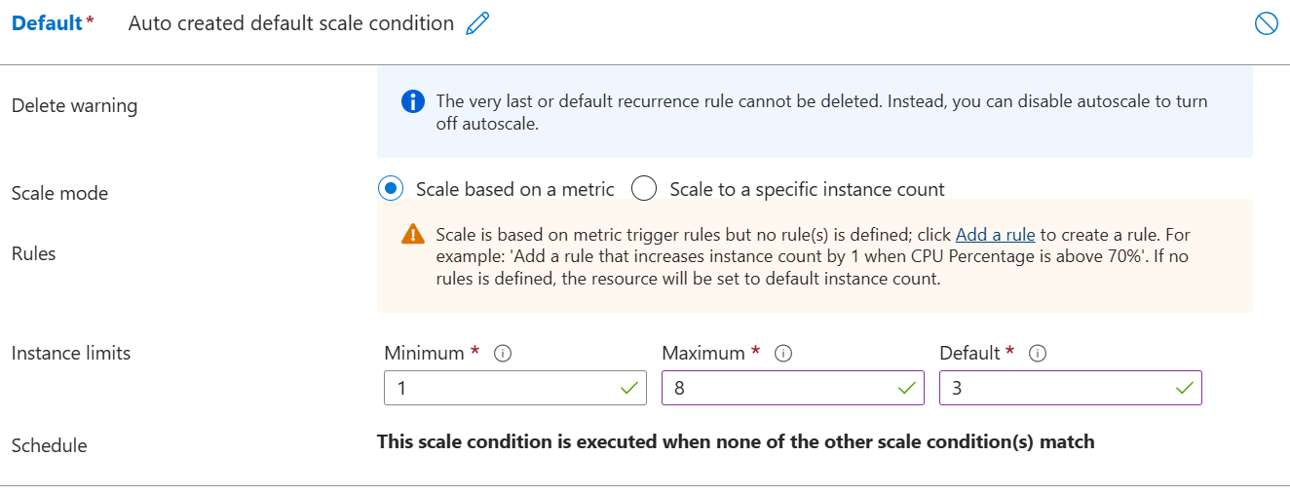

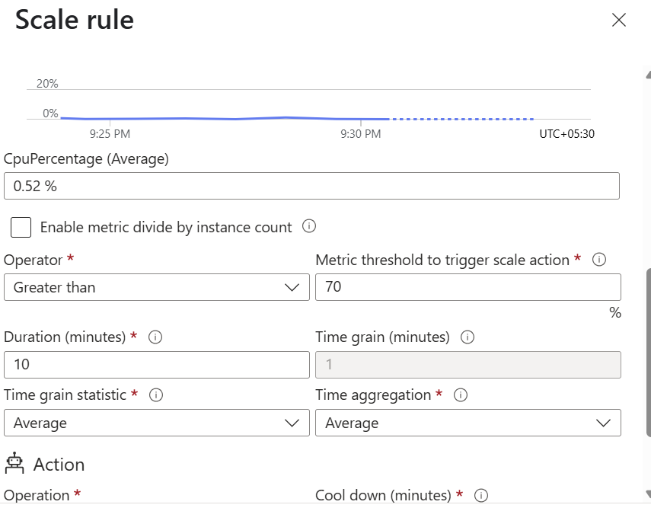

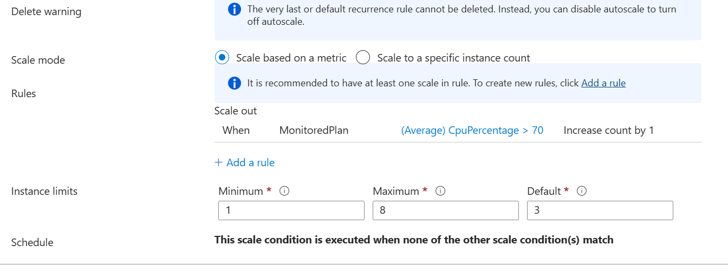

dotnet new webapi --output . --name SimpleApi --framework net8.0

dotnet add package Microsoft.ApplicationInsights --version 2.21.0

dotnet add package Microsoft.ApplicationInsights.AspNetCore --version 2.21.0

dotnet add package Microsoft.ApplicationInsights.PerfCounterCollector --version 2.21.0

dotnet add package Microsoft.ApplicationInsights.Profiler.AspNetCore --version 2.4.0

dotnet publish -c Release -r win-x86 --self-contained -p:PublishReadyToRun=true .\SimpleApi.csproj

cd C:\Allfiles\Labs\11\Starter\Api\bin\Release\net8.0\win-x86\publish\

Compress-Archive -Path * -DestinationPath api.zip

Install-Module Az

Install-Module -Name Az -AllowClobber -Scope CurrentUser

Import-Module Az

Get-AzWebApp -ResourceGroupName MonitoredAssets

Get-AzWebApp -ResourceGroupName MonitoredAssets | Where-Object {$_.Name -like 'smpapi*'}

Get-AzWebApp -ResourceGroupName MonitoredAssets | Where-Object {$_.Name -like 'smpapi*'} | Select-Object -ExpandProperty Name

$webAppName = (Get-AzWebApp -ResourceGroupName MonitoredAssets | Where-Object {$_.Name -like 'smpapi*'})[0] | Select-Object -ExpandProperty Name

Publish-AzWebApp -ResourceGroupName MonitoredAssets -Name $webAppName -ArchivePath "C:\Allfiles\Labs\11\Starter\Api\bin\Release\net8.0\win-x86\publish\api.zip" -force

Publish-AzWebApp -ResourceGroupName MonitoredAssets -Name $webAppName -ArchivePath " C:\Users\mgcli\Milan\Azure\AppInsights\API\bin\Release\net8.0\win-x86\publish\api.zip" -force

