AZ-400: Designing and Implementing Microsoft DevOps Solutions –40+18%gst

<https://www.cloudthat.com/training/devops/az-400-designing-and-implementing-microsoft-devops-solutions>

AZ-2001: Implement security through a pipeline using Azure DevOps – 20+18%GST

AZ-1001: Deploy an Azure Kubernetes Service cluster - ₹14900 + 18% GST

Certified Kubernetes Application Developer (CKAD) Certification Training --Associate



Kubernetes Essentials --Fundamentals

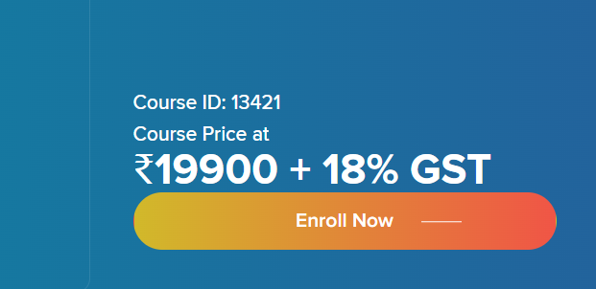

AZ-020T00-A: Microsoft Azure Solutions for AWS Developers Course Overview

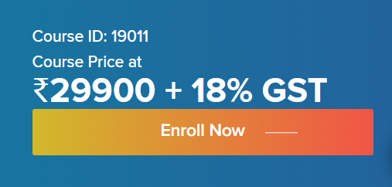

AWS Certified Developer Associate (Developing on AWS)

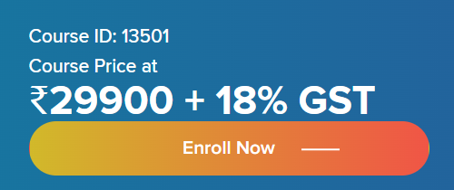

Architecting on AWS (AWS Certified Solutions Architect – Associate)

AZ-303: Microsoft Azure Architect Technologies

<https://www.cloudthat.com/training/azure/az-303-microsoft-azure-architect-technologies>

<https://www.cloudthat.com/training/aws/aws-certified-developer-associate-developing-on-aws>

<https://www.cloudthat.com/training/aws/architecting-on-aws-aws-certified-solutions-architect-associate>

<https://www.cloudthat.com/training/azure/az-020t00-a-microsoft-azure-solutions-for-aws-developers>

<https://www.cloudthat.com/training/devops/certified-kubernetes-application-developer-ckad-certification-training>

AZ-020T00-A: Microsoft Azure Solutions for AWS Developers Course Overview 🡪Very very important

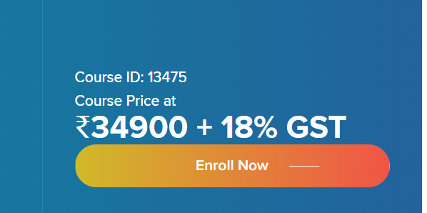

<https://www.cloudthat.com/training/azure/az-020t00-a-microsoft-azure-solutions-for-aws-developers>

AZ-500: Microsoft Azure Security Technologies

<https://www.cloudthat.com/training/azure/az-500-microsoft-azure-security-technologies>

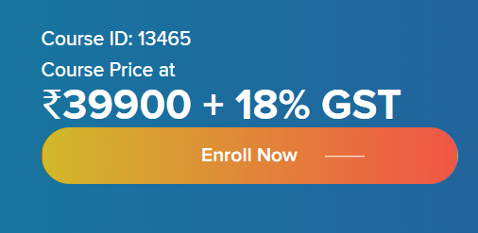

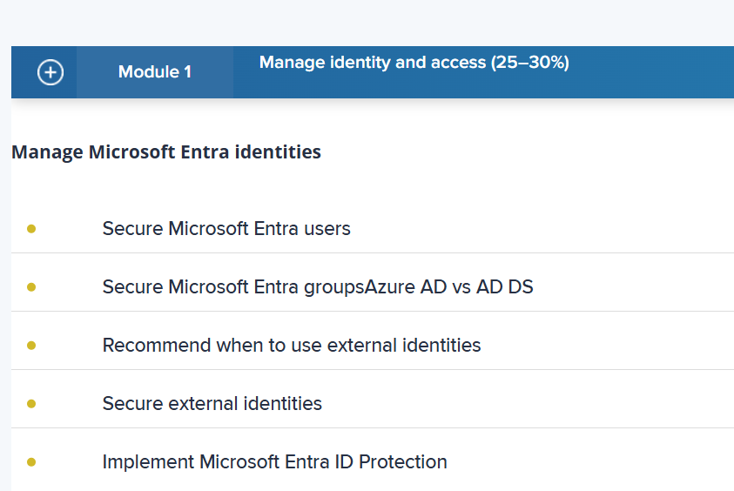

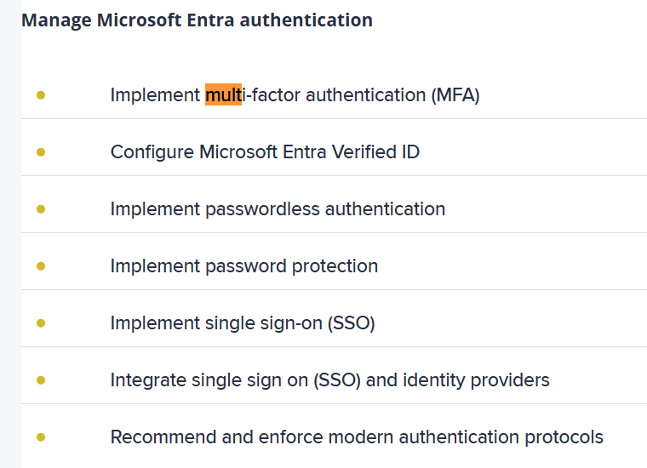

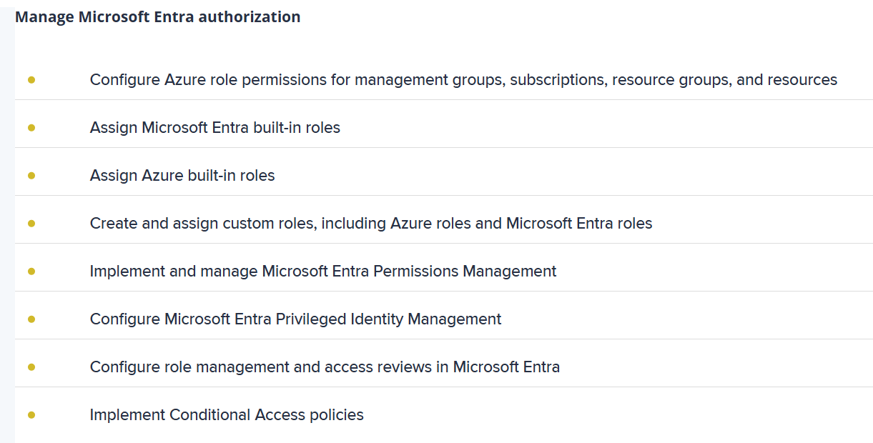

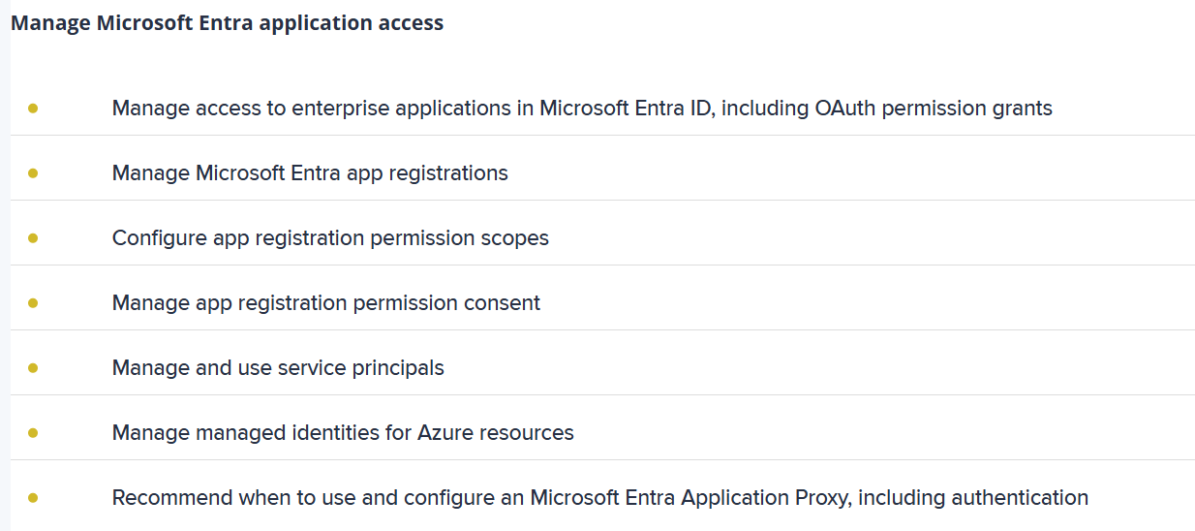

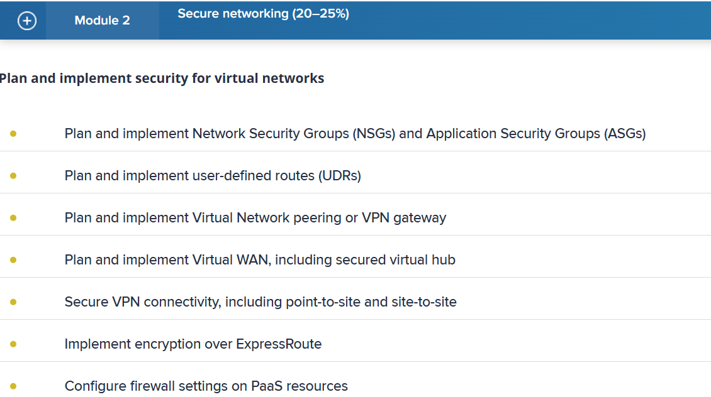

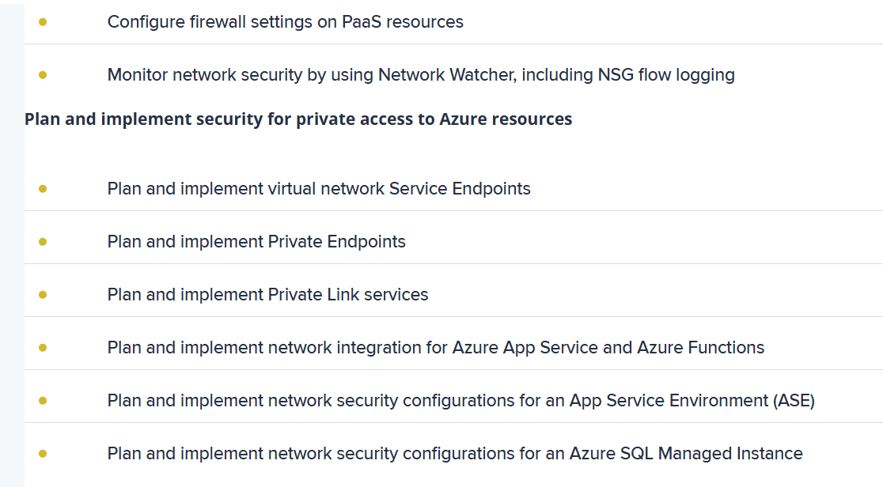

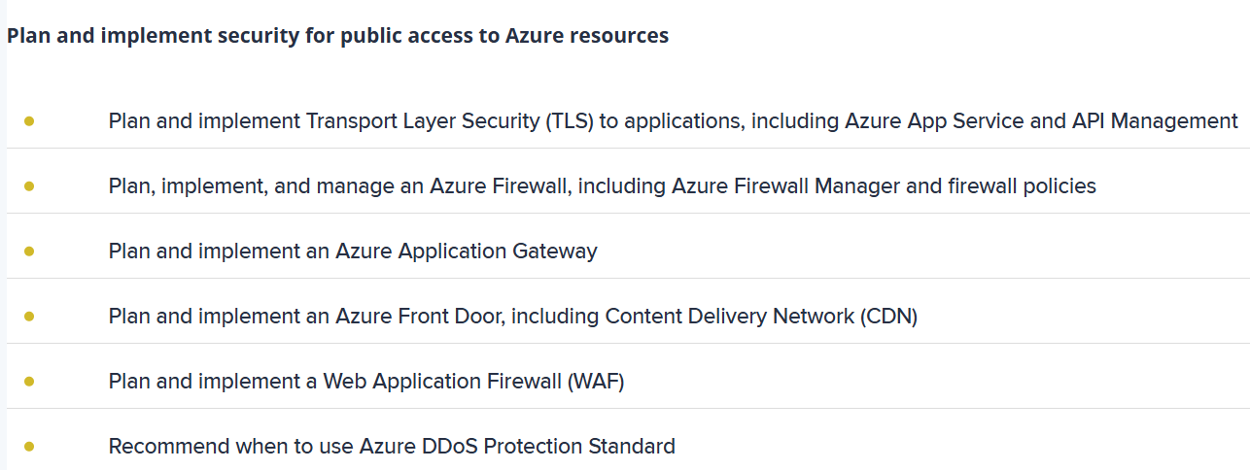

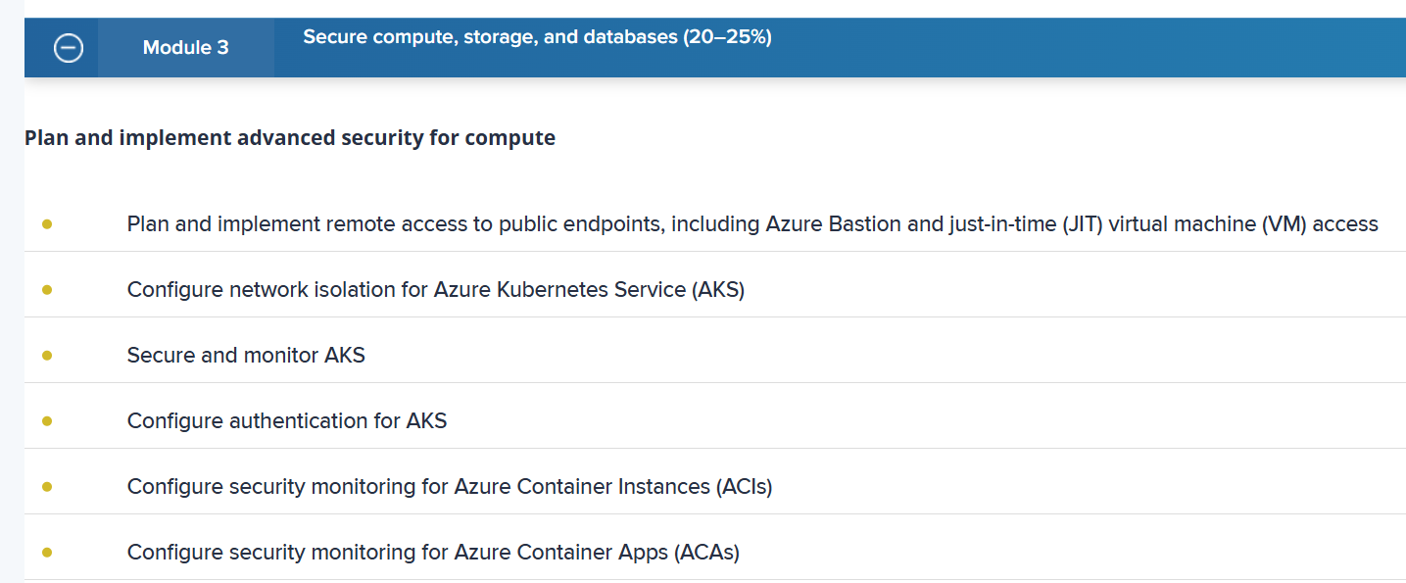

55-sbi

26 – ICICI

30 – hdfc

Total - 111