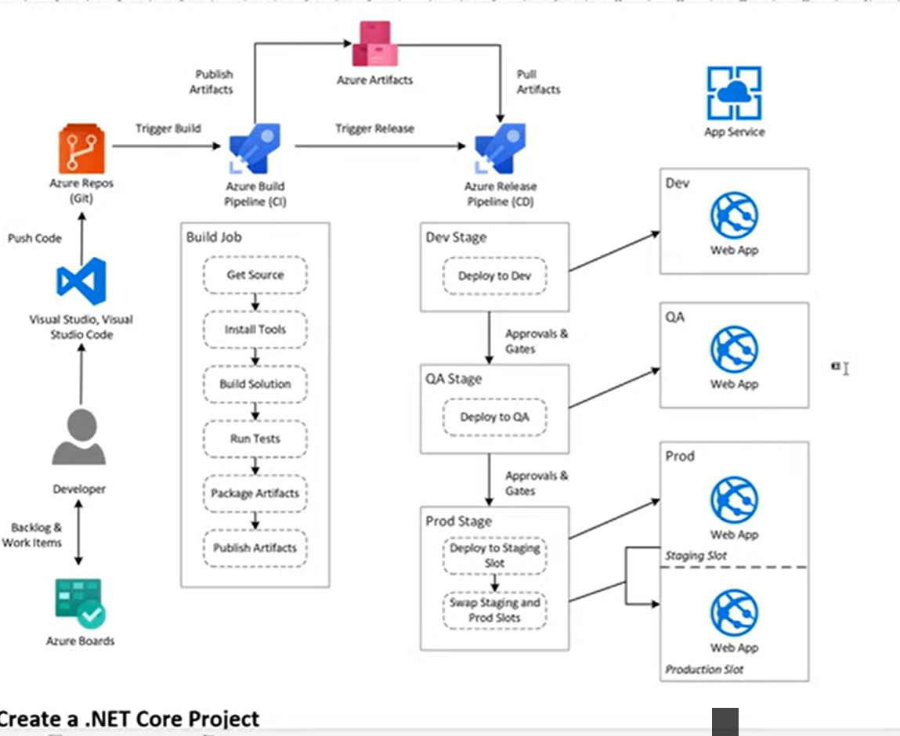

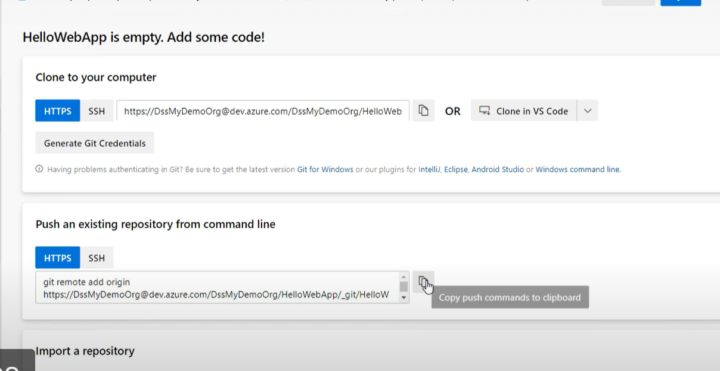

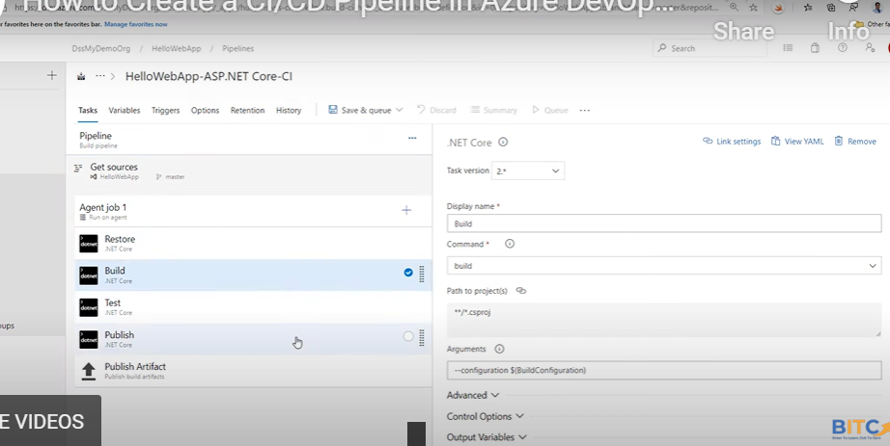

<https://www.geeksforgeeks.org/what-is-git-init/>

admin@DesignPattern382.onmicrosoft.com

**What is Git Init?**

[**https://dev.azure.com/milanmcas/_git/AzureWebAPI**](https://dev.azure.com/milanmcas/_git/AzureWebAPI)

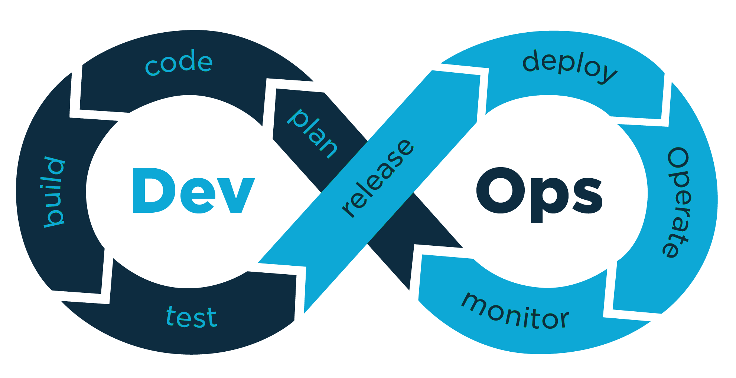

# ASP.NET Core

# Build and test ASP.NET Core projects targeting .NET Core.

# Add steps that run tests, create a NuGet package, deploy, and more:

# https://docs.microsoft.com/azure/devops/pipelines/languages/dotnet-core

trigger:

- master

pool:

  vmImage: ubuntu-latest

variables:

  buildConfiguration: 'Release'

steps:

- script: dotnet build --configuration $(buildConfiguration)

  displayName: 'dotnet build $(buildConfiguration)'

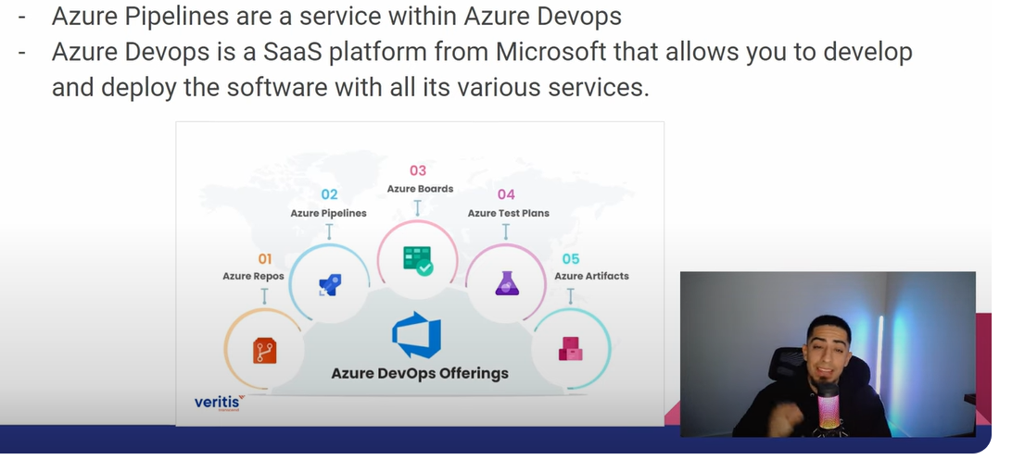

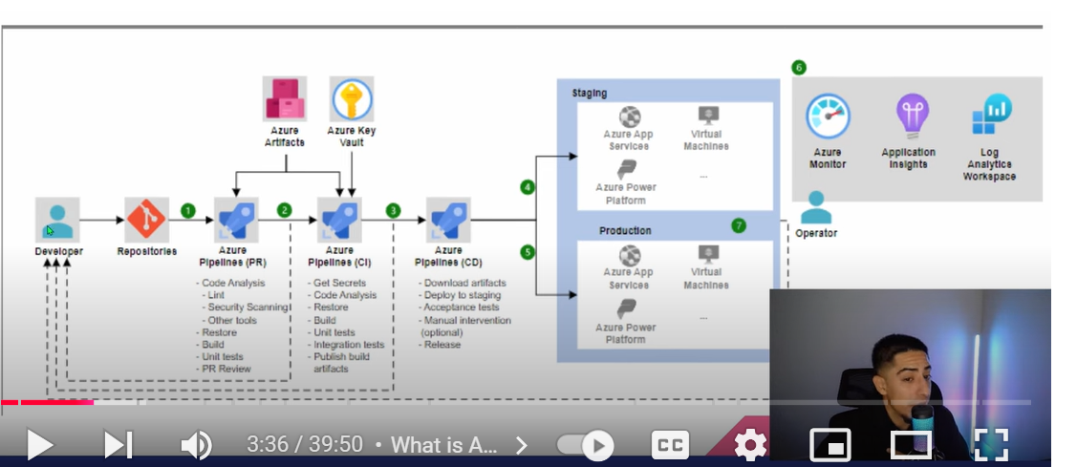

**Blue-Green Deployment:**Blue-Green Deployment is a deployment strategy that involves deploying two identical environments, one with the current version of the application (Blue) and another with the new version of the application (Green). Once the new version of the application is tested and validated, traffic is redirected to the Green environment, and the Blue environment is decommissioned.

Blue-Green Deployment is an excellent choice for teams that need to deploy new features without any downtime. It allows you to test the new version of the application thoroughly before deploying it to production. However, this strategy requires additional infrastructure and resources to maintain two environments simultaneously.

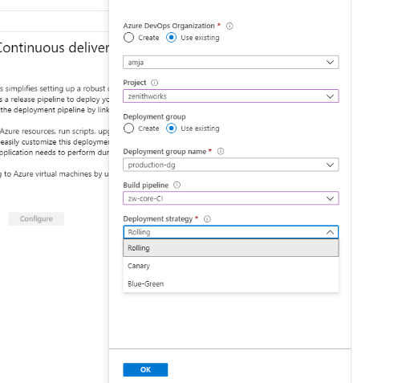

Rolling Update is a deployment strategy that incrementally updates an application or system to a new version with minimal downtime. It works by replacing instances of the old version with instances of the new version one-by-one, rather than stopping the entire system at once.

During a Rolling Update, the system will have a mix of old and new versions running at the same time. The instances running the new version are brought up and tested before moving onto the next set of instances. If issues are detected, the deployment can be rolled back. This minimizes downtime and risk compared to stopping everything at once for an update.

For example, a Rolling Update could be used to deploy a new software version to a cluster of web servers. The update would start by deploying the new code to a few servers. After testing that these new servers work properly, the update would continue to roll out to more servers in batches. Traffic is shifted from old to new servers as the rollout progresses. The update completes when all old servers have been updated. If something goes wrong, the rollback happens one batch at a time.

**Canary Deployment**Canary Deployment is a phased rollout strategy where a new version is released to a subset of users or servers before being made available to everyone. This approach allows early detection of potential issues and mitigates risks by limiting the blast radius of the deployment.

