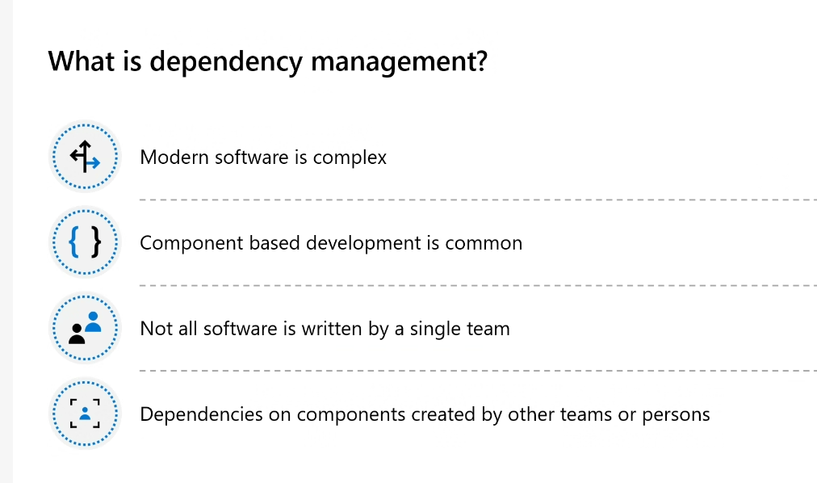

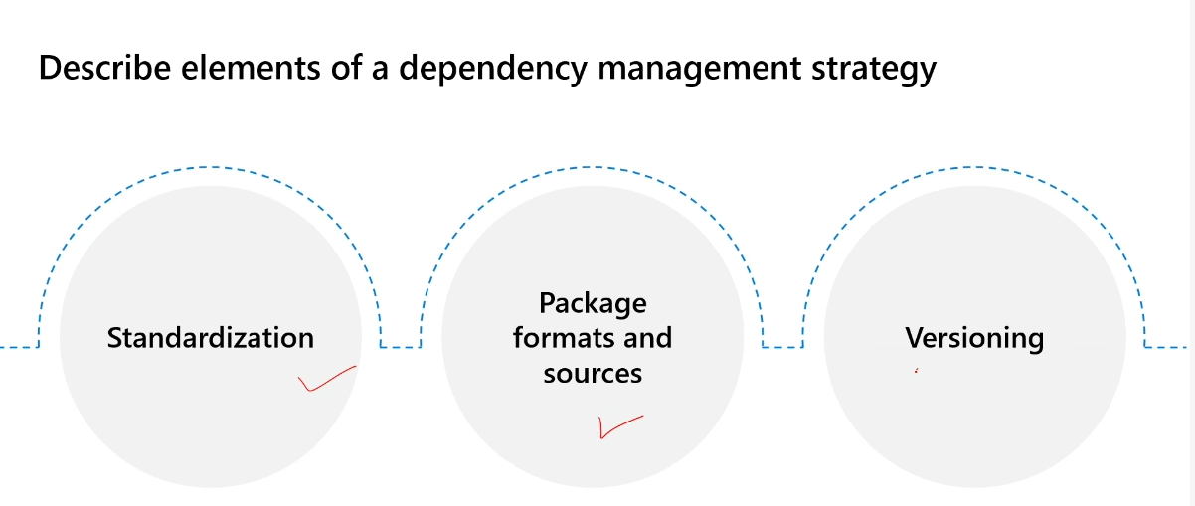

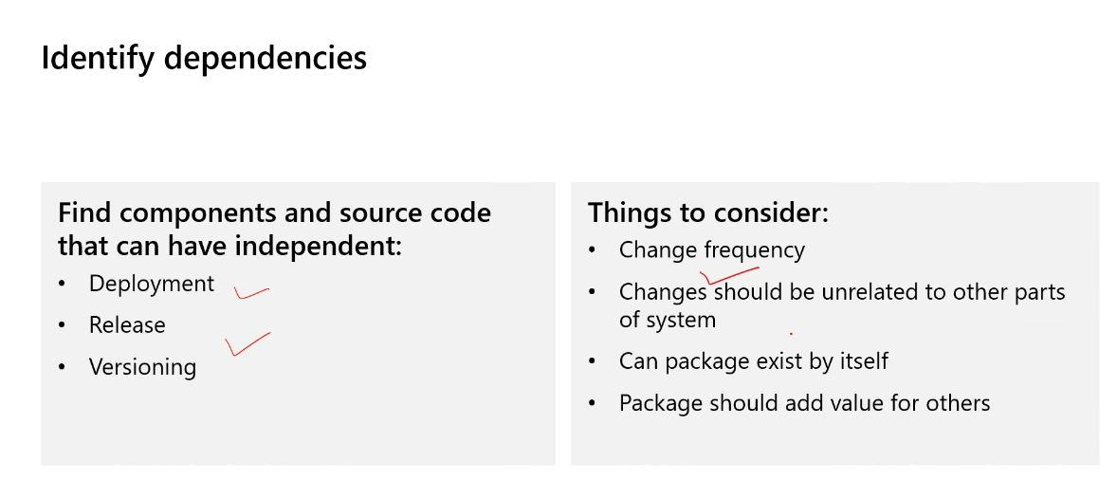

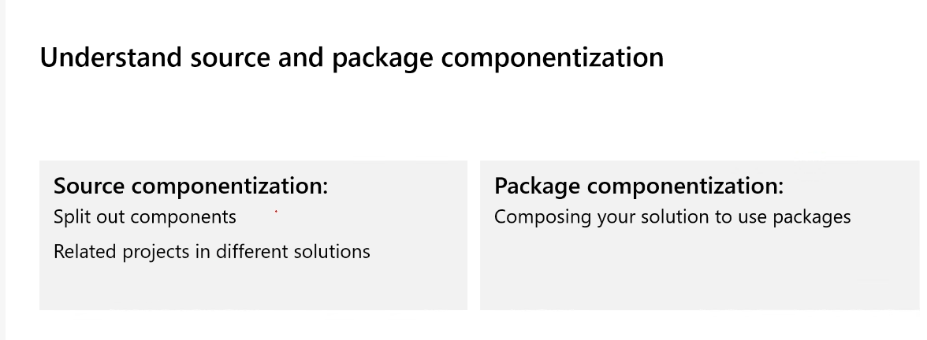

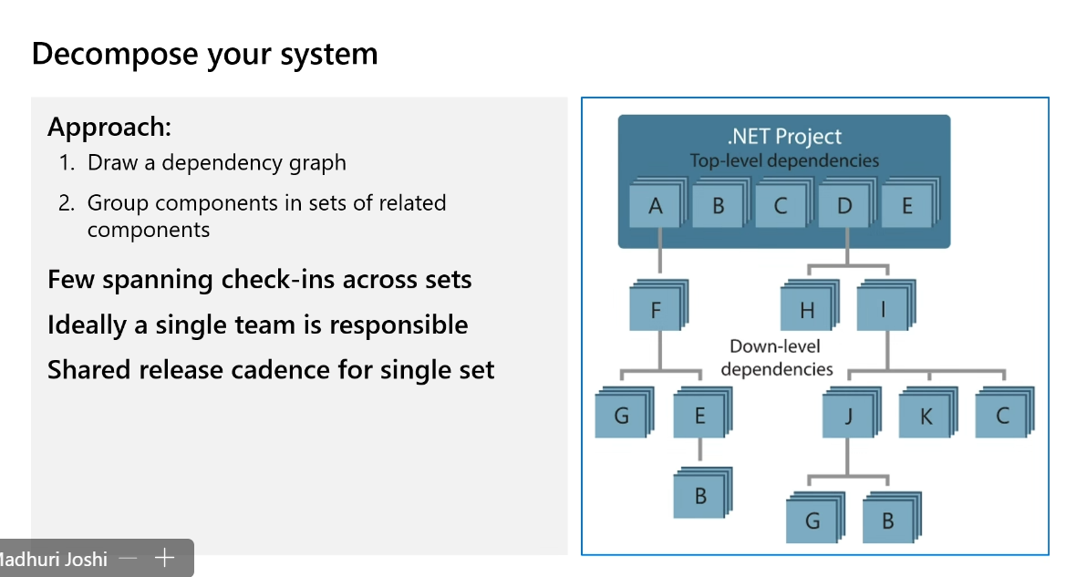

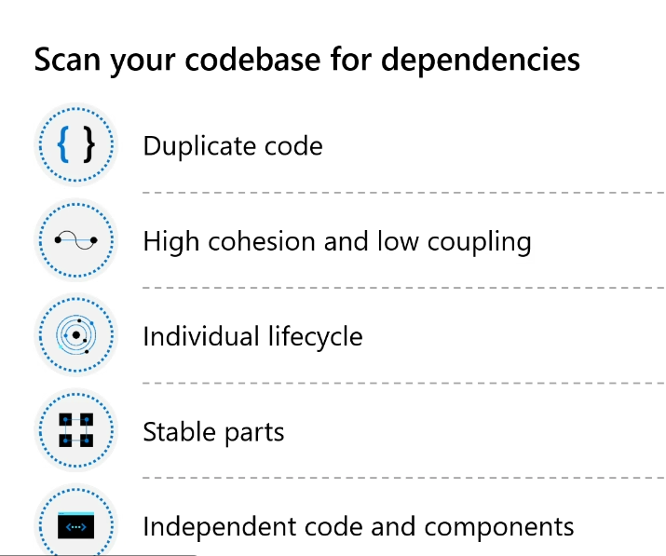

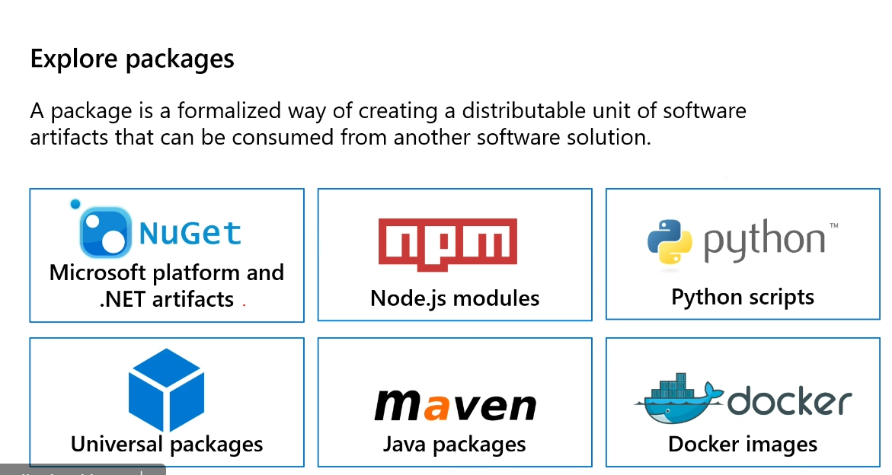

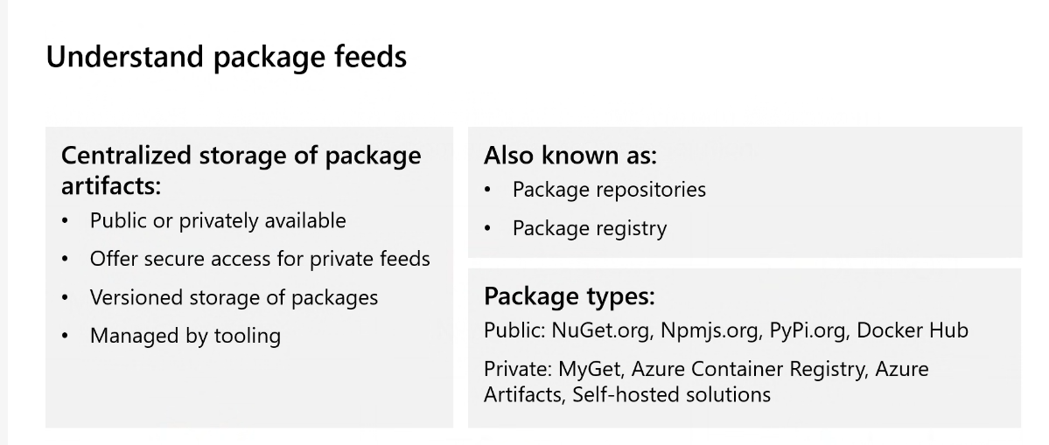

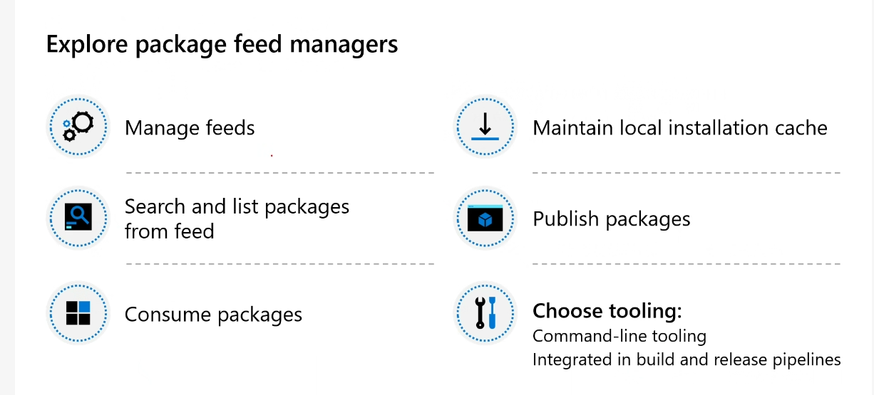

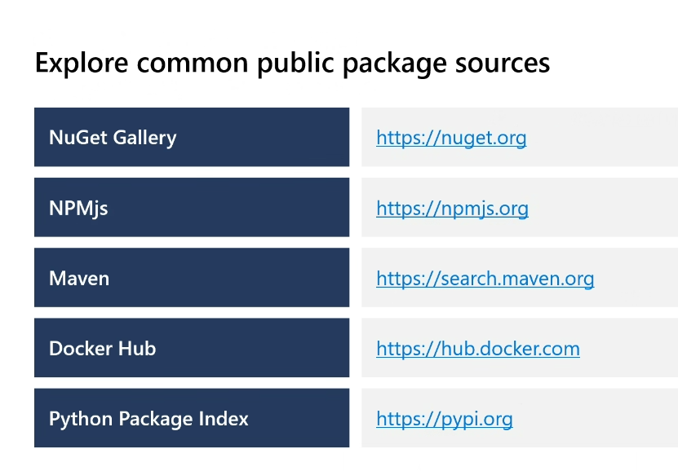

[https://pypi.org](https://pypi.org/)

PyPI · The Python Package Index

The Python Package Index (PyPI) is a repository of software for the Python programming language.

[https://hub.docker.com](https://hub.docker.com/)

Docker Hub Container Image Library | App Containerization

Welcome to the world's largest container registry built for developers and open source contributors to find, use, and share their container images. Build, push and pull.

[https://search.maven.org](https://search.maven.org/)

Maven Central Repository Search

Official search by the maintainers of Maven Central Repository

<https://npmjs.org>

<https://nuget.org>

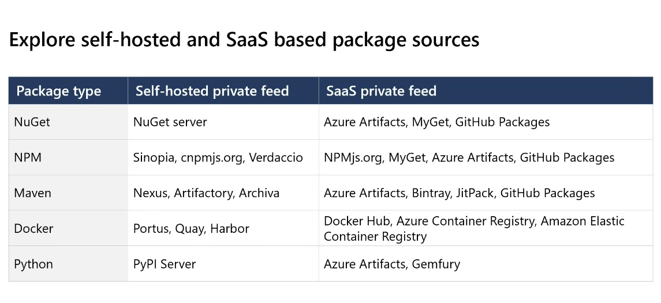

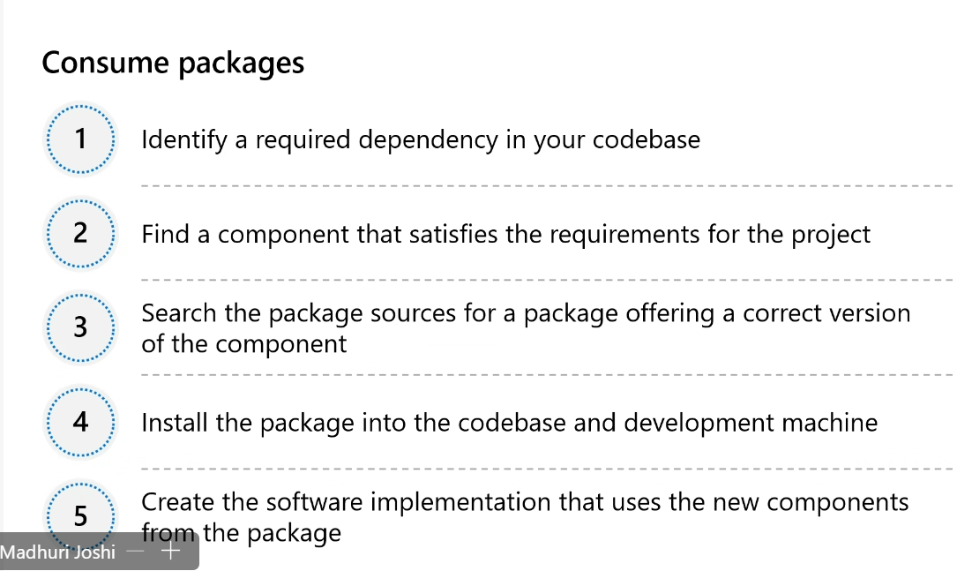

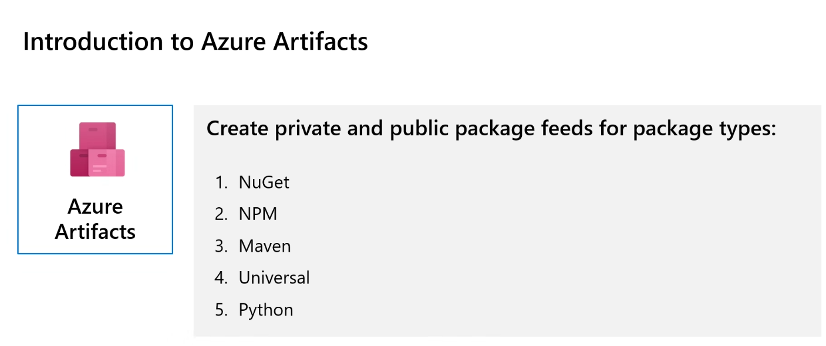

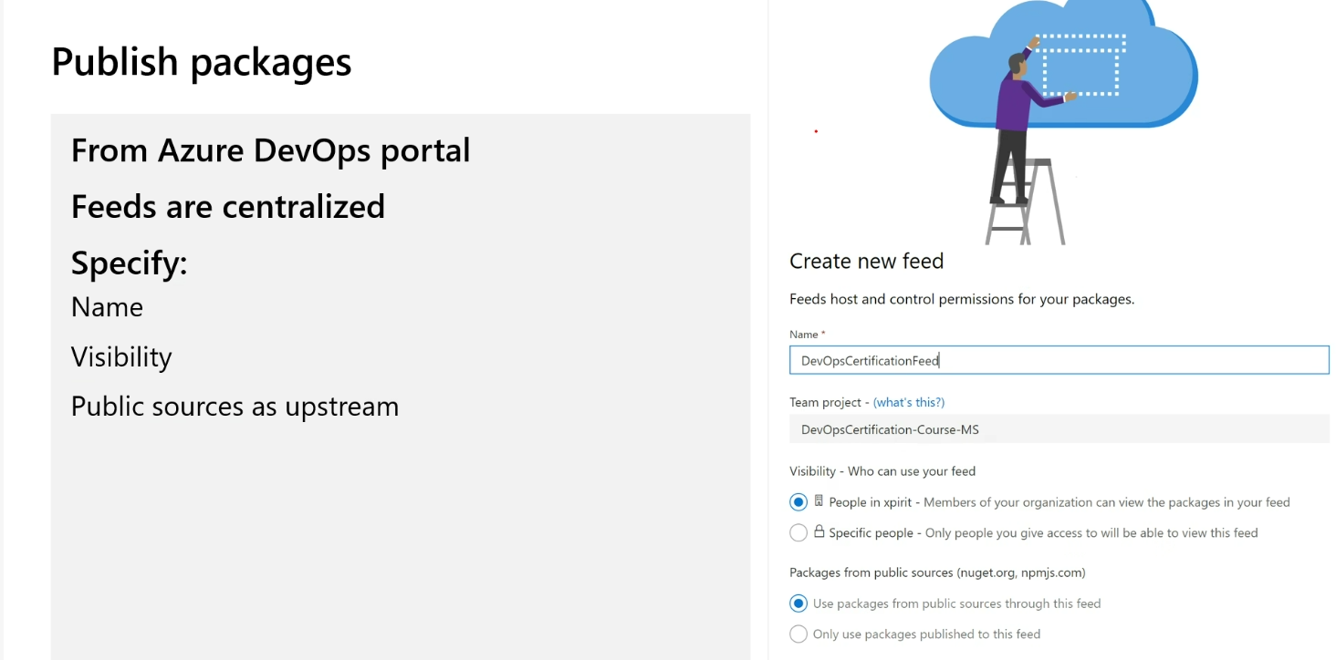

dotnet pack .\eshoponweb.csproj  
 nuget.exe push -Source "demomj" -ApiKey az .\bin\Release\eshoponweb.1.0.0.nupkg

dotnet pack .\eshoponweb.csproj  
 nuget.exe push -Source "demomj" -ApiKey az .\bin\Release\eshoponweb.1.0.0.nupkg

<https://www.metricsthatmatter.com/url/u.aspx?F53B67125225078109>

crnekzltzde7yfk

4xb8DJBj/2oQe1zp0xPi3GF3W8Mza5zyKx9Dg+qmRj+ACRBrSfQV

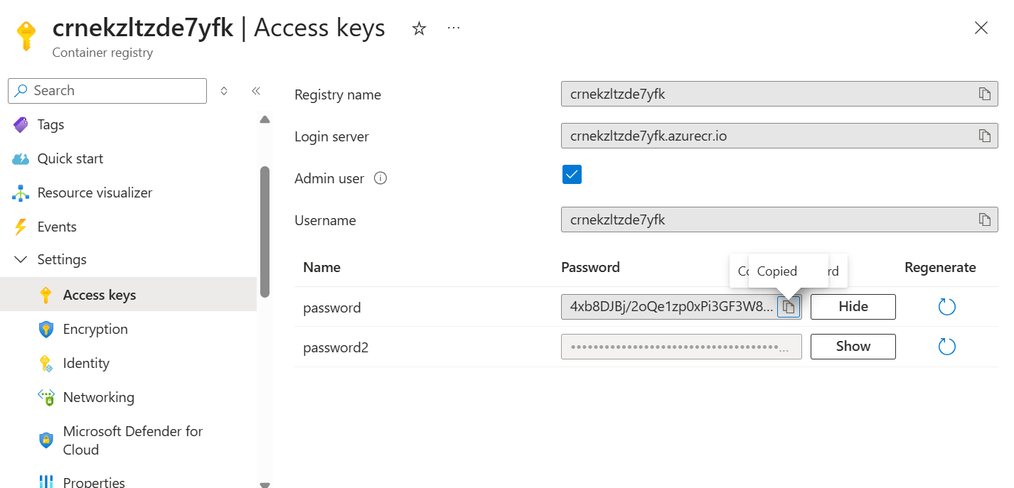

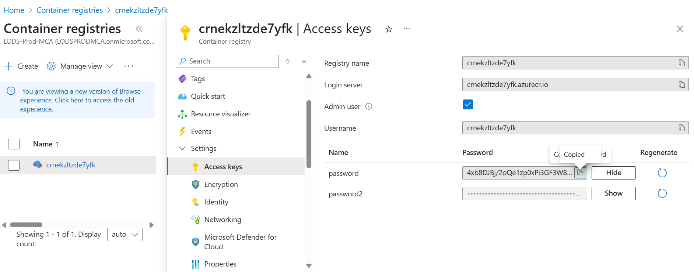

ipAddress: {

type: 'Public'

dnsNameLabel: toLower('${name}-dns') // Must be unique in the region

ports: [

{

port: port

protocol: 'TCP'

}

{

port: 80

protocol: 'TCP'

}

]

}

This will generate a FQDN like:

perl

Copy

Edit

http://${name}-dns.<region>.azurecontainer.io

<https://github.com/MicrosoftLearning/eShopOnWeb.git>

User1-53501770@LODSPRODMCA.onmicrosoft.com

GAp40@g!eD!q

eShopOnWebShared53501770

eShopOnWeb.Shared53501770

dotnet pack .\eShopOnWeb.Shared53501770.csproj -p:PackageId=eShopOnWeb-milanpriya.Shared

dotnet nuget push --source "https://pkgs.dev.azure.com/ ADOCourseOrg01/_packaging/eShopOnWebShared/nuget/v3/index.json" --api-key az "eShopOnWeb-milanpriya.Shared.1.0.0.nupkg"

<https://pkgs.dev.azure.com/Azure-DevOps-Org-Name/_packaging/eShopOnWebShared/nuget/v3/index.json>

<https://pkgs.dev.azure.com/ADOCourseOrg01/eShopOnWeb-53501770/_packaging/eShopOnWebShared53501770/nuget/v3/index.json>

dotnet nuget add source https://pkgs.dev.azure.com/ADOCourseOrg01/_packaging/eShopOnWebShared/nuget/v3/index.json --name eShopOnWebShared --username User1-53501770@LODSPRODMCA.onmicrosoft.com --password GAp40@g!eD!q --store-password-in-clear-text

dotnet nuget push --source "https://pkgs.dev.azure.com/ADOCourseOrg01/_packaging/eShopOnWebShared/nuget/v3/index.json" --api-key az "eShopOnWeb-milanpriya.Shared.1.0.0.nupkg"

dotnet nuget add source https://pkgs.dev.azure.com/ADOCourseOrg01/_packaging/eShopOnWebShared/nuget/v3/index.json --name eShopOnWebShared --username User1-53501770@LODSPRODMCA.onmicrosoft.com --password GAp40@g!eD!q --store-password-in-clear-text

dotnet nuget push --source "https://pkgs.dev.azure.com/ADOCourseOrg01/eShopOnWeb-53501770/_packaging/eShopOnWebShared53501770/nuget/v3/index.json" --api-key az "eShopOnWeb-milanpriya.Shared.1.0.0.nupkg"

[madhuri.j@cloudthat.com](mailto:madhuri.j@cloudthat.com)