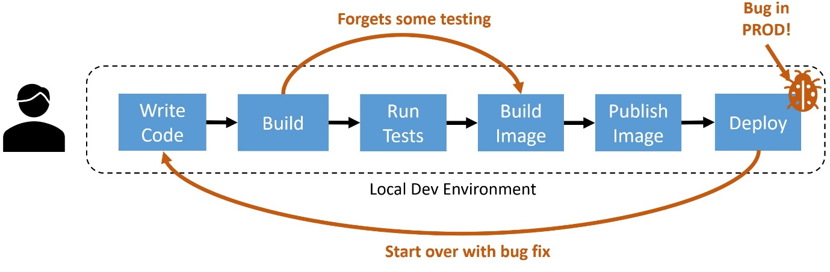

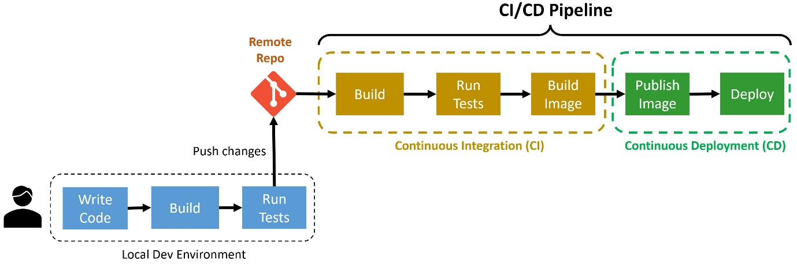

A quick explanation of what you got there:

* **trigger**: This is the event that will trigger the pipeline. In this case, it’s set to trigger on any push to the main branch.
* **pool**: A pool is a collection of agents that can run your pipeline tasks. In this case, it’s set to use agents based on the latest Ubuntu version in the hosted pool provided by Azure Pipelines.
* **variables**: This is where you can define variables that will be used across the pipeline. The build configuration is defined as a variable by default.
* **steps**: This is where you define the steps that will be run in the pipeline. By default, you get a single script step that builds your application in the Release configuration.