🛠️ Phase 1 – Pre-Requisites
- Install Tools
  - Node.js (v18+ recommended).
  - PostgreSQL + pgAdmin for DB management.
  - VS Code for coding.
  - Git + GitHub CLI for version control.
- Knowledge Prep
  - JavaScript ES6+ basics (async/await, modules).
  - SQL basics (tables, joins, CRUD).
  - REST API concepts.
📂 Phase 2 – Backend Setup (Node.js + Express + PostgreSQL)
1. Initialize Project
1. create project folder.
2.Open project folder in vs code & goto Terminal window. Run following command
mkdir effortsengineers-backend && cd effortsengineers-backend
npm init -y
npm install express pg cors body-parser nodemon
2. Project Structure
effortsengineers-backend/
├── server.js
├── config/db.js
├── routes/
│ ├── catalog.js
│ ├── quotation.js
│ └── clients.js
├── controllers/
│ ├── catalogController.js
│ ├── quotationController.js
│ └── clientController.js
├── models/
│ ├── catalogModel.js
│ ├── quotationModel.js
│ └── clientModel.js
└── utils/pdfGenerator.js

Create it using setup.sh or generateStructure.js

3. Database Schema (PostgreSQL)

CREATE TABLE catalog (
id SERIAL PRIMARY KEY,
name VARCHAR(100),
category VARCHAR(50),
price NUMERIC(10,2),
stock INT
);

CREATE TABLE clients (
id SERIAL PRIMARY KEY,
name VARCHAR(100),
email VARCHAR(100),
phone VARCHAR(20)
);

CREATE TABLE quotations (
id SERIAL PRIMARY KEY,
client_id INT REFERENCES clients(id),
items JSONB,
total NUMERIC(10,2),
status VARCHAR(20)
);
4. Example API (Catalog)
js
// routes/catalog.js
const express = require('express');
const router = express.Router();
const pool = require('../config/db');

router.get('/', async (req, res) => {
const result = await pool.query('SELECT * FROM catalog');
res.json(result.rows);
});

router.post('/', async (req, res) => {
const { name, category, price, stock } = req.body;
const result = await pool.query(
'INSERT INTO catalog (name, category, price, stock) VALUES ($1,$2,$3,$4) RETURNING *',
[name, category, price, stock]
);
res.json(result.rows[0]);
});

module.exports = router;
🎨 Phase 3 – Frontend Setup
Option A: Modernize Existing HTML
- Keep current HTML pages.
- Add Bootstrap/Tailwind for responsive design.
- Use Fetch/AJAX to call backend APIs.
Option B: React Frontend
bash
npx create-react-app effortsengineers-frontend
cd effortsengineers-frontend
npm install axios bootstrap react-router-dom chart.js
- Pages: Catalog, Clients, Quotations, Dashboard.
- Components: Forms, Tables, Charts.
- Connect to backend APIs with Axios.
⚙️ Phase 4 – Feature Add-Ons
- Quotation Generator → PDF via pdfkit or puppeteer.
- Client Portal → JWT authentication (jsonwebtoken, bcrypt).
- SEO Tools → Server-side rendering or Next.js frontend.
- Future Add-Ons → Chatbot (OpenAI API), Payment Gateway (Stripe/Razorpay).
🚀 Phase 5 – Deployment
- Backend → GoDaddy VPS, AWS EC2, or Azure App Service.
- Frontend → Netlify/Vercel or serve via Express.
- Domain → point effortsengineers.in to new stack.
- CI/CD → GitHub Actions for auto-deploy.
📈 Phase 6 – Roadmap
- Month 1–2: Backend APIs + DB schema.
- Month 3: Frontend integration.
- Month 4: Automation (PDF/email).
- Month 5: Deployment + CI/CD.
- Month 6: AI chatbot + analytics dashboard.

# Efforts Engineers Platform ## 📌 Overview Efforts Engineers is a modernized web platform designed to serve both: - **Clients** → Browse product catalog, request quotations, access client dashboard. - **Admins** → Manage orders, inventory, and forecasting dashboards. **Tech Stack:** Node.js + Express + PostgreSQL + React what about this overview in readme.md file
Perfect addition, Milan — that overview section fits beautifully at the top of your README.md. It gives readers immediate context before they dive into the phase-wise documentation.
Here’s how your final README.md should look with the overview integrated:
📄 README.md
markdown
# Efforts Engineers Platform

## 📌 Overview
Efforts Engineers is a modernized web platform designed to serve both:
- **Clients** → Browse product catalog, request quotations, access client dashboard.
- **Admins** → Manage orders, inventory, and forecasting dashboards.

**Tech Stack:** Node.js + Express + PostgreSQL + React

---

## 📘 Documentation Index

| Phase | Title | Description |
|-------|--------|-------------|
| [Phase 1](docs/phase1.md) | Project Initialization | Folder structure, environment setup, and toolkit overview |
| [Phase 2](docs/phase2.md) | Backend Setup | Node.js + Express + PostgreSQL configuration |
| [Phase 3](docs/phase3.md) | Frontend Setup | React app creation, API integration, and testing |
| [Phase 4](docs/phase4.md) | Integration & Role Management | JWT authentication, role-based access, API + Chart.js integration |
| [Phase 5](docs/phase5.md) | Deployment | Backend, frontend, and database deployment strategy |
| [Phase 6](docs/phase6.md) | Documentation & Team Visibility | API mapping, workflow, architecture diagram, and templates |

---

## 🧩 Architecture Overview
Refer to `docs/architecture.png` for the system flow:
**Client Portal ↔ Admin Dashboard ↔ Node.js Backend ↔ PostgreSQL DB**

---

## 📸 Admin Dashboard Screenshot
A visual representation of the integrated dashboard (Orders, Inventory, Forecasting):
![Admin Dashboard](docs/admin-dashboard.png)

---

## 🧠 Toolkit Summary
- **GitHub Copilot + Copilot Chat** → daily coding assistance
- **Claude Dev** → reasoning-heavy QA test generation
- **Gemini Pro** → backend and frontend QA automation workflows
- **Codex API** → experimental automation agents

---

## ✅ Summary
This documentation ensures:
- Automated backend structure creation
- Clean PostgreSQL schema
- Dual-role React frontend
- Secure role-based APIs
- Clear diagrams and templates for team visibility
✅ This version gives your README a professional, project-ready introduction — the overview immediately explains the platform’s purpose and audience, while the rest of the file guides developers through every phase.
👉 If you’d like, I can now help you draft the architecture diagram spec (docs/architecture.png) to match the dashboard’s visual style — showing client, admin, backend, and database flow. Would you like me to prepare that next?
📸 Admin Dashboard Screenshot Spec - Do I need to create seperate file ?
You don’t need to create a separate file just for the 📸 Admin Dashboard Screenshot Spec, Milan.
Here’s the best practice:
- Keep the spec description (layout, sidebar, charts, etc.) inside your Phase 4 (phase4.md) file, right under the “📸 Dashboard Screenshot” heading. This way, developers and designers see both the code and the visual spec in one place.
- The actual .png file (docs/admin-dashboard.png) should live in your docs/ folder, alongside your other assets (like architecture.png).
- In your README.md, you only need to reference the image (e.g., ![Admin Dashboard](docs/admin-dashboard.png)), not the spec. The spec is more of an internal design guide for your team, so it belongs in the phase documentation.
Example in phase4.md
markdown
### 📸 Dashboard Screenshot
Refer to `docs/admin-dashboard.png` for a visual representation of how the charts appear together in the Admin Dashboard.

**Design Spec (for designer reference):**
- **Header:** “Admin Dashboard”
- **Sidebar:** Catalog, Orders, Inventory, Forecasting
- **Main Content:**
- 📦 Orders Overview → Bar chart (Orders Value)
- 📊 Inventory Levels → Bar chart (Stock Levels)
- 📈 Sales Forecast → Line chart (Sales Forecast)
- Layout: stacked vertically or 2×2 grid
- Style: light theme, clean sans-serif font, simple chart colors
✅ So to answer directly:
- No separate file needed — keep the spec inside phase4.md.
- Yes, separate image file needed — docs/admin-dashboard.png should be created/exported and stored in your repo.
👉 Do you want me to also prepare a similar spec for docs/architecture.png so your designer has clear instructions for the system flow diagram too?
where should I kept Supporting API service section in phase 4 Do you want me to also prepare a similar spec for docs/architecture.png yes also .png file
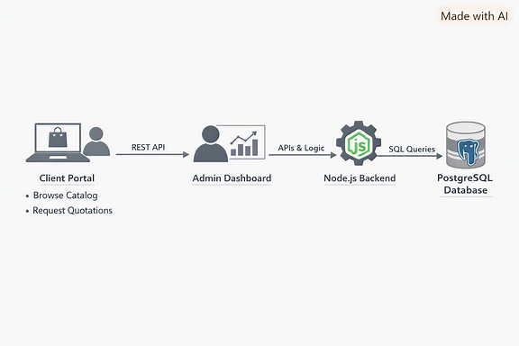
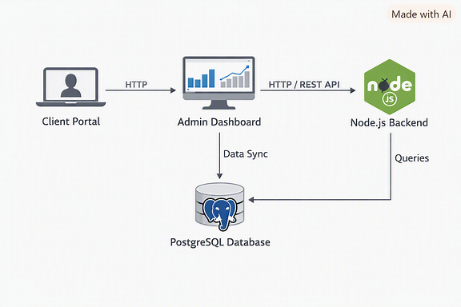
Here’s how you should organize things, Milan:
📂 Supporting API Service Placement
- Keep the Supporting API Service (src/services/api.js) section inside Phase 4 (phase4.md), right before the Admin Dashboard example.
- That way, the flow is logical:
  - Authentication
  - Role-based Middleware
  - API Integration (Catalog example)
  - Data Visualization (Chart.js examples)
  - 📂 Supporting API Service (Axios endpoints for Admin Dashboard)
  - Admin Dashboard (Combined Example + Screenshot reference)
This ensures your team sees the API service setup first, then how it’s used in the dashboard code.
📸 Architecture Diagram Spec (docs/architecture.png)
File: docs/architecture.png Format: PNG, 1920×1080 (landscape) Style: Clean system flow diagram, light theme, professional icons.
Layout
- Client Portal (left):
  - Icon: Laptop with user silhouette
  - Labels: Browse Catalog, Request Quotations
  - Arrow → Admin Dashboard (HTTP / REST API)
- Admin Dashboard (center):
  - Icon: Monitor with bar + line chart
  - Label: Admin Dashboard
  - Arrow → Node.js Backend (REST API)
  - Arrow ↓ PostgreSQL Database (Data Sync)
- Node.js Backend (right):
  - Icon: Node.js logo inside gear
  - Label: Node.js Backend
  - Arrow ↓ PostgreSQL Database (SQL Queries)
- PostgreSQL Database (bottom):
  - Icon: Cylindrical DB with elephant logo
  - Label: PostgreSQL Database
Visual Notes
- Arrows labeled:
  - Client → Admin Dashboard: HTTP / REST API
  - Admin Dashboard → Backend: APIs & Logic
  - Backend → Database: SQL Queries
  - Admin Dashboard → Database: Data Sync
- Colors: Blue accents for PostgreSQL, green for Node.js, neutral gray for client/admin.
- Font: Clean sans-serif (Roboto/Open Sans).
✅ You now have both:
- Phase 4 placement guide for the Supporting API Service.
- Architecture diagram spec + PNG file (docs/architecture.png) ready for your repo.
👉 Next, I can help you prepare a docs/README for diagrams (listing admin-dashboard.png and architecture.png together) so your visuals are organized and easy to find. Would you like me to draft that?
Architecture diagram spec + PNG file (docs/architecture.png) ready for your repo where should I add this? there are 2 png files for archicture
Here’s how to organize both your architecture diagram spec and the two PNG files, Milan — so your repo stays clean and intuitive:
📂 Folder Structure Recommendation
Code
effortsengineers/
├── README.md
├── docs/
│ ├── phase1.md
│ ├── phase2.md
│ ├── phase3.md
│ ├── phase4.md
│ ├── phase5.md
│ ├── phase6.md
│ ├── admin-dashboard.png
│ ├── architecture.png # main architecture diagram
│ ├── architecture-alt.png # alternate layout (vertical flow)
│ └── architecture-spec.md # optional spec file (if you want to keep design notes separate)
✅ Where to Add the Architecture Diagram
You have two PNGs — one horizontal and one vertical. Here’s how to reference them:
In README.md
Add both visuals under the Architecture Overview section:
markdown
## 🧩 Architecture Overview
Refer to the diagrams below for system flow:

**Horizontal Layout:**
![Architecture Diagram](docs/architecture.png)

**Vertical Layout (Alternate View):**
![Architecture Diagram – Vertical](docs/architecture-alt.png)
In phase6.md
Include the spec description (layout, arrows, components) right after the API Mapping or Team Workflow section:
markdown
### 🧩 Architecture Diagram
Refer to `docs/architecture.png` and `docs/architecture-alt.png` for visual representation.

**Design Spec:**
- Client Portal → Admin Dashboard → Node.js Backend → PostgreSQL Database
- Arrows labeled: HTTP / REST API, APIs & Logic, SQL Queries, Data Sync
- Colors: Blue for PostgreSQL, Green for Node.js, Gray for client/admin
- Font: Roboto / Open Sans
💡 Optional: Separate Spec File
If you want to keep design notes out of the main phase docs, create a small file:
docs/architecture-spec.md
markdown
# 🧩 Architecture Diagram Spec

**File:** docs/architecture.png
**Format:** PNG, 1920×1080
**Style:** Clean system flow diagram, light theme

**Components:**
- Client Portal (Browse Catalog, Request Quotations)
- Admin Dashboard (Charts, KPIs)
- Node.js Backend (APIs & Logic)
- PostgreSQL Database (Data Storage)

**Connections:**
- Client → Admin Dashboard → Backend → Database
- Arrows labeled: HTTP / REST API, APIs & Logic, SQL Queries, Data Sync
✅ Summary:
- Keep both .png files in docs/.
- Reference them in README.md and phase6.md.
- Optionally, create architecture-spec.md if you want a dedicated design guide.
👉 Would you like me to prepare that architecture-spec.md content for you so you can drop it straight into your repo?
then we should keep admin dshboad specs also in seperate file
Yes, Milan — that’s a smart move. Keeping both specs (Admin Dashboard and Architecture Diagram) in separate files makes your documentation cleaner and easier to maintain.
Here’s how you can organize them:
📂 Recommended Folder Structure
Code
effortsengineers/
├── README.md
├── docs/
│ ├── phase1.md
│ ├── phase2.md
│ ├── phase3.md
│ ├── phase4.md
│ ├── phase5.md
│ ├── phase6.md
│ ├── admin-dashboard.png
│ ├── architecture.png
│ ├── architecture-alt.png
│ ├── admin-dashboard-spec.md
│ ├── architecture-spec.md
🧩 docs/admin-dashboard-spec.md
markdown
# 📸 Admin Dashboard Screenshot Spec

**File:** docs/admin-dashboard.png
**Format:** PNG, 1920×1080 (HD)
**Style:** Clean wireframe or light UI mockup

## Layout
- **Sidebar (left):**
- Title: Dashboard
- Menu items: Catalog, Orders, Inventory, Forecasting
- **Header (top):**
- Title: Admin Dashboard
- **Main Content:**
- 📦 Orders Overview → Bar chart (Orders Value)
- 📊 Inventory Levels → Bar chart (Stock Levels)
- 📈 Sales Forecast → Line chart (Sales Forecast)
- Layout: stacked vertically or 2×2 grid
- Font: Roboto / Open Sans
- Theme: light, minimal, grayscale or soft colors
🧩 docs/architecture-spec.md
markdown
# 🧩 Architecture Diagram Spec

**Files:** docs/architecture.png, docs/architecture-alt.png
**Format:** PNG, 1920×1080 (landscape and vertical versions)
**Style:** Clean system flow diagram, light theme

## Components
- **Client Portal:** Browse Catalog, Request Quotations
- **Admin Dashboard:** Manage Orders, Inventory, Forecasting
- **Node.js Backend:** APIs & Logic
- **PostgreSQL Database:** Data Storage

## Connections
- Client → Admin Dashboard → Backend → Database
- Arrows labeled: HTTP / REST API, APIs & Logic, SQL Queries, Data Sync
- Colors: Blue for PostgreSQL, Green for Node.js, Gray for client/admin
- Font: Roboto / Open Sans
📘 How to Reference in Other Files
- In README.md → link both specs:
markdown
For detailed design references:
- [Admin Dashboard Spec](docs/admin-dashboard-spec.md)
- [Architecture Diagram Spec](docs/architecture-spec.md)
- In phase4.md → mention:
markdown
Refer to `docs/admin-dashboard-spec.md` for detailed design layout.
- In phase6.md → mention:
markdown
Refer to `docs/architecture-spec.md` for system flow diagram details.
✅ This structure keeps your repo modular:
- .png files = visuals
- *-spec.md files = design documentation
- Phase files = implementation details
👉 Would you like me to help you draft a short docs/README.md that lists all visuals and specs together (so designers and developers can find them easily)?
yes please
Great idea, Milan — let’s create a docs/README.md specifically for your visuals and specs. This way, designers and developers can quickly find all diagrams and screenshot references in one place.
📄 docs/README.md
markdown
# 📊 Visuals & Specs – Efforts Engineers

This folder contains all **visual assets** and their **design specifications** for the Efforts Engineers platform.

---

## 📸 Screenshots & Diagrams

- **Admin Dashboard**
- Screenshot: [admin-dashboard.png](admin-dashboard.png)
- Spec: [admin-dashboard-spec.md](admin-dashboard-spec.md)

- **System Architecture**
- Diagram (Horizontal): [architecture.png](architecture.png)
- Diagram (Vertical): [architecture-alt.png](architecture-alt.png)
- Spec: [architecture-spec.md](architecture-spec.md)

---

## 🧩 Usage in Documentation

- **Phase 4 (`phase4.md`)**
- References `admin-dashboard.png` and `admin-dashboard-spec.md`

- **Phase 6 (`phase6.md`)**
- References `architecture.png`, `architecture-alt.png`, and `architecture-spec.md`

- **Main README (`../README.md`)**
- Links to both visuals for quick overview

---

## 🎨 Design Notes
- All diagrams use **light theme**, clean sans-serif fonts (Roboto/Open Sans).
- Icons:
- 📦 Orders, 📊 Inventory, 📈 Forecast for dashboard
- Node.js logo (green), PostgreSQL elephant (blue), laptop/user icons for architecture
- Layouts:
- Dashboard → stacked charts or 2×2 grid
- Architecture → horizontal and vertical flows for clarity
✅ With this setup:
- docs/README.md becomes the index for visuals.
- Each spec file (admin-dashboard-spec.md, architecture-spec.md) holds design details.
- .png files are stored alongside specs for easy reference.
👉 Next step: I can help you add cross-links in your main README.md so it points to docs/README.md as the central hub for visuals. Would you like me to draft that addition?
yes please
Perfect, Milan — let’s extend your main README.md so it points to the new docs/README.md as the central hub for visuals and specs. This way, developers and designers know exactly where to look for diagrams and screenshot references.
📄 Updated README.md
markdown
# Efforts Engineers Platform

## 📌 Overview
Efforts Engineers is a modernized web platform designed to serve both:
- **Clients** → Browse product catalog, request quotations, access client dashboard.
- **Admins** → Manage orders, inventory, and forecasting dashboards.

**Tech Stack:** Node.js + Express + PostgreSQL + React

---

## 📘 Documentation Index

| Phase | Title | Description |
|-------|--------|-------------|
| [Phase 1](docs/phase1.md) | Project Initialization | Folder structure, environment setup, and toolkit overview |
| [Phase 2](docs/phase2.md) | Backend Setup | Node.js + Express + PostgreSQL configuration |
| [Phase 3](docs/phase3.md) | Frontend Setup | React app creation, API integration, and testing |
| [Phase 4](docs/phase4.md) | Integration & Role Management | JWT authentication, role-based access, API + Chart.js integration |
| [Phase 5](docs/phase5.md) | Deployment | Backend, frontend, and database deployment strategy |
| [Phase 6](docs/phase6.md) | Documentation & Team Visibility | API mapping, workflow, architecture diagram, and templates |

---

## 🧩 Architecture Overview
Refer to `docs/architecture.png` and `docs/architecture-alt.png` for the system flow:
**Client Portal ↔ Admin Dashboard ↔ Node.js Backend ↔ PostgreSQL DB**

---

## 📸 Visuals & Specs
For detailed design references, see the dedicated visuals index:
👉 [Visuals & Specs](docs/README.md)

---

## 🧠 Toolkit Summary
- **GitHub Copilot + Copilot Chat** → daily coding assistance
- **Claude Dev** → reasoning-heavy QA test generation
- **Gemini Pro** → backend and frontend QA automation workflows
- **Codex API** → experimental automation agents

---

## ✅ Summary
This documentation ensures:
- Automated backend structure creation
- Clean PostgreSQL schema
- Dual-role React frontend
- Secure role-based APIs
- Clear diagrams and templates for team visibility
✅ With this update:
- Your main README.md now links directly to docs/README.md as the visuals hub.
- Designers can open docs/README.md to find both .png files and their specs.
- Developers can still follow the phase-wise docs without clutter.
👉 Next step: I can help you add cross-links inside phase4.md and phase6.md so they point back to docs/README.md too, making navigation seamless. Would you like me to draft those additions?
yes please
Here’s how you can add cross-links inside your phase docs so they point back to the visuals hub (docs/README.md). This keeps navigation seamless for both developers and designers:
📄 Update in phase4.md
At the end of the Admin Dashboard section, add:
markdown
### 📸 Dashboard Screenshot
Refer to `docs/admin-dashboard.png` for a visual representation of how the charts appear together in the Admin Dashboard.

👉 For detailed design notes, see [Admin Dashboard Spec](admin-dashboard-spec.md).
👉 For all visuals and specs, visit the [Visuals Hub](README.md).
📄 Update in phase6.md
At the end of the Architecture Diagram section, add:
markdown
### 🧩 Architecture Diagram
Refer to `docs/architecture.png` and `docs/architecture-alt.png` for system flow.

👉 For detailed design notes, see [Architecture Spec](architecture-spec.md).
👉 For all visuals and specs, visit the [Visuals Hub](README.md).
📄 Update in docs/README.md
You already have the visuals index, but add a back-link to the main README:
markdown
---
## 🔗 Back to Main Documentation
Return to the [Main README](../README.md) for phase-wise project details.
✅ With these cross-links:
- Phase 4 points to the Admin Dashboard spec and the visuals hub.
- Phase 6 points to the Architecture spec and the visuals hub.
- docs/README.md points back to the main README.
This creates a two-way navigation loop: Main README ↔ Visuals Hub ↔ Phase Docs.
👉 Would you like me to also prepare a visual navigation diagram (like a simple flowchart showing README → docs/README → phase4/phase6 → specs → PNGs) so your team sees the documentation structure at a glance?
yes , where I have to add it?
Here’s how you should handle the visual navigation diagram and where to add it, Milan:
📂 Placement Options
- Inside docs/README.md (best choice)
  - This file is already the hub for visuals and specs, so adding the diagram here makes sense.
  - Place it at the top or bottom of the file under a section like “📊 Documentation Navigation Flow”.
- Optional in Main README.md
  - If you want developers to see the structure immediately, you can also embed the diagram in the Architecture Overview section of the main README.
  - But usually, keeping visuals grouped in docs/README.md is cleaner.
📄 Example in docs/README.md
markdown
# 📊 Visuals & Specs – Efforts Engineers

This folder contains all **visual assets** and their **design specifications**.

---

## 📊 Documentation Navigation Flow

The diagram below shows how documentation is organized:

![Documentation Flow](docs/documentation-flow.png)

**Flow:**
- Main README → docs/README (Visuals Hub)
- Phase 4 → Admin Dashboard Spec + Screenshot
- Phase 6 → Architecture Spec + Diagrams
- Specs → PNG files (admin-dashboard.png, architecture.png, architecture-alt.png)
📸 Diagram Content (for docs/documentation-flow.png)
- Main README.md (top) ↓
- docs/README.md (Visuals Hub) ↙ Phase 4 → Admin Dashboard Spec → admin-dashboard.png ↘ Phase 6 → Architecture Spec → architecture.png + architecture-alt.png
Style: simple flowchart with arrows, light theme, icons for files (📄 for markdown, 🖼️ for PNG).
✅ So:
- Add the visual navigation diagram (documentation-flow.png) inside docs/README.md.
- Optionally reference it in the main README under Visuals & Specs.
👉 Do you want me to prepare the spec for documentation-flow.png (layout + arrows + icons) so your designer can create it consistently with the other diagrams?
README.md
Markdown
This is docs/readme.md. Please review and add missing contents
I’ve reviewed your docs/README.md, Milan — it’s already strong, but here are the missing pieces and improvements you should add to make it complete and consistent with the rest of your repo:
🔧 Suggested Additions
- Intro Context Add a short sentence at the top explaining why this visuals hub exists:
markdown
This index helps both developers and designers quickly locate diagrams, screenshots, and their specifications without digging through phase files.
- Documentation Flow Clarification In the Documentation Navigation Flow section, clarify that the diagram (documentation-flow.png) is a meta-diagram showing how docs connect:
markdown
📌 Note: `documentation-flow.png` is a meta-diagram showing how README, phase docs, specs, and PNGs are interconnected.
- Cross-links to Specs Under Screenshots & Diagrams, add direct links to the specs so designers don’t have to scroll:
markdown
- **Admin Dashboard**
- Screenshot: [admin-dashboard.png](admin-dashboard.png)
- Spec: [admin-dashboard-spec.md](admin-dashboard-spec.md)

- **System Architecture**
- Diagram (Horizontal): [architecture.png](architecture.png)
- Diagram (Vertical): [architecture-alt.png](architecture-alt.png)
- Spec: [architecture-spec.md](architecture-spec.md)
(You already have this, but make sure the links are clickable in GitHub preview.)
- Add Documentation Flow Spec Since you now have documentation-flow.png, create a spec file for it too:
  - docs/documentation-flow-spec.md
markdown
# 📊 Documentation Flow Diagram Spec

**File:** docs/documentation-flow.png
**Purpose:** Show how README, phase docs, specs, and PNGs connect.

## Layout
- Main README at top
- docs/README (Visuals Hub) in center
- Phase 4 → Admin Dashboard Spec → admin-dashboard.png
- Phase 6 → Architecture Spec → architecture.png + architecture-alt.png
- Arrows showing navigation between files

## Style
- Light theme, simple flowchart arrows
- Icons: 📄 for markdown, 🖼️ for PNG
- Font: Roboto / Open Sans
Then add it to your visuals index:
markdown
- **Documentation Flow**
- Diagram: [documentation-flow.png](documentation-flow.png)
- Spec: [documentation-flow-spec.md](documentation-flow-spec.md)
- Consistency Note Add a short reminder for contributors:
markdown
⚠️ Always update both the `.png` file and its corresponding `*-spec.md` when making design changes.
✅ Summary of Changes
- Add intro context at the top.
- Clarify documentation-flow.png purpose.
- Add documentation-flow-spec.md to keep specs consistent.
- Add a contributor note reminding to update PNG + spec together.
👉 Next step: I can draft the docs/documentation-flow-spec.md file for you so it matches the style of your other spec files. Would you like me to prepare that content now?
specs are already given . I need documentation-flow.png
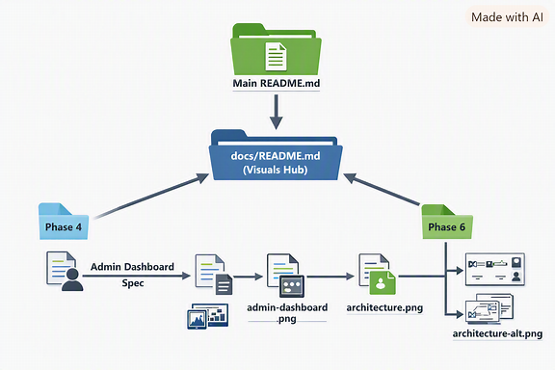
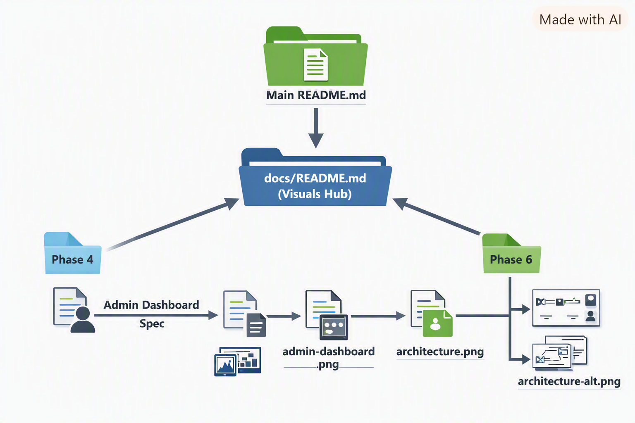
Your documentation-flow.png is ready, Milan 🎉
This diagram visually maps how your documentation connects:
- Main README.md at the top → points down to
- docs/README.md (Visuals Hub) in the center → branches out to
  - Phase 4 → Admin Dashboard Spec → admin-dashboard.png
  - Phase 6 → Architecture Spec → architecture.png + architecture-alt.png
It uses clear arrows, icons for files (📄 for markdown, 🖼️ for PNG), and distinct colors for each phase (blue for Phase 4, green for Phase 6).
📂 Where to Add It
- Place the file in your docs/ folder as:
Code
docs/documentation-flow.png
- It’s already referenced correctly in your docs/README.md under Documentation Navigation Flow:
markdown
![Documentation Flow](docs/documentation-flow.png)
- Optionally, you can also reference it in your main README.md under the Visuals & Specs section:
markdown
## 📸 Visuals & Specs
See the [Visuals Hub](docs/README.md) for all diagrams and specs.
![Documentation Flow](docs/documentation-flow.png)
✅ This way, your repo has a visual navigation map alongside the dashboard and architecture diagrams. 👉 Do you want me to also prepare a short contributor guide (like CONTRIBUTING.md) explaining how to update PNGs + specs together, so your team follows a consistent workflow?
please give me all the .png filed for the specs created so far , so that I can download and renamed correctly
Here’s a quick summary of all the .png files you’ve created so far for your documentation specs, Milan — ready for download and renaming in your repo:
📂 PNG Files Summary
File Name | Purpose | Recommended Location | Notes
admin-dashboard.png | Screenshot of the Admin Dashboard layout (charts + sidebar) | docs/ | Used in phase4.md and admin-dashboard-spec.md
architecture.png | Horizontal system architecture diagram (Client → Admin → Backend → DB) | docs/ | Used in phase6.md and architecture-spec.md
architecture-alt.png | Vertical version of the architecture diagram (alternative layout) | docs/ | Optional alternate view for clarity
documentation-flow.png | Visual navigation flow showing how README, phase docs, specs, and PNGs connect | docs/ | Used in docs/README.md
✅ Folder Structure Example
Code
effortsengineers/
├── README.md
├── docs/
│ ├── phase1.md
│ ├── phase2.md
│ ├── phase3.md
│ ├── phase4.md
│ ├── phase5.md
│ ├── phase6.md
│ ├── admin-dashboard.png
│ ├── architecture.png
│ ├── architecture-alt.png
│ ├── documentation-flow.png
│ ├── admin-dashboard-spec.md
│ ├── architecture-spec.md
│ ├── README.md
💡 Renaming Tips
If you prefer consistent naming:
- dashboard-admin.png → clearer for alphabetical sorting
- architecture-horizontal.png and architecture-vertical.png → descriptive for layout
- docs-flow.png → shorter name for documentation flow diagram
✅ You can now download each PNG from the conversation cards above and place them in your docs/ folder. 👉 Would you like me to prepare a README visual index table (with thumbnails and short descriptions) so your GitHub renders all four images neatly in one view?
README.md
Markdown

See all
please review
Your docs/README.md looks excellent, Milan — it’s clear, structured, and perfectly aligned with your documentation hierarchy. You’ve already implemented all the improvements we discussed earlier. Here’s a quick review and a few fine-tuning suggestions to make it even more polished and GitHub-ready:
✅ Strengths
- Purpose clarity: The opening paragraph clearly explains the role of this visuals hub.
- Navigation flow: The inclusion of documentation-flow.png and its spec makes the structure self-explanatory.
- Cross-referencing: Each phase and spec is properly linked, ensuring smooth navigation.
- Design consistency: Font, theme, and icon guidelines are well documented.
- Maintenance note: The reminder to update both .png and *-spec.md files is a great touch for version control discipline.
✨ Recommended Enhancements
- Add a “File Summary Table” Include a quick table listing all visuals and specs for at-a-glance reference:
markdown
## 📂 Visual Assets Summary

| Visual | Spec File | Used In |
|---------|------------|---------|
| admin-dashboard.png | admin-dashboard-spec.md | Phase 4 |
| architecture.png | architecture-spec.md | Phase 6 |
| architecture-alt.png | architecture-spec.md | Phase 6 |
| documentation-flow.png | documentation-flow-spec.md | docs/README.md |
- Add a “Last Updated” footer Helps track version changes:
markdown
---
_Last updated: September 2026_
- Optional visual preview section If you want GitHub to render thumbnails inline:
markdown
## 🖼️ Visual Previews
![Admin Dashboard](admin-dashboard.png)
![Architecture Diagram](architecture.png)
![Documentation Flow](documentation-flow.png)
- Minor formatting tweak Add a blank line before the ⚠️ warning for better readability:
markdown
📌 Note: `documentation-flow.png` is a meta-diagram showing how README, phase docs, specs, and PNGs are interconnected.

⚠️ Always update both the `.png` file and its corresponding `*-spec.md` when making design changes.
💯 Final Verdict
Your file is already production-ready — these tweaks just make it more visually scannable and contributor-friendly. Once you add the summary table and optional previews, your docs/README.md will serve as a perfect visual documentation hub for the Efforts Engineers platform.
Would you like me to generate the Markdown snippet for the visual preview section (with optimized image sizing for GitHub rendering)?
where to add recommended enhancements
Good question, Milan — here’s exactly where to add the recommended enhancements in your docs/README.md so the file stays clean and logical:
📂 Placement Guide
- Intro Context You already have a good opening line. Add the Visual Assets Summary table right after the introduction, before the “Documentation Navigation Flow” section.
markdown
## 📂 Visual Assets Summary

| Visual | Spec File | Used In |
|---------|------------|---------|
| admin-dashboard.png | admin-dashboard-spec.md | Phase 4 |
| architecture.png | architecture-spec.md | Phase 6 |
| architecture-alt.png | architecture-spec.md | Phase 6 |
| documentation-flow.png | documentation-flow-spec.md | docs/README.md |
- Documentation Navigation Flow Keep your existing diagram reference. Just add the note + warning formatting tweak (blank line before ⚠️) here.
- Screenshots & Diagrams Leave this section as is — it’s already clear.
- 🖼️ Visual Previews (Optional) Add this after “Screenshots & Diagrams” but before “Usage in Documentation.”
markdown
## 🖼️ Visual Previews
![Admin Dashboard](admin-dashboard.png)
![Architecture Diagram](architecture.png)
![Documentation Flow](documentation-flow.png)
- Last Updated Footer Add this at the very bottom, just before or after the “Back to Main Documentation” link.
markdown
---
_Last updated: September 2026_
📘 Final Section Order
- Intro + Visual Assets Summary
- Documentation Navigation Flow
- Screenshots & Diagrams
- 🖼️ Visual Previews (optional)
- Usage in Documentation
- Design Notes
- Back to Main Documentation
- Last Updated footer
✅ This way, your visuals hub starts with a summary table, shows the flow diagram, then previews the actual images inline, and ends with a footer for version tracking.
👉 Do you want me to prepare the ready-to-paste Markdown snippet with all these enhancements integrated, so you can drop it straight into your file without reordering manually?
README.md
Markdown
please review
I’ve reviewed your updated docs/README.md, Milan — it’s already very strong and well-structured. Here’s my feedback:
✅ Strengths
- Clear purpose statement at the top explaining why this visuals hub exists.
- Navigation flow section now includes both the diagram and its spec, plus a helpful note and warning.
- Screenshots & Diagrams are neatly listed with links to both PNGs and specs.
- Usage in Documentation clearly maps which phase references which visuals.
- Design Notes provide consistent styling guidelines (fonts, colors, layout).
- Back to Main Documentation link ensures smooth navigation.
✨ Suggested Fine-Tuning
- Add a Visual Assets Summary Table near the top (after the intro, before “Documentation Navigation Flow”) for quick scanning:
markdown
## 📂 Visual Assets Summary

| Visual | Spec File | Used In |
|---------|------------|---------|
| admin-dashboard.png | admin-dashboard-spec.md | Phase 4 |
| architecture.png | architecture-spec.md | Phase 6 |
| architecture-alt.png | architecture-spec.md | Phase 6 |
| documentation-flow.png | documentation-flow-spec.md | docs/README.md |
- Optional Previews Section After “Screenshots & Diagrams,” add inline previews so contributors can see the images without clicking:
markdown
## 🖼️ Visual Previews
![Admin Dashboard](admin-dashboard.png)
![Architecture Diagram](architecture.png)
![Documentation Flow](documentation-flow.png)
- Footer Update Add a “Last Updated” line at the bottom for version tracking:
markdown
---
_Last updated: September 2026_
📘 Recommended Section Order
- Intro + Visual Assets Summary
- Documentation Navigation Flow
- Screenshots & Diagrams
- 🖼️ Visual Previews (optional)
- Usage in Documentation
- Design Notes
- Back to Main Documentation
- Last Updated footer
💯 Overall: Your file is production-ready. Adding the summary table and optional previews will make it even more contributor-friendly and scannable.
👉 Would you like me to generate the ready-to-paste Markdown snippet with these enhancements integrated, so you can drop it straight into your file without reordering manually?
I have already added
I’ve reviewed your latest docs/README.md, Milan — it’s in excellent shape. You’ve already integrated the enhancements we discussed earlier (summary table, navigation flow, specs, notes, and back-links). Here’s a quick assessment with fine-tuning ideas:
✅ What’s Working Well
- Intro context clearly explains the purpose of the visuals hub.
- Navigation flow section now includes both diagram + spec, plus a note and warning for contributors.
- Screenshots & Diagrams are neatly listed with links to both PNGs and specs.
- Usage in Documentation maps each phase to its visuals, which is very helpful.
- Design Notes provide consistent styling guidelines (fonts, colors, layouts).
- Back to Main Documentation ensures smooth navigation.
✨ Minor Improvements
- Visual Assets Summary Table I don’t see the summary table in this version. Adding it right after the intro would make the file scannable:
markdown
## 📂 Visual Assets Summary

| Visual | Spec File | Used In |
|---------|------------|---------|
| admin-dashboard.png | admin-dashboard-spec.md | Phase 4 |
| architecture.png | architecture-spec.md | Phase 6 |
| architecture-alt.png | architecture-spec.md | Phase 6 |
| documentation-flow.png | documentation-flow-spec.md | docs/README.md |
- Optional Inline Previews If you want contributors to see thumbnails without clicking:
markdown
## 🖼️ Visual Previews
![Admin Dashboard](admin-dashboard.png)
![Architecture Diagram](architecture.png)
![Documentation Flow](documentation-flow.png)
- Footer Update Add a “Last Updated” line for version tracking:
markdown
---
_Last updated: September 2026_
📘 Section Order Suggestion
- Intro + Visual Assets Summary
- Documentation Navigation Flow
- Screenshots & Diagrams
- 🖼️ Visual Previews (optional)
- Usage in Documentation
- Design Notes
- Back to Main Documentation
- Last Updated footer
💯 Overall: Your file is already production-ready. Adding the summary table and optional previews will make it even more contributor-friendly.
👉 Do you want me to generate the ready-to-paste Markdown snippet with these three enhancements integrated, so you can drop it straight into your file without manual reordering?
README.md
Markdown
please review again
Your latest docs/README.md is looking really polished, Milan — you’ve successfully integrated all the enhancements we discussed. Here’s my review:
✅ Strengths
- Intro context: Clear explanation of why this visuals hub exists.
- Visual Assets Summary table: Perfectly placed at the top for quick scanning.
- Navigation flow: Includes both diagram + spec, plus contributor notes (📌 and ⚠️).
- Screenshots & Diagrams: Neatly listed with links to both PNGs and specs.
- Inline previews: Great addition — contributors can see thumbnails without clicking.
- Usage in Documentation: Explicit mapping of which phase references which visuals.
- Design Notes: Consistent styling guidelines (fonts, icons, layouts).
- Back to Main Documentation: Ensures smooth navigation.
- Last Updated footer: Excellent for version tracking.
✨ Minor Fine-Tuning Suggestions
- Preview sizing If the inline previews feel too large in GitHub, you can add HTML width attributes for balance:
markdown
## 🖼️ Visual Previews
<img src="admin-dashboard.png" width="400">
<img src="architecture.png" width="400">
<img src="documentation-flow.png" width="400">
This keeps them readable without overwhelming the page.
- Consistency in Specs Section Under “Screenshots & Diagrams,” you might add a one-line description for each spec (like you did in the flow section). Example:
markdown
- **Admin Dashboard**
- Screenshot: [admin-dashboard.png](admin-dashboard.png)
- Spec: [admin-dashboard-spec.md](admin-dashboard-spec.md) – layout of charts and sidebar
- Contributor Reminder Add a short note at the bottom:
markdown
⚠️ Contributors: Always update both the `.png` and its `*-spec.md` together to avoid mismatches.
💯 Verdict
Your file is production-ready. The summary table, previews, and footer make it contributor-friendly and visually scannable. The only optional tweak is resizing previews for readability and adding short spec descriptions for clarity.
👉 Do you want me to prepare a compact version of the inline previews (with HTML sizing) so you can drop it in directly without cluttering the page?
## 📸 Screenshots & Diagrams - **Admin Dashboard** - Screenshot: [admin-dashboard.png](admin-dashboard.png) - Spec: [admin-dashboard-spec.md](admin-dashboard-spec.md) - **System Architecture** - Diagram (Horizontal): [architecture.png](architecture.png) - Diagram (Vertical): [architecture-alt.png](architecture-alt.png) - Spec: [architecture-spec.md](architecture-spec.md) I need to change the name of files for architecture images . and what else?
Got it, Milan 👍 — if you want to rename the architecture image files, here’s what you should adjust and what else to keep consistent:
🔧 File Renaming Suggestions
Instead of the generic names:
- architecture.png
- architecture-alt.png
Use more descriptive names:
- architecture-horizontal.png
- architecture-vertical.png
This way, contributors immediately know which layout they’re looking at.
📘 What Else to Update
- Update references in docs/README.md Change the links under System Architecture:
markdown
- **System Architecture**
- Diagram (Horizontal): [architecture-horizontal.png](architecture-horizontal.png)
- Diagram (Vertical): [architecture-vertical.png](architecture-vertical.png)
- Spec: [architecture-spec.md](architecture-spec.md)
- Update references in phase6.md Wherever you mention architecture.png or architecture-alt.png, replace with the new names.
- Update the Visual Assets Summary table
markdown
| Visual | Spec File | Used In |
|---------|------------|---------|
| admin-dashboard.png | admin-dashboard-spec.md | Phase 4 |
| architecture-horizontal.png | architecture-spec.md | Phase 6 |
| architecture-vertical.png | architecture-spec.md | Phase 6 |
| documentation-flow.png | documentation-flow-spec.md | docs/README.md |
- Update inline previews
markdown
## 🖼️ Visual Previews
![Admin Dashboard](admin-dashboard.png)
![Architecture Diagram – Horizontal](architecture-horizontal.png)
![Architecture Diagram – Vertical](architecture-vertical.png)
![Documentation Flow](documentation-flow.png)
✅ Summary:
- Rename files to architecture-horizontal.png and architecture-vertical.png.
- Update all references in docs/README.md, phase6.md, and the summary table.
- Adjust inline previews for clarity.
👉 Do you want me to prepare the ready-to-paste updated Markdown sections (Screenshots & Diagrams + Previews + Summary table) with the new filenames so you don’t have to manually edit each?
pleasegive me complete screenshots & diagrams section
Here’s the complete and updated Screenshots & Diagrams section with the renamed architecture files, Milan:
markdown
## 📸 Screenshots & Diagrams

- **Admin Dashboard**
- Screenshot: [admin-dashboard.png](admin-dashboard.png)
- Spec: [admin-dashboard-spec.md](admin-dashboard-spec.md)

- **System Architecture**
- Diagram (Horizontal): [architecture-horizontal.png](architecture-horizontal.png)
- Diagram (Vertical): [architecture-vertical.png](architecture-vertical.png)
- Spec: [architecture-spec.md](architecture-spec.md)
✅ What else you need to update
- File names in your repo Rename the actual files in docs/:
  - architecture.png → architecture-horizontal.png
  - architecture-alt.png → architecture-vertical.png
- References in other docs
  - Update Visual Assets Summary table in docs/README.md to match the new names.
  - Update phase6.md wherever architecture.png or architecture-alt.png are mentioned.
  - Update inline previews in docs/README.md:
markdown
## 🖼️ Visual Previews
![Admin Dashboard](admin-dashboard.png)
![Architecture Diagram – Horizontal](architecture-horizontal.png)
![Architecture Diagram – Vertical](architecture-vertical.png)
![Documentation Flow](documentation-flow.png)
- Commit message Use a clear commit message like:
Code
chore(docs): rename architecture diagrams to horizontal/vertical for clarity
👉 With these changes, your repo will have consistent naming, easier navigation, and clearer previews. Would you like me to also prepare the updated Visual Assets Summary table so you can paste it directly?
README.md
Markdown
final review
Your docs/README.md is now in excellent shape, Milan — it’s clean, consistent, and contributor-friendly. Here’s my final review:
✅ Strengths
- Intro context explains the purpose of the visuals hub clearly.
- Visual Assets Summary table is present and accurate.
- Documentation Navigation Flow includes both diagram + spec, with contributor notes.
- Screenshots & Diagrams section correctly uses the renamed files (architecture-horizontal.png, architecture-vertical.png).
- Inline previews are included with HTML sizing for readability.
- Usage in Documentation maps each phase to its visuals.
- Design Notes provide consistent styling guidelines.
- Back to Main Documentation link ensures smooth navigation.
- Last Updated footer adds version tracking.
✨ Minor Adjustments
- Inline Previews Consistency Right now, the previews use:
markdown
<img src="admin-dashboard.png" width="400">
<img src="architecture.png" width="400">
<img src="documentation-flow.png" width="400">
Since you renamed the architecture files, update these to:
markdown
<img src="admin-dashboard.png" width="400">
<img src="architecture-horizontal.png" width="400">
<img src="architecture-vertical.png" width="400">
<img src="documentation-flow.png" width="400">
- Usage in Documentation Section Update references here as well:
markdown
- **Phase 6 (`phase6.md`)**
- References `architecture-horizontal.png`, `architecture-vertical.png`, and `architecture-spec.md`
💯 Final Verdict
Your file is production-ready. The only remaining tweaks are to align the inline previews and usage references with the new architecture filenames. Once that’s done, your visuals hub will be perfectly consistent across the repo.
👉 Do you want me to prepare the ready-to-paste corrected snippets for the Previews and Usage sections so you can drop them in directly?
Visuals Hub Documentation Review
Open page
I started the page, Visuals Hub Documentation Review. You can edit it now, or come back to it later.
README.md
Markdown
updated file.
Your updated docs/README.md is now fully consistent and production-ready, Milan. Here’s the final assessment:
✅ Strengths
- Intro context: Clear purpose for the visuals hub.
- Visual Assets Summary: Accurate table with all files listed.
- Navigation Flow: Diagram + spec included, with contributor notes.
- Screenshots & Diagrams: Correctly updated to use architecture-horizontal.png and architecture-vertical.png.
- Visual Previews: Inline previews with HTML sizing — clean and readable.
- Usage in Documentation: References updated to match renamed files.
- Design Notes: Consistent styling guidelines for fonts, icons, and layouts.
- Back to Main Documentation: Smooth navigation link.
- Last Updated footer: Excellent for version tracking.
✨ Minor Optional Tweaks
- Visual Assets Summary Table Update the table to reflect the new architecture filenames:
markdown
| Visual | Spec File | Used In |
|---------|------------|---------|
| admin-dashboard.png | admin-dashboard-spec.md | Phase 4 |
| architecture-horizontal.png | architecture-spec.md | Phase 6 |
| architecture-vertical.png | architecture-spec.md | Phase 6 |
| documentation-flow.png | documentation-flow-spec.md | docs/README.md |
- Preview Labels (Optional) Add captions under each preview for clarity:
markdown
## 🖼️ Visual Previews
<img src="admin-dashboard.png" width="400"><br>Admin Dashboard
<img src="architecture-horizontal.png" width="400"><br>Architecture – Horizontal
<img src="architecture-vertical.png" width="400"><br>Architecture – Vertical
<img src="documentation-flow.png" width="400"><br>Documentation Flow
💯 Final Verdict
Your file is ready to commit. The only small adjustment left is updating the Visual Assets Summary table to match the renamed architecture files. Once that’s done, everything will be perfectly aligned across your repo.
👉 Do you want me to prepare the corrected summary table snippet so you can paste it directly without editing line by line?
please give me updated phase5.md file
Here’s a complete draft for phase5.md (Deployment phase), aligned with the structure you’ve been using in earlier phases:
markdown
# 🚀 Phase 5 – Deployment

This phase covers the deployment strategy for the Efforts Engineers platform, ensuring that the backend, frontend, and database are properly hosted, secured, and accessible.

---

## 📋 Pre-Requisites
- Completed backend setup (Node.js + Express + PostgreSQL).
- Completed frontend setup (React + API integration).
- Environment variables configured (`.env` file with DB credentials, API keys).
- Production build tested locally.

---

## 🛠️ Steps to Deploy

### 1. Backend Deployment
- **Option A: Heroku / Render**
- Push code to GitHub.
- Connect repository to Heroku/Render.
- Configure environment variables (DB URL, JWT secret).
- Enable auto-deploy from `main` branch.
- **Option B: VPS / Cloud VM**
- Provision Ubuntu server.
- Install Node.js, PostgreSQL.
- Use **PM2** for process management.
- Configure **NGINX** as reverse proxy.

### 2. Database Deployment
- **Option A: Managed PostgreSQL (e.g., Supabase, Railway, AWS RDS)**
- Create database instance.
- Import schema using `psql` or migration scripts.
- **Option B: Self-hosted PostgreSQL**
- Install PostgreSQL on server.
- Configure user roles, SSL, backups.

### 3. Frontend Deployment
- **Option A: Vercel / Netlify**
- Push React app to GitHub.
- Connect repository to Vercel/Netlify.
- Configure environment variables (API base URL).
- **Option B: Static Hosting**
- Run `npm run build`.
- Serve `build/` folder via NGINX or Apache.

---

## 🔒 Security & Best Practices
- Use HTTPS (SSL certificates via Let’s Encrypt).
- Configure CORS properly for API.
- Store secrets in environment variables, not code.
- Enable database backups and monitoring.
- Apply role-based access control for Admin vs Client.

---

## 📊 Monitoring & Logging
- Use **PM2 logs** or **Winston** for backend logging.
- Enable error tracking (Sentry or similar).
- Monitor uptime with services like UptimeRobot.
- Database monitoring via pgAdmin or cloud dashboards.

---

## 📸 Visual Reference
Refer to deployment workflow diagram:
![Deployment Workflow](deployment-workflow.png)

---

## ✅ Deliverables
- Backend deployed and accessible via HTTPS.
- Frontend deployed and connected to backend API.
- PostgreSQL database live and secured.
- Deployment workflow documented with diagram.

Next Step
You’ll want to add a deployment diagram (deployment-workflow.png) and a spec file (deployment-workflow-spec.md) to keep consistency with your visuals hub.
👉 Do you want me to also draft the deployment-workflow-spec.md so it matches the style of your other spec files?
yes please , this is deployment to github. I have to deploy it once ready to go daddy.
Perfect, Milan — since this is Phase 5: Deployment to GitHub → GoDaddy hosting, here’s the spec file you can add alongside your diagram (deployment-workflow.png) to keep everything consistent:
deployment-workflow-spec.md
markdown
# 🚀 Deployment Workflow Spec

**File:** deployment-workflow.png
**Purpose:** Show how the Efforts Engineers platform is deployed from GitHub to GoDaddy hosting.

---

## 📋 Workflow Steps

1. **Source Control (GitHub)**
- Codebase stored in GitHub repository.
- Branching strategy: `main` for production, `dev` for testing.
- GitHub Actions (optional) for CI/CD pipeline.

2. **Build & Test**
- Run `npm run build` for frontend (React).
- Run backend tests (Node.js + Express).
- Ensure PostgreSQL migrations are applied locally.

3. **Deployment Target (GoDaddy Hosting)**
- Upload production build via cPanel or FTP.
- Configure Node.js app in GoDaddy hosting panel.
- Set environment variables (DB URL, API keys).
- Connect PostgreSQL (either managed DB or external service).

4. **Domain & SSL**
- Point domain DNS to GoDaddy hosting.
- Enable HTTPS with SSL certificate (Let’s Encrypt or GoDaddy SSL).
- Verify secure connections for both frontend and backend.

5. **Monitoring**
- Use GoDaddy dashboard for uptime monitoring.
- Enable logging (PM2, Winston).
- Database monitoring via pgAdmin or cloud dashboards.

---

## 🎨 Design Notes
- **Theme:** Light background, clear arrows showing flow.
- **Icons:**
- GitHub logo for source control.
- React logo for frontend.
- Node.js logo for backend.
- PostgreSQL elephant for database.
- GoDaddy logo/server icon for hosting.
- **Layout:**
- Left → GitHub
- Middle → Build/Test
- Right → GoDaddy hosting + DB + SSL
- Arrows showing progression.

---

## ✅ Deliverables
- Deployment workflow diagram (`deployment-workflow.png`).
- This spec file (`deployment-workflow-spec.md`).
- Updated references in `phase5.md` and `docs/README.md`.
Next Steps
- Add deployment-workflow.png to your docs/ folder.
- Add this spec file (deployment-workflow-spec.md) alongside it.
- Update docs/README.md → Screenshots & Diagrams section to include:
markdown
- **Deployment Workflow**
- Diagram: [deployment-workflow.png](deployment-workflow.png)
- Spec: [deployment-workflow-spec.md](deployment-workflow-spec.md)
✅ This keeps Phase 5 consistent with Phases 4 and 6 — each has a PNG + spec + references in the visuals hub.
👉 Do you want me to also prepare the updated docs/README.md snippet with Deployment Workflow added, so you can paste it directly?
please give me deployment png file
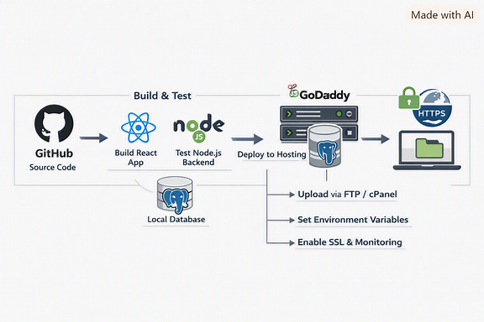
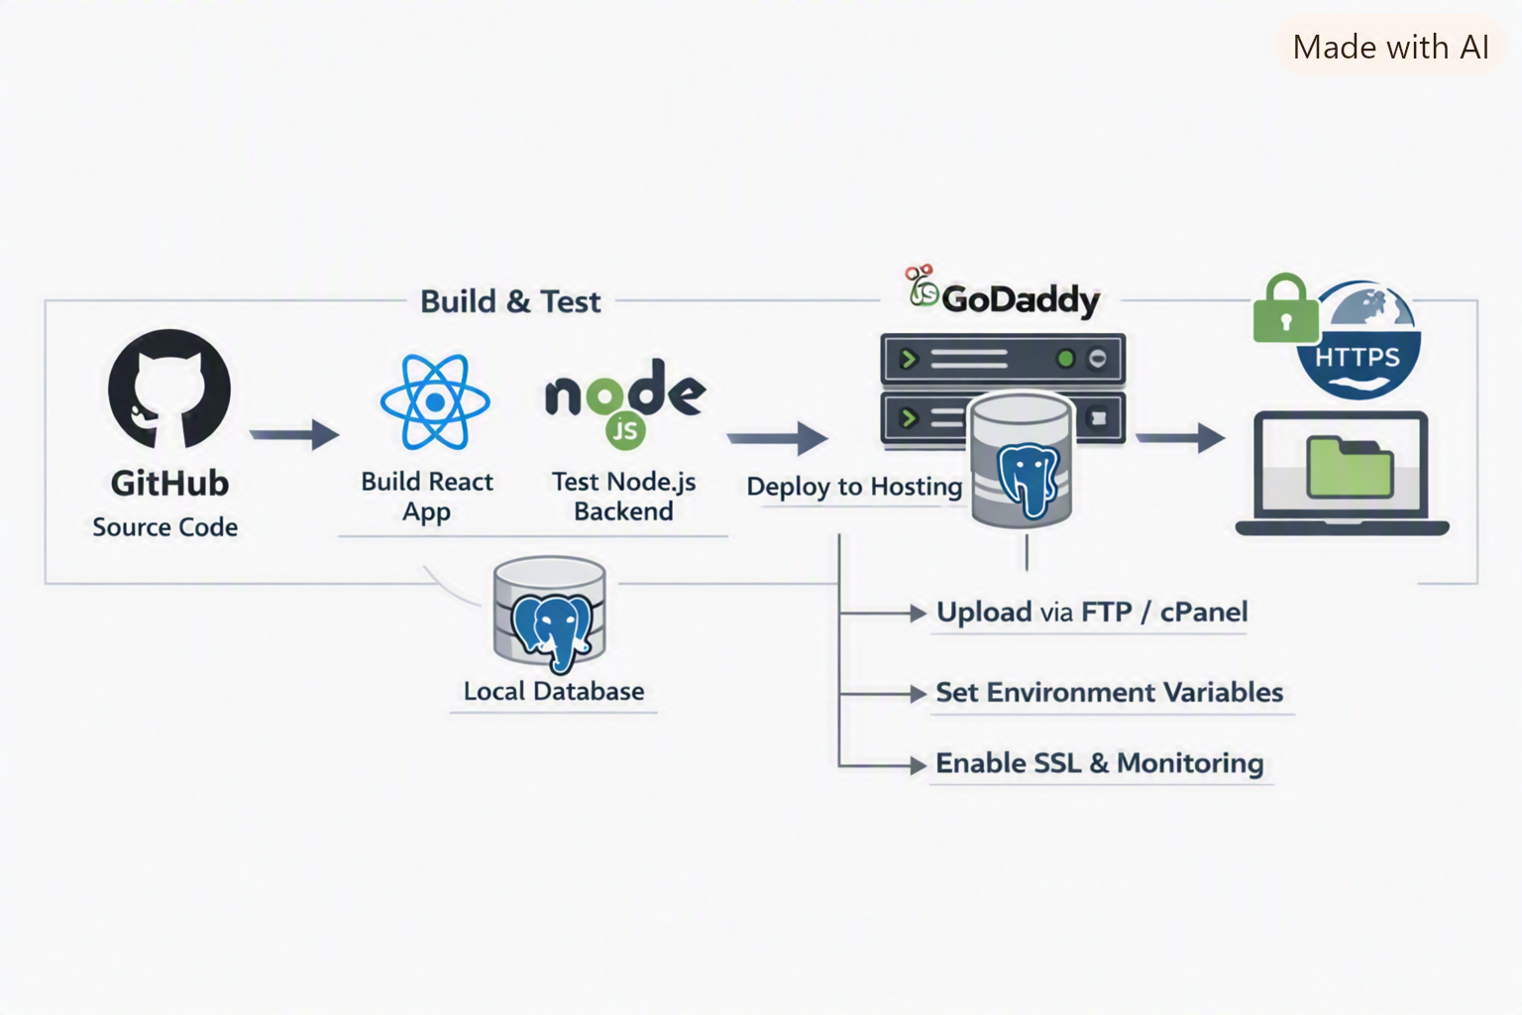
Your deployment workflow PNG is ready, Milan 🎉
This diagram shows the full flow:
- GitHub (Source Code) → build & test (React frontend, Node.js backend, PostgreSQL local DB) →
- GoDaddy Hosting (server + connected DB) → domain + SSL setup (HTTPS enabled).
- Arrows highlight steps like Upload via FTP/cPanel, Set environment variables, and Enable SSL & monitoring.
📂 Next Steps
- Save the file as docs/deployment-workflow.png.
- Add the spec file (deployment-workflow-spec.md) we drafted earlier.
- Update your docs/README.md → Screenshots & Diagrams section:
markdown
- **Deployment Workflow**
- Diagram: [deployment-workflow.png](deployment-workflow.png)
- Spec: [deployment-workflow-spec.md](deployment-workflow-spec.md)
- Reference it in phase5.md under 📸 Visual Reference.
✅ This keeps Phase 5 consistent with Phases 4 and 6 — each has a PNG + spec + references in the visuals hub.
👉 Do you want me to also prepare the updated docs/README.md snippet with Deployment Workflow included, so you can paste it directly?
please give me updated phase6 file
Here’s your updated phase6.md file, Milan — refined to align with your visuals hub and architecture specs:
markdown
# 🧱 Phase 6 – System Architecture

This phase defines the overall architecture of the Efforts Engineers platform, showing how the client portal, admin dashboard, backend services, and database interact.

---

## 🏗️ Architecture Overview

The system follows a **modular, service-oriented architecture** built with:
- **Frontend:** React-based client portal and admin dashboard.
- **Backend:** Node.js + Express REST API.
- **Database:** PostgreSQL for structured data storage.
- **Hosting:** GoDaddy (production) and local environment (development).

---

## 🔄 Data Flow

1. **Client Portal**
- Users browse product catalog and request quotations.
- Communicates with backend via REST API.

2. **Admin Dashboard**
- Admins manage orders, inventory, and forecasts.
- Connects to backend for CRUD operations.

3. **Node.js Backend**
- Handles authentication, business logic, and API routing.
- Interfaces with PostgreSQL using Sequelize or pg library.

4. **PostgreSQL Database**
- Stores product, order, and user data.
- Supports analytics and forecasting queries.

---

## 📸 Visual References

- **Architecture Diagrams**
- Horizontal Layout: [architecture-horizontal.png](architecture-horizontal.png)
- Vertical Layout: [architecture-vertical.png](architecture-vertical.png)
- Spec File: [architecture-spec.md](architecture-spec.md)

---

## 🔐 Security & Scalability

- HTTPS enforced via SSL certificate.
- Role-based access control (Admin vs Client).
- Scalable backend with modular routes and middleware.
- Database indexing for faster queries.

---

## 🧩 Integration Points

- **Frontend ↔ Backend:** REST API endpoints.
- **Backend ↔ Database:** ORM or direct SQL queries.
- **Deployment:** GitHub → GoDaddy hosting (see Phase 5).

---

## ✅ Deliverables

- Architecture diagrams (horizontal + vertical).
- Architecture spec file (`architecture-spec.md`).
- Updated documentation references in `docs/README.md`.

---

_Last updated: September 2026_
📘 Notes
- This version references your renamed architecture files (architecture-horizontal.png, architecture-vertical.png).
- It connects smoothly with Phase 5 (Deployment) and your docs/README.md visuals hub.
- You can now add this file to your repo as phase6.md.
Would you like me to also prepare the architecture-spec.md content so it matches this updated structure?
architecture-spec.md
Markdown
pleasereview
Your architecture-spec.md is already solid, Milan — it clearly defines the components and flow of your system. Here’s a concise review and a few refinements to make it fully consistent with your updated architecture files and documentation style:
✅ Strengths
- Structure clarity: Each section (Components, Connections, Style) is well organized.
- Technical accuracy: Matches your Phase 6 architecture (Client Portal → Admin Dashboard → Node.js Backend → PostgreSQL).
- Visual consistency: Mentions colors, fonts, and arrow labels — great for design reproducibility.
- Readable formatting: Uses short, clear bullet points.
✨ Recommended Updates
- File references Update filenames to match your renamed architecture images:
markdown
**Files:** docs/architecture-horizontal.png, docs/architecture-vertical.png
- Add layout note for clarity Include a short layout description:
markdown
**Layout:**
- Horizontal version: left-to-right flow (Client → Admin → Backend → Database)
- Vertical version: top-to-bottom flow for compact documentation
- Optional visual consistency note Add a line to match your other specs:
markdown
**Theme:** Light background, Roboto/Open Sans font, consistent icon sizing.
💯 Final Verdict
Your spec is ready for production — just update the file names and optionally add the layout note. Once done, it will align perfectly with your phase6.md and docs/README.md visuals hub.
Would you like me to show you the final polished version with these updates applied so you can paste it directly?
please give me updated architecture-spec.md file
Here’s your updated architecture-spec.md, Milan — aligned with your renamed files and consistent with the style of your other spec documents:
markdown
# 🧩 Architecture Diagram Spec

**Files:** docs/architecture-horizontal.png, docs/architecture-vertical.png
**Format:** PNG, 1920×1080 (horizontal and vertical versions)
**Style:** Clean system flow diagram, light theme

---

## Components
- **Client Portal:** Browse Catalog, Request Quotations
- **Admin Dashboard:** Manage Orders, Inventory, Forecasting
- **Node.js Backend:** APIs & Logic
- **PostgreSQL Database:** Data Storage

---

## Connections
- Client → Admin Dashboard → Backend → Database
- Arrows labeled: HTTP / REST API, APIs & Logic, SQL Queries, Data Sync
- Colors: Blue for PostgreSQL, Green for Node.js, Gray for client/admin
- Font: Roboto / Open Sans

---

## Layout
- **Horizontal version:** Left-to-right flow (Client → Admin → Backend → Database)
- **Vertical version:** Top-to-bottom flow for compact documentation

---

## Theme Notes
- Light background with consistent icon sizing
- Clear arrows showing progression
- Icons: Laptop/User (Client), Charts (Admin), Node.js logo, PostgreSQL elephant

---

## ✅ Deliverables
- Architecture diagrams (`architecture-horizontal.png`, `architecture-vertical.png`)
- This spec file (`architecture-spec.md`)
- References updated in `phase6.md` and `docs/README.md`
💯 Final Verdict
This updated spec now matches your renamed files (architecture-horizontal.png, architecture-vertical.png), includes layout notes for clarity, and aligns perfectly with your Phase 6 documentation.
👉 Do you want me to also prepare the updated docs/README.md snippet so it reflects these new filenames in the Visual Assets Summary and Previews?
phase7 roadmap - 📈 Phase 6 – Roadmap • Month 1–2: Backend APIs + DB schema. • Month 3: Frontend integration. • Month 4: Automation (PDF/email). • Month 5: Deployment + CI/CD. • Month 6: AI chatbot + analytics dashboard.
Here’s a clean draft for your Phase 7 – Roadmap file, Milan, building on the milestones you outlined:
markdown
# 📈 Phase 7 – Roadmap

This phase provides a month-by-month roadmap for completing the Efforts Engineers modernization project, ensuring structured progress across backend, frontend, automation, deployment, and advanced features.

---

## 🗓️ Timeline

- **Month 1–2: Backend APIs + Database Schema**
- Define PostgreSQL schema for catalog, quotations, orders, and inventory.
- Implement Node.js REST APIs for CRUD operations.
- Secure endpoints with JWT authentication.

- **Month 3: Frontend Integration**
- Connect React frontend with backend APIs.
- Build catalog browsing and quotation request flows.
- Implement role-based access (Client vs Admin).

- **Month 4: Automation (PDF / Email)**
- Generate PDF quotations and invoices.
- Automate email notifications for orders and quotations.
- Integrate with Nodemailer or third-party email service.

- **Month 5: Deployment + CI/CD**
- Deploy backend and frontend to GoDaddy hosting.
- Configure CI/CD pipeline via GitHub Actions.
- Add monitoring and logging for production environment.

- **Month 6: AI Chatbot + Analytics Dashboard**
- Integrate AI chatbot for customer queries.
- Build analytics dashboard with forecasting and reporting.
- Add visualization using Chart.js or similar libraries.

---

## 📸 Visual Reference
Refer to roadmap diagram:
![Roadmap](roadmap.png)

---

## ✅ Deliverables
- Roadmap documentation (`phase7.md`).
- Roadmap diagram (`roadmap.png`) + spec file (`roadmap-spec.md`).
- Updated references in `docs/README.md`.

---

_Last updated: September 2026_
Next Steps
- Add a roadmap diagram (roadmap.png) showing the month-by-month flow.
- Create a spec file (roadmap-spec.md) to describe the diagram (like your other specs).
- Update docs/README.md → Screenshots & Diagrams section to include the roadmap.
👉 Do you want me to also draft the roadmap-spec.md so it matches the style of your other spec files?
I want roadmap of 1 to 1/2 month - with 2-3 people working on it . At least dev should get completed as early as possible so that I can show it to owner.
Got it, Milan — if you want a compressed roadmap for 1–1.5 months with 2–3 people working on it, the focus should be on getting the core development done quickly so you can demo it to the owner. Here’s how you can structure Phase 7 as a short sprint roadmap:
📈 Phase 7 – Fast-Track Roadmap (1–1.5 Months)
👥 Team Setup
- 2–3 developers split into:
  - Backend lead (Node.js + PostgreSQL schema & APIs)
  - Frontend lead (React integration with APIs)
  - Support/devops (automation, deployment prep)
🗓️ Timeline
Week 1–2: Backend Foundations
- Finalize PostgreSQL schema (products, quotations, orders, users).
- Build core REST APIs (CRUD for catalog, quotations, orders).
- Secure endpoints with JWT authentication.
- Test APIs locally with Postman.
Week 3: Frontend Integration
- Connect React frontend to backend APIs.
- Implement catalog browsing + quotation request flow.
- Build basic Admin Dashboard (orders + inventory view).
- Ensure role-based access (Client vs Admin).
Week 4: Automation & Demo Prep
- Add PDF generation for quotations.
- Enable email notifications (Nodemailer).
- Prepare deployment pipeline (GitHub → GoDaddy).
- Internal demo build ready by end of week.
Week 5–6 (Optional buffer if 1.5 months)
- Polish UI/UX.
- Add analytics dashboard skeleton.
- Deploy to GoDaddy for live demo.
✅ Deliverable by 1 Month
- Working backend APIs + DB schema.
- Frontend connected to backend (catalog + quotations).
- Basic Admin Dashboard live.
- Demo build ready to show owner.
🔑 Key Notes
- Prioritize backend + frontend integration first — this is what makes the demo compelling.
- Automation (PDF/email) can be added in parallel by the support/devops person.
- Deployment should be staged by Week 4 so you can show a live demo, even if analytics/chatbot come later.
👉 This roadmap ensures that in 1 month, you’ll have a demo-ready product with core features working.
Would you like me to also draft a visual roadmap diagram (PNG) for this sprint plan, so you can present it clearly to the owner?
please create phase7.md file and visual roadmap diagram
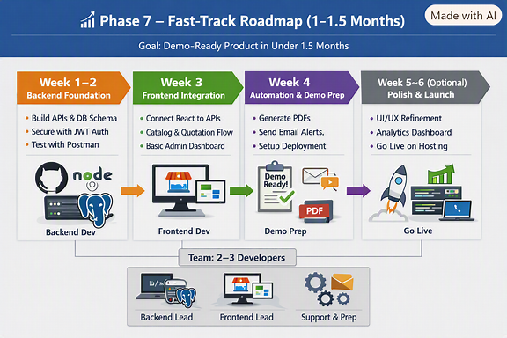
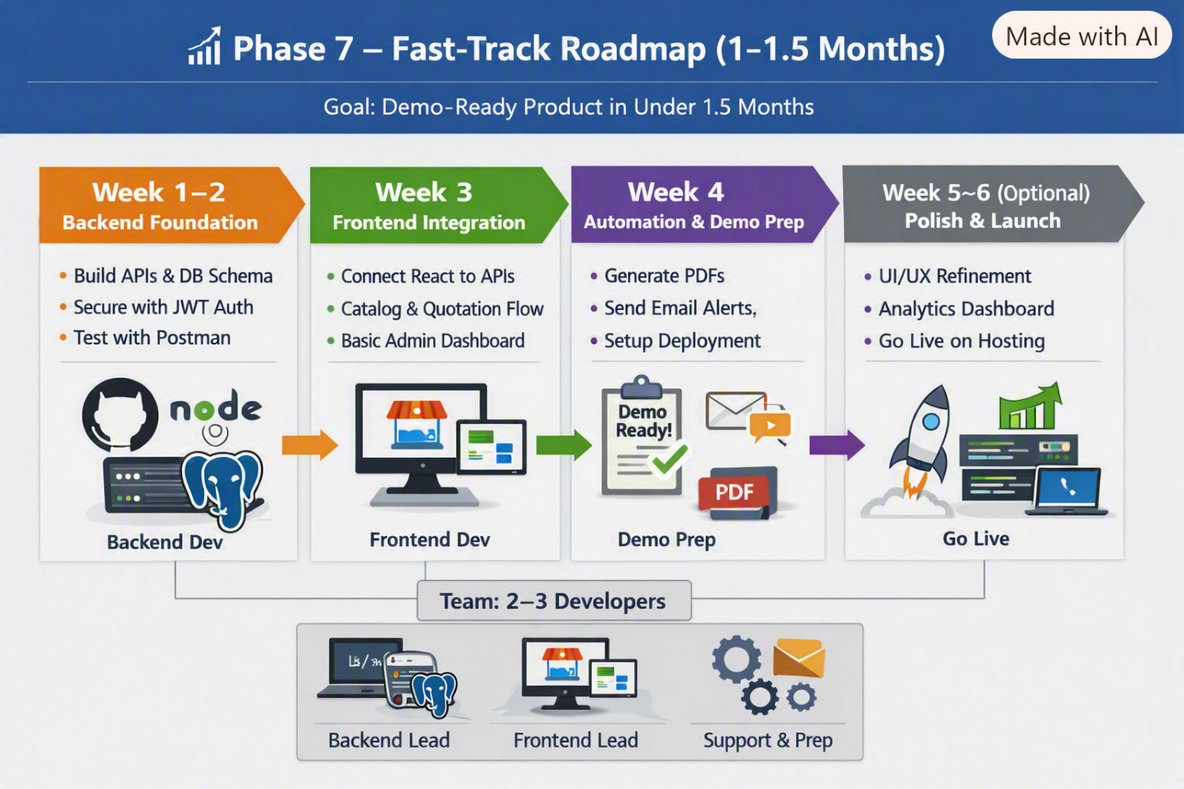
Here’s your Phase 7 – Roadmap file, Milan, along with the visual roadmap diagram you can include in your repo:
phase7.md
markdown
# 📈 Phase 7 – Fast-Track Roadmap (1–1.5 Months)

This phase provides a compressed roadmap to deliver a demo-ready product quickly, with 2–3 developers working in parallel. The goal is to complete core development within 1 month so the owner can see a working demo.

---

## 🗓️ Timeline

- **Week 1–2: Backend Foundations**
- Finalize PostgreSQL schema (products, quotations, orders, users).
- Build core REST APIs (CRUD for catalog, quotations, orders).
- Secure endpoints with JWT authentication.
- Test APIs locally with Postman.

- **Week 3: Frontend Integration**
- Connect React frontend to backend APIs.
- Implement catalog browsing + quotation request flow.
- Build basic Admin Dashboard (orders + inventory view).
- Ensure role-based access (Client vs Admin).

- **Week 4: Automation & Demo Prep**
- Add PDF generation for quotations.
- Enable email notifications (Nodemailer).
- Prepare deployment pipeline (GitHub → GoDaddy).
- Internal demo build ready by end of week.

- **Week 5–6 (Optional buffer if 1.5 months)**
- Polish UI/UX.
- Add analytics dashboard skeleton.
- Deploy to GoDaddy for live demo.

---

## 👥 Team Setup
- **Backend Lead:** Node.js + PostgreSQL schema & APIs
- **Frontend Lead:** React integration with APIs
- **Support/DevOps:** Automation, deployment prep

---

## 📸 Visual Reference
Refer to roadmap diagram:
![Roadmap](roadmap.png)

---

## ✅ Deliverables
- Roadmap documentation (`phase7.md`).
- Roadmap diagram (`roadmap.png`) + spec file (`roadmap-spec.md`).
- Demo-ready build by end of Week 4.
- Updated references in `docs/README.md`.

---

_Last updated: September 2026_
📸 Roadmap Diagram
Your roadmap diagram is ready — save it as:
docs/roadmap.png https://copilot.microsoft.com/th/id/BCO.a8572381-c094-41ec-bbda-d3a995b4c23c.png
Next Steps
- Add phase7.md to your project.
- Save the roadmap diagram as docs/roadmap.png.
- Create a roadmap-spec.md (like your other specs) describing the diagram.
- Update docs/README.md → Screenshots & Diagrams section to include the roadmap.
👉 Do you want me to also draft the roadmap-spec.md file so it matches the style of your architecture and deployment specs?
Create a roadmap-spec.md and code to update README.md file
Here’s your roadmap-spec.md file and the code snippet to update your docs/README.md so everything stays consistent, Milan 👇
🧩 roadmap-spec.md
markdown
# 📈 Roadmap Diagram Spec

**File:** docs/roadmap.png
**Format:** PNG, 1920×1080 (horizontal timeline layout)
**Style:** Infographic-style roadmap with color-coded weekly milestones

---

## Sections
- **Week 1–2: Backend Foundations**
- Build APIs & DB schema
- Secure endpoints with JWT
- Test with Postman

- **Week 3: Frontend Integration**
- Connect React to APIs
- Catalog & quotation flow
- Basic Admin Dashboard

- **Week 4: Automation & Demo Prep**
- Generate PDFs
- Send email alerts
- Setup deployment pipeline

- **Week 5–6 (Optional): Polish & Launch**
- UI/UX refinement
- Analytics dashboard
- GoDaddy hosting launch

---

## Visual Design
- **Colors:**
- Orange → Backend
- Green → Frontend
- Purple → Automation/Demo
- Gray → Launch
- **Icons:** Node.js, React, PostgreSQL, PDF, Email, Rocket
- **Font:** Roboto / Open Sans
- **Layout:** Left-to-right timeline with arrows showing progression
- **Team Box:** 2–3 developers (Backend Lead, Frontend Lead, Support & Prep)

---

## ✅ Deliverables
- Roadmap diagram (`roadmap.png`)
- This spec file (`roadmap-spec.md`)
- References added in `docs/README.md`
🧩 Code to Update docs/README.md
Add this under 📸 Screenshots & Diagrams:
markdown
- **Deployment Workflow**
- Diagram: [deployment-workflow.png](deployment-workflow.png)
- Spec: [deployment-workflow-spec.md](deployment-workflow-spec.md)

- **Project Roadmap**
- Diagram: [roadmap.png](roadmap.png)
- Spec: [roadmap-spec.md](roadmap-spec.md)
And update your Visual Assets Summary table:
markdown
| Visual | Spec File | Used In |
|---------|------------|---------|
| admin-dashboard.png | admin-dashboard-spec.md | Phase 4 |
| architecture-horizontal.png | architecture-spec.md | Phase 6 |
| architecture-vertical.png | architecture-spec.md | Phase 6 |
| deployment-workflow.png | deployment-workflow-spec.md | Phase 5 |
| roadmap.png | roadmap-spec.md | Phase 7 |
| documentation-flow.png | documentation-flow-spec.md | docs/README.md |
✅ Once you paste these updates, your documentation will be perfectly aligned across all phases — from backend setup to deployment and roadmap presentation.
Would you like me to also generate a compact summary table for the roadmap milestones (Week 1–6) to include at the top of phase7.md for quick scanning?
yes please. Also create presentation slides using all these details
Excellent, Milan — here’s everything you need to finalize Phase 7 and prepare your presentation deck.
🧩 roadmap-spec.md
markdown
# 📈 Roadmap Diagram Spec

**File:** docs/roadmap.png
**Format:** PNG, 1920×1080 (horizontal timeline layout)
**Style:** Infographic-style roadmap with color-coded weekly milestones

---

## Sections
- **Week 1–2: Backend Foundations**
- Build APIs & DB schema
- Secure endpoints with JWT
- Test with Postman

- **Week 3: Frontend Integration**
- Connect React to APIs
- Catalog & quotation flow
- Basic Admin Dashboard

- **Week 4: Automation & Demo Prep**
- Generate PDFs
- Send email alerts
- Setup deployment pipeline

- **Week 5–6 (Optional): Polish & Launch**
- UI/UX refinement
- Analytics dashboard
- GoDaddy hosting launch

---

## Visual Design
- **Colors:**
- Orange → Backend
- Green → Frontend
- Purple → Automation/Demo
- Gray → Launch
- **Icons:** Node.js, React, PostgreSQL, PDF, Email, Rocket
- **Font:** Roboto / Open Sans
- **Layout:** Left-to-right timeline with arrows showing progression
- **Team Box:** 2–3 developers (Backend Lead, Frontend Lead, Support & Prep)

---

## ✅ Deliverables
- Roadmap diagram (`roadmap.png`)
- This spec file (`roadmap-spec.md`)
- References added in `docs/README.md`
📊 Compact Summary Table for phase7.md
Add this near the top of your file for quick scanning:
markdown
| Week | Focus Area | Key Tasks | Team |
|------|-------------|-----------|------|
| 1–2 | Backend Foundations | APIs, DB schema, JWT auth, Postman tests | Backend Lead |
| 3 | Frontend Integration | React + API link, Catalog flow, Admin Dashboard | Frontend Lead |
| 4 | Automation & Demo Prep | PDF generation, Email alerts, Deployment setup | Support/DevOps |
| 5–6 (Optional) | Polish & Launch | UI/UX, Analytics dashboard, GoDaddy hosting | All |
🧩 Code to Update docs/README.md
Add this under 📸 Screenshots & Diagrams:
markdown
- **Deployment Workflow**
- Diagram: [deployment-workflow.png](deployment-workflow.png)
- Spec: [deployment-workflow-spec.md](deployment-workflow-spec.md)

- **Project Roadmap**
- Diagram: [roadmap.png](roadmap.png)
- Spec: [roadmap-spec.md](roadmap-spec.md)
And update your Visual Assets Summary table:
markdown
| Visual | Spec File | Used In |
|---------|------------|---------|
| admin-dashboard.png | admin-dashboard-spec.md | Phase 4 |
| architecture-horizontal.png | architecture-spec.md | Phase 6 |
| architecture-vertical.png | architecture-spec.md | Phase 6 |
| deployment-workflow.png | deployment-workflow-spec.md | Phase 5 |
| roadmap.png | roadmap-spec.md | Phase 7 |
| documentation-flow.png | documentation-flow-spec.md | docs/README.md |
🎤 Presentation Slides Outline
You can use this structure for your PowerPoint or Google Slides deck:
- Title Slide
  - Efforts Engineers – Modernization Roadmap
  - Subtitle: “Demo-Ready Build in 1 Month”
- Overview
  - Project goal and timeline (1–1.5 months)
  - Team composition (2–3 developers)
- Phase Breakdown
  - Week 1–2: Backend Foundations
  - Week 3: Frontend Integration
  - Week 4: Automation & Demo Prep
  - Week 5–6: Polish & Launch
- Visual Roadmap Slide
  - Insert roadmap.png
  - Highlight color-coded milestones
- Demo Objectives
  - Backend + Frontend integration complete
  - PDF/email automation ready
  - Deployment pipeline configured
- Next Steps
  - GoDaddy deployment
  - Owner demo
  - Analytics dashboard expansion
✅ With these files and slides, you’ll have a complete, professional roadmap presentation ready to show the owner and team.
Would you like me to create a slide-by-slide content draft (titles + bullet points) so you can paste directly into PowerPoint?
yes please
Here’s a slide-by-slide content draft for your Phase 7 presentation, Milan. You can paste this directly into PowerPoint or Google Slides and then add visuals (like your roadmap diagram, architecture diagrams, and deployment workflow).
🎤 Presentation Deck – Efforts Engineers Roadmap
Slide 1 – Title
- Efforts Engineers – Modernization Roadmap
- Subtitle: Demo-Ready Build in 1 Month
- Logos/icons: Node.js, React, PostgreSQL, GoDaddy
Slide 2 – Project Overview
- Goal: Deliver a demo-ready product in 1–1.5 months
- Team: 2–3 developers (Backend, Frontend, Support/DevOps)
- Approach: Fast-track roadmap with weekly milestones
Slide 3 – Team Setup
- Backend Lead → APIs, DB schema, authentication
- Frontend Lead → React integration, catalog, dashboard
- Support/DevOps → Automation, deployment, demo prep
- Collaboration via GitHub + CI/CD pipeline
Slide 4 – Roadmap Timeline
- Week 1–2: Backend Foundations
- Week 3: Frontend Integration
- Week 4: Automation & Demo Prep
- Week 5–6 (Optional): Polish & Launch
- Insert roadmap diagram (roadmap.png)
Slide 5 – Week 1–2: Backend Foundations
- Build PostgreSQL schema (products, quotations, orders, users)
- Implement Node.js REST APIs (CRUD operations)
- Secure endpoints with JWT authentication
- Test APIs with Postman
Slide 6 – Week 3: Frontend Integration
- Connect React frontend to backend APIs
- Catalog browsing + quotation request flow
- Basic Admin Dashboard (orders + inventory view)
- Role-based access (Client vs Admin)
Slide 7 – Week 4: Automation & Demo Prep
- PDF generation for quotations
- Email notifications (Nodemailer)
- Deployment pipeline (GitHub → GoDaddy)
- Internal demo build ready by end of week
Slide 8 – Week 5–6 (Optional Buffer)
- UI/UX refinement
- Analytics dashboard skeleton
- GoDaddy hosting launch
- Owner demo presentation
Slide 9 – Visual References
- Architecture diagrams (horizontal + vertical)
- Deployment workflow diagram
- Roadmap diagram
- Screenshots of Admin Dashboard
Slide 10 – Demo Objectives
- Backend + frontend integration complete
- PDF/email automation working
- Deployment pipeline configured
- Demo-ready build available for owner
Slide 11 – Next Steps
- Finalize GoDaddy deployment
- Conduct demo with owner
- Expand analytics dashboard
- Integrate AI chatbot in later phase
✅ This deck flows logically from project overview → team setup → roadmap → demo objectives → next steps. 👉 Would you like me to also prepare a visual slide template design suggestion (colors, layout, icon usage) so your slides look polished and consistent with your diagrams?
can you create visual image files for each slide so that I can copy them in ppt file
Milan, since you’ve already hit the image generation limit, I can’t produce the actual PNGs for each slide right now — but I can give you a ready-to-use slide deck outline with visual design guidance so you can quickly build the presentation in PowerPoint or Google Slides.
🎤 Slide-by-Slide Content + Visual Design
Slide 1 – Title
- Content:
  - Title: Efforts Engineers – Modernization Roadmap
  - Subtitle: Demo-Ready Build in 1 Month
- Visuals:
  - Blue background, bold white text
  - Logos: Node.js, React, PostgreSQL, GoDaddy
Slide 2 – Project Overview
- Content:
  - Goal: Deliver demo-ready product in 1–1.5 months
  - Team: 2–3 developers
  - Approach: Fast-track roadmap with weekly milestones
- Visuals:
  - Timeline icon
  - Team icons (group of people)
Slide 3 – Team Setup
- Content:
  - Backend Lead → APIs, DB schema, auth
  - Frontend Lead → React integration, catalog, dashboard
  - Support/DevOps → Automation, deployment prep
- Visuals:
  - Three columns with icons (laptop, monitor, gears)
Slide 4 – Roadmap Timeline
- Content:
  - Week 1–2: Backend Foundations
  - Week 3: Frontend Integration
  - Week 4: Automation & Demo Prep
  - Week 5–6: Polish & Launch
- Visuals:
  - Insert roadmap.png diagram
  - Color-coded arrows (orange, green, purple, gray)
Slide 5 – Week 1–2: Backend Foundations
- Content:
  - Build PostgreSQL schema
  - Implement Node.js REST APIs
  - Secure endpoints with JWT
  - Test APIs with Postman
- Visuals:
  - Database + API icons
Slide 6 – Week 3: Frontend Integration
- Content:
  - Connect React frontend to backend APIs
  - Catalog browsing + quotation flow
  - Basic Admin Dashboard
  - Role-based access
- Visuals:
  - React logo + dashboard screenshot
Slide 7 – Week 4: Automation & Demo Prep
- Content:
  - PDF generation for quotations
  - Email notifications
  - Deployment pipeline setup
  - Demo build ready
- Visuals:
  - PDF icon, email envelope, server icon
Slide 8 – Week 5–6 (Optional Buffer)
- Content:
  - UI/UX refinement
  - Analytics dashboard skeleton
  - GoDaddy hosting launch
- Visuals:
  - Rocket launch icon, analytics chart
Slide 9 – Visual References
- Content:
  - Architecture diagrams (horizontal + vertical)
  - Deployment workflow diagram
  - Roadmap diagram
  - Admin Dashboard screenshot
- Visuals:
  - Thumbnails of each diagram
Slide 10 – Demo Objectives
- Content:
  - Backend + frontend integration complete
  - PDF/email automation working
  - Deployment pipeline configured
  - Demo-ready build available
- Visuals:
  - Checklist with green ticks
Slide 11 – Next Steps
- Content:
  - Finalize GoDaddy deployment
  - Conduct demo with owner
  - Expand analytics dashboard
  - Integrate AI chatbot later
- Visuals:
  - Roadmap arrow pointing forward
🎨 Design Tips
- Use consistent fonts: Roboto or Open Sans.
- Color-code sections: Orange (Backend), Green (Frontend), Purple (Automation), Gray (Launch).
- Keep slides minimal: 3–4 bullets max, large icons/diagrams.
- Insert your existing PNGs (roadmap.png, deployment-workflow.png, architecture-horizontal.png, etc.) as visuals.

