Contents

1. GIT INSTALLATION STEPS 2

1. Download link 2

2. Components to be installed -> default selection 2

3. Default editor -> select Visual Studio Code 2

4. Initial branch name in new repositories -> select “Leg Git decide” 3

5. Adjusting PATH environment -> select “Recommended” option 3

6. Chose HTTPS transport backend -> select “Use the OpenSSL library” 4

7. Configure the line ending conversions -> select “Checkout Windows style” 4

8. Configuring the terminal emulator -> select “Use MinTTY” 5

9. Choose default behavior of “git pull” -> select “Default” 5

10. Choose a credential helper -> choose “None” 6

11. Configuring extra options -> select “Enable file system cashing” 6

12. Configuring experimental options -> skip this 7

# GIT INSTALLATION STEPS

## Download link

<https://git-scm.com/download/win>

## Components to be installed -> default selection

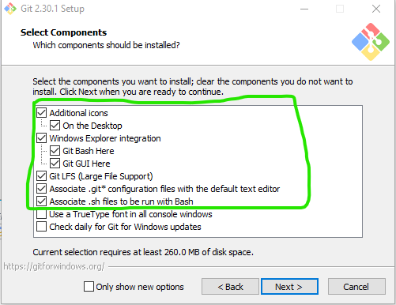

Figure 1 - Select components for installation

## Default editor -> select Visual Studio Code

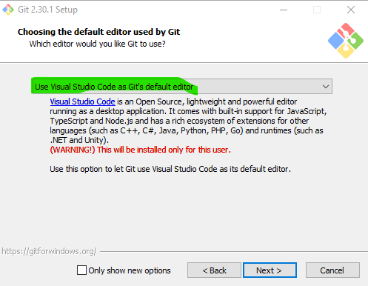

Figure 2 - Select default Git editor

## Initial branch name in new repositories -> select “Leg Git decide”

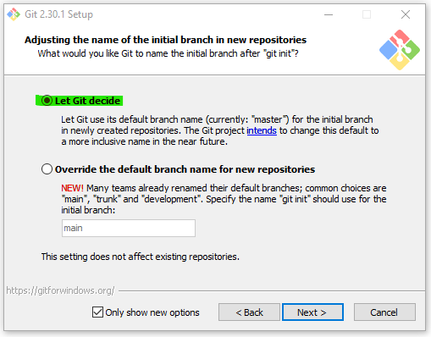

Figure 3 - Initial branch name in new repositories

## Adjusting PATH environment -> select “Recommended” option

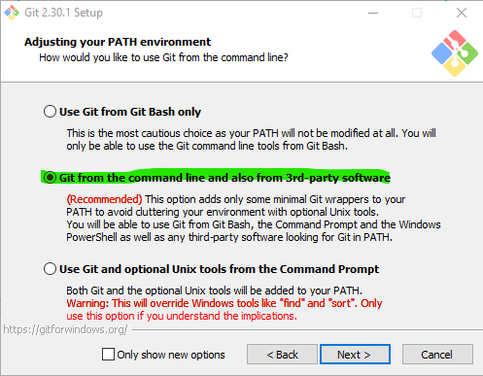

Figure 4 - Adjusting PATH environment

## Chose HTTPS transport backend -> select “Use the OpenSSL library”

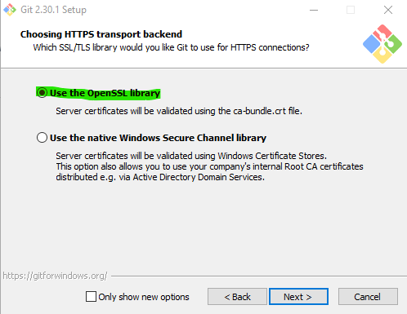

Figure 5 - Choose HTTPS transport backend

## Configure the line ending conversions -> select “Checkout Windows style”

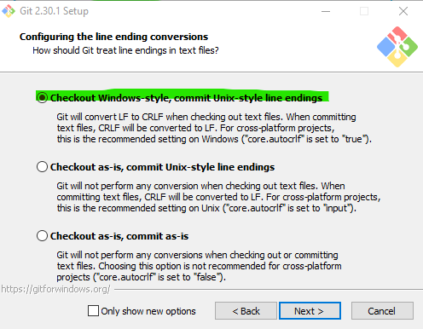

Figure 6 - Configuring the line ending conversions

## Configuring the terminal emulator -> select “Use MinTTY”

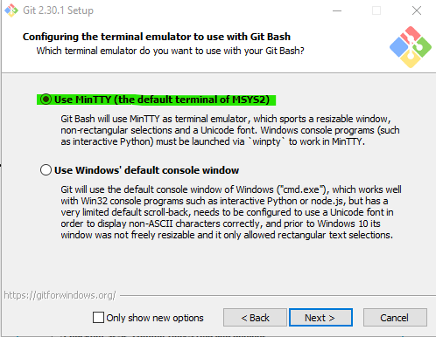

Figure 7 - Configuring the terminal emulator

## Choose default behavior of “git pull” -> select “Default”

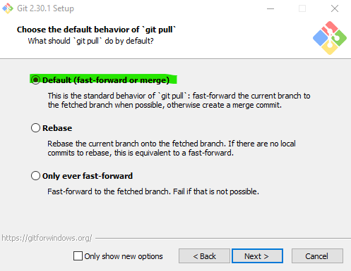

Figure 8 - Choose default behaviour of git pull

## Choose a credential helper -> choose “None”

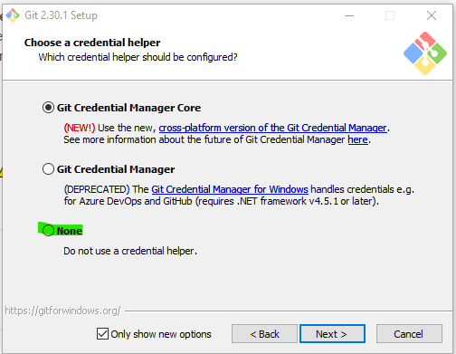

Figure 9 - Choose a credential helper

## Configuring extra options -> select “Enable file system cashing”

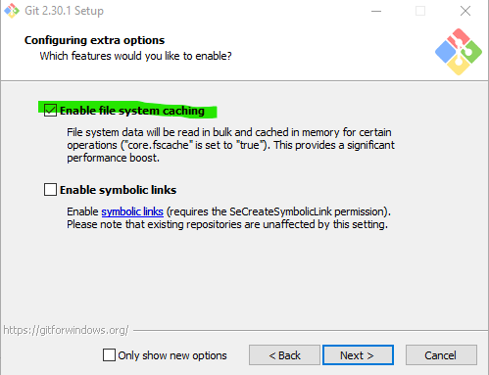

Figure 10 - Configuring extra options

## Configuring experimental options -> skip this

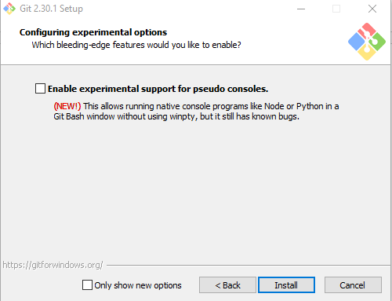

Figure 11 - Configuring experimental options

* Download link

<https://desktop.github.com/>

* If you already have a GitHub account, skip this step.

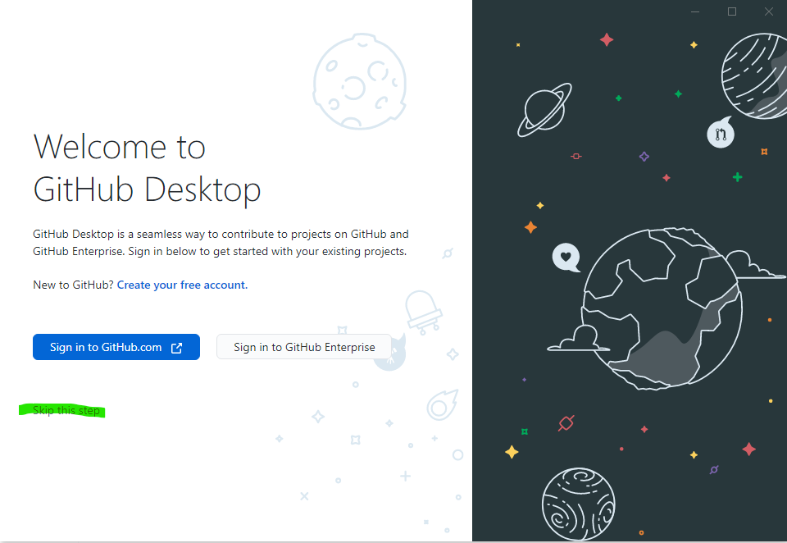

* Fill in requested data (name and email)

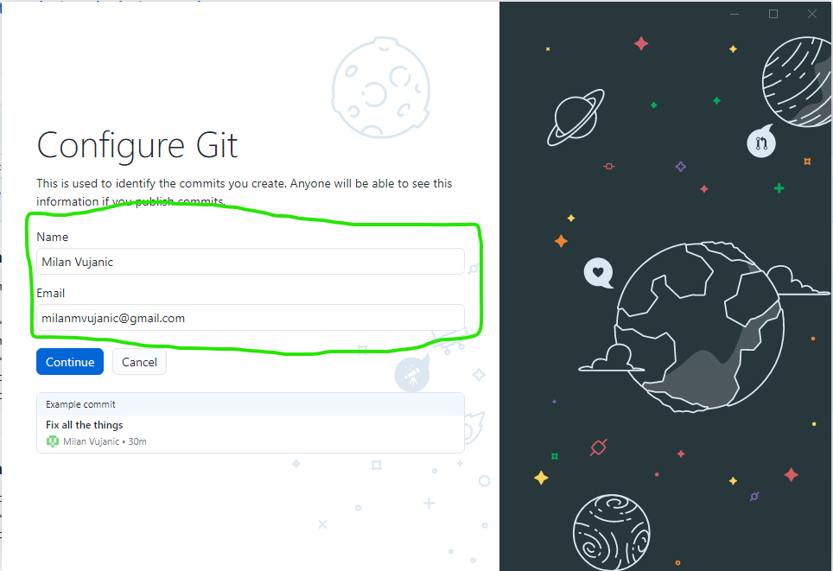

* Uncheck this suggestion and click “Finish”

