Requirements

No | Non-functional requirement | Description
NFR1 | Design | The look and the feel of the system should be chosen with high taste and the appearance of it should match type of the business it has been developed for.
NFR2 | Usability | The application should be easy to use and follow. Use simple but descriptive, content navigation icons and text
NFR3 | Performance | The application should respond UI events quickly without delays.
NFR4 | Accessibility | The application should to take into account the user disabilities. It has been found that certain users suffer from color blindness. Thus, choice of colors should be taken into deep consideration to increase UI accessibility.

No | Functional requirement | Description
FR1 | Weather | Display weekly weather information
FR2 | User Registration | Users should be able to sign in and sign up with the following information (username, password)
FR3 | User Profile | Each user should have exclusive profile and should be able to change their profile
FR4 | User Database | Each signed up user should be added to a database
FR5 | Search | Users should be able to search news by title
FR6 | Publisher | News should be sortable by publishers  (i.e. BBC, CNN and etc.)

UML Activity Diagram
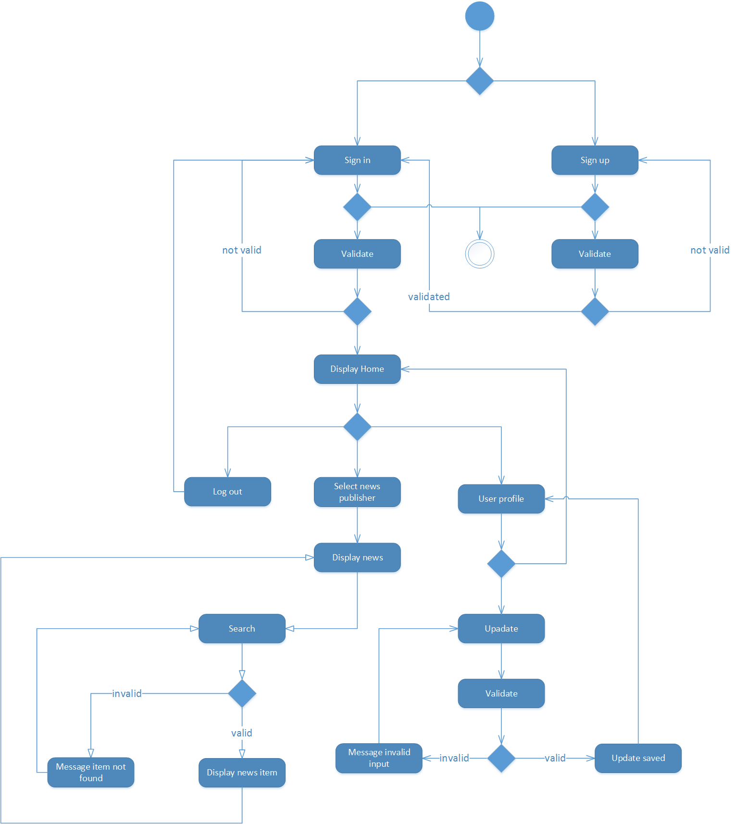

Prototyping

Sign up > Sign in > Home
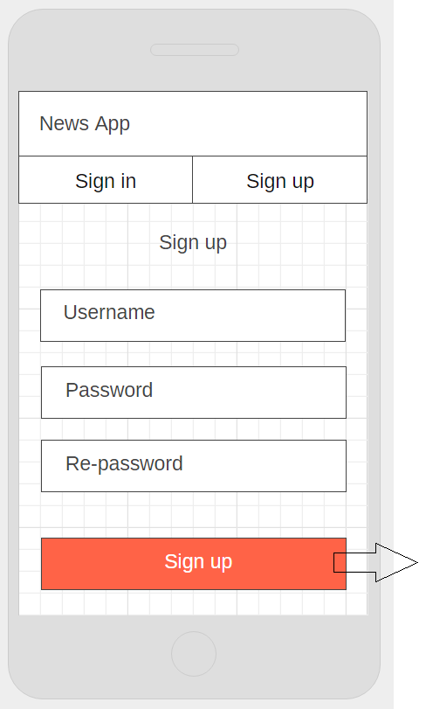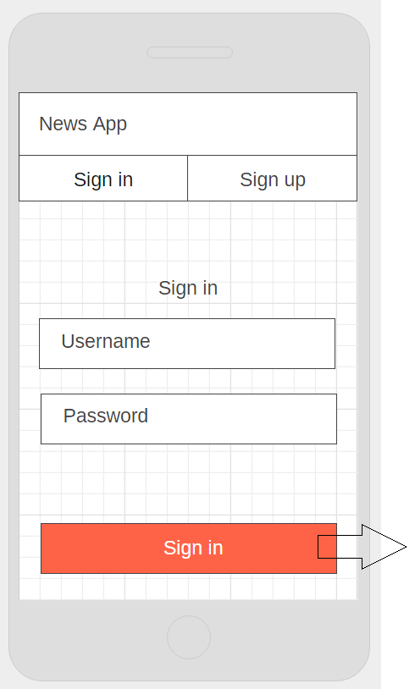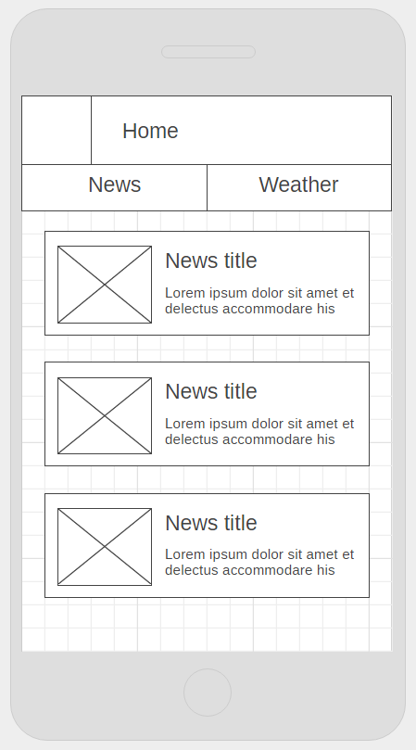
Home>Select Item news
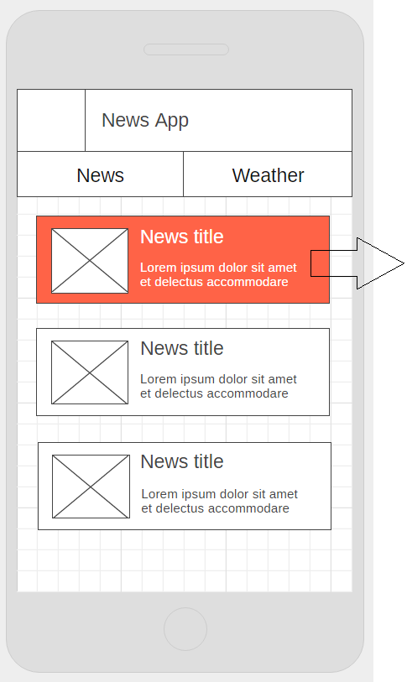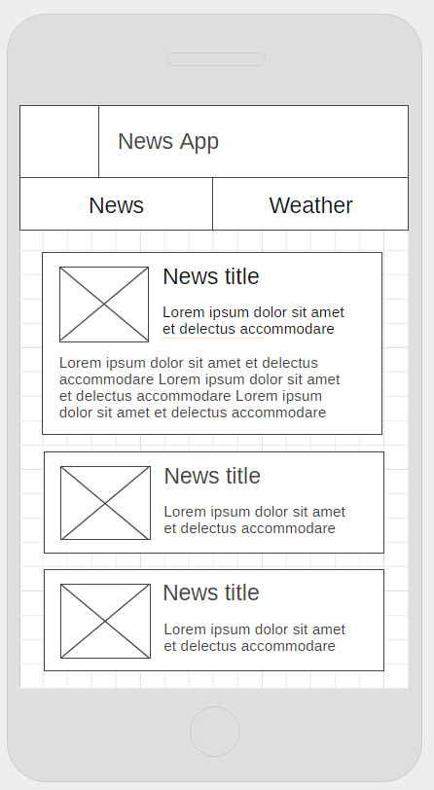
Home>Weather
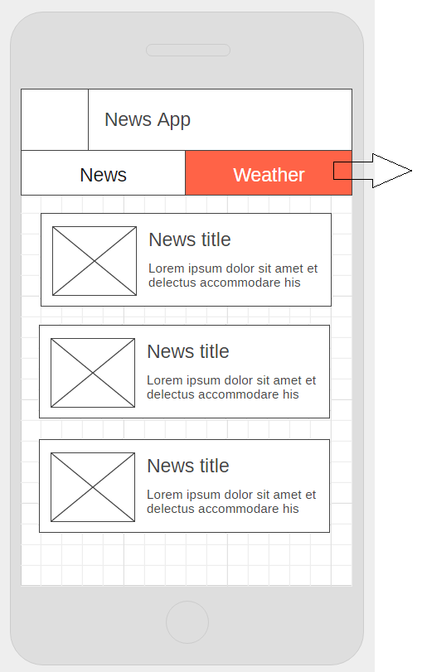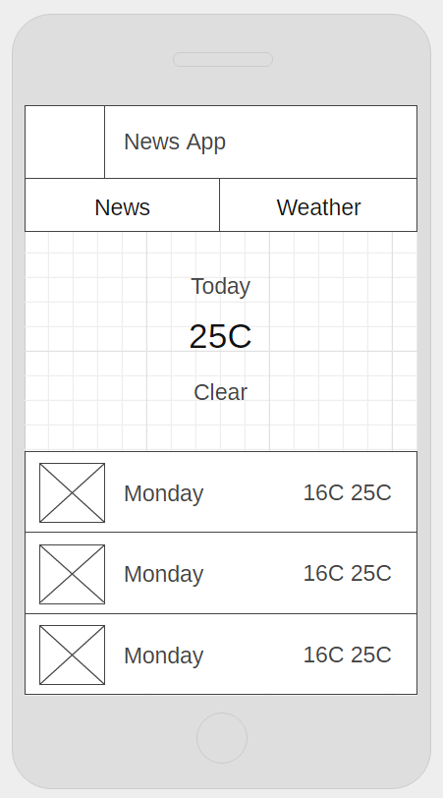
Drawer>User>Profile
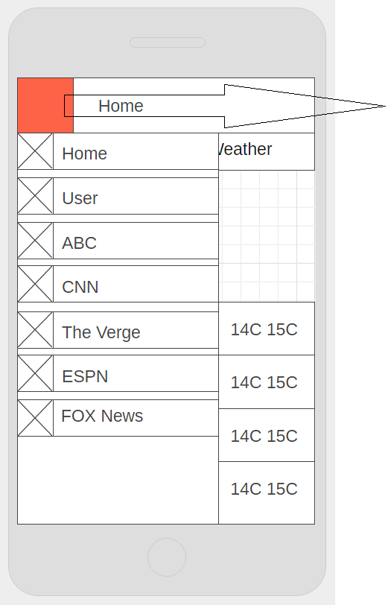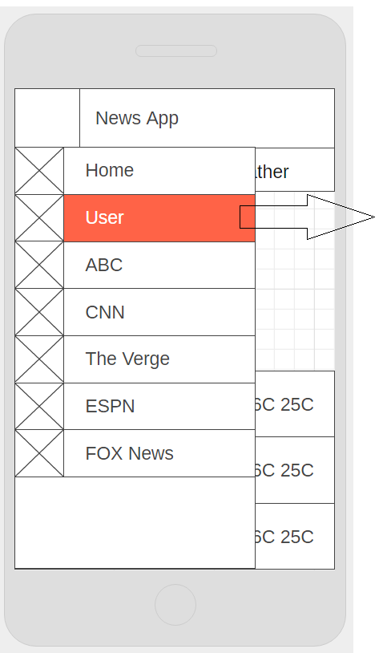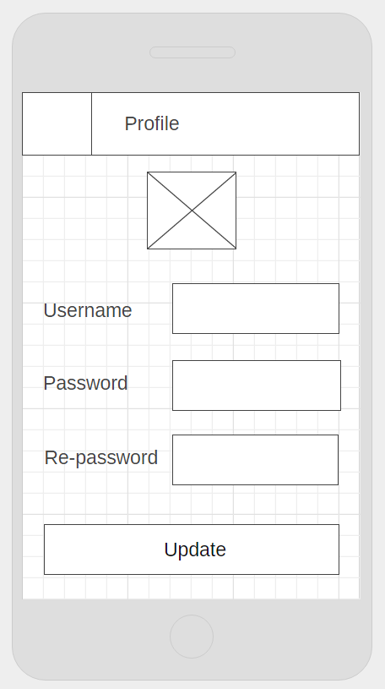
Drawer>Publisher>Publisher
