2048 Number Puzzle Game




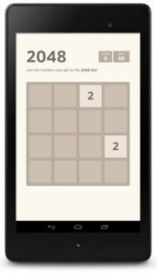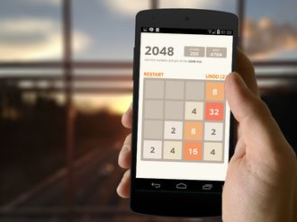
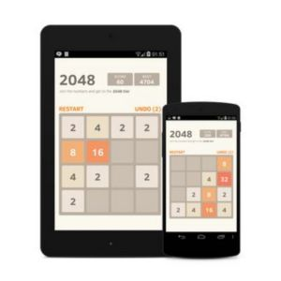

Best Iq Test
Run your imagination and find a logical explanation for the mysterious puzzles! Find the solution, open the Cryptex and see what awaits you in the next stage. Play The Best IQ Test and find out if you're a genius!

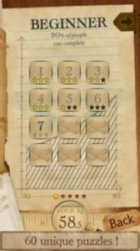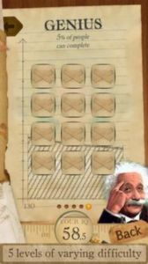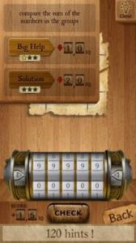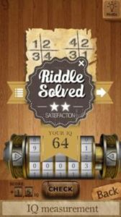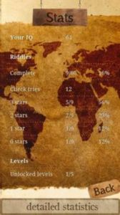

PyramidHD
Tired of simple Solitaire games?
Presenting to you an highly interactive Solitaire game.
Pyramid is a one-player trump card game with simple rules that you can play repeatedly.
FEATURES
* Simple operations by simply tapping the screen.
* Beautiful 3D graphics.
HOW TO PLAY
*Cards are chosen or deleted so that the total sum of the numbers is 13.
*After choosing one card, any card can be deleted by choosing the Joker card.
*The game is cleared once all the cards are deleted.
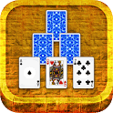
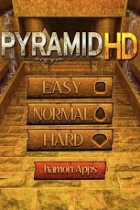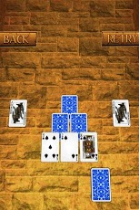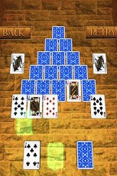

Sudoku Master
Sudoku Master is #1 Sudoku game available in Google Play with beautiful graphics and killer features.
Sudoku Master has been polished to perfection
and boasts an intuitive, touch screen game play which makes you never need a paper puzzle again. Now challenge yourself to more than 2000 puzzles and 4 levels of difficulty from Easy to Expert!
Game Features:
- Two modes - Classic & Casual (auto remove the wrong numbers)
- 4 Levels - Easy, Normal, Hard, Expert
- Smooth interface and Impressive graphics
- Auto-save & Resume
- Undo & Redo function
- Smart Notes (pencil marks)
- Error checking (incorrect entry highlighting)
- Selected digit highlighting
- Statistics tracking
Game Rules:
Sudoku is a logic-based number-placement puzzle. The objective is to fill a 9×9 grid with digits so that each column, each row, and each of the nine 3×3 sub-grids contains all of the digits from 1 to 9.
