**C:\Users\1122\Desktop\bullshit - копия\template_blank\Games\Clockwork Brain - Training with Insanely Fun Puzzles on the App Store on iTunes_files\freedownload.jpg**

**American Mensa Brain Test**

**By Barnstorm Games**

* Version: 1.3.0
* Size: 39.7 MB
* Language: English
* Seller: NOMISIAN LTD

**Compatibility:**Requires iOS 4.3 or later. Compatible with iPhone, iPad, and iPod touch.

**Elevate - Brain Training**

**By Elevate, Inc.**

* Version: 1.20
* Size: 89.6 MB
* Languages: English, Arabic, Bokmål, Norwegian, Catalan, Czech, Danish, Dutch, Finnish, French, German, Greek, Hebrew, Hungarian, Indonesian, Italian, Japanese, Korean, Malay, Norwegian Nynorsk, Polish, Portuguese, Romanian, Russian, Simplified Chinese, Slovak, Spanish, Swedish, Thai, Traditional Chinese, Turkish, Ukrainian, Vietnamese
* Seller: Elevate Labs, LLC
* © 2014 Elevate, Inc.

**Compatibility:**Requires iOS 7.1 or later. Compatible with iPhone, iPad, and iPod touch. This app is optimized for iPhone 5, iPhone 6, and iPhone 6 Plus.

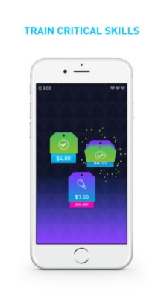**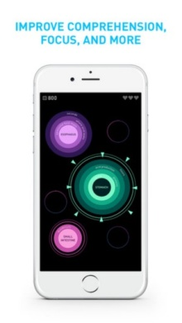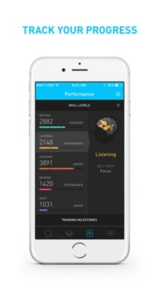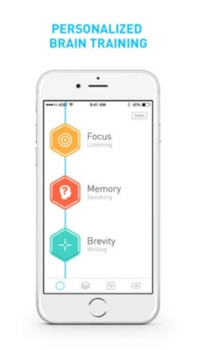**

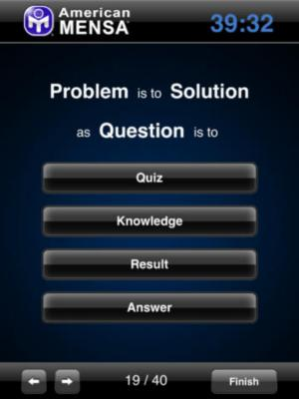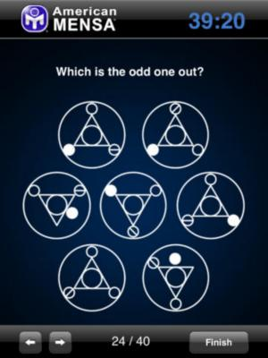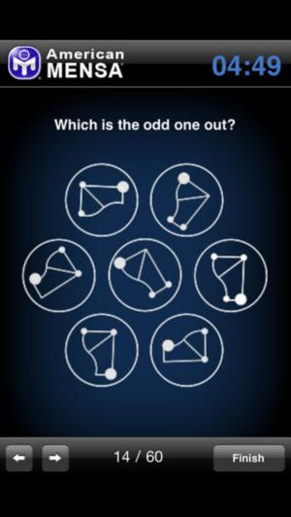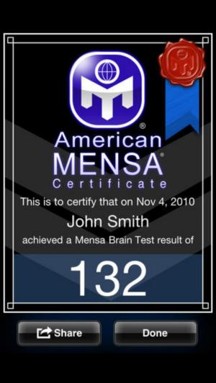

**Clockwork Brain - Training with Insanely Fun Puzzles**

**By Total Eclipse P.C.**

* Version: 1.3.4
* Size: 82.8 MB
* Language: English
* Seller: Total Eclipse P.C.

**Compatibility:**Requires iOS 6.0 or later. Compatible with iPhone, iPad, and iPod touch.



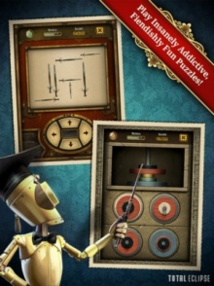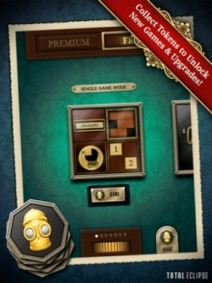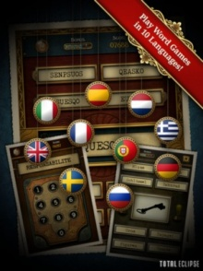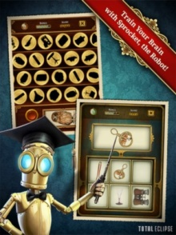



**Brain School ™ Training - Games Trainer !**

**By Mastersoft Mobile Solutions**

* Version: 1.36
* Size: 48.9 MB
* Language: English
* Seller: Dominic Masters
* © Mastersoft Ltd

**Compatibility:**Requires iOS 8.0 or later. Compatible with iPhone, iPad, and iPod touch.

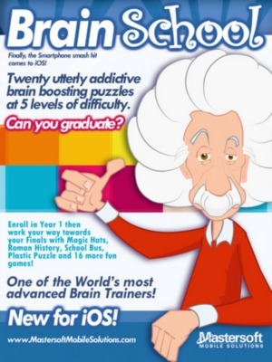

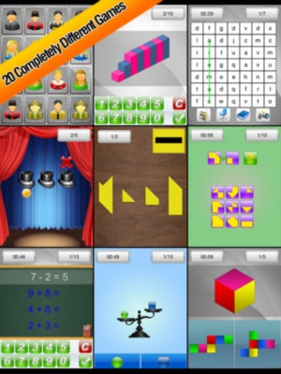

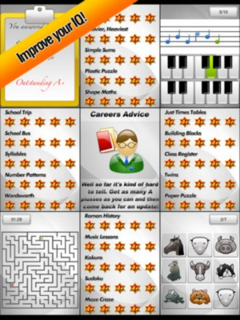

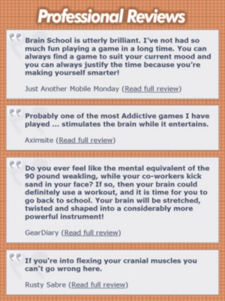



**CogniFit Brain Fitness**

**By CogniFit**

* Size: 157 MB
* Language: English
* Seller: CogniFit
* © CogniFit

**Compatibility:**Requires iOS 7.1 or later. Compatible with iPhone, iPad, and iPod touch.

