**COURSEWORK SUBMISSION FORM**

|  |  |  |  |
| --- | --- | --- | --- |
| **STUDENT USE** | | **STAFF USE** | |
| Module Name | Introduction to Web Publishing | First Marker’s  (acts as signature) |  |
| Module Code | 2UZB409 | Second Marker’s  (acts as signature) |  |
| Lecturer Name | Farhod Fayzullayev | Agreed Mark |  |
| UoW Student IDs |  | **For Registrar’s office use only (hard copy submission)** | |
| WIUT Student IDs | 00003741 |
| Deadline date | 14 March 2016 |
| Assignment Type | 🗌Group☑Individual |

**SUBMISSION INSTRUCTIONS**

**COURSEWORKS *must* be submitted in *both* HARD COPY (to the Registrar’s Office) *and* ELECTRONIC unless instructed otherwise.**

For hardcopy submission instructions refer to: <http://intranet.wiut.uz/Shared%20Documents/Forms/AllItems.aspx> - Coursework hard copy submission instructions.doc

For online submission instructions refer to: <http://intranet.wiut.uz/Shared%20Documents/Forms/AllItems.aspx> - Coursework online submission instructions.doc

|  |
| --- |
| **MARKERS FEEDBACK (Continued on the next page)** |
|  |

Ketty Clothing

00003741.webhosting.com

Ketty clothing is a clothing store designed to supply latest fashion trends. The main target is young people and children. The main objectives of the web site is to provide latest fashion clothes and inform about latest fashion trends.

Advantages

There are number of advantages to use website. The major one would be access to wide range of users. A website is accessible in anywhere in the world with internet connection. Unlike physical store accessibility is limited to a certain region. Another advantage of using website is related to cost. To make more profit you have to lower your costs to a minimum. Web site can be very useful in doing so. Since web hosting is significantly cheaper than renting a physical store which includes utility costs as well (i.e. electricity).

Design

Design of a website may not be important in most of the content, but the objective is their functionality (e.g. taxi ordering company). However its not the case when you build fashion website. Layout, look, and feel of a website is not only important but critical. To ensure right designed I had to make some research. I studied similar websites (e.g. GUCCI, ARMANI, CALVIN KLEN and etc.) I used web site designing tools such as Proto Sketch, Macow Scarlet and Photoshop to make sure appropriate design. Moreover, I used sites such as coolors.co and platteo.com to generate appropriate colors that distract eyes, easy to read and suitable with the content design and layout. I also used latest trending fonts on web design from Google fonts.

Accessibility

Accessibility is an essential ingredient of any successful website. To make my website accessible to a wide range of user I used accessibility check site such as webaim.org. in addition I read some articles on psychology of colors and used colors that easy to read and non-distractive

Features

Slide

Photo change on hover

Mega Menu

Google Map API

Form

Search (valid inputs: time, home, phone sales)

Font Bold

Navigation

I used linear-horizontal navigation menu with image dropdown as main navigation

Screenshot

Also I have used side vertical menu on products and sales content.

Screenshot

Footer navigation

Screenshot

JavaScript

I have used JavaScript for the following

Drop-down menu

Mouseenter.show()

Mouseleave.hide()

To change font

When you click B butoon it calls function bold() which bolds all the fonts

Function bold() {

$(“#content”).css({“font-weight”:”bold”})

}

For Slide

The logic behind the slide is quite simple

1. I put images in ul li item in horizontal order with float:left
2. I create function that changes the margin-left when margin left is changed ul moves left and shows next image
3. I set interval that execute slide function in every 5 seconds

Search Engine

To make search field work I did the following:

1. I create function and declare cases such as time, home, contact inside function
2. I created case functions
3. And linked to input and button

So when user write something it takes user input and compares with the cases and if any true then it executes case function else it shows not valid input

Evaluation

I tested my website across different browsers (chrome, Opera, Firefox and IE).

I used online tools to check online evaluation tools such as WAWE (Web Accessibility Evaluation Tool) webaim.org and webs.purchase.edu. Also feedback from tutor and friends

Competitor Evaluation

To evaluate other website I used the techniques

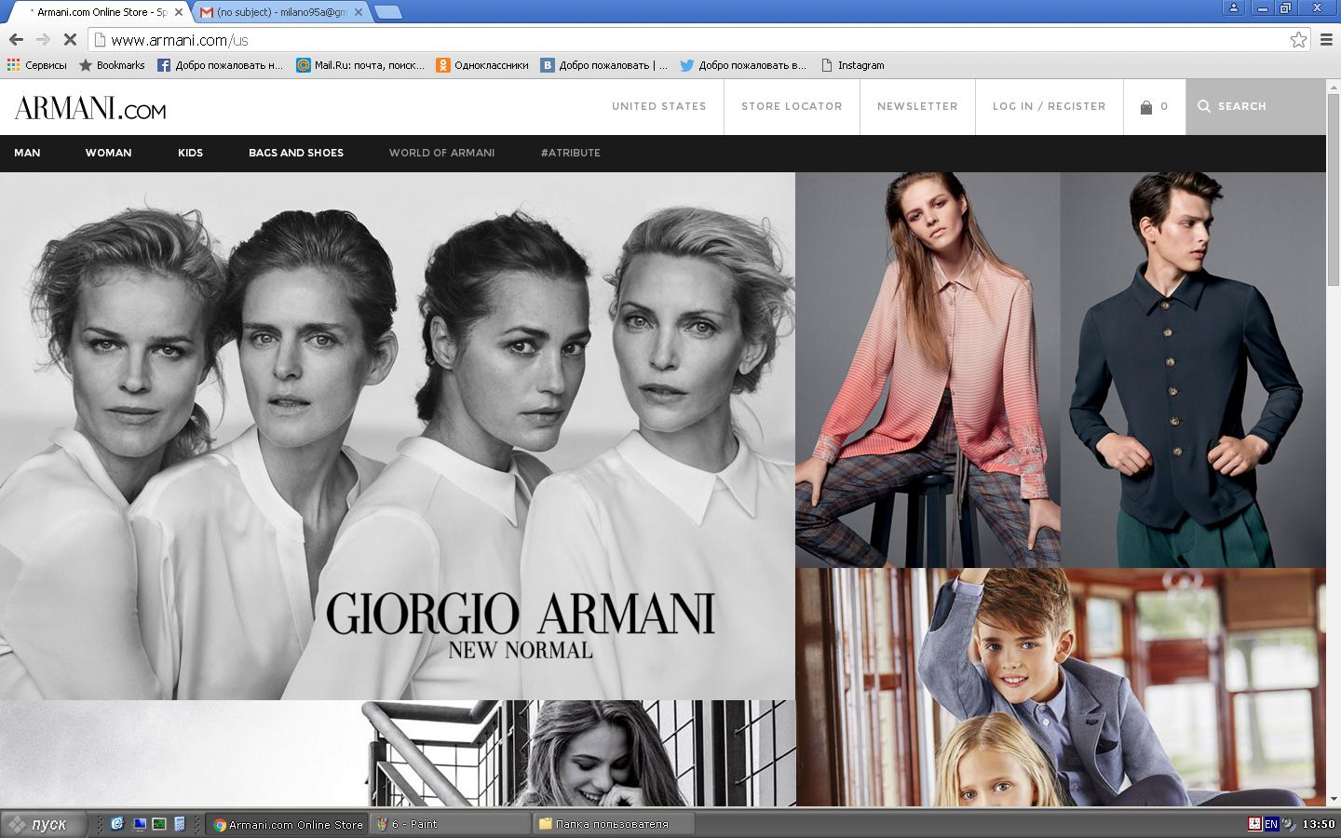

<http://www.armani.com/wx>

ARMANI

|  |  |
| --- | --- |
| Advantage | Disadvantage |
| Exceptional design | Slow |
| Appropriate fonts |  |
| Appropriate colors |  |
| Direct Contact |  |
| Exceptional image zooming |  |

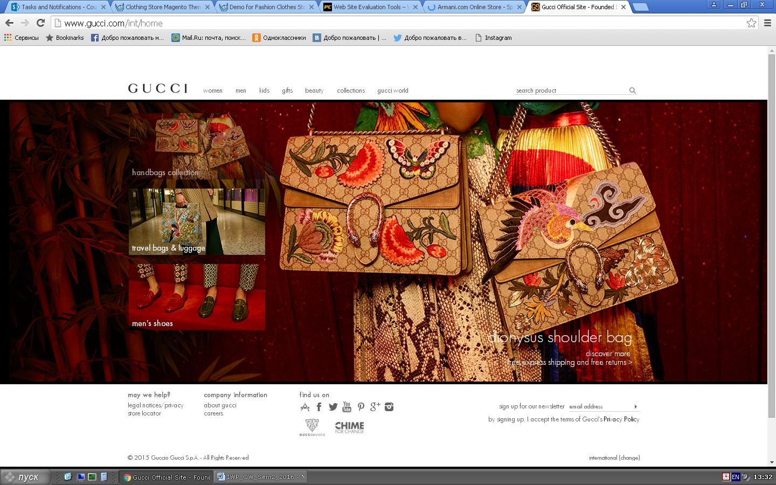

<https://www.gucci.com/us/en/>

GUCCI

|  |  |
| --- | --- |
| Advantages | Disadvantage |
| Exceptional design technique’s | Readability is low |
| appropriate colors | Colors in contras |
| Offline magnifier |  |
| Social engagement |  |
| Direct contact |  |