Task-3

- Start a full vulnerability scan.
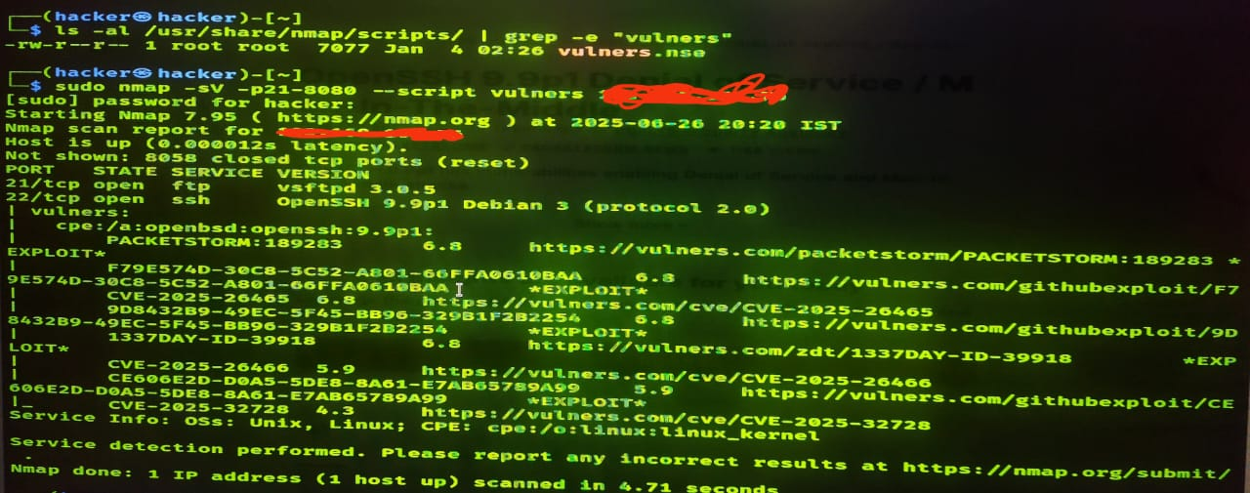

Command- 1) ls -al /usr/share/nmap/scrips/ | grep -e “vulners”
2) nmap -sV -p21-8080 -scripts vulners <IP>

