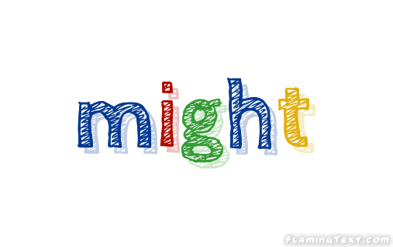

Um darüber zu reden, was möglicherweise (nicht) geschehen könnte, verwendest du
might bzw. might not.
It might rain later. We might not go to the party on Saturday.

I might → I might not We might → We might not
You might → You might not You might → You might not
She might → She might not They might → They might not
_________________________________________________________________________________________
Exercises
- Match the sentences. Draw lines.

1 | I might arrive a bit late. | A | Take a jumper.
2 | It might be cold in the cinema. | B | I think it closes at 8 p. m.
3 | It might be a secret. | C | Please don’t tell anyone.
4 | They might know Sandro. | D | She isn’t feeling very well.
5 | I might not have any dinner. | E | He’s got a problem with his phone.
6 | Lisa might not go to school today. | F | Please don’t wait for me.
7 | The supermarket might not be open. | G | They go to the same school.
8 | Dan might not get your message. | H | I’m not very hungry.

- Your turn: Write sentences and share with your partner.
Three things you might do this evening:
- ______________________________________________________
- ______________________________________________________
- ______________________________________________________

Three things you might not do this evening:
- ____________________________________________________
- ____________________________________________________
- ____________________________________________________

