This script needs to have either xampp or wamp server. User has to place file and click to run

api-unsplash.php

1 data. php = It is configuration settings file such as for API Key, Pagination count changes etc..  
  
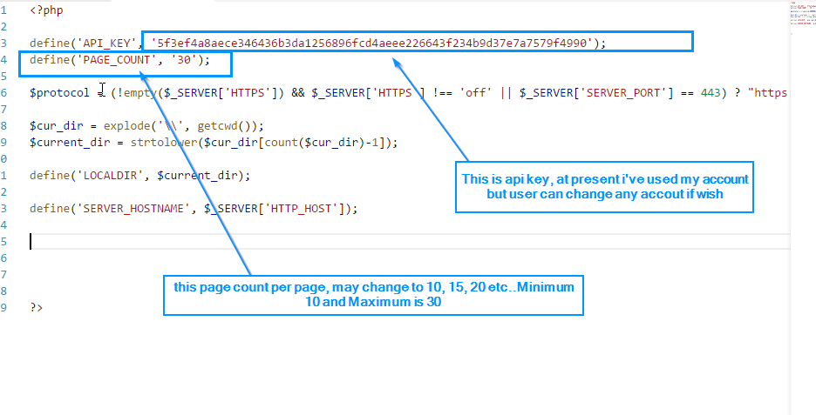

2 api-unsplash.php = Main api file to display photos.