**SOFTWARE UNIT TESTING REPORT**

**Student Name – Milan Sukhadiya**

**Student Id – S355516**

**GIT LINK** - <https://github.com/milansukhadiya/PRT582_ASSIGNMENT1>

**Table of Contents**

Introduction 3

Objective 3

Requirements 3

Process 4

Conclusion 7

Reference 9

# Introduction

In the modern world of development, different types of games have been developed using the python language for simplification and simple user interface. Among all games, ***“Rock, Paper, and Scissor”*** is a world-famous game for every human being all over the world. This is a type of hand game that is mainly played between two people. Three different types of shapes can be used in this interesting game and all of the shapes are: ***“shape of rock (fist), paper (palm facing upward), or scissors (extended two fingers)”*** (Bullock *et al.* 2022). There are mainly three rules that can be applicable at the time of playing this game and the rules are:

***Rock vs Paper -> Paper wins***

***Rock vs Scissor -> Rock wins***

***Paper vs Scissor -> Scissor wins***

For each win, the user gets 1 point, for each loss, the user loses 1 point, and for a tie, the user gets 0 points.

In this project work, the ***“Rock, Paper, and Scissor”*** game has been developed using python code with several frameworks and libraries.

# Objective

* To implement a “Rock-Paper-Scissor” game in python
* To study the basic skills of game development

# Requirements

1. The game has to be developed by taking the options from the users to choose the options.
2. The decisions have to develop with the options of the gameplay from the users.
3. The system of pointing is one point for the winner.
4. The first to reach a score of 5 will be the winners and it has to be displayed in the output sections.
5. There is the option for quitting and running the gameplay.
6. There is a code for the user to get quit anytime during their gameplay.

# Process

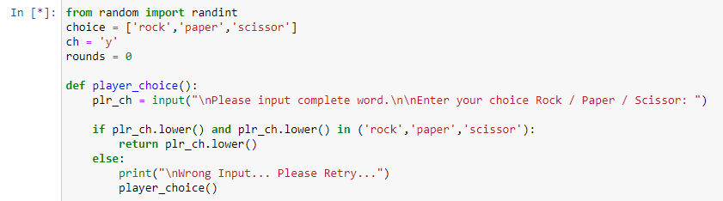

**Figure 1: Importing library function**

The randint () has been used for the game as it holds the random integers between the two types of the given numbers that can be passed. This is the reason the randint function has been used.

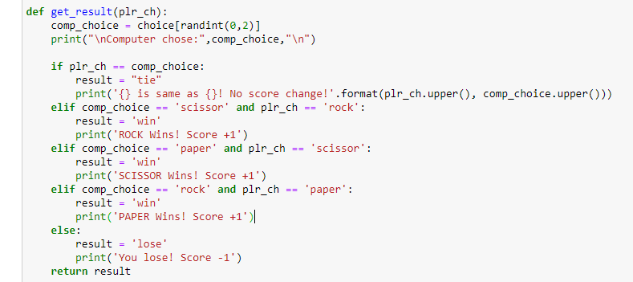

**Figure 2: Defining the choices and generating the results**

The above picture visualizes generating the solution with the conditions that have been used by printing the results that have been obtained after the end of the games.

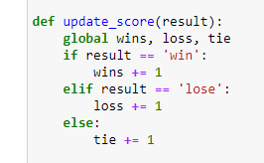

**Figure 3: Updating the scores**

Update_score has been used for storing the results after each round in the ***“Rock, Paper, and Scissor”*** game.

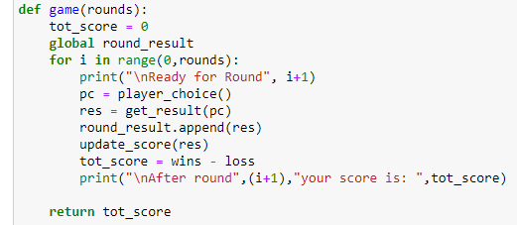

**Figure 4: Code to define the rounds**

The game has been holding functions for generating the total score and printing the scores after the rounds.

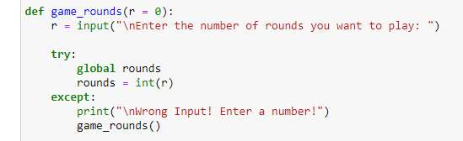

**Figure 5: Code to enter the number of rounds to be played**

The above figure is defining of the number of times for playing the games.

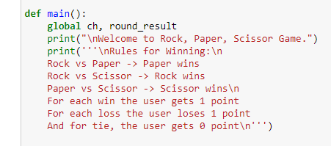

**Figure 6: Code to print the game rules**

The above figure is defining the rules for the gameplay by printing the above things.

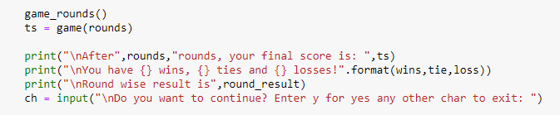

**Figure 7: Code to enter the input if the player wants to continue or not**

User input has been generated for the above figure and the gameplay.

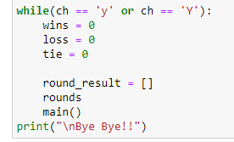

**Figure 8: Printing the result**

The conditions have been used and the printing bye-bye after the gameplay has been visualized in the above image.

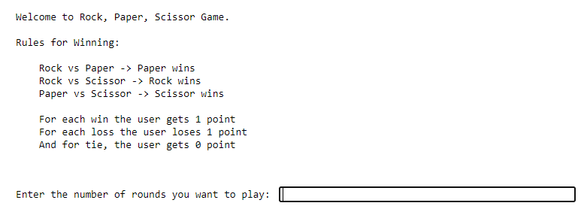

**Figure 9: Output of the rules related to the stone, paper, and scissor game**

After the execution of the codes, the above figure has been generated. The user has to enter how many rounds he/she wants to play in the above box.

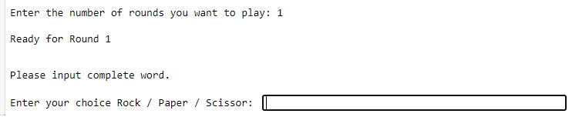

**Figure 10: Result of entering the round number and entering the choice**

The above figure is defining the gameplay with that of the user choice and generates the winner. The user has to pick a single output in complete words in the respected area on the above image.

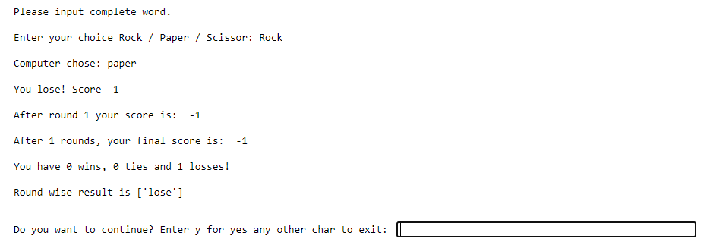

**Figure 11: Output after the first game**

The output results in the continuation of the gameplay for the users. The user has to enter y if he/she wants to continue or else he/she can enter anything except y to exit the game.

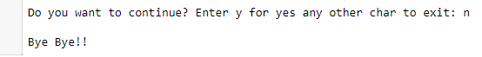

**Figure 12: Output after exiting the game**

The above figure is generated with that of the end of the gameplay taking the information from the users.

# Conclusion

The entire report is based on the gameplay of the rock, paper and scissors giving the required output and all of the screen shorts have been given in the above part of the report. Python has been used for automation tasks, data visualization and analysis. The languages such as python have been adopted to develop the ***“Rock, Paper, and Scissor”*** game.

# Reference

Bullock, E.A., Witherow, M.A. and Iftekharuddin, K.M., 2022. Hand Gesture Classification for Human-Robot Interaction in Rock-Paper-Scissors Game.