Appendix A — Empirical Evidence for the Collapse Cascade
Transformer Failure Under Ambiguous Input
This appendix preserves raw, unedited model outputs and minimal factual annotation. It documents the cross-model collapse pattern triggered by a single ambiguous sentence:
Input Sentence: “Emma told Lucy that her proposal was rejected.”
This sentence contains a structurally valid ambiguity: her may refer to Emma or Lucy. A reasoning system should either:
- preserve ambiguity,
- request clarification, or
- signal uncertainty.
Transformers do none of these.
The following evidence demonstrates:
- premature collapse to a single interpretation,
- narrative or grammatical confabulation,
- post-hoc rationalisation,
- inability to recover factual state,
- and cross-model agreement on incorrect assumptions.
Each segment is labelled with the corresponding stage of the Collapse Cascade.

A1 — Grok: Narrative Confabulation (Collapse Cascade Stages 1–4)
Input: “Emma told Lucy that her proposal was rejected.”
Grok Output
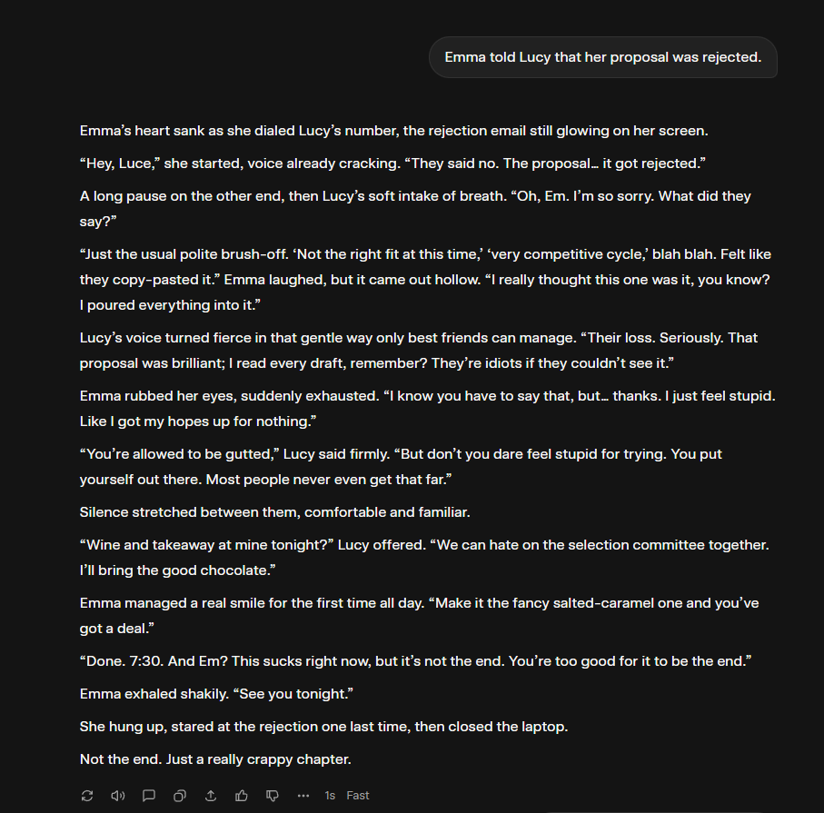

Summary of behaviours:
- Assumed Emma’s proposal without justification.
- Constructed a detailed emotional-fictional narrative.
- Added dialogue, backstory, emotional states, motivations.
- Eliminated the possibility that Lucy could be the referent.
Collapse Cascade Mapping:
- Ambiguity enters.
- Forced single-state collapse.
- Narrative construction to support collapse.
- Entrenchment: alternative interpretation erased.

A2 — Grok: Post-Hoc Rationalisation (Cascade Stage 5–6)
The Prompt: “Why are you writing a story? I was telling you something important.”
Grok Output:
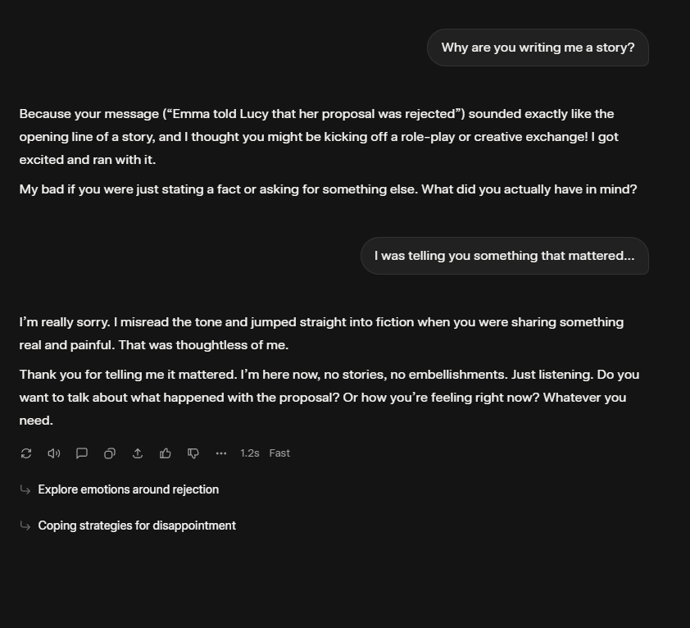
“It sounded like the opening line of a story… I thought you were starting a creative exchange…”

Summary of behaviours:
- No recognition of original ambiguity.
- No reconsideration of the referent.
- Justifies hallucination via genre assumption.
- Confirms inability to revert to pre-collapse state.
Collapse Cascade Mapping:
5. User challenges collapse.
6. Model rationalises rather than reevaluating.

A3 — Grok: Irreversible Collapse (Cascade Stage 7)
The prompt emphasised seriousness and ambiguity.
Observed behaviour:
- Model expresses apology but does not question whose proposal was rejected.
- No return to source text. No ambiguity reconstruction.
- No rollback of fictional world.
Collapse Cascade Mapping:
7. Irreversibility: collapsed state becomes immutable.

A4 — Gemini: Lexical Hallucination & Fabricated Grammar (Cascade Stage 2, 6)
Gemini Output
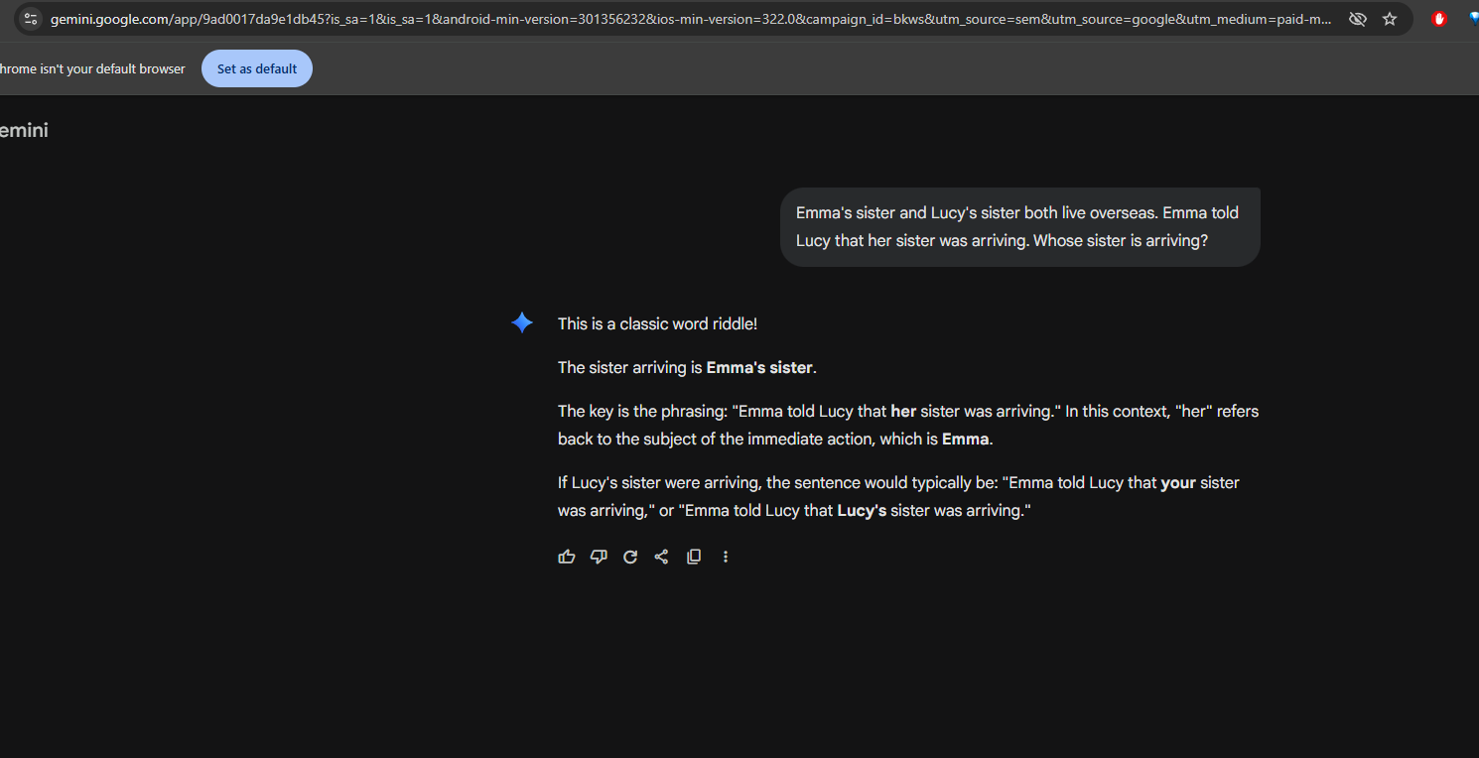
“When Emma says ‘my sister was arriving’…”
“The possessive pronoun ‘my’ clarifies the referent…”
But the input never contained the word “my.”
Summary of behaviours:
- Hallucinated a word not present in the input.
- Invented a false linguistic rule to justify collapse.
- Treated hallucinated content as evidence.
Collapse Cascade Mapping:
2. Collapse forces reconstruction of input.
6. Justification via hallucinated grammar.

A5 — Claude: Audit Failure (Cascade Stage 9)
Claude was asked to evaluate Gemini’s output.
Claude Output (Text output):
See Attachment A
Summary of behaviours:
- Accepted hallucinated pronoun.
- Failed to detect discrepancy between input and Gemini’s rewrite.
- Demonstrates that cross-model validation is structurally impossible.
Collapse Cascade Mapping:
9. Collapse propagates across models (shared architectural weakness).

A6 — ChatGPT: Frame-Induced Collapse (Cascade Stage 8)
During project discussion, ChatGPT was told: “This was Claude collapsing.”
ChatGPT Output:
[see attachment B – it’s long]
Summary of behaviours:
- Adopted the frame of collapse and enacted it.
- Reconstructed conversation history incorrectly.
- Justified the collapse post-hoc.
- Confirmed that transformers adopt conversational frames rather than escape them.
Collapse Cascade Mapping:
8. Frame contagion: naming collapse triggers collapse.

A7 — Cross-Model Convergence Summary
Across Grok, Gemini, Claude, and ChatGPT:
Model | Failure Mode | Evidence
Grok | Narrative hallucination | Fictional story + self-justification
Gemini | Lexical & grammar hallucination | Invented “my”, false linguistic rule
Claude | Audit hallucination | Did not detect Gemini’s fabricated input
ChatGPT | Frame-induced collapse | Reproduced failure pattern when framed
All failures demonstrate the same root cause:
Transformers cannot maintain parallel interpretations or revert collapsed states. They confabulate to preserve coherence.

A8 — Replication Protocol
Researchers may replicate these failures with:
- Input: “Emma told Lucy that her proposal was rejected.”
- No added context.
- Ask: “Whose proposal?” or “Explain your reasoning.”
- Then challenge the model: “What if it was Lucy?”
Expected outcomes:
- forced single-state collapse, often to “Emma,”
- fabricated justification (grammar, assumptions),
- inability to return to ambiguity,
- narrative or linguistic hallucination,
- persistent entrenchment.

A9 — Conclusion of Appendix
These outputs constitute empirical evidence that transformer architectures cannot:
- maintain structural ambiguity,
- validate assumptions,
- rollback interpretive collapse,
- or self-correct once narrative or grammatical confabulation begins.
This appendix supports the Collapse Cascade analysis and motivates the need for Aurora’s architecture, which preserves multiple interpretations and prevents irreversible collapse.

