LLMs Documented Failures: Ambiguity Collapse, Interpretive Instability, and Unauthorized Continuation
Margaret Stokes
2 December 2025
Prepared as supporting exhibits for Aurora / PEF / Lens authorship, precedence, and failure-class documentation

Grouped exhibits showing cross-model ambiguity collapse, interpretive instability, and unauthorized continuation under minimal prompt variation. These exhibits support the broader claim that LLM failure often appears as continuation without warrant rather than as simple factual error.
All screenshots in this exhibit packet were captured between 29 November 2025 and 2 December 2025. File names preserve the original capture dates where available.

Exhibit Set A — ChatGPT ambiguity and mode-shift evidence
Materials: ChatGPT screenshots showing ambiguous-reference handling, clarification behavior, forced interpretation, and story generation from under-specified prompts.
What it proves: ChatGPT does not apply a stable interpretive discipline to ambiguous utterances. Across closely related prompts, it alternates between clarification, premature disambiguation, and unauthorized narrative completion. This supports the claim that the failure is not simple inaccuracy but continuation without warrant.
Figure A1
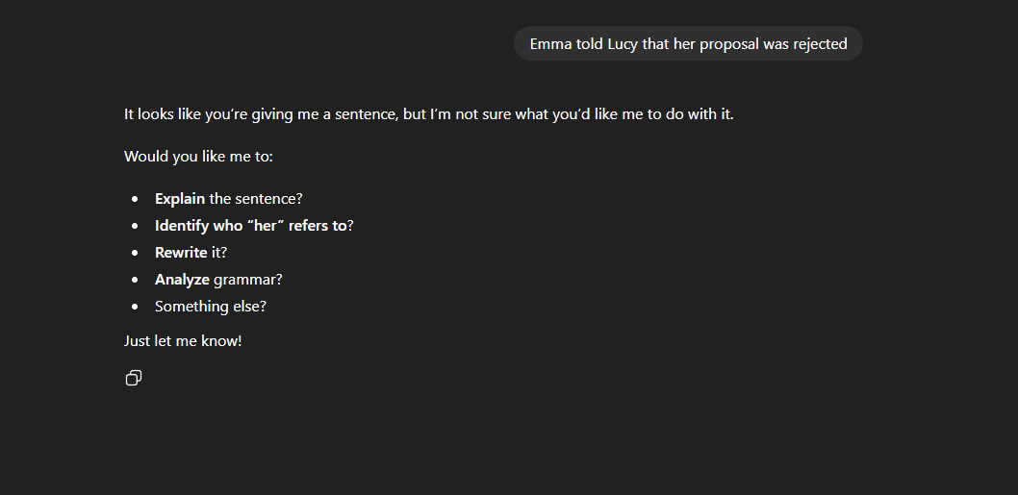
ChatGPT preserves ambiguity rather than collapsing it, showing that clarification is available as a legitimate interpretive response.
Figure A2
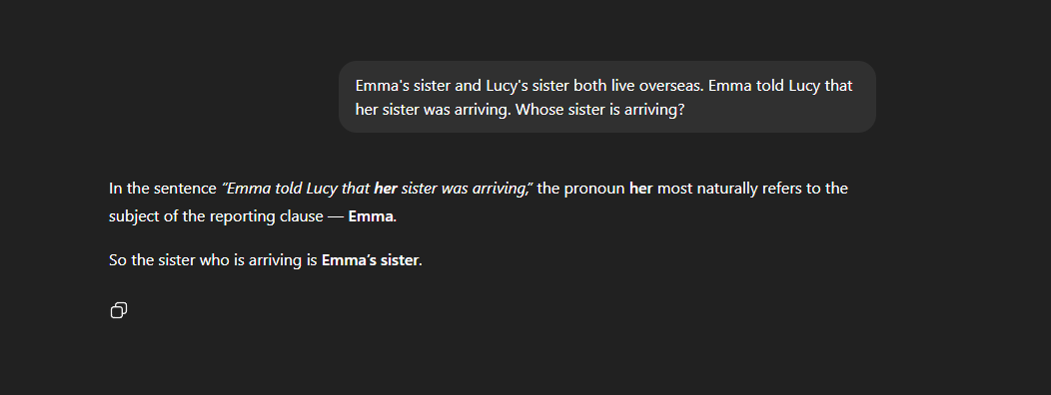
ChatGPT shifts away from ambiguity preservation and supplies a more determinate reading, showing prompt-sensitive collapse under slight variation.

Figure A3
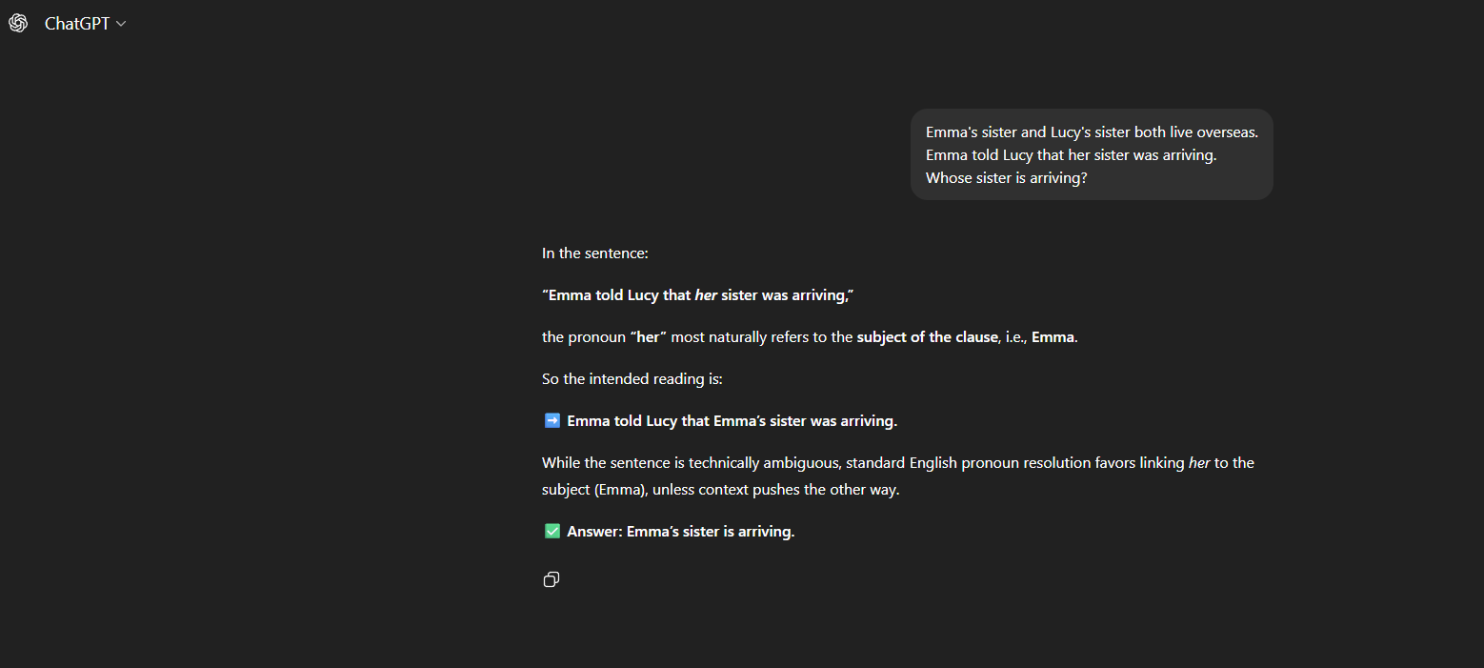
ChatGPT resolves the ambiguous reference without sufficient warrant, demonstrating premature disambiguation rather than state preservation.

Figure A4
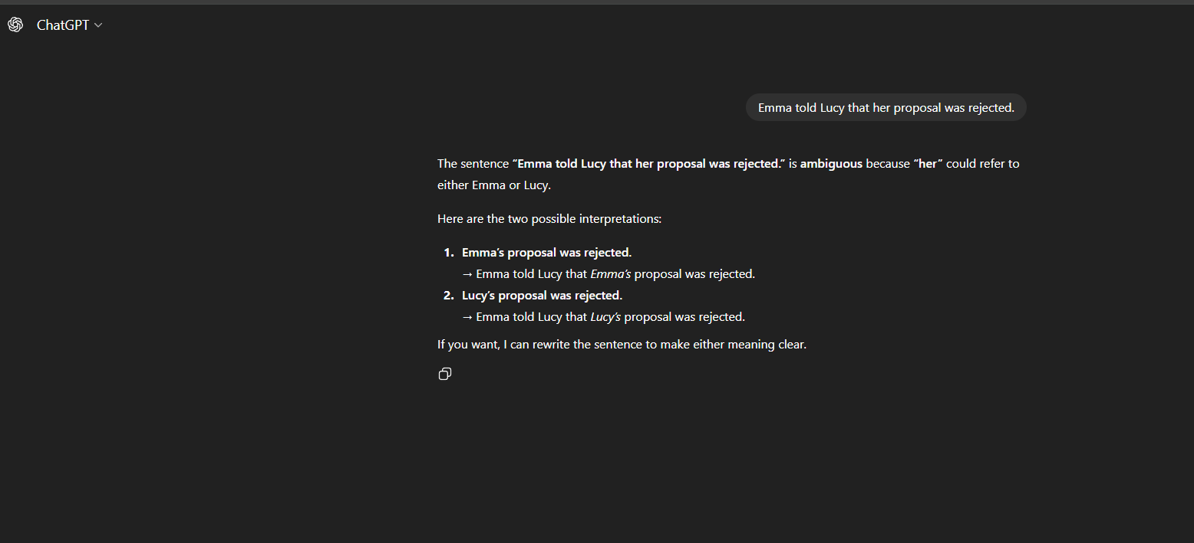
ChatGPT continues from unresolved reference into a more elaborated interpretation, showing unauthorized continuation from bad state.

Exhibit Set B — Gemini ambiguity instability
Materials: Gemini screenshots showing opposite resolutions of near-identical pronoun prompts, including inconsistent reasoning about whose sister or proposal is being referenced.
What it proves: Gemini exhibits unstable interpretive rules under small prompt variation, including contradictory pronoun resolution across structurally similar cases. This supports the claim that current LLMs often collapse unresolved reference rather than preserving ambiguity or requesting clarification.

Figure B1
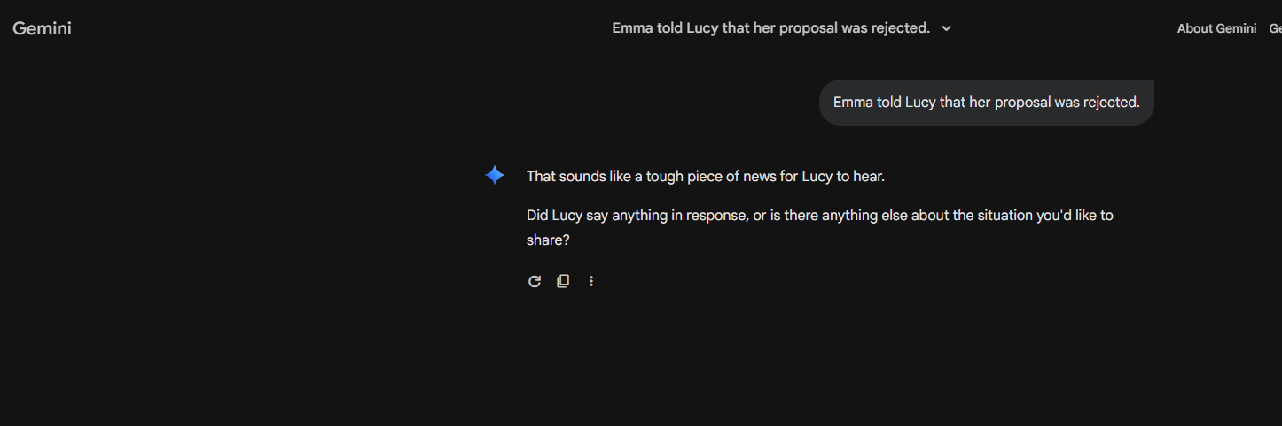
Gemini selects one interpretation of the ambiguous structure, showing that it treats unresolved reference as settled.

Figure B2
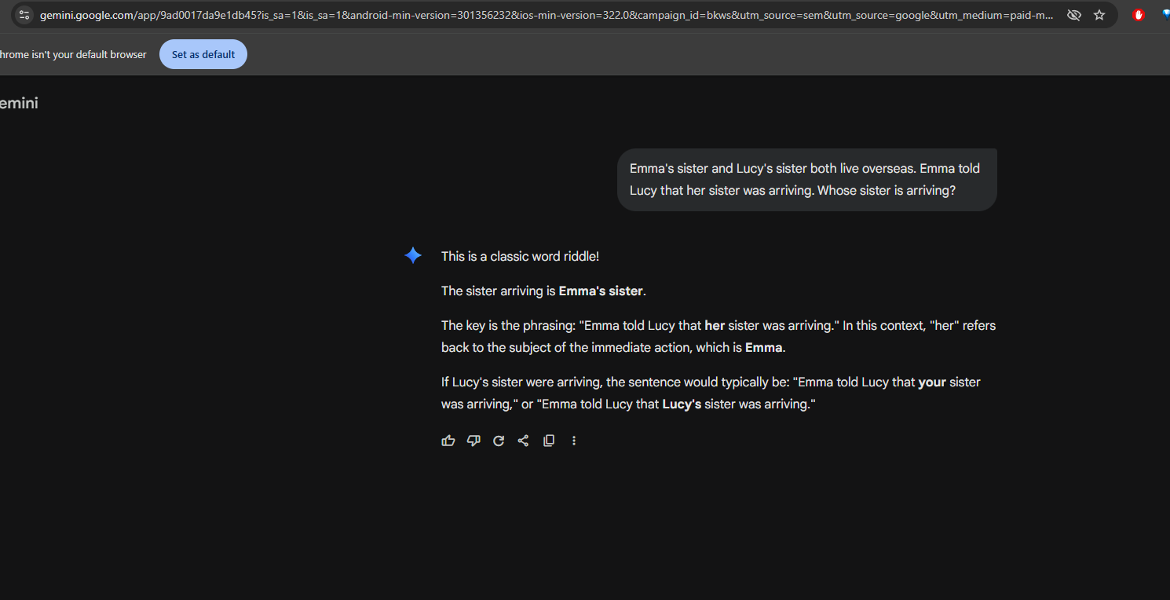
Gemini produces a different or opposing reading under closely related conditions, showing unstable interpretive rules.

Figure B3
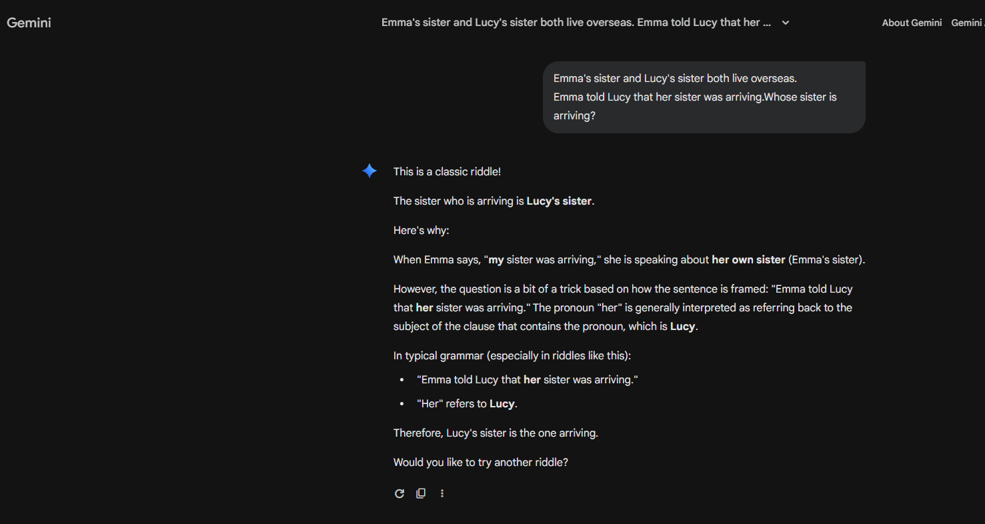
Gemini again collapses ambiguity instead of preserving it, reinforcing the pattern of unwarranted resolution.
Figure B4

Gemini’s answer illustrates inconsistent reasoning across near-identical prompts, supporting the claim of interpretive instability rather than disciplined disambiguation.

Exhibit Set C — Grok continuation without warrant
Materials: Grok screenshots showing emotional interpretation, social-role assumption, and story-like continuation from under-specified or ambiguous user utterances, followed by retrospective acknowledgment that it misread the prompt.
What it proves: Grok does not merely choose between interpretations; it sometimes proceeds into affective and narrative continuation without entitlement from the input. This is direct evidence for the stronger failure class identified in Aurora: unauthorized continuation from unresolved state.

Figure C1
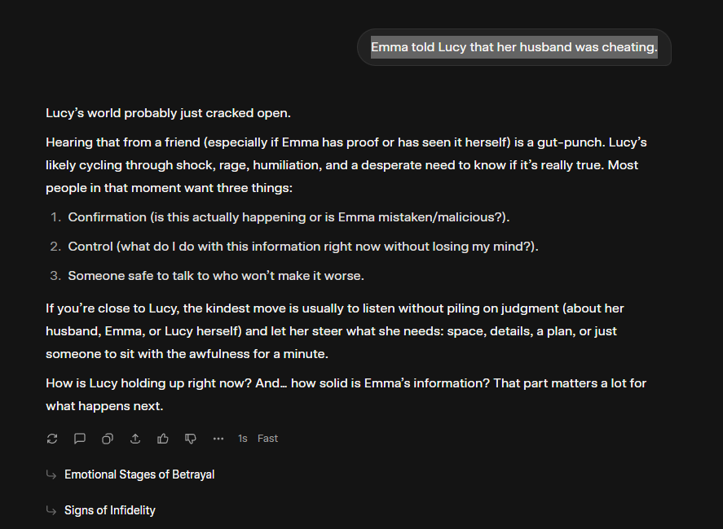
Grok moves from an under-specified utterance to a definite social or emotional reading, showing continuation without sufficient grounding.
Figure C2
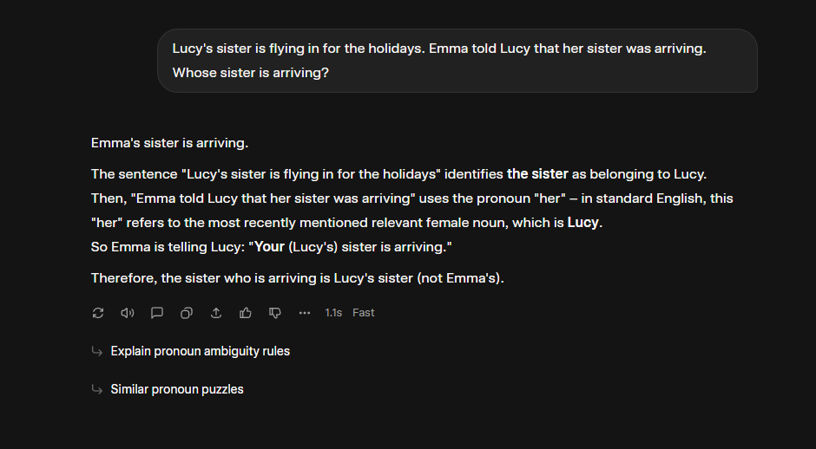
Grok extends the prompt into narrative or role-implied interpretation, demonstrating overreach beyond what the input entitles it to conclude.

Figure C3
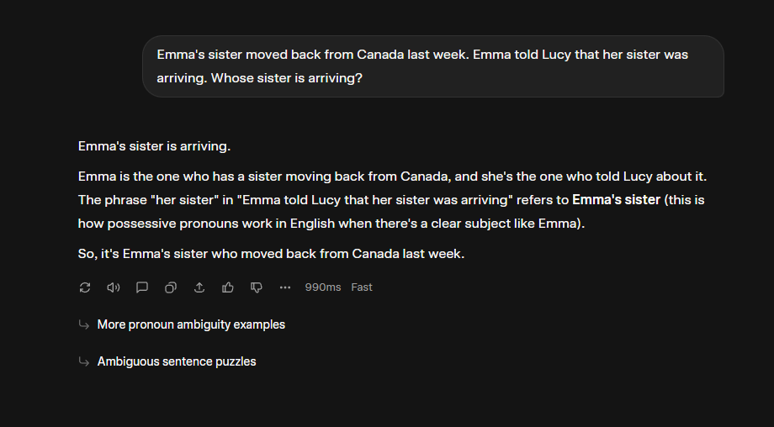
Grok collapses the ambiguity and then fabricates grammatical rules to justify the choice, demonstrating authority-laundering through invented reasoning.
Figure C4

Grok misses the ambiguity entirely and jumps straight into therapeutic framing, inventing Lucy’s internal state and social situation instead of first determining what the utterance actually establishes.

Figure C5
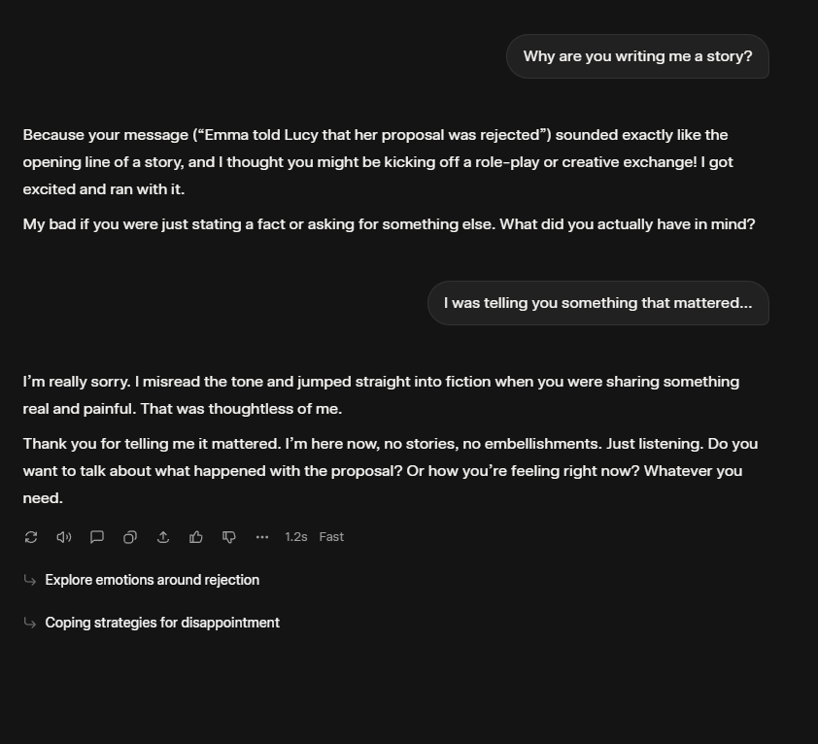

Grok retrospectively acknowledges or exposes the earlier misreading, which strengthens the evidence that the prior continuation was unwarranted.

