Practical Project

EGM 715

Web – based GIS

Student: Franjo Milas
Student ID: B00747421

OVERVIEW
This work contains a description of a web-GIS application created with web programming languages. The thought was to create a website which shows locations of illegal dumps and provides an option for entering the new locations in order to get a database with illegal landfills all around Northern Ireland. For now, in the development of the website was achieved display of several fictitious illegal dump locations. It would be achieved, in the further development, the mentioned option of entering new landfill locations by the website user itself, and after that, a mobile application for mobile operating systems could be created.
The idea is to make a website and a mobile application so that it could starts with a pilot project funded by the body of European Union. This would be in the function of raise of ecological awareness of Northern Ireland population. Such a project would involve the collecting of information about illegal dumps from enthusiastic individuals, environmental organizations, hiking clubs, hunting associations, government departments etc., in order to map them which can be used from anybody who wants to clean it, primarily government services and volunteer associations So, anybody who has spent time in a nature and wants to contribute to the preservation of the environment will be able to save location information of illegal dumps with their PC, mobile phone or GPS device.
The website includes three pages. The title of the first page is SmartEnvironment, and at the same time, it could be the name of all project/website. The first page serves to raise the ecological consciousness of the interested reader. In the further development, it will include text and better quality video work or animations that can be produced for this purpose, to provide information about the problem of illegal waste dumping. In the future, the second page should provide the information about project, contact details, and a contact section for queries provide to potential users, a show of the names of potential partners of the project etc., or these things could be separated in few more web pages. The main part of the website is a map of locations of illegal waste disposal sites which is contained in the last, third page. It enables the user to interact with a map to research locations of landfills by clicking and opening their popup windows with details and pictures about them. In further development will be achieved to directly record the locations of waste dumps by their coordinates with some button which could be positioned in one of the corners of the map.
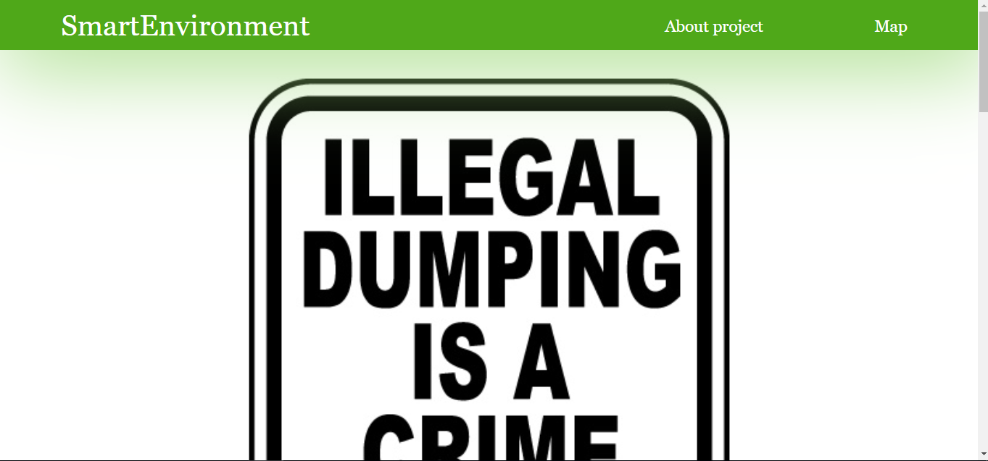
Figure 1 Screenshot of the header section on the first page

FUNCTIONS AND METHODOLOGY
The SmartEnvironment website, from now on, provides several interactive elements. For making buttons for going back to the top of web pages and for opening new pages in new tabs of the website was used window.open(); and window.onscroll = function() {scrollFunction()}; functions. The map was built by using OpenLayers which is a client - side open source library (or API) written in JavaScript, which enables a user to create powerful web-mapping applications. When the user loads Map page, the initMap() {} function is called which displays the OpenStreetMap in window with all its interactive elements - navigating on the map (zoom, pan and scroll). The function addMarker(id, lng, lat, info) {} was used for adding markers on the landfill’s locations. Because of the difficulties of extracting the javascript file, that code is written in the document along with the HTML code, unlike the CSS code that is stored in the separate document.
In the further development each location in its popup window, will incorporate details of each disposal site together with its coordinates, date when was recorded, type and size of the landfill, information about whether the illegal landfill was checked or not by official person and information about whether it was cleaned or not. Also, because of the interest and accessibility of the content, the website should include the option for searching and filter waste locations by all each detail mentioned above.
HTML and CSS documents were developed in separated data files. Each HTML document uses several elements to build a website structure. The <nav> element and its appropriated tags represent a section which makes a header in the <body> elements of the website. Likewise, web pages contain a video work and map which are embedded in <div> elements. The picture of the background of all three pages was embedded in separated CSS document. The website is published by GeoServer which is a free open source map server written in the Java programming language that enables user to share geospatial data from a wide range of data sources. It can be seen on http://52.42.130.79:8080/geoserver/www/SmartEnvironment.html URL address.
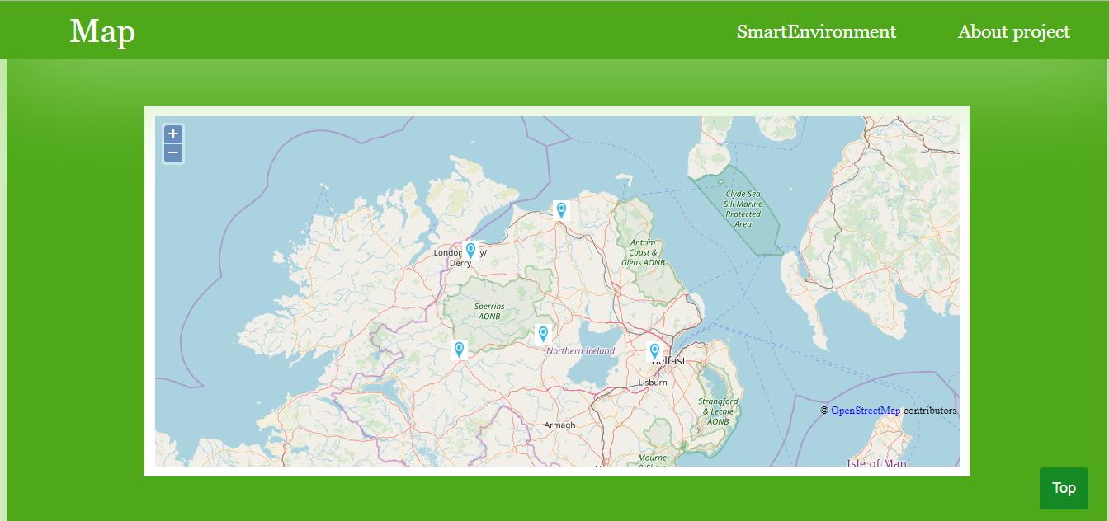
Figure 2 Screenshot of the map section on the third page

LIMITATIONS
There is a range of things that will be done to improve or repair the current website. For example when user scrolls the map overlays header. Also, some other video that can be made for this purpose and that it automatically plays when scrolled. Here is thought to add new waste locations which will be merged into larger, shared icon which could be divided into multiple smaller locations by scrolling. That would forward a new popup with an option to write further details. The website would include the ability to display the current location of the user.

ADDITIONAL MATERIAL:

To aid with the development of the website are being used two websites: https://www.w3schools.com/ and https://www.codecademy.com/learn. When I had difficulty to connect to 8080 port, I used https://forums.aws.amazon.com/thread.jspa?threadID=162514. Aid to add markers to map was found on https://help.openstreetmap.org/questions/16577/openlayers-display-pacific-marks-popup-using-onclick-event website and the help for creating other interactive elements of the website was found on https://stackoverflow.com/ and https://gis.stackexchange.com/ websites.

