MICROCONTROLLER
(3351101)

DIPLOMA 5TH SEMESTER



LABORATORY MANUAL



Compiled by
Milav J Dabgar

DEPARTMENT OF ELECTRONICS AND COMMUNICATION ENGINEERING
GOVERNMENT POLYTECHNIC, PALANPUR

GOVT. POLYTECHNIC, PALANPUR
Electronics & Communication Department

Index

Sr. No | Title | CO | Date | Assessment Rubrics |  |  |  |  | Total | Sign
 |  |  |  | Exp.  setup | Operating setup | Safety measurers | Record/Observation | Result | Total | Sign
1. | To study the architecture of 8051 µC | CO1
2. | Basic Tutorial for Keil Software | CO1
3. | Write and execute ALPs based on Arithmetic and Logical Instructions | CO2
4 | Write and execute ALPs based on Data transfer, Branching and looping Instructions | CO2
5 | Write and execute ALPs based on Timer/Counter and Interrupt Instructions | CO2
6. | To perform the interfacing of LED with µC 89C51 | CO3
7. | To perform the interfacing of relay with 8051 microcontroller. | CO3
8 | To perform the interfacing of LCD with µC 89C51 | CO3
9. | To perform the interfacing of STEPPER MOTOR with µC 89C51 | CO4
10. | To interface LDR and seven segment with microcontroller 89C51. | CO4
11 | To perform the interfacing of ADC-0804 with µC 89C51 | CO4
12 | To perform the interfacing of EXTERNAL MEMORY with µC 89C51 | CO5
13 | To perform the Interfacing of 8255 and 8279 with 89C51. | CO5
14 | To perform Serial communication with PC Using HyperTerminal | CO5

EXPERIMENT-1
AIM: To study the architecture of 8051 µC

THEORY:

Introduction:
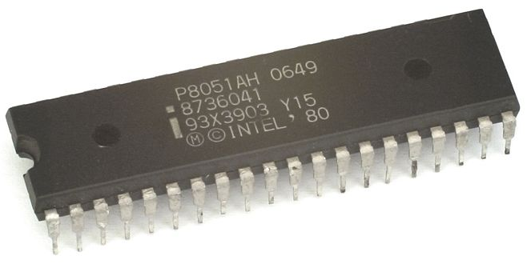
The Intel MCS-51 (commonly referred to as 8051) is Harvard architecture, single chip microcontroller (µC) series which was developed by Intel in 1980 for use in embedded systems. Intel's original versions were popular in the 1980s and early 1990s. While Intel no longer manufactures the MCS-51, binary compatible derivatives remain popular today.
Intel's original MCS-51 family was developed using NMOS technology, but later versions, identified by a letter C in their name (e.g., 80C51) used CMOS technology and consumed less power than their NMOS predecessors. This made them more suitable for battery-powered devices.
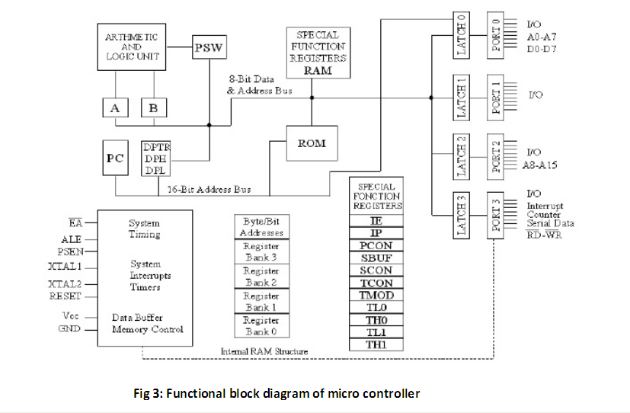
Simplified Block diagram:

Features:
- 8-bit ALU, Accumulator and 8-bit Registers; hence it is an 8-bit microcontroller
- 8-bit data bus – It can access 8 bits of data in one operation
- 16-bit address bus – 64 KB (65536 locations) each of RAM and ROM
- On-chip RAM – 128 bytes (data memory)
- On-chip ROM – 4 Kbyte (program memory)
- Four byte bi-directional input/output port
- UART (serial port)
- Two 16-bit Counter/timers with Two-level interrupt priority
- Power saving mode (on some derivatives)

Pin diagram:
Pins 1-8: Port 1, Each of these pins can be configured as an input or an output.
Pin 9: RS A, logic one on this pin disables the microcontroller and clears the contents of most registers. In other words, the positive voltage on this pin resets the microcontroller. By applying logic zero to this pin, the program starts execution from the beginning.
Pins10-17: Port 3 Similar to port 1, each of these pins can serve as general input or output. Besides, all of them have alternative functions:
Pin 10: RXD Serial asynchronous communication input or Serial synchronous communication output.
Pin 11: TXD Serial asynchronous communication output or Serial synchronous communication clock output.
Pin 12: INT0 Interrupt 0 input.
Pin 13: INT1 Interrupt 1 input.
Pin 14: T0 Counter 0 clock input.
Pin 15: T1 Counter 1 clock input.
Pin 16: WR Write to external (additional) RAM.
Pin 17: RD Read from external RAM.
Pin 18, 19: X2, X1 Internal oscillator input and output. A quartz crystal which specifies operating frequency is usually connected to these pins. Instead of it, miniature ceramics resonators can also be used for frequency stability. Later versions of microcontrollers operate at a frequency of 0 Hz up to over 50 Hz.

Pin 20: GND Ground.
Pin 21-28: Port 2 If there is no intention to use external memory then these port pins are configured as general inputs/outputs. In case external memory is used, the higher address byte, i.e. addresses A8-A15 will appear on this port. Even though memory with capacity of 64Kb is not used, which means that not all eight port bits are used for its addressing, the rest of them are not available as inputs/outputs.
Pin 29: PSEN If external ROM is used for storing program then a logic zero (0) appears on it every time the microcontroller reads a byte from memory.
Pin 30: ALE Prior to reading from external memory, the microcontroller puts the lower address byte (A0-A7) on P0 and activates the ALE output. After receiving signal from the ALE pin, the external register (usually 74HCT373 or 74HCT375 add-on chip) memorizes the state of P0 and uses it as a memory chip address. Immediately after that, the ALU pin is returned its previous logic state and P0 is now used as a Data Bus. As seen, port data multiplexing is performed by means of only one additional (and cheap) integrated circuit. In other words, this port is used for both data and address transmission.
Pin 31: EA By applying logic zero to this pin, P2 and P3 are used for data and address transmission with no regard to whether there is internal memory or not. It means that even there is a program written to the microcontroller, it will not be executed. Instead, the program written to external ROM will be executed. By applying logic one to the EA pin, the microcontroller will use both memories, first internal then external (if exists).
Pin 32-39: Port 0 Similar to P2, if external memory is not used, these pins can be used as general inputs/outputs. Otherwise, P0 is configured as address output (A0-A7) when the ALE pin is driven high (1) or as data output (Data Bus) when the ALE pin is driven low (0).
Pin 40: VCC +5V power supply.
Memory Organization
The 8051 has two types of memory and these are Program Memory and Data Memory. Program Memory (ROM) is used to permanently save the program being executed, while Data Memory (RAM) is used for temporarily storing data and intermediate results created and used during the operation of the microcontroller. Depending on the model in use (we are still talking about the 8051 microcontroller family in general) at most a few Kb of ROM and 128 or 256 bytes of RAM is used. However…
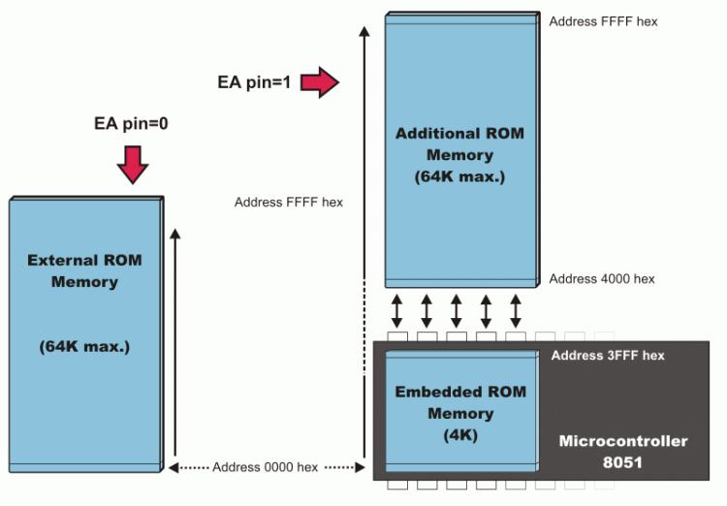
All 8051 microcontrollers have a 16-bit addressing bus and are capable of addressing 64 kb memory. It is neither a mistake nor a big ambition of engineers who were working on basic core development. It is a matter of smart memory organization which makes these microcontrollers a real “Programmers’ goody“.
EA=0 In this case, the microcontroller completely ignores internal program memory and executes only the program stored in external memory.
EA=1 In this case, the microcontroller executes first the program from built-in ROM, then the program stored in external memory.
In both cases, P0 and P2 are not available for use since being used for data and address transmission. Besides, the ALE and PSEN pins are also used.
Special Function Registers (SFRs)
Special Function Registers (SFRs) are a sort of control table used for running and monitoring the operation of the microcontroller. Each of these registers as well as each bit they include, has its name, address in the scope of RAM and precisely defined purpose such as timer control, interrupt control, serial communication control etc. Even though there are 128 memory locations intended to be occupied by them, the basic core, shared by all types of 8051 microcontrollers, has only 21 such registers. Rest of locations is intentionally left unoccupied in order to enable the manufacturers to further develop microcontrollers keeping them compatible with the previous versions.

Counters and Timers
As you already know, the microcontroller oscillator uses quartz crystal for its operation. As the frequency of this oscillator is precisely defined and very stable, pulses it generates are always of the same width, which makes them ideal for time measurement. Such crystals are also used in quartz watches. In order to measure time between two events it is sufficient to count up pulses coming from this oscillator. That is exactly what the timer does. If the timer is properly Programmed, the value stored in its register will be incremented (or decremented) with each coming pulse, i.e. once per each machine cycle. A single machine-cycle instruction lasts for 12 quartz oscillator periods, which means that by embedding quartz with oscillator frequency of 12MHz, a number stored in the timer register will be changed million times per second, i.e. each microsecond.
The 8051 microcontroller has 2 timers/counters called T0 and T1. As their names suggest, their main purpose is to measure time and count external events. Besides, they can be used for generating clock pulses to be used in serial communication, so called Baud Rate.
Interrupts
There are five interrupt sources for the 8051, which means that they can recognize 5 different events that can interrupt regular program execution. Each interrupt can be enabled or disabled by setting bits of the IE register. Likewise, the whole interrupt system can be disabled by clearing the EA bit of the same register. Refer to figure below.
Now, it is necessary to explain a few details referring to external interrupts- INT0 and INT1. If the IT0 and IT1 bits of the TCON register are set, an interrupt will be generated on high to low transition, i.e. on the falling pulse edge (only in that moment). If these bits are cleared, an interrupt will be continuously executed as far as the pins are held low.

CONCLUSION:
______________________________________________________________________________________________________________________________________________________________________________________________________________________________________________________

EXPERIMENT-2
AIM: Basic Tutorial for Keil Software

APPARTUS:
    - Minimum PC requirement:
Windows XP SP2, Windows Vista or Windows 7
Mouse or Similar Pointing Device
Available Hard Disk Space
C51: 200Mbytes
C251: 100Mbytes
C166: 100Mbytes
MDK: 1.4GBytes
1GBytes of RAM (2GB recommended)
Pentium Class PC

THEORY:
The sample program included in the tutorial toggles Ports 1 and 2 on the 8051
Basic Keil Tutorial
Open Keil from the Start menu
The Figure below shows the basic names of the windows referred in this document
Starting a new Assembler Project
- Select New Project from the Project Menu.
- Name the project ‘Toggle.a51’
- Click on the Save Button.
- The device window will be displayed.
- Select the part you will be using to test with. For now we will use the Dallas Semiconductor part DS89C420.
- Double Click on the Dallas Semiconductor
- Click OK.
In case of Atmel AT89C51 select it from

Creating Source File
- Click File Menu and select New.

- A new pop-up window will open in the Keil IDE.
- Write a program to toggle the Port.

- Click on File menu and select Save As… .ASM and SAVE it
Adding File to the Project
- Expand Target 1 in the Tree Menu

- Click on Project and select Targets, Groups, Files…

- Click on Groups/Add Files tab

- Under Available Groups select Source Group 1

- Click Add Files to Group… button

- Add created .ASM file

- Click OK when return to target menu

- Expand the Source Group 1 in the Tree menu to ensure that the file was added to the project

Creating HEX file
- Click on Target 1 in Tree menu
- Click on Project Menu and select
Options for Target 1
- Select Target Tab Change Xtal (MHz) to 11.059 MHz (or as your target board crystal frequency)

- Select an Output tab and click on Creating Hex file, with Hex file name and target folder.
(Note: Here make sure to rename Hex file name for different .ASM files for same Project .uv2 file, otherwise same Hex file will be replaced by new rebuild program)
- Click on Project Menu and select
- Rebuild all Target Files
- In the Build Window it should report
‘0 Errors (s), 0 Warnings’
- Now your Hex file is ready to burn into controller

CONCLUSION:

EXPERIMENT - 3
AIM: Write and execute assembly language programs based on Arithmetic and Logical Instructions.

Program 1: Decrement contents of TL0, TH0, TL1 and TH1 by 1.

Program 2: Increment the contents of RAM location 13H, 14H, 15H using indirect addressing only.

Program 3: Add the bytes in register R3 and R4; put the result in RAM location 4Ah(LSB) and 4BH(MSB).

Program 4: Subtract the contents of TH0 from TH1; put the result in TL0.

Program 5: Multiply the data in RAM location 22h and 15h;put the result in RAM location 19(low byte) and 1Ah(high byte)

Program 6: Divide data in internal RAM location 45h by data 12h put quotient in external RAM location 4545h and reminder in external RAM location 4546h.

Program 7: OR The contents of Port 1 and Port 2,put the result in external ram location 0100h.

Program 8: Swap the nibbles of R0 and R1.So that the lower nibbles of R0 swaps with higher nibble of R1 and vice versa.

Program 9: Move bit 4 of RAM location 30H to bit 2 of A.

Program 10: Rotate the contents of @0 four times left and add it in the contents of R1 and store the result in internal RAM location 2Ah.

CONCLUSION:
______________________________________________________________________________________________________________________________________________________________________________________________________________________________________________________

EXPERIMENT - 4
AIM: Write and execute assembly language programs based on Data Transfer, Branching & Looping Instructions.

Program 1: Place the number 3Bh in internal RAM locations 40h to 42h.

Program 2: Set timer 1 at A25Eh.

Program 3: Load R7 by data from external location A397h.

Program 4: Copy the data in external RAM location 0123h to TL0 and data in external RAM location 0234h to TH0.

Program 5: Copy the external code byte at address 2050h to external RAM address 2050h.

Program 6: Exchange both low nibbles of register R5 and R6; put the low nibble of R5 and R6, and the low nibble of R6 and R5.

Program 7: Write code to clear the accumulator f bits p2.1 and p2.2 are both high; otherwise make A= FFh

Program 8: Monitor bit P1.5 continuously. When it becomes low, send 55h to P2.

Program 9: Fill the external data memory location from 0100h to 0200h with the number AAh.

Program 10: To initialize port 1 as input, port 2 as output. If port 1 is FFh(all high) then p2.0 is high else p2.0 is low.

CONCLUSION:
______________________________________________________________________________________________________________________________________________________________________________________________________________________________________________________

EXPERIMENT-5
AIM: Write and execute assembly language programs based on Timer/Counter & Interrupts.

Program 1: Write a program to generate a square wave of 2 kHz on p1.1. Crystal frequency is 11.0592MHz.

Program 2: Write a program for timer 0 to create pulse width of 5ms on p2.2. Assume that XTAL=11.0592MHz.

Program 3: Write a program for counter 1 in mode 2 to count the pulses and display the state of the TL1 and count on P2. Assume that clock pulses are fed into pin T1.

Program 4: Write a program that continuously gets 8-bot data from p0 and send it to p1 while simultaneously creating square wave of 200µsec period on p2.1. Use Timer 0 to creat the square wave.
Assume XTAL=11.0592MHz.

Program 5: Write a program to generate a square wave of 50kHz frequency on p1.7. User Timer 1. Mode 1 interrupt driven and assume XTAL=11.0592MHz.

Program 6: Assuming that pin 3.3(INT1) is connected to a pulse generator. Write a program in which the falling edge of the pulse will send a high P1.3, Which is connected to an LED.

CONCLUSION:
______________________________________________________________________________________________________________________________________________________________________________________________________________________________________________________

EXPERIMENT-6
AIM: To study the interfacing of LED with µC 89C51

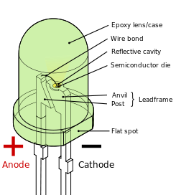
APPARATUS:
    - Micro controller 89C51
    - LED
    - 12 MHz crystal
    - 7805 voltage regulator IC
    - Bridge rectifier IC
    - 33 PF capacitor
    - 10 microf/63V capacitor
    - 8K2 resistor
    - 1K resistors
THEORY:
LEDs are by far the most widely used means of taking output. They find huge application as indicators during experimentations to check the validity of results at different stages. They are very cheap and easily available in a variety of shape, size and colors.
The principle of operation of LEDs is simple. The commonly available LEDs have a drop voltage of 1.7 V and need 10mA to glow at full intensity. The following circuit describes “how to glow a led”.
The value of resistance R can be calculated using the equation, R= (V-1.7)/10 mA. Since most of the controllers work on 5V, so substituting V= 5V, the value of resistance comes out to be 330 ohm. The resistance 220 ohm, 470 ohm is commonly used substitute in case 330 ohm is not available.
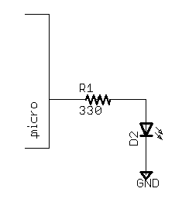
CIRCUIT DIAGRAM:
LEDs are connected to the port P0. LEDs need approximately 10mA current to flow through them in order to glow at maximum intensity. However the output of the controller is not sufficient enough to drive the LEDs, so if the positive leg of the LED is connected to the pin and the negative to ground as shown in the figure, the LED will not glow at full illumination.
To overcome this problem LEDs are connected in the reverse order and they run on negate.ve logic i.e., whenever 1 is given on any pin of the port, the LED will switch off and when logic 0 is provided the LED will glow at full intensity.
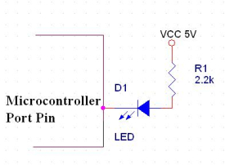
As soon as we provide supply to the controller, the LEDs start blinking i.e., they become on for a certain time duration and then become off for the same time duration. This delay is provided by calling the delay function.

ALGORITHM:
Start

Turn ON LED

Wait for some time (delay)

Turn OFF LED

Wait for some time (delay)

Go to start

You can see in the modified algorithm that after turning ON the LED the controller waits for the delay period & then turns OFF the led & again waits for the delay period & then goes back to the start.

PROGRAM:
ORG 0000h
loop: CLR P1.0
CALL DELAY
SETB P1.0
CALL DELAY
JMP loop
delay: mov R7,#100
l1_delay: djnz r7,l1_delay
ret

CONCLUSION:
______________________________________________________________________________________________________________________________________________________________________________________________________________________________________________________

EXPERIMENT-7
AIM: To study the interfacing of relay with 8051 microcontroller.

APPARTUS:
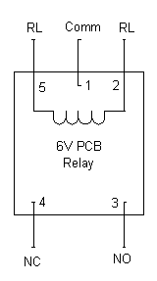
    - Micro controller 89C51
    - Relay
    - 12 MHz crystal
    - 7805 voltage regulator IC
    - Bridge rectifier IC
    - 33 PF capacitor
    - 10 µF/63V capacitor
    - 8K2 resistor
    - 1K resistors

THEORY:
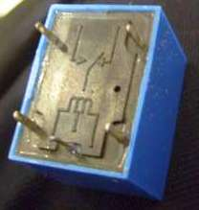
A relay is an electrically operated switch. Many relays use an electromagnet to operate a switching mechanism mechanically, but other operating principles are also used. Relays are used where it is necessary to control a circuit by a low-power signal (with complete electrical isolation between control and controlled circuits), or where several circuits must be controlled by one signal. The first relays were used in long distance telegraph circuits, repeating the signal coming in from one circuit and re-transmitting it to another. Relays were used extensively in telephone exchanges and early computers to perform logical operations. A type of relay that can handle the high power required to directly control an electric motor is called a contractor. Solid-state relays control power circuits with no moving parts, instead using a semiconductor device to perform switching. Relays with calibrated operating characteristics and sometimes multiple operating coils are used to protect electrical circuits from overload or faults; in modern electric power systems these functions are performed by digital instruments still called "relays”. A simple electromagnetic relay consists of a coil of wire surrounding a soft iron core, an iron yoke which provides a low reluctance path for magnetic flux, a movable iron armature, and one or more sets of contacts (there are two in the relay pictured). The armature is hinged to the yoke and mechanically linked to one or more sets of moving contacts. It is held in place by a spring so that when the relay is de-energized there is an air gap in the magnetic circuit. In this condition, one of the two sets of contacts in the relay pictured is closed, and the other set is open. Other relays may have more or fewer sets of contacts depending on their function. The relay in the picture also has a wire connecting the armature to the yoke. This ensures continuity of the circuit between the moving contacts on the armature, and the circuit track on the printed circuit board (PCB) via the yoke, which is soldered to the PCB. When an electric current is passed through the coil it generates a magnetic field that attracts the armature and the consequent movement of the movable contact either makes or breaks (depending upon construction) a connection with a fixed contact. If the set of contacts was closed when the relay was de-energized, then the movement opens the contacts and breaks the connection, and vice versa if the contacts were open. When the current to the coil is switched off, the armature is returned by a force, approximately half as strong as the magnetic force, to its relaxed position. Usually this force is provided by a spring, but gravity is also used commonly in industrial motor starters. Most relays are manufactured to operate quickly. In a low-voltage application this reduces noise; in a high voltage or current application it reduces arcing. When the coil is energized with direct current, a diode is often placed across the coil to dissipate the energy from the collapsing magnetic field at deactivation, which would otherwise generate a voltage spike dangerous to semiconductor circuit components. Some automotive relays include a diode inside the relay case. Alternatively, a contact protection network consisting of a capacitor and resistor in series (snubber circuit) may absorb the surge. If the coil is designed to be energized with alternating current (AC), a small copper "shading ring" can be crimped to the end of the solenoid, creating a small out-of-phase current which increases the minimum pull on the armature during the AC cycle.
CIRCUIT DIAGRAM:

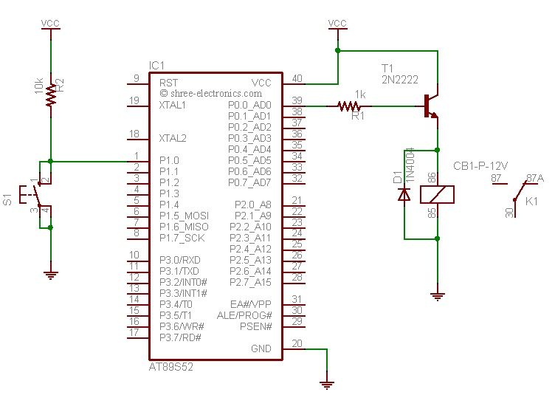
WORKING:
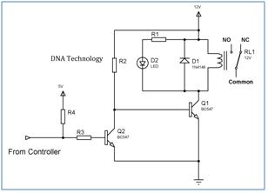
Microcontrollers have internal pull up resistors hence when a port pin is HIGH the output current flows through this internal pull up resistor. 8051 microcontrollers have an internal pull up of 10KΩ. Hence the maximum output current will be 5v/10k = 0.5ma. This current is not sufficient to drive the transistor into saturation and turn ON the relay. Hence an external pull up resistor R3 is used. Let us now calculate the value of R3. Normally a relay requires a pull in current of 70ma to be turned ON. So our BC547 transistor will require enough bases current to make sure it remains saturated and provide the necessary collector current i.e. 70ma. The gain (h_{fe}) of BC547 is 100 so we need to provide at least 70ma/100 = 0.7ma of base current. In practice you require roughly double the value of this current so we will calculate for 1.4ma of base current.
From the above equation the value of R3 comes out to be 5.55KΩ. Typically I use 4.7KΩ resistor.
Whenever 8051 microcontroller is turned ON initially the controller is in reset state and all the controller pins are HIGH which would result in TURNING ON the relay every time power is turned ON or if there is a power fluctuation. This may also damage the device connected to relay so as to avoid this problem another transistor Q2 has been added between the controller & the previous transistor. This transistor acts as an inverter. Figure 2 shows the updated Relay Driver Circuit. So now when a High is applied from the controller the TRANSISTOR Q2 turns ON so the base of transistor Q1 gets 0 so the transistor Q1 turns OFF so the relay turns OFF. And when a LOW is applied from the controller the TRANSISTOR Q2 turns OFF so the base of transistor Q1 gets high voltage through the resistor R2 so the transistor Q1 turns ON which turns ON the relay.

PROGRAM:
relay equ P1.0
sw equ P2.0
org 0000h

Main:clr relay ;Configure inp and outp
setb sw
up: jnb sw,on ;wait for switch to be pressed
clr relay
acall delay
sjmp up
on: setb relay ;Turn ON relay
acall delay
acall delay
here:jb sw,here ;wait for switch to be released
clr relay ;Turn OFF relay
acall delay
acall delay
sjmp up ;Loop

delay:mov r7,#0ffh ;delay subroutine
again:mov r6,#0ffh
djnz r6,$
djnz r7,again
ret

CONCLUSION:
____________________________________________________________________________________________________________________________________________________________________________________________________________________________________________________

EXPERIMENT-8
AIM: To study the interfacing of LCD with µC 89C51

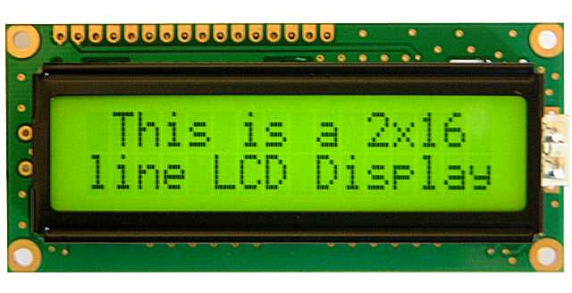
APPARTUS:
    - Micro controller 89C51
    - LCD
    - 12 MHz crystal
    - 7805 voltage regulator IC
    - Bridge rectifier IC
    - 33 PF capacitor
    - 10 µF/63V capacitor
    - 8K2 resistor
    - 1K resistors

THEORY:
Liquid Crystal Display also called as LCD is very helpful in providing user interface as well as for debugging purpose.
These LCD's are very simple to interface with the controller as well as are cost effective.
The most commonly used ALPHANUMERIC displays are
1*16 (Single line & 16 characters),
2*16 (Double line & 16 characters per line),
4*20 (Four lines & 20 characters per line).
The LCD requires 3 control lines (RS, R/W & EN) & 8 (or 4) data lines. The number on data lines depends on the mode then 8 data lines + 3 control lines i.e. total 11 lines are required and if operated in 4-bit mode then 4 data line required.
Now how do we decide which mode to use? It’s simple if you have sufficient data lines you can go for 8 bit mode & if the display should be faster then we have to use 8-bit mode because basically 4-bit mode takes twice as more time.

PIN DISCRIPTION:
Pin No. | Symbol | Function
1 | Vss | Ground
2 | Vdd | Supply Voltage
3 | V0 | Contrast Setting
4 | RS | Register Select
5 | R/W | Read/Write Select
6 | En | Chip Enable Signal
7 to 14 | DB0-DB7 | Data Line
15 | A/Vee | GND for the backlight
16 | K | Vcc for backlight
When RS is low (0), the data is to be created as a command. When RS is high (1), the data being sent is considered as text data which should be displayed on the screen.
When R/W is low (0), the information on the data bus is being written to the LCD. When RW is high (1), the program is effectively reading from the LCD. Most of the times there is no need to read from the LCD so this line can directly be connected to GND thus saving one controller line.
The ENABLE pin is used to latch the data present on the data pins. A HIGH - LOW signal is required to latch the data. The LCD interprets and executes our command at the instant the EN line is brought low. If you never bring EN low, your instruction will never be executed.
For Contrast setting a 10K pot should be used as shown in the figure.
In this interfacing we used the port 1 & port 3. The data line D0 to D7 of LCD is connected to the port 1.
The chip enable signal, RS signal and R/W signal is connected to the port number 3.
COMMAND OF LCD:
Code (Hex) | Command to Instruction Register | Code (Hex) | Command to Instruction Register
1 | clear display screen | C | Display on, cursor off
2 | Return home | E | Display on, cursor blinking
4 | Decrement cursor (shift cursor left) | F | Display on, cursor blinking
6 | Increment cursor (shift cursor right) | 10 | Shift cursor position to left
5 | Shift display right | 14 | Shift cursor position to right
7 | Shift display left | 18 | Shift the entire display to the left
8 | Display off, cursor off | 80 | Force cursor to beginning to 1st line
A | Display off, cursor on | C0 | Force cursor to beginning to 2nd line

CIRCUIT DIAGRAM:
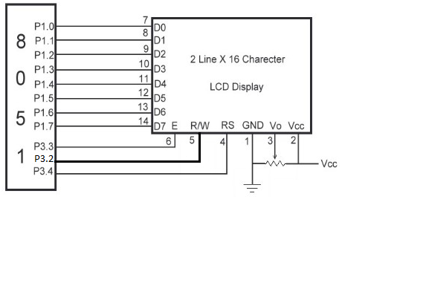
PROGRAM:
ORG 0000H ;
MOV A, #38H ; INITIATE LCD
ACALL COMMWRT ;
ACALL DELAY ;
MOV A, #0EH ; DISPLAY ON CURSOR ON
ACALL COMMWRT ;
ACALL DELAY ;
MOV A, #01H ; CLEAR LCD
ACALL COMMWRT ;
ACALL DELAY ;
MOV A, #84H ; CURSOR AT LINE 1 POSITION 4
ACALL COMMWRT ;
ACALL DELAY ;
MOV A, #'A' ; SEND ASCII DATA
ACALL DATAWRT ;
ACALL DELAY ;
AGAIN :
SJMP AGAIN ;
COMMWRT:
MOV P1, A ;
CLR P2.0 ; RS = 0 FOR COMMAND REGISTER
CLR P2.1 ; R/W = 0 FOR WRITE
SETB P2.2 ; E = 1 FOR HIGH PULSE
ACALL DELAY ;
CLR P2.2 ; E = 0 FOR LOW PULSE
RET
DATAWRT:
MOV P1, A ;
SETB P2.0 ; RS = 1 FOR DATA REGISTER
CLR P2.1 ; R/W = 0 FOR WRITE
SETB P2.2 ; E = 1 FOR HIGH PULSE
ACALL DELAY ;
CLR P2.2 ; E = 0 FOR LOW PULSE
RET

DELAY :
MOV R3, #50H ;
BACK:
MOV R4, #255H ;
HERE:
DJNZ R4, HERE ;
DJNZ R3, BACK ;
RET
END

CONCLUSION:

EXPERIMENT-9
AIM: To study the interfacing of STEPPER MOTOR with µC 89C51

APPARTUS:
    - Micro controller 89C51
    - Stepper motor
    - ULN2003A
    - 12 MHz crystal
    - 5V regulated supply
    - 33 PF capacitor
    - 10 µF/63V capacitor
    - 8K2 resistor
    - 1K resistors

THEORY:
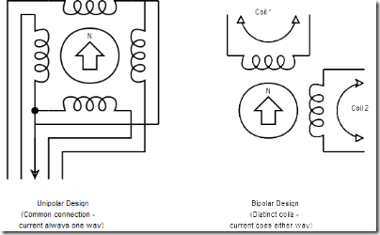
Uni-polar stepper motor
The unipolar stepper motor has five or six wires and four coils (actually two coils divided by center connections on each coil). The center connections of the coils are tied together and used as the power connection. They are called uni-polar steppers because power always comes in on this one pole.
Bipolar stepper motor
The bipolar stepper motor usually has four wires coming out of it. Unlike unipolar steppers, bipolar steppers have no common center connection. They have two independent sets of coils instead. You can distinguish them from unipolar steppers by measuring the resistance between the wires. You should find two pairs of wires with equal resistance. If you've got the leads of your meter connected to two wires that are not connected (i.e. not attached to the same coil), you should see infinite resistance (or no continuity).
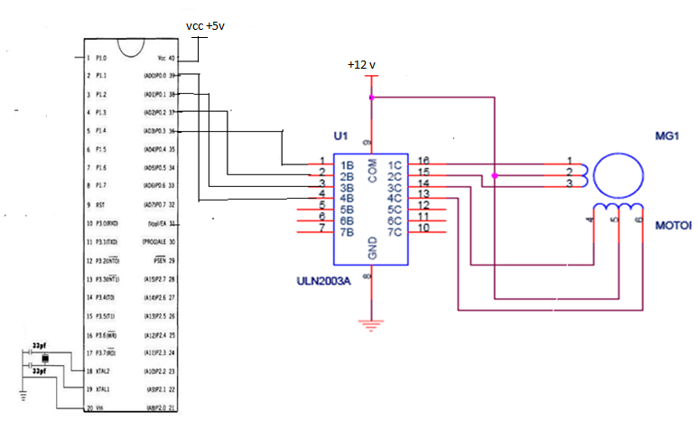
CIRCUIT DIAGRAM:

WORKING:
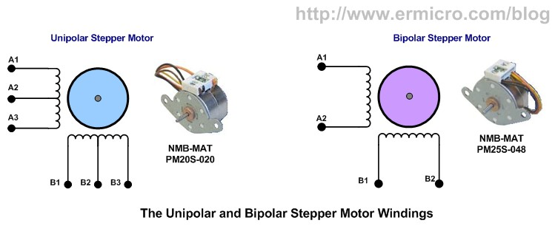
A Unipolar Stepper Motor is rotated by energizing the stator coils in a sequence. In unipolar stepper, the direction of current in stator coils is not required to be controlled by the driving circuit. Just applying the voltage signals across the motor coils or motor leads in a sequence is sufficient to drive the motor.
A two phase unipolar stepper motor has a total of six wires/leads of which four are end wires (connected to coils) and two are common wires. The color of common wires in the stepper motor used here is Green. Each common wire is connected to two end leads thus forming two phases. The end leads corresponding to each phase have to be identified.
In some cases, when the leads cannot be directly identified in the motor, the identification of endpoints and common points can be done by measuring the resistance between the leads. The leads of different phase will show open circuited condition with respect to each other. This way the leads corresponding to different phase can be separated. The resistance between any two end points of same phase will be twice the resistance between a common point and an end point. This way the common and end points of both the phases can be identified.
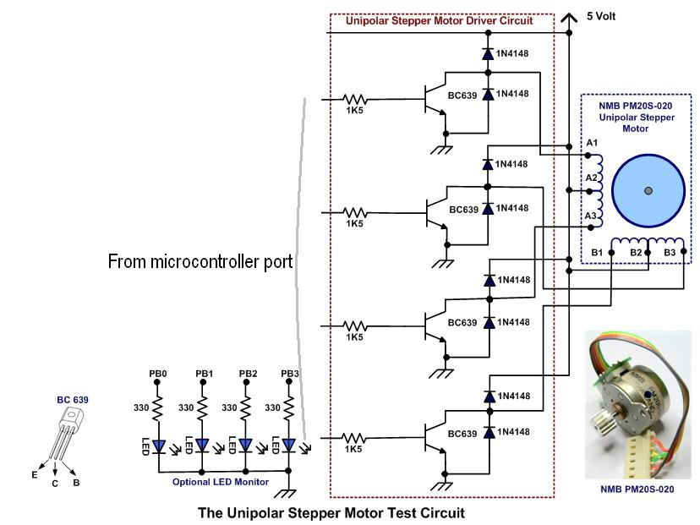
In the circuit, Port P2 is defined as output port to provide the input sequence for the stepper motor. Four transistors are used as switches to drive the motor. The motor leads are not directly interfaced with the microcontroller pins because stepper motor requires 60mA current while AT89C51 has the maximum current rating of 50mA. So the transistors switches are used to transfer signals from the microcontroller to the stepper wires.
The sequence of signals mentioned in the tables above rotates the motor in clockwise direction. Reversing these input sequences would rotate the motor in counter clockwise direction.

PROGRAM:
org 0H
stepper equ P1
main: mov stepper, #0CH
acall delay
mov stepper, #06H
acall delay
mov stepper, #03H
acall delay
mov stepper, #09H
acall delay
sjmp main
delay: mov r7,#4
wait2: mov r6,#0FFH
wait1: mov r5,#0FFH
wait: djnz r5,wait
djnz r6,wait1
djnz r7,wait2
ret
end

CONCLUSION:

EXPERIMENT-10
AIM: To interface LDR and seven segment with microcontroller 89C51.
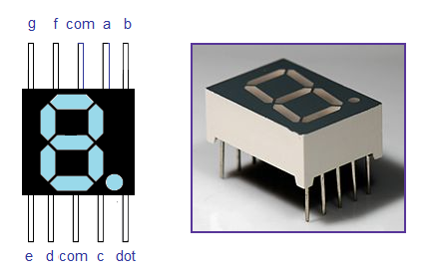
APPARTUS:
    - Micro controller 89C51
    - LDR
    - Seven segment display
    - SN7447A
    - 12 MHz crystal
    - 5V regulated power supply
    - 33 PF capacitor
    - 330Ω resistor
THEORY:
LDR
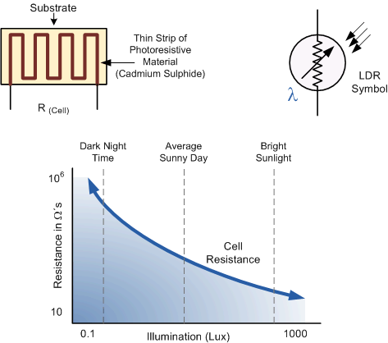
A photo resistor or light dependent resistor is a resistor whose resistance decreases with increasing incident light intensity; in other words, it exhibits photoconductivity.
A photo resistor is made of a high resistance semiconductor. If light falling on the device is of high enough frequency, photons absorbed by the semiconductor give bound electrons enough energy to jump into the conduction band. The resulting free electron (and its hole partner) conduct electricity, thereby lowering resistance.
A photoelectric device can be either intrinsic or extrinsic. An intrinsic semiconductor has its own charge carriers and is not an efficient semiconductor, e.g. silicon. In intrinsic devices the only available electrons are in the valence band, and hence the photon must have enough energy to excite the electron across the entire band gap. Extrinsic devices have impurities, also called dopants, and added whose ground state energy is closer to the conduction band; since the electrons do not have as far to jump, lower energy photons (i.e., longer wavelengths and lower frequencies) are sufficient to trigger the device. If a sample of silicon has some of its atoms replaced by phosphorus atoms (impurities), there will be extra electrons available for conduction. This is an example of an extrinsic semiconductor. Photo resistors are basically photocells.
Seven segment display
A seven-segment display (SSD), or seven-segment indicator, is a form of electronic display device for displaying decimal numerals that is an alternative to the more complex dot-matrix displays. Seven-segment displays are widely used in digital clocks, electronic meters, and other electronic devices for displaying numerical information.
Seven Segment are available in two configuration - (1) Common Anode (2) Common Cathode.
The circuit diagram shows the connections of seven segments to the controller. The pins a to g of the Seven Segment are connected to the Port P2 of the microcontroller. The common pin of the seven segments is connected to Vcc. The ‘h’ has not been used, which is the dot pin of the controller.
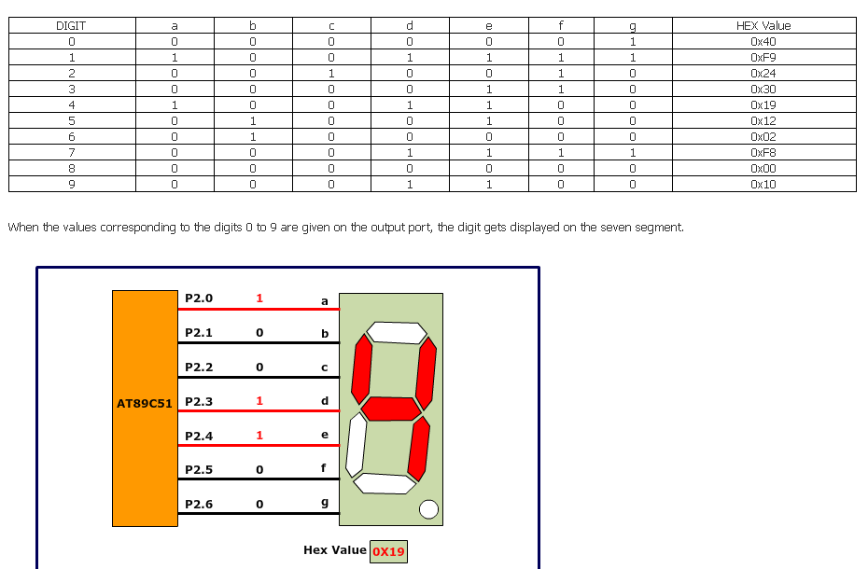
Since the seven segment display works on negative logic, we will have to provide logic 0 to the corresponding pin to make an LED glow. Table below shows the hex values used to display the different digits.

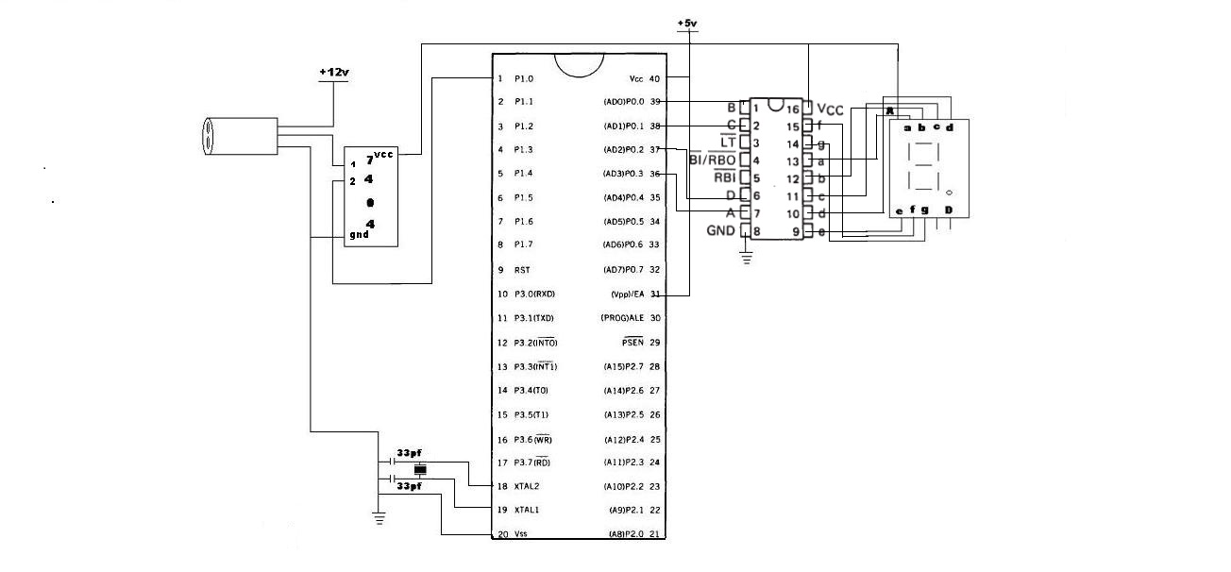
CIRCUIT DIAGRAMPROCEDURE:
- Connect the set up as shown in the circuit above.
- Switch ON the supply.
- Now, when any object passes in front the photocell in the range of 1 ft., the photocell gives the 12V in the output.
- Now this 12V is given to 7404 IC which in turn gives 0V as output to the µC.
- Here, sn7447a IC is used for conversion of BCD to 7 – Segment.
- Now, as 0V is obtained at µC, 7 – Segment LED is incremented by 1.
- Thus the passed object is counted.

PROGRAM:
Seven segment Interfacing
ORG 000H //initial starting address
START: MOV A,#00001001B // initial value of accumulator
MOV B,A
MOV R0,#0AH //Register R0 initialized as counter which counts from 10 to 0
LABEL: MOV A,B
INC A
MOV B,A
MOVC A,@A+PC // adds the byte in A to the program counters address
MOV P1,A
ACALL DELAY // calls the delay of the timer
DEC R0 //Counter R0 decremented by 1
MOV A,R0 // R0 moved to accumulator to check if it is zero in next instruction.
JZ START //Checks accumulator for zero and jumps to START. Done to check if counting has been finished.
SJMP LABEL
DB 3FH // digit drive pattern for 0
DB 06H // digit drive pattern for 1
DB 5BH // digit drive pattern for 2
DB 4FH // digit drive pattern for 3
DB 66H // digit drive pattern for 4
DB 6DH // digit drive pattern for 5
DB 7DH // digit drive pattern for 6
DB 07H // digit drive pattern for 7
DB 7FH // digit drive pattern for 8
DB 6FH // digit drive pattern for 9
DELAY: MOV R4,#05H // subroutine for delay
WAIT1: MOV R3,#00H
WAIT2: MOV R2,#00H
WAIT3: DJNZ R2,WAIT3
DJNZ R3,WAIT2
DJNZ R4,WAIT1
RET
END

CONCLUSION:
____________________________________________________________________________________________________________________________________________________________________
__________________________________________________________________________________

EXPERIMENT-11
AIM: To study the interfacing of ADC-0804 with µC 89C51

APPARTUS:-
    - Micro controller 89C51
    - ADC-0804
    - 12 MHz crystal
    - 7805 voltage regulator IC
    - Bridge rectifier IC
    - 33 PF capacitor
    - 10 microf/63V capacitor
    - 8K2 resistor
    - 1K resistors
THEORY:
ADC0804 is one of the most commonly used analog to digital converter IC. In many applications it is required to convert the output of the sensor, which is analogue in nature to a digital form. The data in digital format can then be utilized for further processing by the digital processors. Typical applications include sound processing, temperature processing etc. This circuit demonstrates the principle and operation of interfacing a simple ADC 0804 using 8051 microcontroller (AT89C51).
ADC0804 is connected as shown in the circuit diagram. Here the input is taken from a preset, which gives different analog signals to the ADC. The output pins of the ADC are connected to LEDs. The control pins of the ADC are connected to the microcontroller AT89C51.
ADC0804 is a single channel analog to digital convertor i.e., it can take only one analog signal. An ADC has n bit resolution (binary form) where n can be 8,10,12,16 or even 24 bits. ADC 0804 has 8 bit resolution. The higher resolution ADC gives smaller step size. Step size is smallest change that can be measured by an ADC. For an ADC with resolution of 8 bits, the step size is 19.53mV (5V/255).
The time taken by the ADC to convert analog data into digital form is dependent on the frequency of clock source. ADC0804 can be given clock from external source. It also has an internal clock. However the conversion time cannot be more than110us. To use the internal clock a capacitor and resistor is connected to pin 19 and 4 as shown in the circuit diagram. The frequency is given by the relation f= 1/ (1.1RC). The circuit uses a resistance of 10k and a capacitor of 150pF to generate clock for ADC0804. Vin, which is the input pin, is connected to a preset to provide analog input.
In this circuit microcontroller is used to provide the control signals to the ADC. CS pin of ADC is directly connected to ground. The pin P1.1, P1.0 and P1.2 are connected to the pin WR, RD and INTR of the ADC respectively. When the input voltage from the preset is varied the output of ADC varies which can be seen on the LCD. When the preset is at minimum level, no LED glows and when the preset is at maximum position all the LEDs starts glowing.
PIN DIAGRAM:
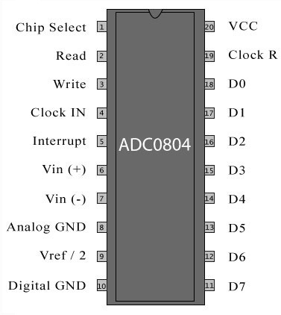
PIN DISCRIPTION:
Pin No | Function | Name
1 | Activates ADC; Active low | Chip select
2 | Input pin; High to low pulse brings the data from internal registers to the output pins after conversion | Read
3 | Input pin; Low to high pulse is given to start the conversion | Write
4 | Clock Input pin; to give external clock. | Clock IN
5 | Output pin; Goes low when conversion is complete | Interrupt
6 | Analog non-inverting input | Vin(+)
7 | Analog inverting Input; normally ground | Vin(-)
8 | Ground(0V) | Analog Ground
9 | Input pin; sets the reference voltage for analog input | Vref/2
10 | Ground(0V) | Digital Ground
11-18 | 8 bit digital output pins | D7-D7
19 | Used with Clock IN pin when internal clock source is used | Clock R
20 | Supply voltage; 5V | Vcc

PROCEDURE:
The following steps are used to interface the ADC0804.
1) Send a low to high pulse to pin WR to start the conversion.
2) Keep monitoring the INTR pin. If INTR is low, go to next step else keep checking the status.
3) A high to low pulse is sent to the RD pin to bring the converted data on the output pins.

CIRCUIT DIAGRAM:
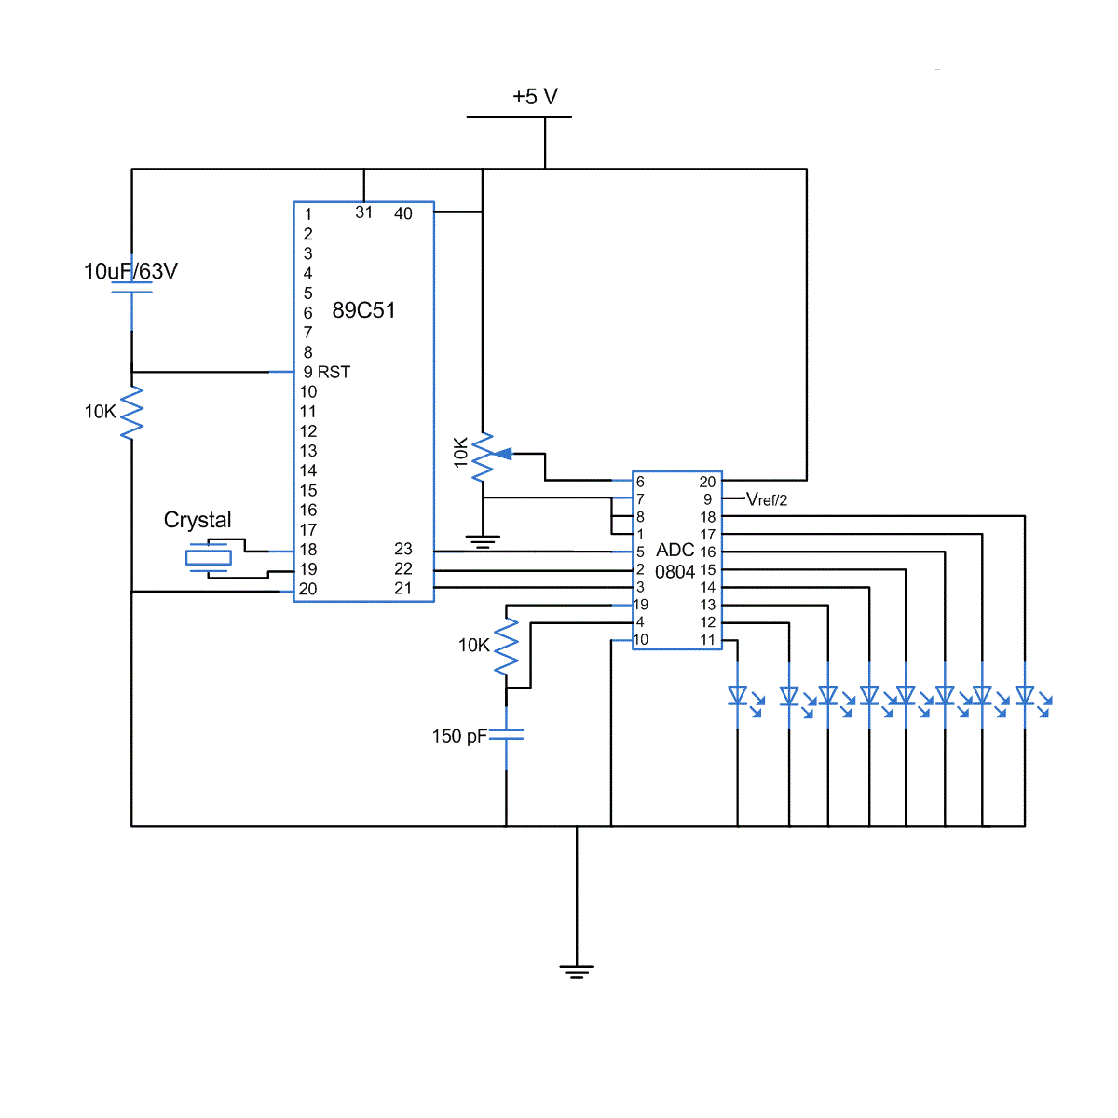

PROGRAM:
rd equ P1.0 ;Read signal P1.0
wr equ P1.1 ;Write signal P1.1
cs equ P1.2 ;Chip Select P1.2
intr equ P1.3 ;INTR signal P1.3

adc_port equ P2 ;ADC data pins P2
adc_val equ 30H ;ADC read value stored here

org 0H
start: ;Start of Program
acall conv ;Start ADC conversion
acall read ;Read converted value
mov P3,adc_val ;Move the value to Port 3
sjmp start ;Do it again

conv: ;Start of Conversion
clr cs ;Make CS low
clr wr ;Make WR Low
nop
setb wr ;Make WR High
setb cs ;Make CS high
wait:
jb intr,wait ;Wait for INTR signal
ret ;Conversion done

read: ;Read ADC value
clr cs ;Make CS Low
clr rd ;Make RD Low
mov a,adc_port ;Read the converted value
mov adc_val,a ;Store it in local variable
setb rd ;Make RD High
setb cs ;Make CS High
ret ;Reading done

CONCLUSION:
______________________________________________________________________________________________________________________________________________________________________________________________________________________________________________________

EXPERIMENT-12
AIM: To study the interfacing of EXTERNAL MEMORY with µC 89C51

APPARTUS:
    - Micro controller 89C51
    - IC KM62256C(1)
    - 12 MHz crystal
    - 7805 voltage regulator IC
    - Bridge rectifier IC
    - 33 PF capacitor
    - 10 µf 63V capacitor
    - Resistor
THEORY:
Figure shows the connection between microcontroller and external memory. At this time the largest static RAMs available are 32k in size; RAM can be expanded to 64K by using two 32K RAMs that are connected through address A14 of port 2. The 32K RAM is enabled when A15 of port 2 is low. The main feature of the RAM is that read and write both operation can done. Interfacing this RAM with microcontroller is very easy.

As the name suggests, External RAM is any random access memory which is found off-chip. Since the memory is off-chip it is not as flexible in terms of accessing, and is also slower. For example, to increment an Internal RAM location by 1 requires only 1 instruction and 1 instruction cycle. To increment a 1-byte value stored in External RAM requires 4 instructions and 7 instruction cycles. In this case, external memory is 7 times slower here in this the 32K RAM is interfaced with microcontroller. The KM62256c IC is use for the 32K static RAM. The pin diagram of this IC is given
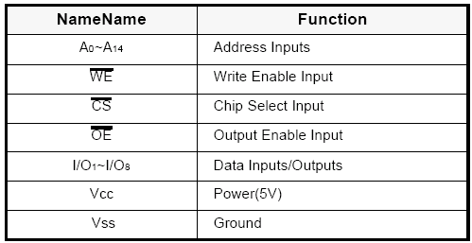
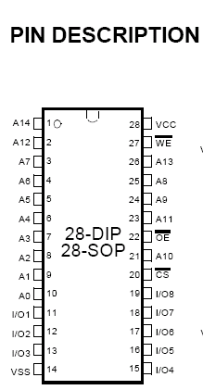
As shown in Diagram this IC is of 28 pin. There are 8 address line and 8 data line.
The function of each pin is shown in table.
CIRCUIT DIAGRAM:

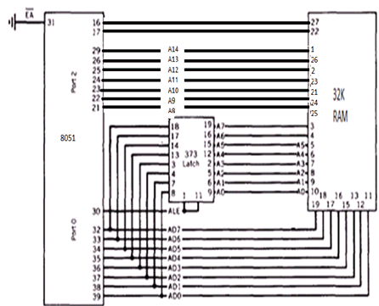
The timing diagram of read cycle and write cycle is given follow; The timing diagram of read cycle is shown in figure. Here THz and those are defined as the time at which the output achieve the open circuit conditions and are not referenced to output voltage levels. At any given temperature and voltage condition, THz (Max.) is less than TLz (Min.) both for a given device and from device to device inter connection.

The timing diagram for write cycle is also shown in figure. A write occurs during the overlap of a low CS and a low WE. Write beings at the latest transition among CS going Low and WE going low: A write end at the earliest transition among CS going high and WE going high, twp is measured from the beginning of write to end of write.

Tcw is measured from the CS going low to end of write.
TAS is measured from the address valid to the beginning of write.
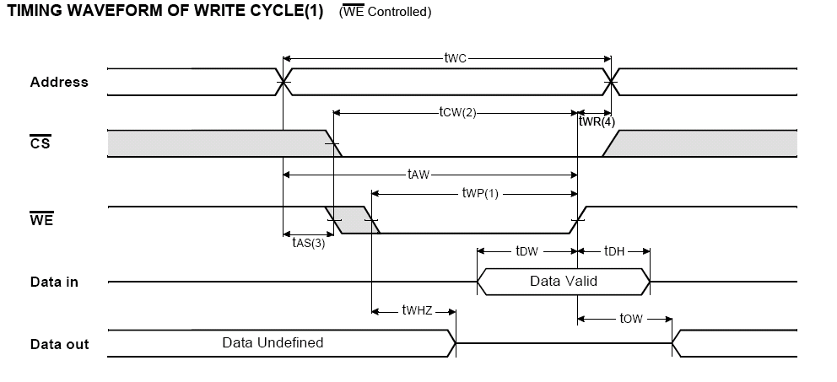
Twr is measured from the end of write to the address change. Twr applied in case a write ends as CS or WE going high.

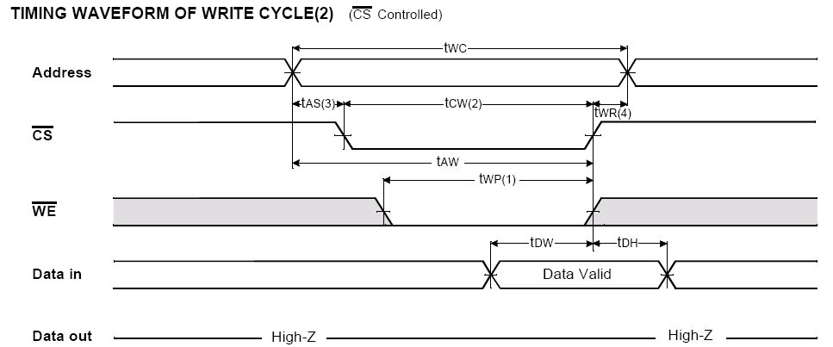

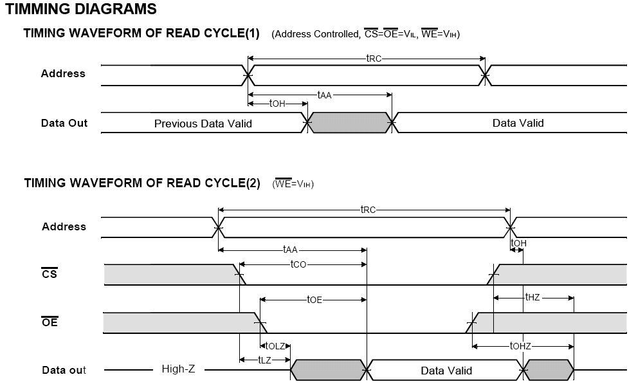

CONCLUSION:
______________________________________________________________________________________________________________________________________________________________________________________________________________________________________________________

EXPERIMENT-13
AIM: To study the Interfacing of 8255 and 8279 with 89C51 microcontroller.

APPARTUS:
    - Micro controller 89C51
    - 8255 IC
    - 8279 IC
    - 74LS373
    - 74LS138
    - DB25 pin socket
    - 3×8 decoder
    - 7 segment led 6pcs
    - 12 MHz crystal
    - 5V power supply
.
THEORY:
There are many families of programable port chips. The one choosen here is the popular 8255 programable interface adaptor, which is available from no. of vendors. The 8255 has an internal mode resistor to which control words are written by the host computer. These controls words determine the action of the 8255ports, named a,b,c enabling them to act as input ports, output ports, some combination of both.
The no. of ports is now three 8 bit ports for the system. The penalty paid for expanding I/O in this manner is reduction in speed that occurs due to the overhead time needed to write control bits to port 1 and 3 before resulting I/O line selected can be accessed. The advantage of using I/O port expansion is that the entire range of 8051 instructions can be used to access the added ports via ports 1 and 3.

CIRCUIT DIAGRAM:
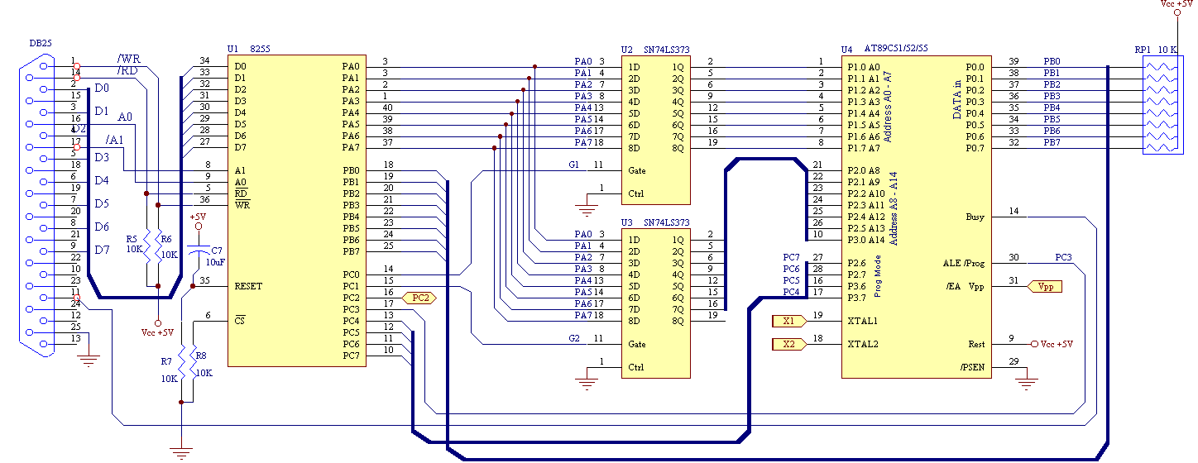

Interfacing of 8255 with 8051

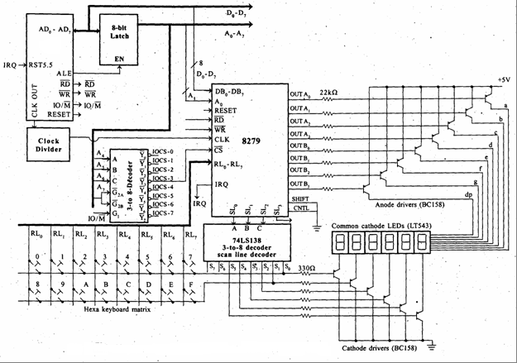
Interfacing of 8279 with 8051

The interfacing of 8279 with 8051 initially T₁ is connected with /CS of 8279 and then T₀ are connected to reset of 8279 to activate both the timers. Now /INT1 is connected with A₀ and /INT0 is connected with A₁ here the interrupt pin 1 and 0 is given to 8279. Transmission of 8051 is connected with /RD and reception is connected with /WR of 8279 so that the information can be read and write from 8279. Now port 1 is connected with the data port of 8255 to exchange data from each other.

CONCLUSION:
______________________________________________________________________________________________________________________________________________________________________________________________________________________________________________________

EXPERIMENT-14
AIM: To perform Serial communication with PC Using HyperTerminal

APPARTUS:
    - Micro controller 89C51
    - MAX232
    - 12 MHz crystal
    - 5V regulated power supply
    - 33 PF capacitor
    - PC Serial port
    - 8K2 resistor
    - 1K resistors
THEORY:

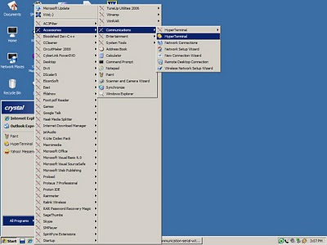
In Windows-95, win-98, window-Me, win-NT, and windows 2K & XP have Hyper-Terminal built in program. The prime object of HyperTerminal is having serial communication either through RS-232 port or modem. We can send or receive up to many bytes (according to application) or even send/ receive files through hyper terminal.
It can also be used to get information from your modem about the firmware/driver version installed.
The Hyper-Terminal program is very versatile in its application and there are some settings and configuration required prior to use it.
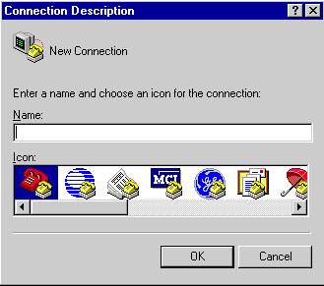
To configure the Hyper-Terminal for sending and receiving data between micro-controller and PC via RS-232port, below are the steps used in the connection building.

- Start the Hyper Terminal .exe program "hyperterminal.exe". Click on START, then ACCESSORIES, then COMMUNICATIONS, then HYPERTERMINAL. (Note: Some versions of Windows has Hyper terminal is Accessories.)

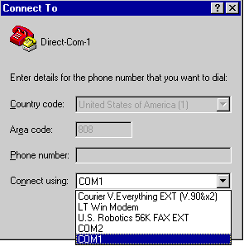
- This brings up this dialog. Enter a Name (like RS-232-microcontroller or dirct-com-1, or whatever you wish to). Chose an ICON - whatever you wish. Click OK
- The dialog (as shown in the figure below) then appears. Click the selection arrow on the "Connect using" list box, and select the COM port (the computer can have more than one serial port, select the port on which your hardware is connected). Please remember to select port 1 to port 3, from the list but do not select the modem name from here. When you select the COM port, the phone number to dial boxes is grayed. Click OK
4. The COM port properties box comes up, just like below figure. Here you have to set some properties of the serial communications.
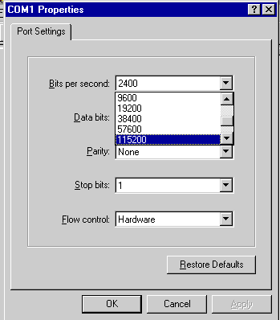
- The Bits per second: Select the baud rate you want to use in this connection, please look on your hardware of micro-controller and select the suitable (matching) baud rate from this list. Usually 8051 microcontrollers’ works with 9600 baud rates.
- Data bits: there is list of selecting the data bits; normally it is "8" in many applications. And there is by default "8" which is correct. but the list may include (5,6,7,8 )
- Parity bit. Select the option for parity bit- "None".
- Stop bits: Normally '1' stop bit is used in serial protocols.
- Flow control: None.
- OK
5. You now get the Hyper Terminal window where you are able to control your data with commands. Here you can get and display of data and send the data from the PC to microcontroller.

CONCLUSION:
____________________________________________________________________________________________________________________________________________________________________________
____________________________________________________________________________________

