**Government Polytechnic, Palanpur.**

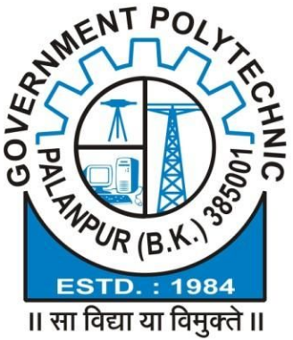

**EC Department Vision-Mission Formulation Committee Summit**

**Date : __/07/2019**

**Venue: New academic building, G. Polytechnic, Palanpur**

**FEEDBACK/ SUGGESTION FORM**

|  |  |
| --- | --- |
| **Name of Expert:** |  |
| **In committee served as a:** | **Industry expert/ Government Representative/ Guardian/ Recruiter/ Alumni/ Student/ Person from society** |
| **Profession:** |  |
| **Name of organization:** |  |
| **Contact No.** |  |
| **Email Id:** |  |

|  |
| --- |
| **Vision of EC department, GP, Palanpur** |
| To prepare competent diploma level electronics and communication engineers, catering the needs of either industries or society as an excellent employee, innovator and entrepreneur with moral values. |
|  |
| **Mission of EC department, GP, Palanpur** |
| 1. Provide quality education in the field of EC engineering. 2. Develop state of art laboratories, classrooms and upgraded faculties knowledge wise. 3. Strengthen industrial liaison by offering mutual beneficiaries services. 4. Execute extra co curricular activities to inculcate innovation, entrepreneurship and moral values |

**Feedback from expert: __________________________________________________________________________________________________________________________________________________________________________**

**Suggestions from expert: __________________________________________________________________________________________________________________________________________________________________________**

**Date: Signature of expert**

**Place:**