**Project No – 3(3D Reconstruction)**

4 free days were used because the work on this project was delayed due to some prior commitments

**3.1.1 Implement the 8-point algorithm**

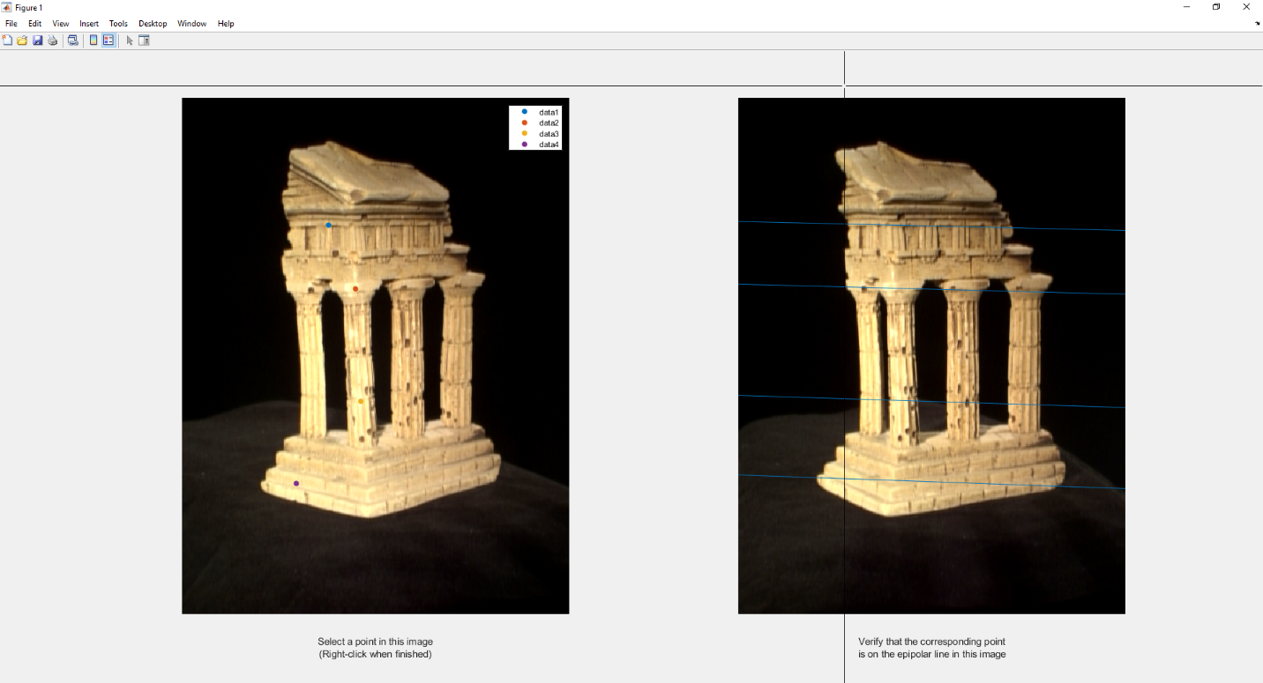

**3.1.2 Find the epipolar correspondences**

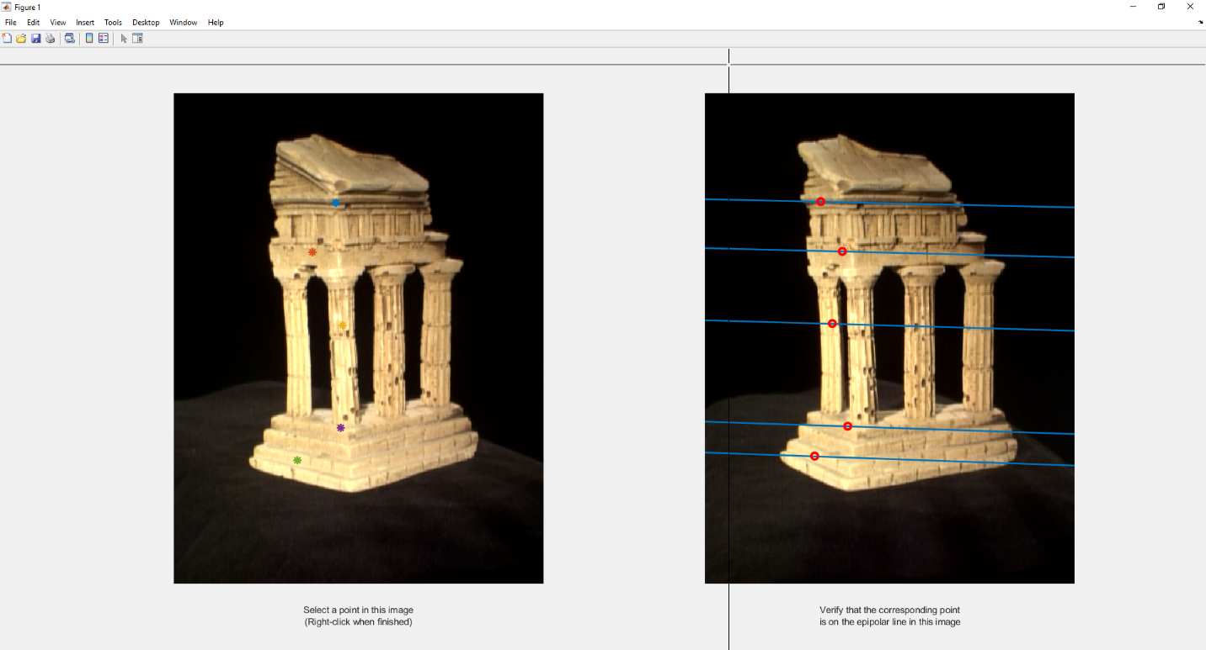

The reciprocal of the Manhattan distance between a target window of image 1 and candidate window of image 3, with window size of 7 was used as a similarity matrix. The matching algorithm’s success rate is high usually, but it might fail when there are similar but unmatched windows along the epipolar line.

**3.1.3 Write a function to compute the essential matrix**

**3.1.4 Implement Triangulation**

The correct extrinsic matrix is determined by first computing the 4 sets of 3D points with the 4 candidate extrinsic matrices, then for each set we count how any points have a positive depth coordinate. Lastly, the candidate with the highest count is the correct extrinsic matrix(index 2). The re-projection error for pts1 is 0.5664 and for pts2 is 0.5711.

**3.1.5 Write a test script that uses templeCoords**

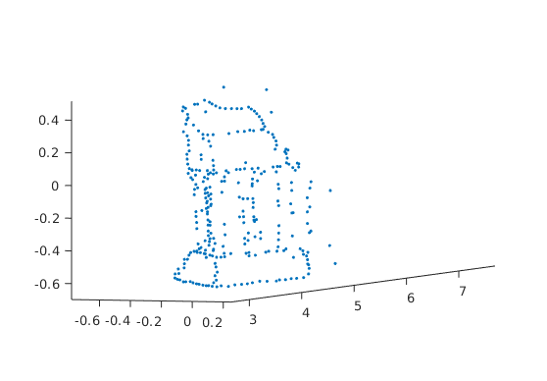

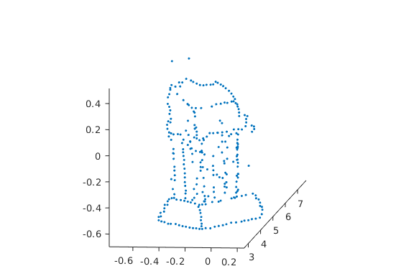

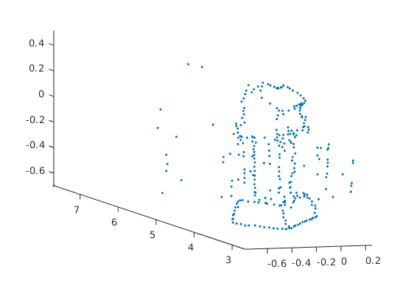

**3.2.1 Image Rectification**

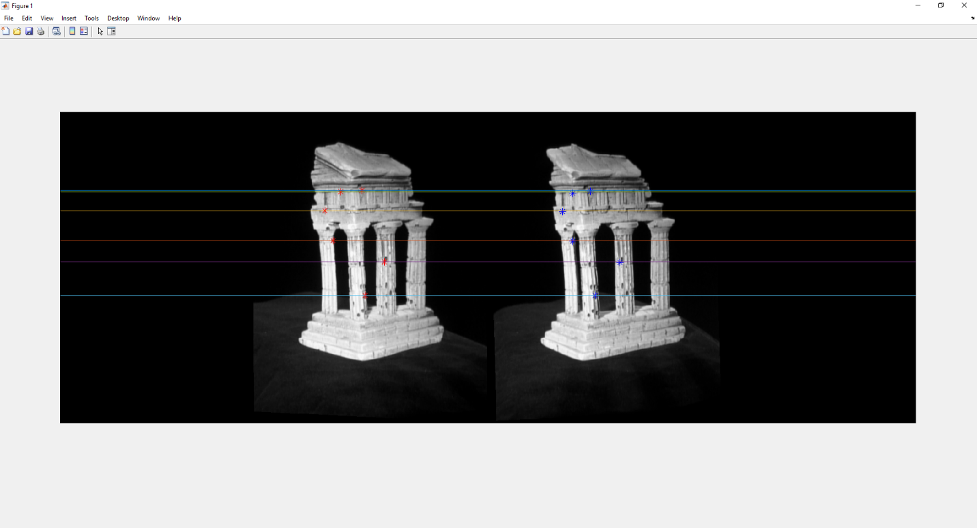

**3.2.3 Depth Map & Disparity Map**

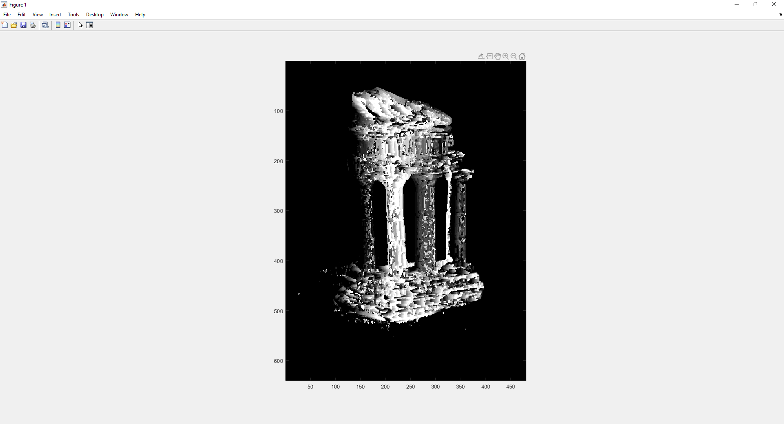

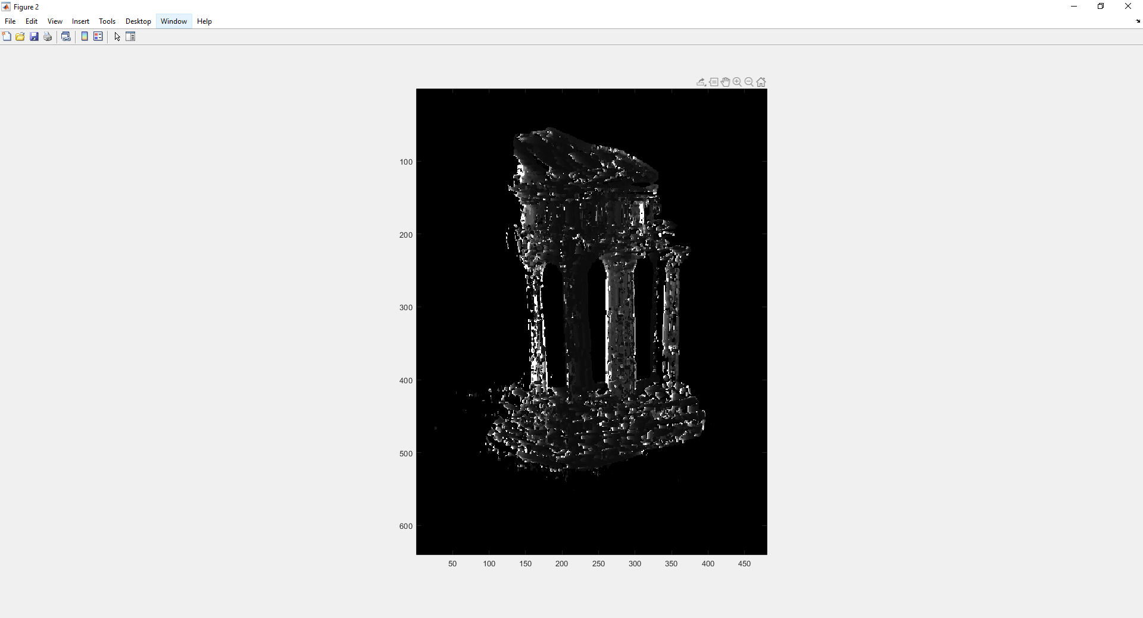

**3.3.1 Estimate camera matrix P**

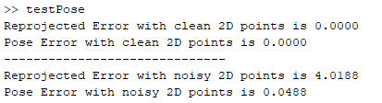

**3.3.2 Estimate intrinsic/extrinsic parameters**

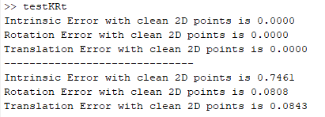

**3.3.3 Project a CAD model to the image**

