Lab Prerequisite Steps:

1. Log into Event Engine with [provided link](https://dashboard.eventengine.run/login). (Hash will be provided)
2. Choose “**Email One-Time Password**”

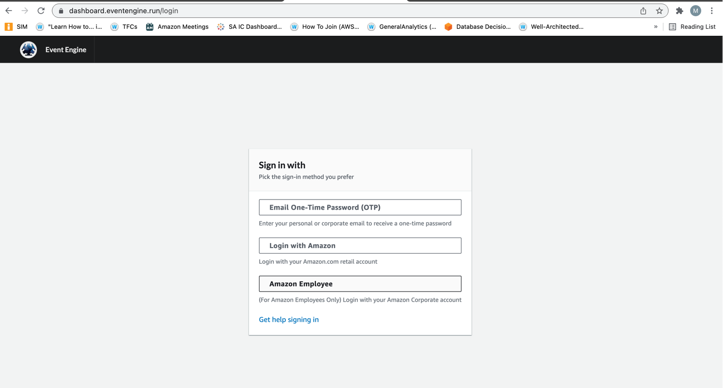

1. Enter email and wait for One Time Password (~3 minutes)
2. After entering your OTP, select **AWS CONSOLE** you will be redirected to the team dashboard, every individual has their own team.
3. 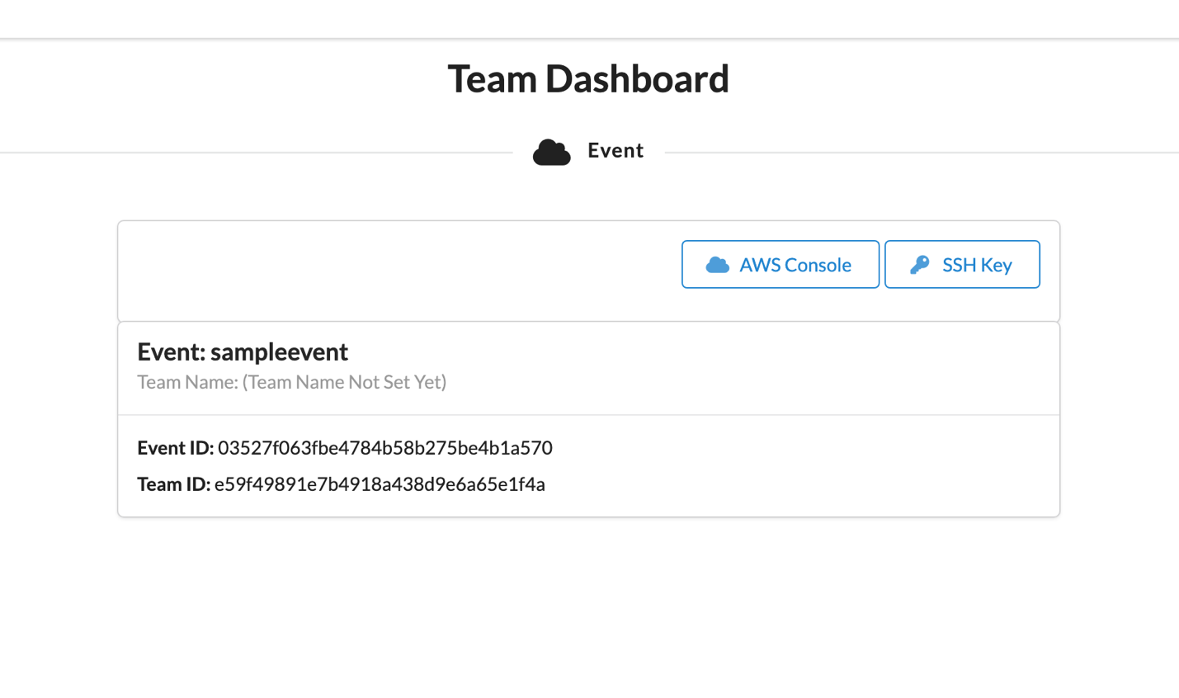
4. **Click “Open AWS Console”** – this will redirect you to your AWS Lab Environment.
5. 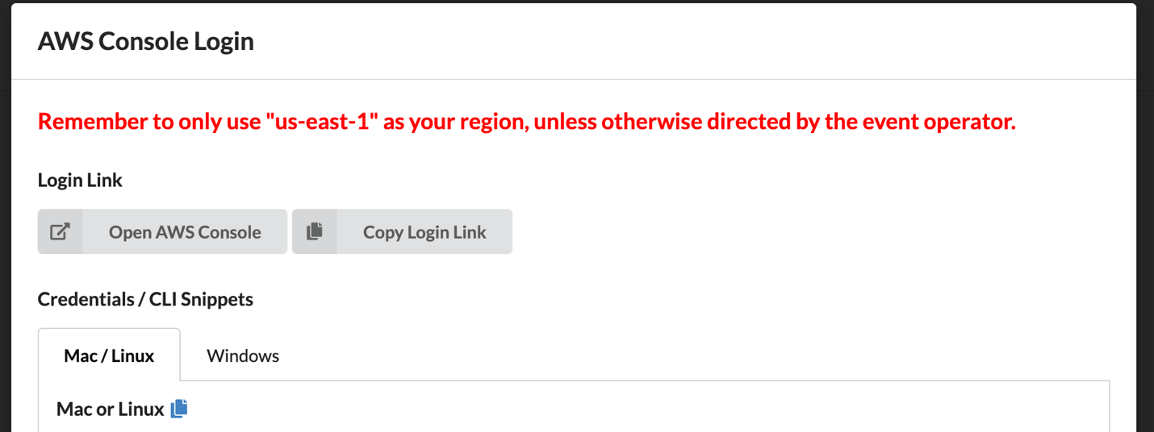
6. In the Search Bar, search and select for “Cloud9”
7. 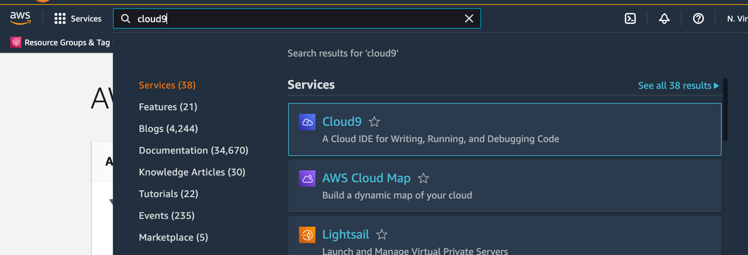
8. Select “**Create Environment**”
9. 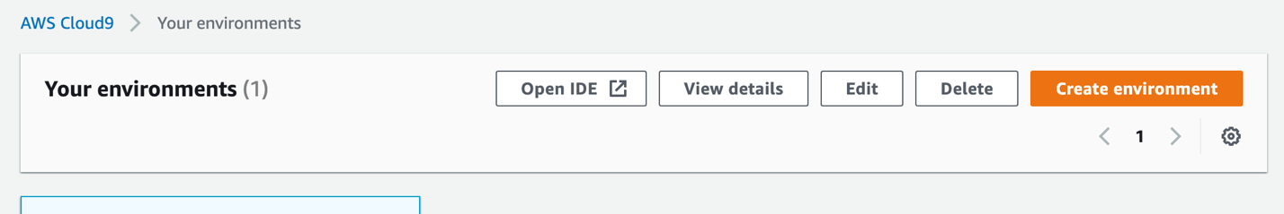
10. Inputs for Cloud9
    1. Name: LabEnv-{YourFirstName}
    2. Environment type: Leave as first radio option
    3. Instance type: T2.Micro
    4. Platform: Amazon Linux 2
    5. Cost Savings Settings: After 4 hours
    6. Click **NEXT STEP**
    7. Click **CREATE ENVIRONMENT**
11. Click Green Plus button and select “New Terminal”

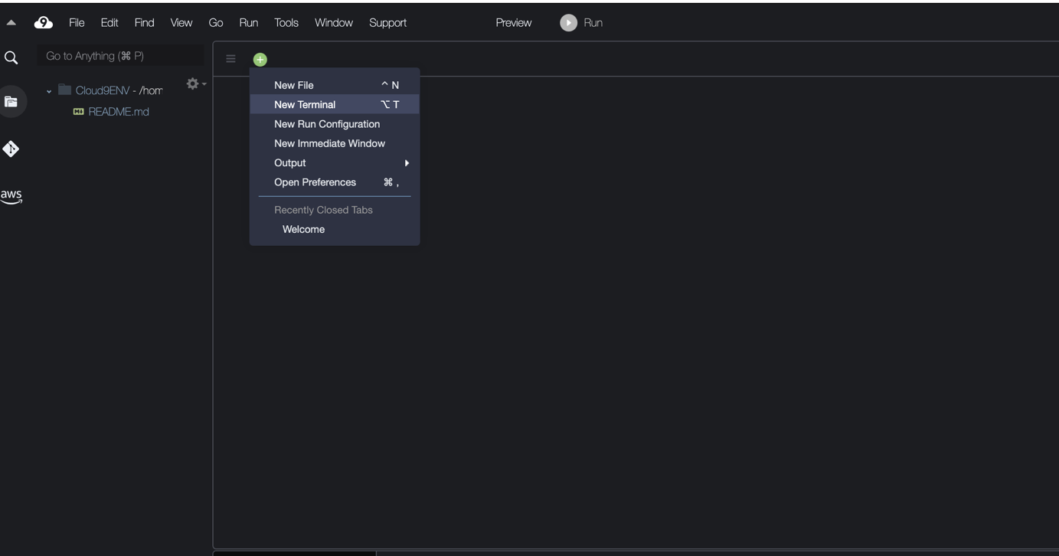

1. Run the following command:

git clone https://github.com/aws-samples/cfn101-workshop

1. 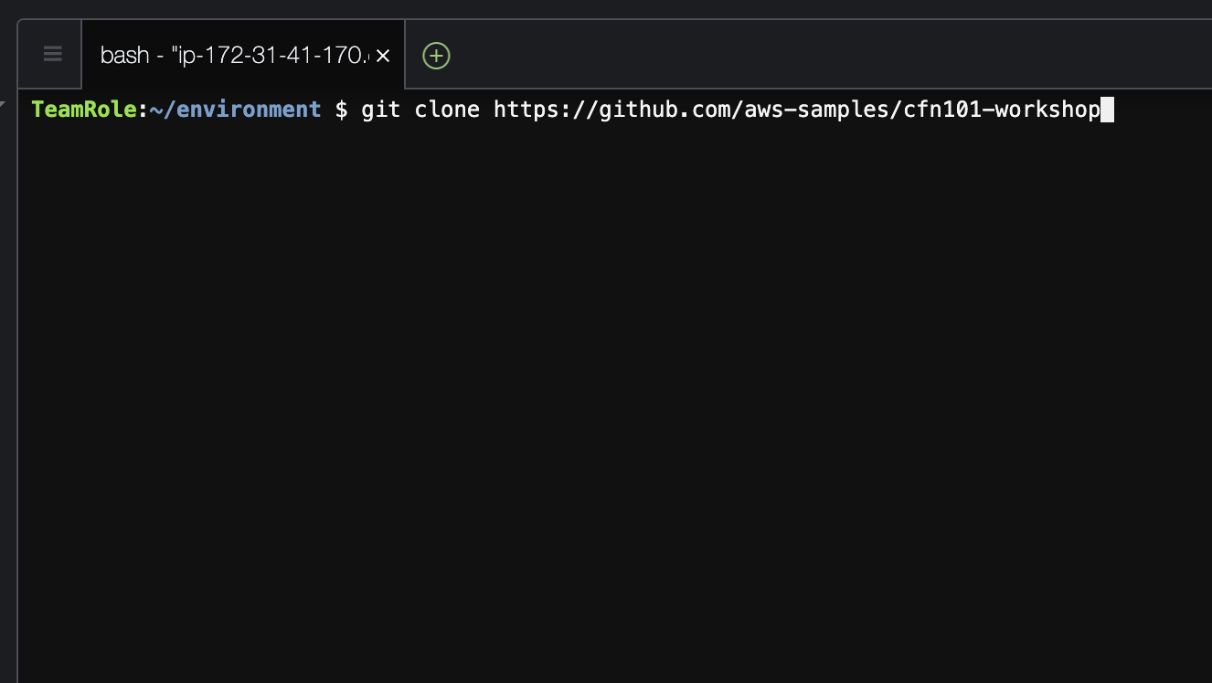
2. You should see on a new folder on the left and now you can begin the workshop!