How to see ECS task logs for stopped (error) tasks.

In AWS navigate to Elastic Container Service (ECS)

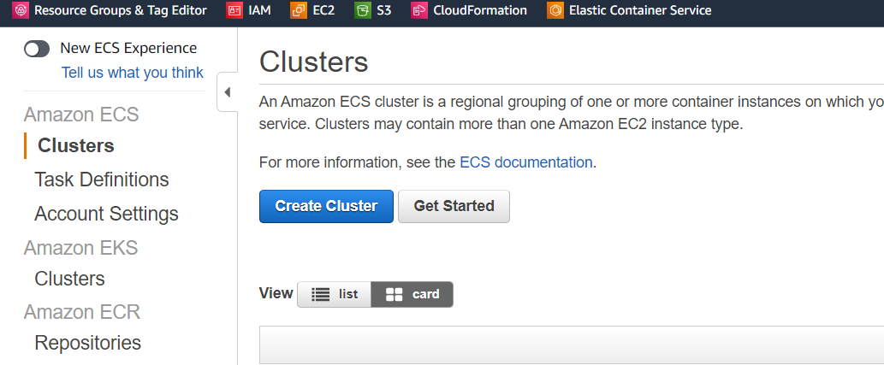

Open the Cluster and select the “**Task**” tab

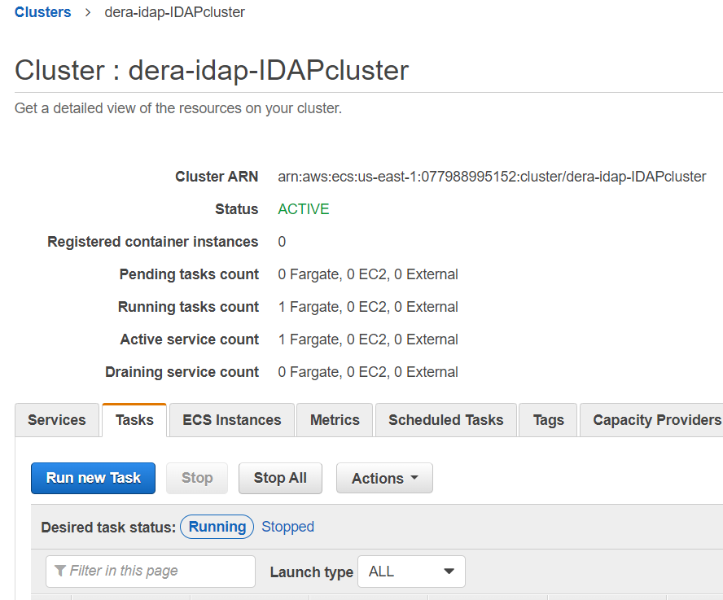

Select *Desired task status*: **Stopped** Select the **Task** (*00480d3bd34.*.) , not task definition

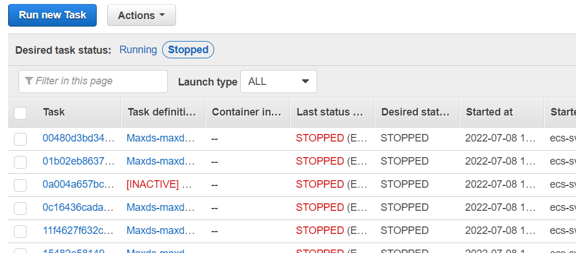

Scroll to the bottom of the task page to containers.

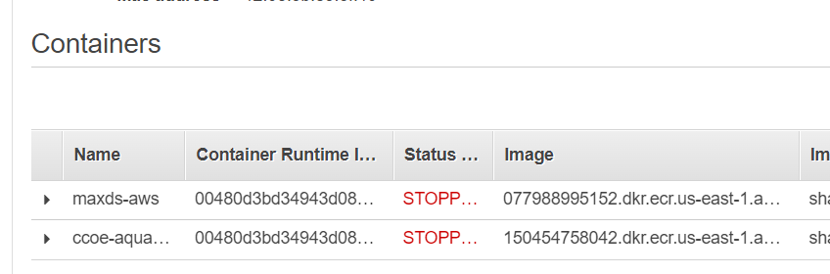

Extend the stopped container with the arrow on the left.

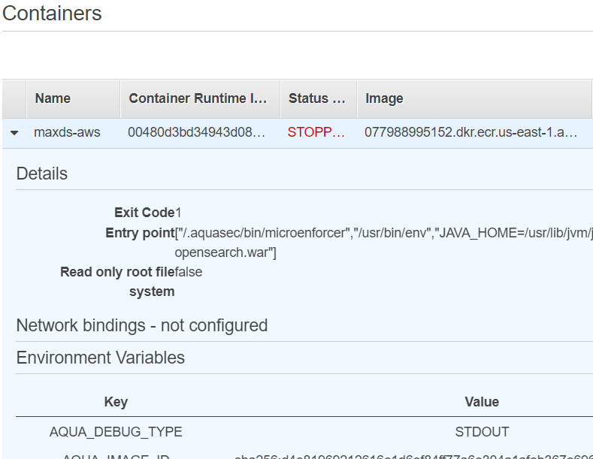

Scroll down to *Log Configurations*,Click on the **“View logs in CloudWatch”**

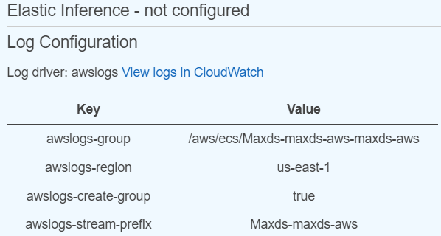

Here are the logs, **Notice the Load More will extend to see more logs.**

