Step1:

Select any term rule example:

Business Acquisition Footnote - Investments

* ACQBP - Acquisition, Bargain Purchase

Click on Process Term as shown below

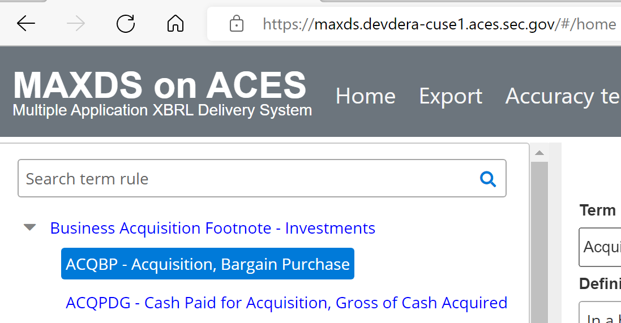

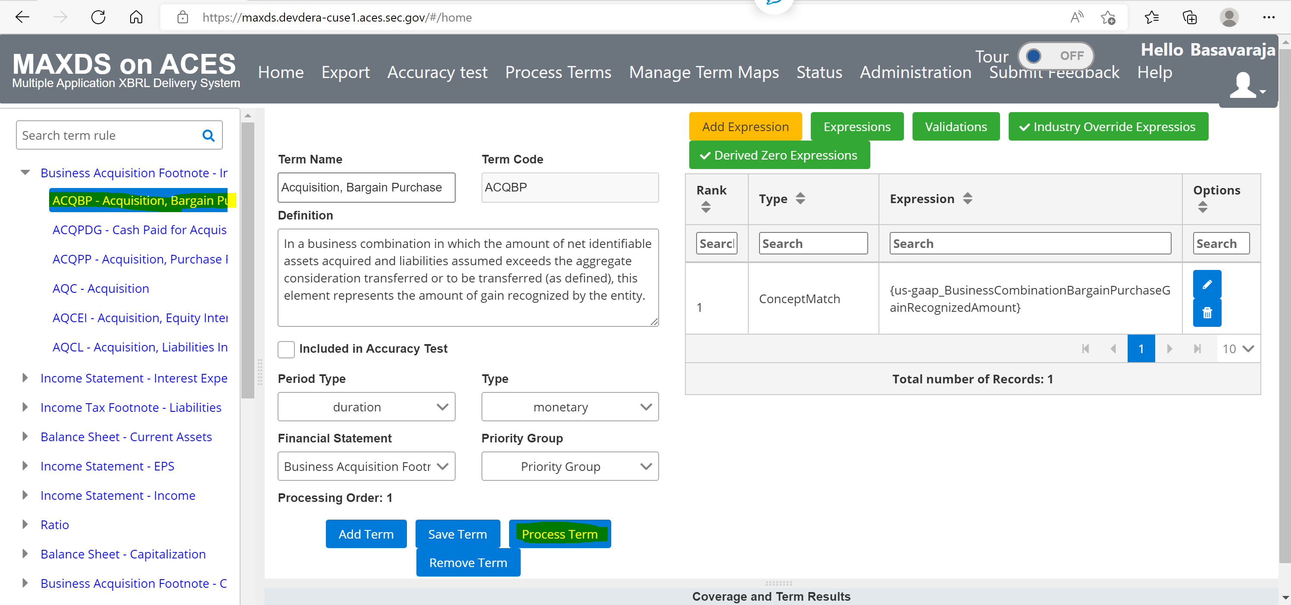

Step2:

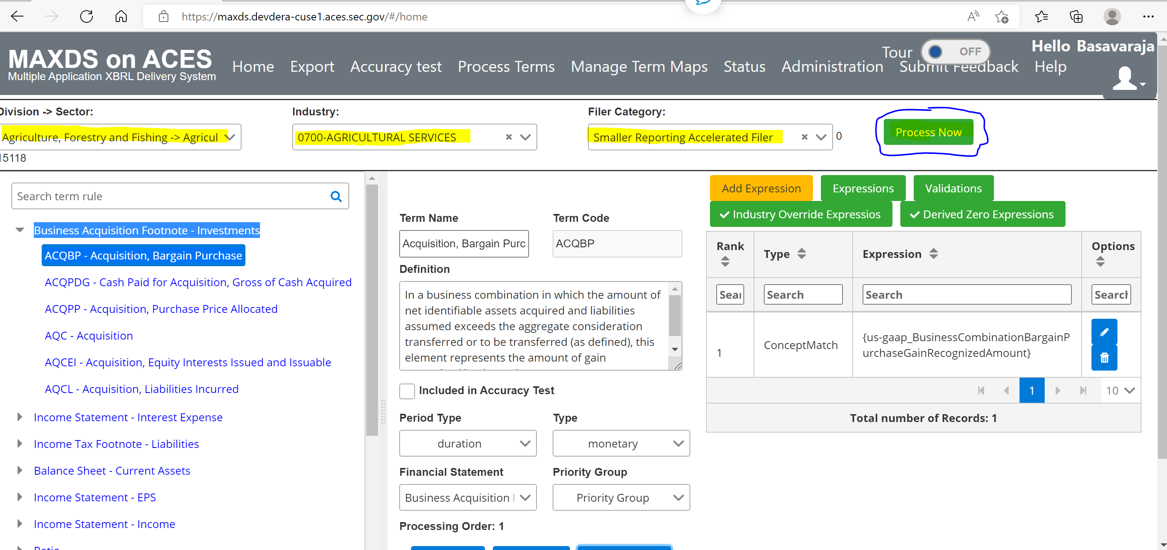

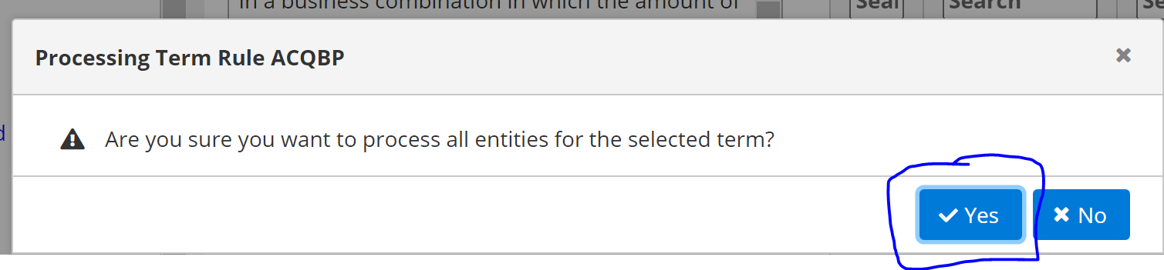

On normal operational behavior the processing should complete within few seconds, in present MaxDS on ACES deployment build the process never completed. Seeing errors in the Developer build tool as shared below.

