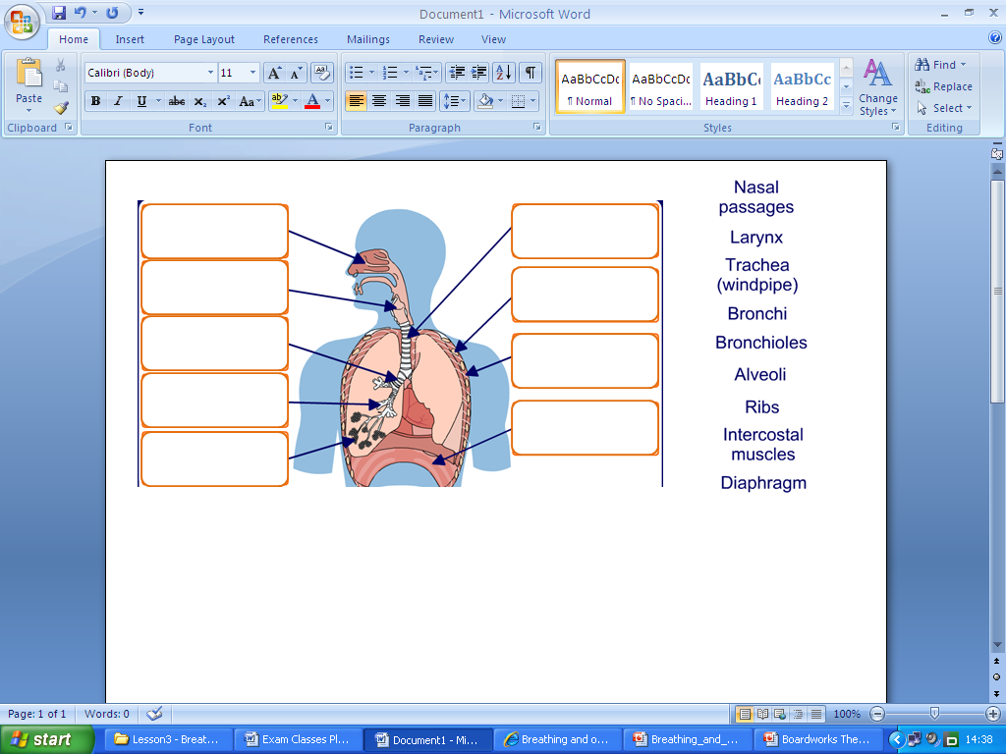

**The Respiratory System**

Using the key words below: Match the part of the respiratory system with what it does

Alveoli, Bronchi, Diaphragm, Ribs, Intercostal Muscles, Trachea, Bronchioles,

___________ -This is also known as the windpipe. This is where oxygen flows from the nasal passages and into the bronchi

_____________ - these are the two tubes that are joined to the trachea and one goes into each lung

____________ - This is the muscle underneath the lungs that contracts and relaxes which allows us to breathe

________________ - These protect the lungs on the outside and are made of bone.

____________ - these are tubes that branch of from the Bronchi and have alveoli on the end of them

___________ - These are muscles that are in between the ribs that help the lungs move.

___________ - these are the tiny sacs at the end of the bronchioles that allow gas exchange to take place.