# Spelling and Grammar Check

1. Open a new word document
2. Set the line spacing for double spaced (2.0)
3. Save the document as ***SpellCheck – Your Name***
4. Key the following paragraph. As you are typing correct **as many errors as you can**. Make sure you use word wrap and indent the paragraphs.

**I cdnuolt blveiee taht I cluod aulaclty uesdnatnrd waht I was rdanieg. The phaonmneal pweor of the hmuan mind; aoccdrnig to a rshecearh taem at Cmabrigde Uinervtisy, it deosn't mttaer in waht oredr the ltteers in a wrod are, the olny iprmoatnt tihng is taht the frist and lsat ltteer be in the rghit pclae. The rset can be a taotl mses and you can sitll raed it wouthit a porbelm. Tihs is bcuseae the huamn mnid deos not raed ervey lteter by istlef, but the wrod as a wlohe. Such a cdonition is arppoipatrely cllaed Typoglycemia :)-   
Amzanig huh? Yaeh and yuo awlyas thought slpeling was ipmorantt.**

*Microsoft Word will underline each misspelled word with a red wavy line. It will also underline the grammatical errors with a green wavy line.*

1. 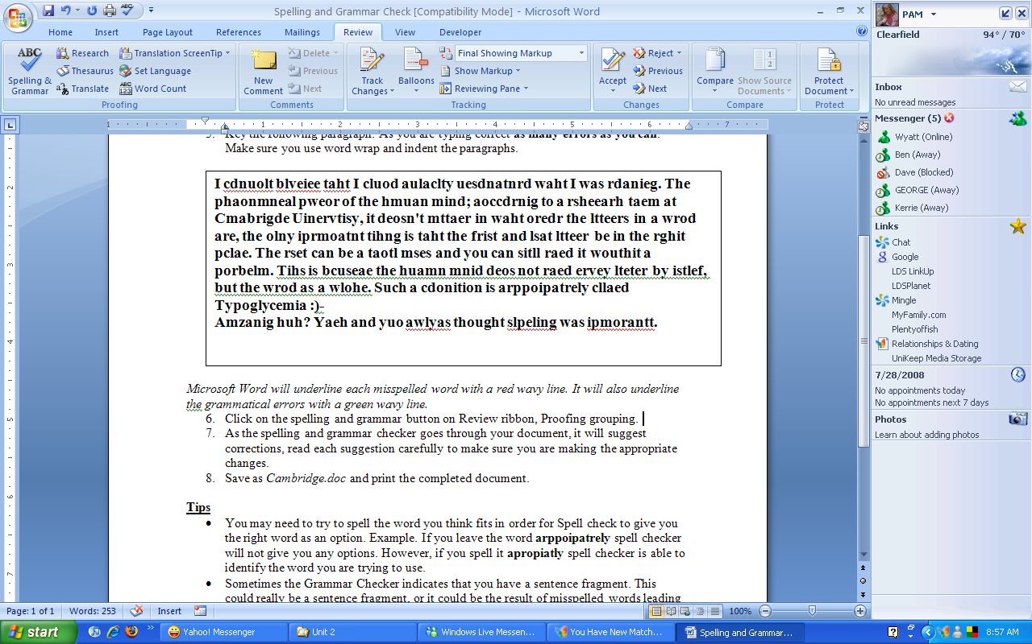Click on the spelling and grammar button on Review tab, in the Proofing grouping.
2. Or you can use the keyboard shortcut, **ALT +F7 to run a spell check.**
3. As the spelling and grammar checker goes through your document, it will suggest corrections, **read each suggestion carefully** to make sure you are making the appropriate changes.
4. Save as ***SpellCheck – Your Name***

**Tips**

* You may need to try to spell the word you think fits in order for Spell check to give you the right word as an option. Example. If you leave the word **arppoipatrely** spell checker will not give you any options. However, if you spell it **apropiatly** spell checker is able to identify the word you are trying to use.
* Sometimes the Grammar Checker indicates that you have a sentence fragment. This could really be a sentence fragment, or it could be the result of misspelled words leading the computer to *think* it is a sentence fragment.
* **Typoglycemia is spelled correctly for the purposes of this document.** It’s a joke, ha ha!