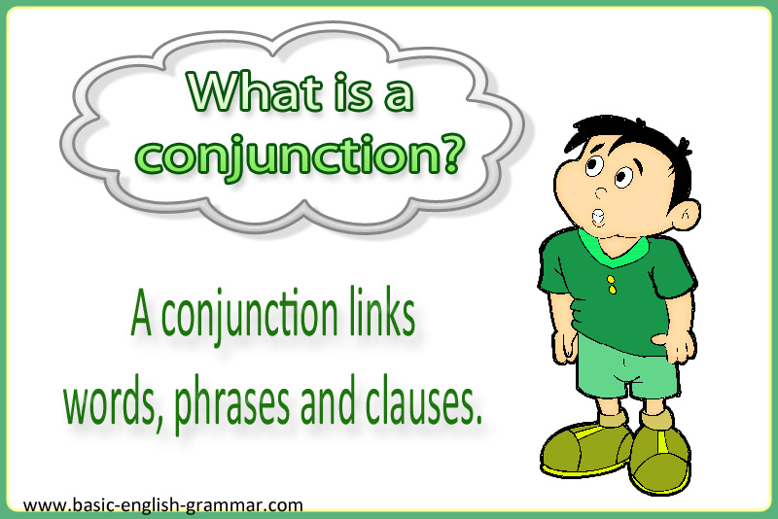

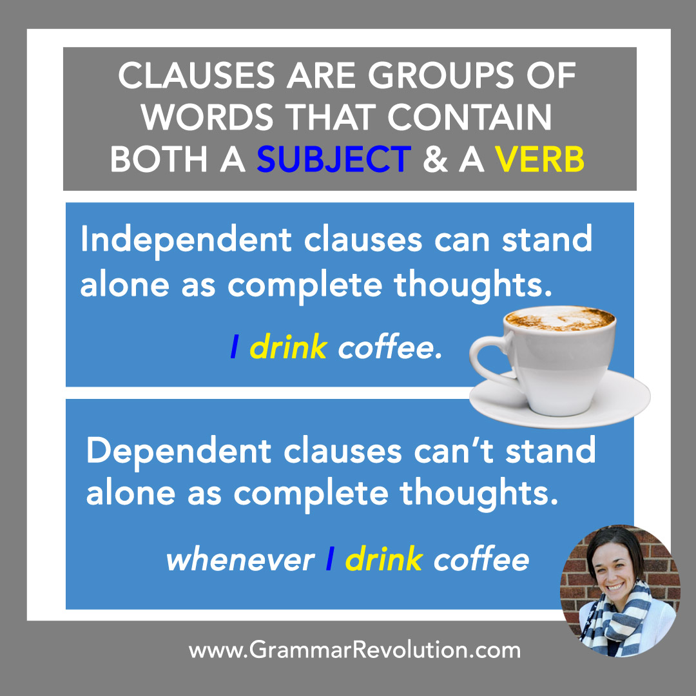

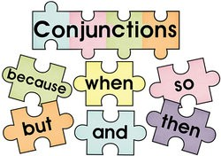

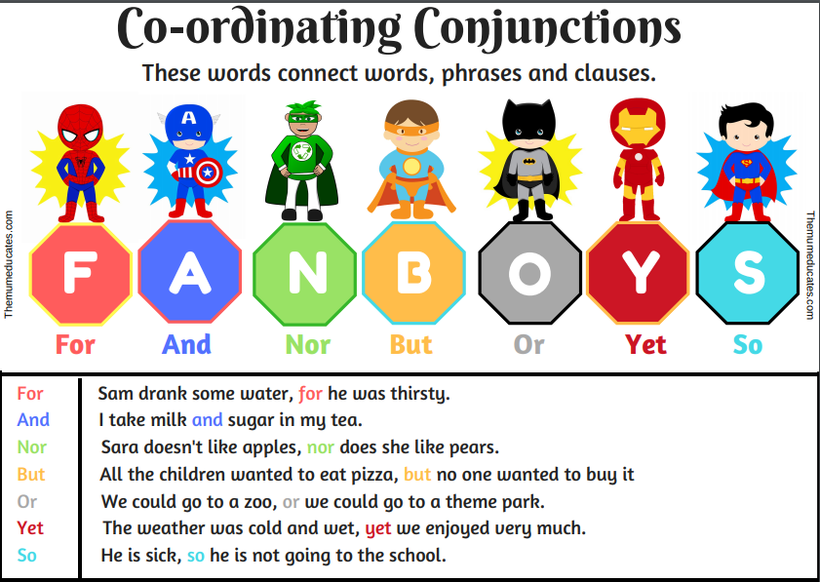

Combine the two sentences using the word in brackets.

1. Nathan likes chocolate. He likes ice cream. (and)

2. The girls went to the mall. They went to the store. (and)

3. We could play Monopoly. We could play cards. (or)

4. My teacher is strict. He is fair. (but)

5. Mom asked my sister and me to clean our room. She asked us to vacuum. (and)

6. Do you want salad with your meat? Do you want rice? (or)

7. The painters finished the living room. They finished the kitchen. (and)

8. Leila plays with dolls. Leila plays with toy cars. (and)

9. You could finish your work. You could play outside. (or)

10. Jenna likes hot chocolate. She does not like coffee. (but)

11. The twins visited their grandparents. They went to a restaurant. (and)

12. You can have the blue marker. You can have the red marker. (or)