


Analysis and mitigation of writeback cache lock-ups in Linux

Alba Mendez Orero

Project Critical Review
REVISION HISTORY AND APPROVAL RECORD

Revision | Date | Purpose
1 | 2020-03-31 | Initial version
2 | 2020-04-12 | Incorporate latest updates

DOCUMENT DISTRIBUTION LIST

Name | E-mail
Alba Mendez Orero | me@alba.sh
Juan Jose Costa | jcosta@ac.upc.edu

WRITTEN BY: |  |  | REVIEWED AND APPROVED BY:
Date | 2020-04-12 |  | Date | 2020-04-13
Name | Alba Mendez Orero |  | Name | Juan Jose Costa
Position | Project author |  | Position | Project Supervisor

Contents
0. Contents 3
1. General comments about the work progress 4
1.1. Incidences 4
1.2. Work Plan modifications 4
2. updated work plan 5
2.1. Updated Work Packages, Tasks and Deliverables 5
2.2. Updated Time Plan (Gantt diagram) 6

General comments about the work progress

Incidences

COVID-19 is impacting our ability to conduct follow-up sessions, but fortunately not much as this is closer to a software project than a hardware one. There is also a one-week delay from the initial work plan, this is mostly attributable to COVID-19 as well.

Progress

Related to the above is User-Mode Linux, which has been adopted as a way of conducting experiments and measures in a kernel without running it in actual hardware. This improves reproducibility, as lots of factors can now be controlled, enables the experiments to be fully automated, and enables a quick testing / debugging workflow. UML, unlike Virtual Machines, needs no privileges or hardware support and is easily automatable.
All in all, WP1 has been finished and we are now working at tasks 1 / 2 of WP2 and will soon start developing the patch, which —unlike what was foreseen in the work plan— will probably be in form of a kernel module or patch.

Work Plan modifications

No work plan modifications were deemed necessary.

updated work plan

Updated Work Packages, Tasks and Milestones

Work Packages:

Project: Analysis | WP ref: WP1
Major constituent: measurement & analysis | Sheet 1 of 1
Short description:  Develop necessary tools to non-invasibly measure and analyze the dynamics of the I/O throttling and how it affects other processes. | Planned start date:  2020-03-01  Planned end date:  2020-03-28
Internal task T1: real-time monitor  Internal task T2: ftrace analysis  Internal task T3: dummy loads / processes  Internal task T4: perform basic tests  Internal task T5: perform cgroup tests | Deliverables:  None | Dates:  None

Project: Implementation | WP ref: WP2
Major constituent: design & development | Sheet 1 of 1
Short description:  Understand throttling dynamics. Design & develop Proof of Concept to (partly) isolate throttling | Planned start date:  2020-03-29  Planned end date:  2020-05-02
Internal task T1: understand throttling dynamics  Internal task T2: design general operation, validate it  Internal task T3: PoC development  Internal task T4: perform basic tests | Deliverables:  Critical review | Dates:  None

Project: Discussion | WP ref: WP3
Major constituent: testing & deployment | Sheet 1 of 1
Short description:  Test the PoC in production systems, measure improvement, optionally develop proper kernel patch | Planned start date:  2020-05-03  Planned end date:  2020-06-08
Internal task T1: production test, measures  Internal task T2: improvement anaysis  Internal task T3: [Optional] kernel patch development | Deliverables:  Final memory, source code | Dates:  None

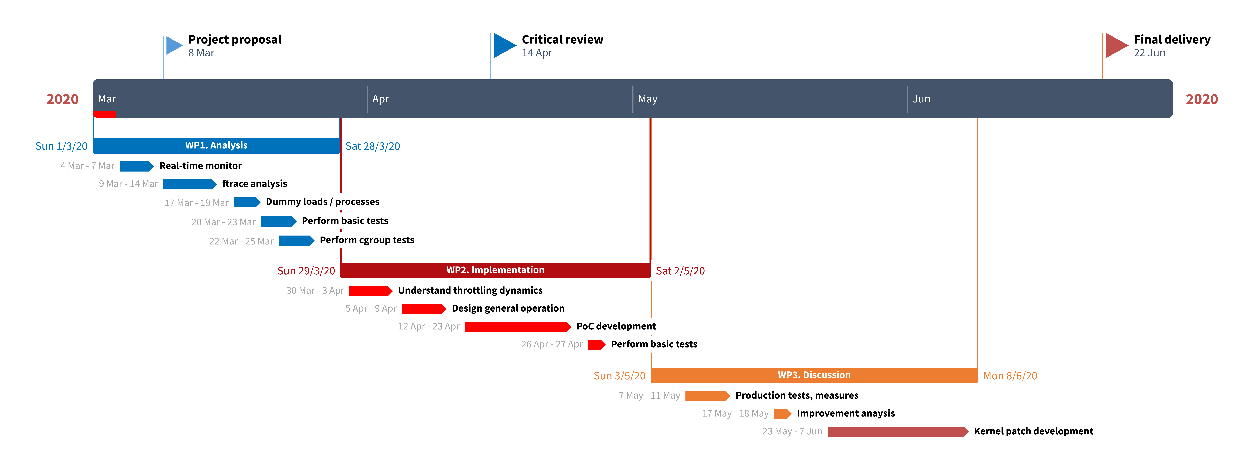

Updated Time Plan (Gantt diagram)

