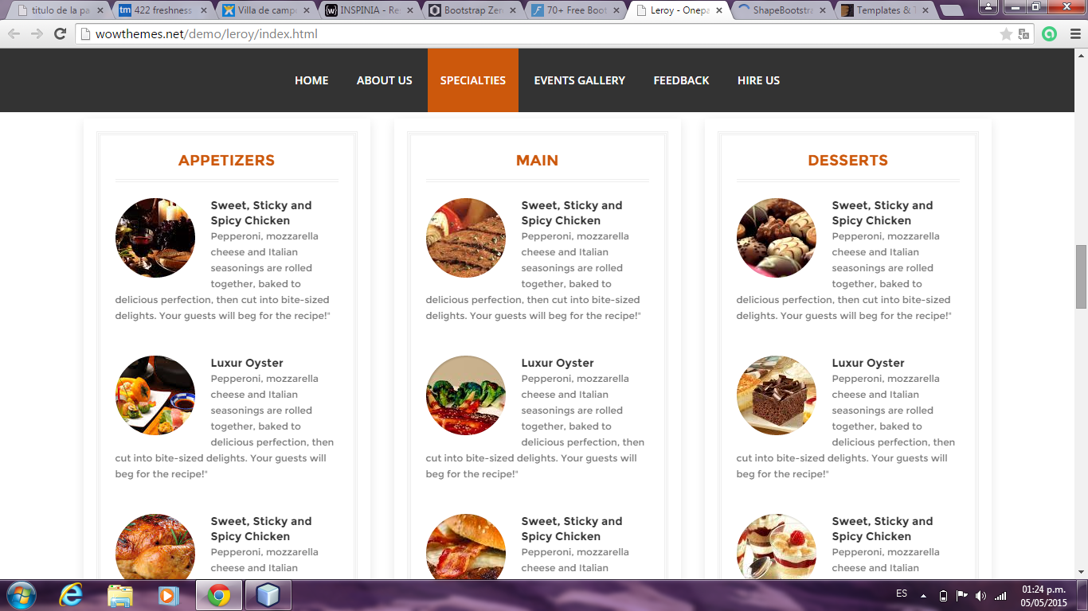

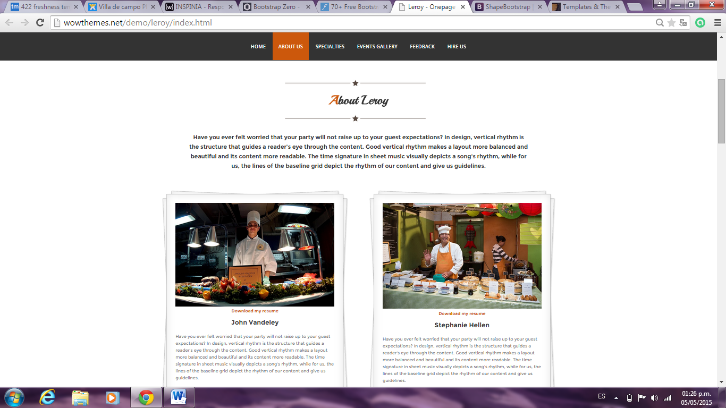

.papers {

1.  position: relative;
2.  width: 90%;
3.  padding: 2em;
4.  margin: 0px auto;
5.  margin-top: 40px;
6.  font-size: 12px;

}

.papers, .papers:before, .papers:after {

1.  background-color: #fff;
2.  border: 1px solid #ccc;
3.  box-shadow: inset 0 0 30px rgba(0,0,0,0.1),1px 1px 3px rgba(0,0,0,0.2);

}

[index.html](http://wowthemes.net/demo/leroy/index.html)

media="screen"

.text-center {

1.  text-align: center;

}

[index.html](http://wowthemes.net/demo/leroy/index.html)

media="screen"

* {

1. ~~ -webkit-box-sizing: border-box;~~
2. ~~-moz-box-sizing: border-box;~~
3.  box-sizing: border-box;

}

user agent stylesheet

div {

1.  display: block;

}

Inherited from

body {

1.  font-family: 'Montserrat',sans-serif;
2. ~~ font-size: 16px;~~
3.  line-height: 1.7;
4.  color: #777;
5.  font-weight: 400;
6.  overflow-x: hidden;

}

[index.html](http://wowthemes.net/demo/leroy/index.html)

media="screen"

body {

1. ~~ font-family: "Helvetica Neue",Helvetica,Arial,sans-serif;~~
2. ~~ font-size: 14px;~~
3. ~~ line-height: 1.42857143;~~
4. ~~ color: #333;~~
5.  background-color: #fff;

}

Inherited from

[index.html](http://wowthemes.net/demo/leroy/index.html)

media="screen"

html {

1. ~~ font-size: 10px;~~
2.  -webkit-tap-highlight-color: rgba(0,0,0,0);

}

[index.html](http://wowthemes.net/demo/leroy/index.html)

media="screen"

html {

1. ~~ font-family: sans-serif;~~
2. ~~-webkit-text-size-adjust: 100%;~~
3. ~~-ms-text-size-adjust: 100%;~~

}

Pseudo ::before element

.papers:before, .papers:after {

1.  content: "";
2.  position: absolute;
3.  left: 0;
4.  top: 0;
5.  width: 100%;
6.  height: 100%;
7. ~~ -webkit-transform: rotateZ(2.5deg);~~
8. ~~-o-transform: rotate(2.5deg);~~
9.  transform: rotateZ(2.5deg);
10.  z-index: -1;

}

.papers, .papers:before, .papers:after {

1.  background-color: #fff;
2.  border: 1px solid #ccc;
3.  box-shadow: inset 0 0 30px rgba(0,0,0,0.1),1px 1px 3px rgba(0,0,0,0.2);

}

[index.html](http://wowthemes.net/demo/leroy/index.html)

media="screen"

:before, :after {

1. ~~ -webkit-box-sizing: border-box;~~
2. ~~-moz-box-sizing: border-box;~~
3.  box-sizing: border-box;

}

Pseudo ::after element

.papers:after {

1. ~~ -webkit-transform: rotateZ(-2.5deg);~~
2. ~~-o-transform: rotate(-2.5deg);~~
3.  transform: rotateZ(-2.5deg);

}

.papers:before, .papers:after {

1.  content: "";
2.  position: absolute;
3.  left: 0;
4.  top: 0;
5.  width: 100%;
6.  height: 100%;
7. ~~ -webkit-transform: rotateZ(2.5deg);~~
8. ~~-o-transform: rotate(2.5deg);~~
9. ~~ transform: rotateZ(2.5deg);~~
10.  z-index: -1;

}

.papers, .papers:before, .papers:after {

1.  background-color: #fff;
2.  border: 1px solid #ccc;
3.  box-shadow: inset 0 0 30px rgba(0,0,0,0.1),1px 1px 3px rgba(0,0,0,0.2);

}

[index.html](http://wowthemes.net/demo/leroy/index.html)

media="screen"

:before, :after {

1. ~~ -webkit-box-sizing: border-box;~~
2. ~~-moz-box-sizing: border-box;~~
3.  box-sizing: border-box;

}

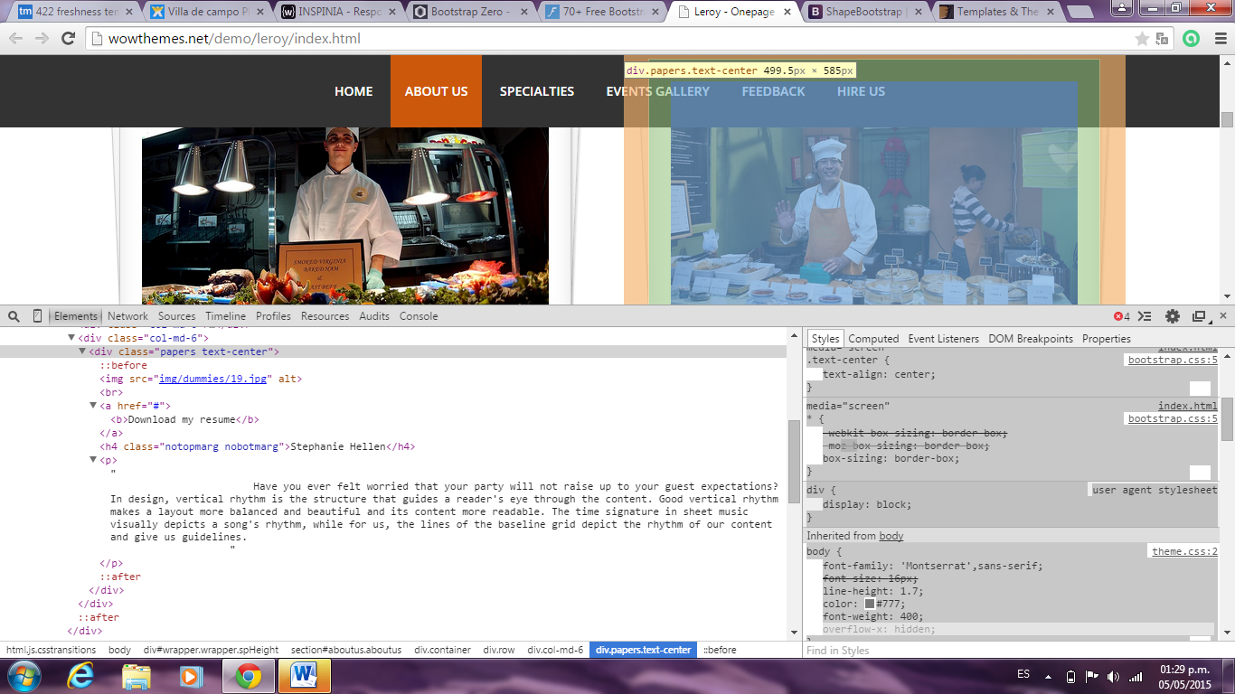

<http://wrapbootstrap.com/preview/WB0R5L90S>

<http://www.templatemonster.com/demo/45962.html>