Performance Benchmark of PHP Frameworks with Database Select Methods

Mile Janev, Blagoj Delipetrev
Faculty of Computer Science, University “Goce Delcev”
Krste Misirkov bb. 2000 Stip

Abstract
PHP is one of the most popular programming languages for web applications backend development. In order to quickly develop an application, many companies have created their own frameworks. Today, there are hundreds of frameworks in PHP, but all are not equally popular. Only a few of them stand on top of the most popular frameworks (Zend, Codeigniter, Yii, CakePHP, Symfony, Laravel). Each of these frameworks has its own advantage over others, some are faster in database operations, other are better in security, or allow rapid application development. The choice of which framework will be used for development depends from application needs. One of the most important aspects when we are choosing framework is speed, no one wants to wait long for loading some web page. Even Google have clearly stated that all those sites which needs more than 2 seconds to load will negatively rated. In this article we elaborated three of the most used PHP frameworks (Yii, Zend and Codeigniter) and we test them how quickly will retrieve data from database.

Вовед
PHP is used in almost 82% of all internet web sites as a backend programming language. There are many frameworks in PHP, some created for companies needs, others for general use. But all of them have the same goal: to speed up the process of application development and to increase level of security.
With increasing security mechanisms the speed of application is reduced, and this directly affects the interest of visitors. Nobody wants to wait longer than 2-3 seconds to read some information.
This is one of the reasons why is necessary to make an appropriate balance between all of these factors. Mostly used frameworks managed to achieve this balance. Here we will point out three of them which are more and more used. These are Zend, Yii and Codeigniter.
Almost all web applications using database, which means it is very important how quickly some framework can communicate with the database. Every framework has their own classes and methods for extracting data from database. These classes are also called Active Record classes. They have embedded security mechanisms (filters) and some other methods who are reducing the speed of extraction data.
To develop this benchmark we have created application where we have tested every method from all frameworks for extracting data on same database. Application can be found on the following link .
The project has clearly defined two objectives:
- The first is to make internal of all methods in given framework and to determine the fastest method for selecting data from database.
- The other is to determine which of these frameworks is the fastest.

Test environment
All tests are made on local machine on LAMP server, Linux Ubuntu operating system. Hardware and software specifications are the following:
- Processor: Intel Core i5-2430M (2 Cores, 4 Threads, 2.4GHz)
- RAM memory: 6GB
- Operating system: Linux Ubuntu 12.04 LTS, 32-bit
- Apache server, version 2.2.22
- MySQL database, version 5.6.21
- PHP version 5.3.10
Framework versions are:
- Yii version 1.1.15
- Zend version 1.11.11
- Codeigniter version 2.2.0
We test on three differently filled tables with data, so we will be able to determine how every framework will handle when web site is increasing the amount of data.
Tables are with following sizes:
- s_post – 10 000 records
- m_post – 100 000 records
- l_post – 300 000 records
All tests were done with disable caches on server. Operation environment is completely same in everyone.
Each method has run 900 seconds or 300 seconds of each table. For example, we tested how many times method findAll() in Yii will be performed in 300 seconds in each table.
All information displayed further will be expressed in number of executions of the method in one minute.

Methods description
Every method in each framework has its own purpose why is there, although sometimes more methods may be used for the same purpose. Some methods are faster, some easier to create dynamic queries. Programmer should always choose the right method according to the needs. You should always choose the method that will be able to complete the required task but in same time will be the fastest one.
In this chapter we will briefly explain every function for selecting database record in each framework individually, what parameters they receive and what is returned as result.

Yii
Yii has eight methods for extracting data from the database. Four of them select one entry from the base, and four select all records that will meet the specified requirement.
Methods containing abbreviation "All" in its name return an array of objects that satisfy the given condition, while those that do not contain return one row from database mapped into object.
The methods are:
- find() – Accept an object from class CDbCriteria as parameter.
- findByPk() – Accept an integer (database primary key fot the record) as parameter.
- findByAttributes() – Accept an array in format “key”=>”value” as parameter, where “key” is column name and “value” is the given condition.
- findBySql() – Accept one or two parameters. The first is manually defined query in which all conditions should be replaced with some strings, while the second one is an array where on each string will be given some value. For example, findBySql(“SELECT * FROM s_post WHERE id = :id”, array(“:id”=>5).
- findAll() – Accept one parameter or not receive parameters. If parameter is not given all records will be returned. If you like to add some condition (parameters) should be object from class CDcCriteria.
- findAllByPk() – Accept an array of integers (primary keys for records in database) as parameter. findAllByAttributes() – Accept an array in format “key”=>”value”, where “key” is the column name from database, and “value” is the given condition.
- findAllBySql() – Accept one or two parameters. The first is manually defined query in which all conditions should be replaced with some strings, while the second one is an array where on each string will be given some value. For example, findBySql(“SELECT * FROM s_post WHERE id = :id”, array(“:id”=>5).

Zend
Zend have four ways of extracting data from database. Two of them (find and fetchRow) return one result, while two (fetchAll and Zend_Db_Select) return all records that satisfy the given condition.
These methods are:
- find() – Accept an integer (primary key) or array of integers as parameter. Returns an object from class Zend_Db_Table_Rowset_Abstract.
- fetchRow() – Accept a string as query condition (example: “id=”.$id). Returns an object from class Zend_Db_Table_Row.
- fetchAll() – Accept a string as query condition (example: “id=”.$id). Returns an object from class Zend_Db_Table_Rowset_Abstract.
- Zend_Db_Select – Represents a SQL SELECT condition in query. Class has methods for partial adding parameters to query.

Codeigniter
In Codeigniter all methods return an object from class CI_DB_mysql_result.
- get_where() – Accept four parameters. First is table name (string), the second is array in format “key”=>”value”, where “key” is column name and “value” is our condition. Third and fourth parameters are limit and offset, and they are not mandatory.
- get() – Partial query.
- query() – Manually defined query ready for direct execution in the database.

Testing results
In testing process all server caches were completely disabled.

Yii
The diagram on Figure 1 shows all methods in Yii with number of executed operations in one minute, grouped by table size.
From the diagram we can note that the fastest method is findBySql() and findAllBySql(), while the slowest is findAll(). With increasing the content in tables positions of methods are not changed, findBySql() remains on top and findAll is slowest.
The advantage of findAll() and higher usage than findBySql) and other methods is that he receives an object from class CDbCriteria as parameter, who allows creating partial queries, while findBySql() and findAllBySql() accepts only manually created query in string format.
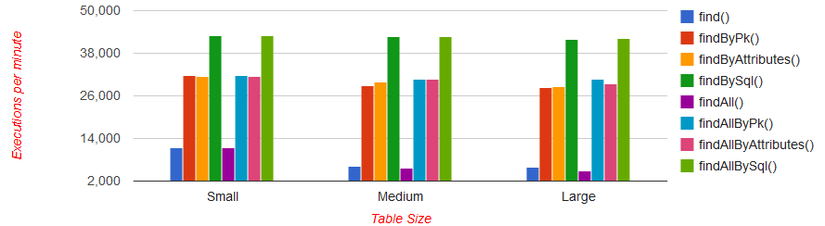
Figure 1: Number of queries performed in one minute on small, medium and large database table in Yii
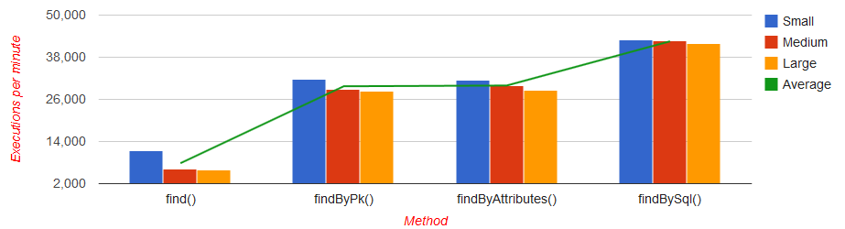
Figure 2: Number of queries performed in one minute grouped by same method on different table, only with methods who return one record in Yii
On figure 2 is shown a diagram where are represented only methods who return one record. On this diagram grouping by columns is made by one method on different table size, and it is easier to distinguish the execution speed on some method when the number of records in table size is increased.
The biggest difference in deceleration when number of records in table are increased is in find() method. For table with 10 000 records method is performed 11,377 times per minute, while for table with 100,000 records 6,265 times or almost in half. But with further increasing records in table we can notice that speed is stabilized again, and for 300,000 records we have 5,873 executions.
The situation is similar in other methods too, which means that bigger difference is notable small and medium table than between medium and large. Most stable method is findBySql() where is noted slightest difference when records in table will be increased.
We must underline that in our case the difference between the smallest and the largest table is around 300,000 records so the difference is not very large, but if it would be a few million, then the difference will be much higher.
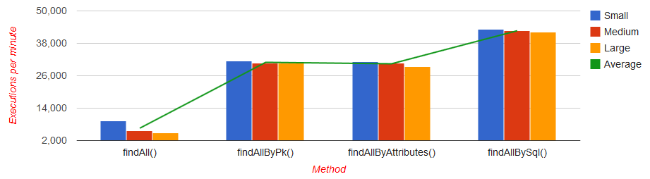
Figure 3: Number of queries performed in one minute grouped by same method on different table, only with methods who return multiple record in Yii

The methods that return more records grouped by methods are presented in Figure 3. The results are similar to the methods for selecting one record. Method findAll() with 6,602 average executions in one minute is the slowest one, and findAllBySql() with 42,674 is the fastest.

Zend
Similar as in Yii, in Zend also will be represented two images with diagrams, where in the first methods will be presented regarding to the execution speed on one table, and in the second will be grouped by method so will be easier to distinguish the execution speed on some method when the number of records in table size is increased.
In the first case, in Figure 4 we see that the fastest method is fetchAll(), while the slowest is selecting records with Zend_Db_Select. With increasing the number of records in table position of methods is not changed.
On Figure 5 presents the second case, where we can see an interesting situation in which almost is no difference in the speed of method no matter the number on records has been increased. Even there are cases when some methods are quickly performed in large table, but this difference is very small and insignificant, probably caused because processor had other processes in that time.
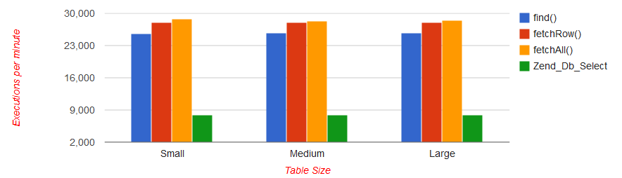
Figure 4: Number of queries performed in one minute on small, medium and large database table in Zend
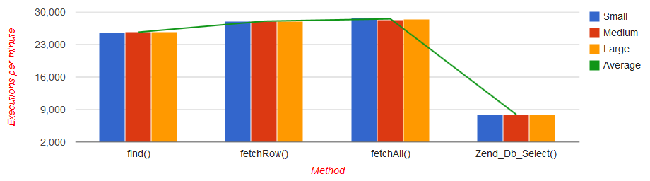
Figure 5: Number of queries performed in one minute grouped by same method on different table in Zend

Codeigniter
In figure 6 we have presented all methods grouped regarding the execution speed on small, medium and large table. From the diagram we can easily conclude that the fastest method in Codeigniter is query(), followed by get_where() and the slowest one is get().
From Figure 7 where we have grouping by method, we can see some minimal difference in all methods between small and medium table, while the difference between medium and large table is minimal. This means that Zend can great handle with large databases, and is suitable for large projects.
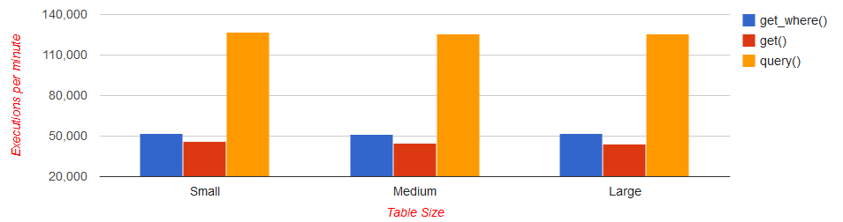
Figure 6: Number of queries performed in one minute on small, medium and large database table in Codeigniter
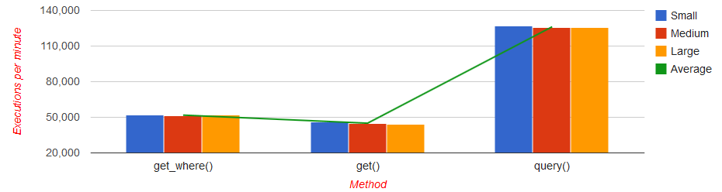
Figure 7: Number of queries performed in one minute grouped by same method on different table in Codeigniter

All Framework Comparation
Lorem ipsum dolor sit amet.

Mile Janev (mile.janev89@yahoo.com)
PhD Blagoj Delipetrev (blagoj.delipetrev@ugd.edu.mk)

