This document is about PIMS2, Profiles Integrated Management System. It serves as a Technical Reference, and provides answers to FAQs, Frequently Asked Questions.
Below is a list of the various issues addressed in this document. Ctrl-click on a subject to reach the paragraph:
Starting PIMS2: command-line 2
Temp-folder and buffer-folder 4
Companies-folders 4
On network, mapped v/s non-mapped drives 4
Data-files, and Windows users privileges (for BDE users) 5
Data-files, access-rights & read-only 6
How PIMS2 versions are numbered 6
Time Synchronization on Windows networks. 7
Multi-Branch 8
Branch-Exchange 8
Implementing PIMS2 on a network, using Update2 scripts 9
On Windows 8, using shortcuts to launch Update2 scripts 11
Starting PIMS2 on various Windows platforms 11
PIMS2 is working extremely slowly 12
PIMS2 showed error "error loading MIDAS.DLL" 13
PIMS2 is not starting, and you are using Windows 98 or ME 13
Payroll: Time-Attendance devices supported 14
Arabic not showing on my computer 14
Input using Turkish characters 15
Comma-separated files improperly handled by my Excel 16
Using dates and date formats, with Excel 16
Printer not printing as expected 17
Printer not printing characters, only graphics 17
Epson dot-matrix printer printing too slow 18
Recovering from BLOB errors 18
Remote Assistance, using TeamViewer 18
Sybase SAP Advantage database, server detection problems 20
Sybase SAP Advantage database, error 5185 when using in remote session 21
Sybase SAP Advantage database, degraded performance 21
Network interference, unusual problems 22

Starting PIMS2: command-line
To start PIMS2, you will most probably make a Windows shortcut, with a command-line.
There are various ways of starting PIMS2, depending on the command-line elements you provide, or those you do not provide.
Here are typical command-lines, with the explanation of each of their elements:

C:\PIMS2\pims2.exe C:\CLI\myself.pms
C:\CLI\myself.pms is your PIMS2 license file. It is usually named after your company name, such as Bristol.pms, MonaCool.pms, etc.
Your PIMS2 license file defines which modules you are entitled to use, as well as any license rights pertaining to your PIMS2 system.
At first, the data is assumed to be in the same location as the license-file, i.e. in the same folder. If no data is found in the same folder as the license file, then PIMS2 searches for data is in the same location where data was, the last time you started the same license. Else, data is assumed to be in C:\PIMS2\DATA.

C:\CLI\myself.pms
C:\CLI\myself.pms you may start your PIMS2 system by invoking your PIMS2 license file alone. This will most probably be the case when you double-click your license-file, or a shortcut to it.
This is the only situation where you can start PIMS2 by double-clicking (running) a single file; in all other cases, parameters are needed, which are typically provided by using a shortcut.
If you have multiple copies of pims2.exe on your computer, the one that will execute is the one that was last executed on this computer. If you never executed PIMS2 before on this computer, or if the pims2.exe that was executed last is no longer available, PIMS2 will not start.
Concerning the data location, see previous sample.

C:\PIMS2\pims2.exe C:\CLI\myself.pms C:\MYDATA
C:\PIMS2\pims2.exe C:\CLI\myself.pms \\server\MYDATA
C:\ MYDATA this is the folder where the PIMS2 data files are expected to be found. A server location can also be indicated, such as \\server\mydata.

C:\PIMS2\pims2.exe C:\CLI\myself.pms C:\MYDATA /web
/web this is a command-line option. Command-line options always start with a slash or a minus-sign, such as /web or -web. Supported command-line options are:
/web optimize for operating across the web (using PC-Anywhere, Citrix Metaframes, etc)
/256 force using 256 colors, even if more colors are available in Windows.
/font PIMS2 displays may not be accurate when Windows fonts size is set to a value other than normal. The normal value for Windows fonts is 96 ppi, ie 96 pixels per inch. PIMS2 will refuse to start if the Windows font size is not 96 ppi. This command-line option will allow starting PIMS2 in spite of this setting.

Temp-folder and buffer-folder
PIMS2 needs to locate your temp (temporary) folder, as it will create in it some temporary files, as well as a buffer folder.
There may be in your Windows system an environment variable named TEMP, which identifies your temp folder. Otherwise, your temp folder is assumed to be C:\TEMP. If that folder does not exist, PIMS2 creates it automatically. On a network, your temp folder should better be on the local computer, rather than on the server, for improved performance.
PIMS2 will create a subfolder of your temp folder, known as the buffer-folder. A buffer-folder will hold all the buffer-tables created as part of the normal working process of PIMS2. A buffer-folder is typically named C:\TEMP\~PIMS000.
If more than one PIMS2 sessions are started on your computer, each session will create its own buffer-folder, named ~PIMS001, ~PIMS002, etc.
If your PIMS2 session crashes for any reason, the buffer-folder would not be deleted, and will remain in your temp folder. If, upon starting, PIMS2 notices that the temp folder contains too many buffer-folders, then PIMS2 asks the user to clean-up before it is able to start.

Companies-folders
Each company in PIMS2 has its data in a subfolder of the main data folder. To be identified as a company-folder, this subfolder must also contain a valid company-configuration file, always named company.cfg (this is an encrypted file).
The company-code is the first 8 characters of the name of the company- folder. Excess characters are disregarded. Duplicates are also rejected ("TradeGroup1" and "TradeGroup2" both have the same 8-char company-code "TradeGro").
The capitalization of the folder-name is maintained, and reflected in printed reports. However, "Mycomp" and "MYCOMP" are rejected as duplicates.

On network, mapped v/s non-mapped drives
If your data-folder is on a network, you will want that various computer stations access the same data simultaneously (provided your PIMS2 license includes the Multi-User feature).
It may be that different computer stations do see the data-folder under different paths. While one computer station may be calling PIMS2 with the following command-line:
C:\PIMS2\pims2.exe C:\CLI\myself.pms F:\MYDATA
while another computer-station may be calling PIMS2 using:
C:\PIMS2\pims2.exe C:\CLI\myself.pms G:\Accounts\MYDATA
or:
C:\PIMS2\pims2.exe C:\CLI\myself.pms \\server\MYDATA
PIMS2 will only work properly if all computer stations are asked to see the data-folder under the same path.
You may need to create additional shares on your computers, to reach such a situation where all computers do see the data under the same path.
Even when you use your local computer as the data server, i.e. when the data is on your local hard-disk, you must create a share on your local computer, and use it to access the data, else data will no longer be accessible to other computers.

Data-files, and Windows users privileges (for BDE users)
This consideration applies only to users of PIMS2 under BDE, users of PIMS2 under Sybase SAP Advantage are not concerned.
During the installation of PIMS2, and as with many other applications, the user carrying out the installation must have Administrative access-rights with Windows.
After having done the setup, and using BDE-Admin, one should change the NETDIR parameter to a folder other than C:\, typically to C:\Temp.
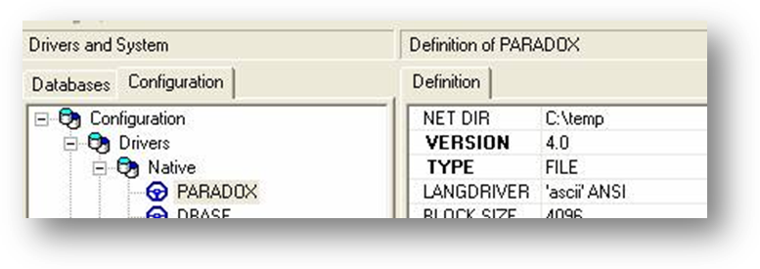
The point is that, upon installation and by default, the NETDIR parameter is usually set to C:\, while non-Administrator users are often prevented by firewalls and similar security devices from writing in the root of C: drive.
Once this is done upon initial setup, the privileges of the user running PIMS2 can be the standard User privileges. The user will however need to have full rights and privileges on the data folder, where PIMS2 tables reside (be it on the local drive or on the network). Those privileges must include the right to create and delete files and subfolders. Full privileges must also be granted for the temp folder, the one indicated by the NETDIR parameter.
Normally, the BDE-Admin applet can be found in the Control Panel. But if, for any reason, it does not have a shortcut in the Control Panel, one can find it easily by searching for the file "bdeadmin.exe".
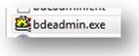

Data-files, access-rights & read-only
For PIMS2 to operate, it needs to read from data-files, and to write onto them.
A typical mistake is to overlook this, and fail to grant write access-rights to files. Here are some usual cases, where PIMS2 will fail to operate:
- As a Windows user, you have not been granted read-write access to the data-files. This is most likely when those files are on a data server.
- Data files were copied from a CD to the computer hard-disk: usually, Windows marks such files as read-only; you need to uncheck the read-only status of those files. Read-only status can be changed from the files and folders Properties panel. Right-click on the main data folder, and choose the Properties menu option.
- As a Windows user, you must also be granted read-write access to the temporary folder. This could be C:\Temp, or a sub-folder of C:\Documents and Settings.

How PIMS2 versions are numbered
To read the version number of your current PIMS2, open the About form (main-menu, Help, About PIMS).
At the top of the About PIMS2, find the line that looks like this:
PIMS2 203-1635-04.01.07
In this line: 203 is the release number, 1635 is the build time, and 04.01.07 is the build date (in this case January the 7th, 2004).
When you work on your data using a given version of PIMS2, the data is stamped with that version number. If later on you try working on that data with a different version of PIMS2, the following happens:

version stamped  in data | version of  new PIMS2.exe | what will happen when starting PIMS2
203-1635-04.01.07 | 203-1635-04.01.08 | A new build of PIMS2 is used now, dated later than the one that had been used before. PIMS2 will automatically perform a reindexing, to verify the structures of tables.
203-1635-04.01.07 | 203-1930-04.01.07 | The PIMS2 used now was built on the same date as the one used previously. No action done.
203-1635-04.01.07 | 203-1635-04.01.06 | The PIMS2 used was built earlier than the one used previously. It has however the same release number, 203. PIMS2 will ask for your confirmation to proceed. Proceed only if you cannot do otherwise.
203-1635-04.01.07 | 202-1635-04.01.01 | You are attempting to start using a PIMS2 with a release number, 202, former to the last PIMS2 used, 203. Release numbers change when data structures evolve substantially. PIMS2 will not start.

Time Synchronization on Windows networks.
If computer A has worked on PIMS, with a date 15/01/2000, then PIMS assumes that the "real life" date is 15/01/2000, or later, but it cannot be earlier.
If then computer B starts PIMS, pretending that the "real life" date is 14/01/2000, then PIMS starts complaining that it cannot be 14/01/2000, since the day 15/01/2000 is already reached or passed.
So having, on one network, computers with different dates (or times) is not an acceptable situation.
Always make sure that, in a Windows network, one of the PCs is appointed as a "time server". The PC used as the file or database server is a natural choice.
The command which can synchronize the clock of your station on the clock of the selected server is named “net.exe”, and typically found in the “system32” sub-folder of your Windows folder.
Assuming that your selected server is named MyServerName, the command would read:
C:\Windows\System32\net time \\MyServerName /set /yes
Include this command in a Windows shortcut, which you will create in the StartUp folder of your Windows, therefore ensuring that it gets executed each time you start your computer.

Multi-Branch
PIMS2 is designed as a Multi-Branch platform. You may be receiving transaction-documents from your different branches. You then input all those transactions into one same computer, to reflect the overall situation.
Each of your PIMS2 companies may have its own branches, which you create, with a 2-letter code, and a name, such as: code = CD, name = Central District.
One of the branches is known as the Main Branch, its code is always '00' (zero zero). When you think that you are working without using branches, you are in fact working on a single branch system, on the Main Branch 00.
Every operator has his current branch for every company. When an operator selects a different company, he selects implicitly his current branch in that company.
An operator can select a different branch in the current company anytime, from the 'Company' menu.
At any moment, the main-form caption shows not only the current company, but also the current branch if the current company has more than one branch.

Branch-Exchange
Branch-Exchange is having one PIMS2 operating at each of your branches, on a separate computer.
An import-export and file-exchange mechanism allows all those branches to interchange all or part of the processed information, so that each branch eventually has available all the necessary data it needs to operate, and only that data.
The Main Branch, code '00', will always have complete data, reflecting also the activity at all the other branches.

Implementing PIMS2 on a network, using Update2 scripts
When PIMS2 is to be implemented on a multi-station network, it is better and safer to implement it according to the below scheme.
In this scheme, PIMS2 is launched using an Update2 script. This script will first ensure that the latest version of PIMS2 is propagated to the workstation: if the version of PIMS2 on the server is more recent than the one on the local station, it will be copied onto the station before PIMS2 is started.
This way, any station starting PIMS2 will be using the latest version available on the server, ensuring that all stations are always using the same version of PIMS2 anytime. This also applies to notebooks that could connect at a much later time.
When a new release of PIMS2 is available, placing this new release on the server will suffice for it to propagate to all stations later on.
To implement this scheme, proceed step by step as follows:

On the server:
- On the server drive, create these folders:
\\server
\Profiles
\PIMSprog
This folder contains ALL the contents of the downloaded PIMS2.zip, including Update2.exe, DelNetLck.exe, Capture.exe, TeamViewer.exe, etc.
One should be able, at any moment, to delete all contents of this folder and replace them by the contents of the downloaded PIMS2.zip.
\Tools
This folder typically contains system installation and maintenance tools, such as bdeonlysetup.exe.
\Start
this folder contains:
- the .pms license(s)
- the Update2 startup scripts.
\Data
- Share the \\server\profiles folder to all users who need to see this folder, giving them full control.
- Open \\server\profiles\PIMSprog
- From this location, run update2.exe so that the Update2 application registers on the local computer (you may need to run this twice)
- In \\server\profiles\Start, create the PIMS2.UPD script, which starts PIMS2, and which should contain:
Title = Starting PIMS
LeftPath = \\Server\Profiles\PIMSprog
RightPath = C:\PIMS2
UpdateMode = LMaster
EXCLUDE = *.NET, *.LCK
Execute
ExitFolder = C:\PIMS2
ExitProgram = C:\PIMS2\pims2.exe
\\server\Profiles\Start\license.pms \\server\profiles\Data
- In \\server\profiles\Start, create the Backup.UPD script, which creates daily backup of the PIMS2 data, and which should contain:
Title = Backup of PIMSUSER data to \ROOT\PIMSBACKUP FOLDER
;---------------------------------------------------------
Message = per-Month backup
LEFTPATH = \\server\profiles\data
RIGHTPATH = \\somewhere\BKUPData\{YEAR2}-{MTHnum}-{DAYNUM}
UPDATEMODE = LMaster
EXCLUDE = IDX\*.*, *.NET, *.TBK, *.PBF, *.PX, *.XH*, *.XG*, *.X0*, *.Y*, *.ADI, *.BAK
EXECUTE

On each station:
- Open folder \\server\profiles\PIMSprog
- From this location, run update2.exe so that the Update2 registers with the local computer (sometimes you may need to run this twice)
- Run the \\server\profiles\tools\bdeonlysetup.exe setup program, which installs BDE on the local machine.
- Run the path \\server\profiles\Start.
- Send the file PIMS2.upd as a shortcut to the desktop.
- Run this shortcut for the first time to copy all files from PIMSprog to a folder named PIMS2 on the local disk C.
- In the properties of the shortcut, change its icon, use that of C:\PIMS2\PIMS2.exe.

If you want to use the Server as a PIMS2 station as well:
- Open the folder \\server\profiles\Start.
- Send the file PIMS2.upd as a shortcut to the desktop.
- Run this shortcut for the first time to copy all files from PIMSprog to a folder named PIMS2 on the local disk C.
- In the properties of the shortcut, change its icon, use that of C:\PIMS2\PIMS2.exe.

On Windows 8, using shortcuts to launch Update2 scripts
Under Windows 8, it appeared that shortcuts may fail in the following case:
If the command-line of a shortcut contains
N:\profiles\start\pims2.upd
this is supposed to launch Update2.exe, and feed it with the indicated script file. But when the script file is indicated using a mapped drive (such as N:), Windows 8 is failing to convert properly.
Instead, simply refer to the intended drive using its actual name, and the shortcut will work properly. This would be something like
\\server\profiles\start\PIMS2.upd

Starting PIMS2 on various Windows platforms

Windows-Vista and Windows-7:
Windows-Vista and Windows-7 both have overly powerful security rules, which rate most applications as suspicious. When starting PIMS2 under Vista or Win-7, you may face a number of problems, such as being systematically asked to confirm that you trust the PIMS2 application, or failing to access your data if it is on a server, especially if using Sybase SAP Remote Server.
This protection is known as User Account Control, or UAC.
In order to disable UAC, and be able to utilize PIMS2 normally, you should
- Click Start, Settings, Control Panel
- Windows Vista: go to Users, and "Turn User Account Control off".
- Windows 7: go to Users Accounts Control Settings, and scroll the vertical slider down to "Never Notify".
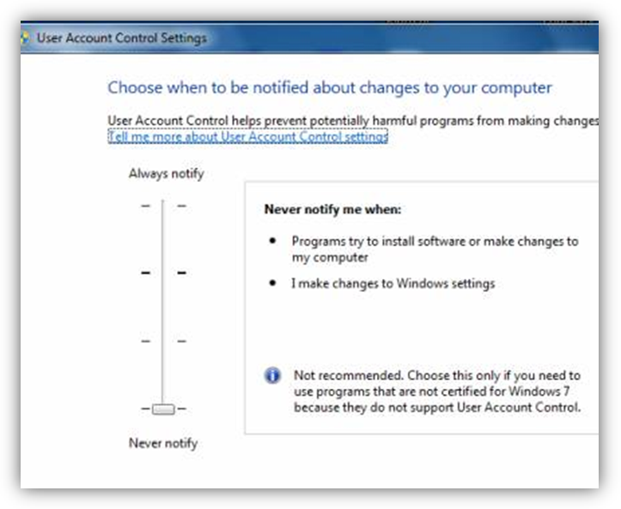

Windows 8:
With Windows 8, PIMS2 will always start up properly, regardless of the UAC settings.

PIMS2 is working extremely slowly
You may have an anti-virus active. PIMS2 tables have the extension .db, which is considered by most virus scanners as a hazardous type of file, and therefore included in the list of files that are "scanned on access".
This means every bit of information that your computer reads out of this file is scanned, to check if it contains any virus.
Most anti-virus tools offer an "exclude" option, where you instruct it to ignore files like *.db.
With some anti-virus tools, excluding explicit file extensions may prove difficult, if not impossible. In such case, you may consider excluding the whole data folder altogether from virus scanning.
With some anti-virus tools, exclusions only take effect only after you reboot the computer, the effect of the exclusion is therefore not immediate.
There are also other possible reasons why your system is slow. Looking at the Windows Task Manager, you may identify other applications that consume CPU time on your PC. You may want to suspend those activities while working on PIMS2. Typical such applications: messengers, remote access, system utilities, etc.

PIMS2 showed error "error loading MIDAS.DLL"
MIDAS.DLL is a necessary component of the PIMS2 system. DLL stands for Dynamic Link Library, if you care to know.
Normally, DLLs get automatically registered by Windows, and become therefore available to applications using them.
But this automatic registration may sometimes fail. This is probably the case with you. In order to recover, you need to register MIDAS.DLL manually. To do so, you must type the following command-line:
regsvr32 pimspath\midas.dll
where pimspath is the full-path where your PIMS2 application and executable are stored.
This path is most often C:\PIMS2, and the exact command would probably be:
regsvr32 c:\pims2\midas.dll
Hint 1: to type a command-line, you may either do so in Windows by clicking Start … Run, or by opening the Command Prompt module from Start … All Programs … Accessories.
Hint 2: for registration to work at all, you must be logged-in as an Administrator. If you are logged-in as a non-Administrator, you may believe that registration succeeded, while it did not; sometimes, Windows fails to tell you that registration did not succeed.

PIMS2 is not starting, and you are using Windows 98 or ME
PIMS2 is growing. Growing in features, growing in size.
It appeared that there is a limit to the size of applications that can execute in Windows-98 and Windows-ME.
Microsoft officially declared that “Effective July 11, 2006, Windows 98, Windows 98 Second Edition, and Windows ME will transition to a non-supported status” (http://support.microsoft.com/w98)
Starting July 2006, PIMS2 is therefore non-compatible with the above-mentioned versions of Windows, and affected users should upgrade to Windows 2000 or Windows XP.

Payroll: Time-Attendance devices supported
A highly demanded companion of the Payroll is the Time-Attendance feature.
A Time-Attendance device is installed at the door(s) or gate(s) of your company, and every employee clocks in when entering or leaving the company. This generates a data-file used by PIMS2 Payroll to tell who came to work, who was absent, or late, who gets overtime, etc.
A number of Time-Attendance brands are currently supported by PIMS2. Here is a list of them, with the file formats that they generate:
device brand-name | output file extension | file contents, fields in each line
generic, no brand-name | CSV,TXT | "code", #date&time#, in("I") / out("O")
Card Scan | DBF | code, date, time-in, time-out
Hand Punch | CSV,TXT | date, hour, name, In(10000000) / Out(30000000), code
Hand Scan | CSV,TXT | date, time, name, in/out, code
Hunno | CSV,TXT | code, date, time, In(1) / Out(2)
I_Guard | CSV,TXT,DAT | code, name, date, time, In / Out
Identix | CSV,TXT | In(7) / Out(8), code, date, time
Star 505R | CSV,TXT | date, time, code, name, IN / OUT

Arabic not showing on my computer
To input and display Arabic in your PIMS2 system, you need to do a few things:

Enable Arabic in Windows:
This is to make your Windows system capable of displaying Arabic properly. Each flavor of Windows requires different steps to achieve this, in Windows:
- Click Start, Settings, Control Panel, and choose "Regional and Language Options"
- Windows Vista or Windows 7: In the “Keyboard and Languages” page, click “Change Keyboards”, and add “Arabic (your country)” keyboard. This will enable the Language Bar. In the “Administrative” page, click “Change system locale”, and set “Arabic (your country)” as the “current system locale”
- Windows XP: In the Advanced page, in “language to match the language version of the non-Unicode programs you want to use”, choose “Arabic (your country)”
- Windows 2000: In the General page, click on Arabic option, then “Set to Default” the “Arabic (your country)”
- Restart your computer, for those new settings to take effect.

Enable Arabic in PIMS2:
To change the current language of the user interface, (i.e. the language in which menus, buttons, etc are displayed), click the language bubble-icon on the PIMS2 toolbar, and select the desired language:
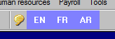
Now that your Windows system is capable of displaying Arabic properly, you need PIMS2 to support Arabic characters in the input of data. In PIMS2:
- go to Tools … Technical maintenance … Technical properties
- in the “language to support in data entry” section, choose “Arabic”.

Possible problems with Arabic on printers:
You will probably also face problems in printing, and may need to disable Optimization from your printer driver. See elsewhere in this document for further details.

Input using Turkish characters
To input and display Turkish characters in your PIMS2 system, you need to do as follows:
- Click Start, Settings, Control Panel, and choose "Regional and Language Options"
- In the Languages page, click the Details button
- Add Turkish as one of the input languages:
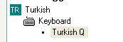
This should do it.

Comma-separated files improperly handled by my Excel
Comma-separated files are files where info is in rows and columns, and each the info for each column is separated from the next by a comma. For instance: "123,0,34".
The standard extension for these files is CSV (Comma Separated Values).
Normally, CSV files are properly decoded by Excel, and values are properly distributed over the columns. But it may happen that Excel stops decoding those files properly.
This may be the result of activating Arabic in your Windows 2000 or your Windows XP, as described in the paragraph above. Usually, when changing language or locale, Windows also changes a number of its internal settings, to match the selected locale.
The setting you need to restore is the List Separator, which must be set back as a comma.
To find it, open Control Panel, open Regional and Language Options, select Regional Options, click Customize…, in Customize Regional Options select Numbers, and change List Separator to be a comma.

Using dates and date formats, with Excel
Excel will comply with the regional settings you have instructed Windows to use. You can tell Windows what date format to use by opening your Control Panel, and selecting the “Regional and Language options”. Whatever format you specify for the display of dates, Excel will abide by this setting and display dates accordingly.
The current version of EPL is unable to comply with all possible formats, and accepts the “dd/mm/yyyy” date format only. The “dd” part represents the day, “mm” the month, and “yyyy” the year expressed in four digits. Any attempt to run EPL with other date formats may result in error messages, or even yield wrong results.
Also, be aware that an EPL Excel sheet prepared on a PC that complies with this format will not be processed if copied onto another PC with different date format settings.
We are currently working on lifting this limitation.

Printer not printing as expected
It has been sometimes reported that some printers were not printing as expected: missing areas, clipped edges, etc.
In most - if not all - cases, it turned out to be a driver problem. Downloading, from the printer manufacturer website, the latest release of the driver for your printer and your flavor of Windows has showed that it solves the problem.
Please make sure that you have tried obtaining and installing the latest driver for your printer and your Windows version, before reporting the problem to Profiles Support.
Your printer has probably been manufactured, boxed and shipped with a driver on floppy or CD well before your version of Windows was released, so it must be expected that the version of the driver that comes with it is not fully compliant. In addition, the driver that is included in your Windows may have shown bugs, which were corrected by the printer manufacturer later on. For all those reasons, the best driver you can get is the one you would download from the printer manufacturer website.

Printer not printing characters, only graphics
If your printer is printing the graphics of your report (as in red frame), but not the letters and the digits (as in blue frame), then you need to disable the "optimization" feature of your Windows printer driver, and all should be fine.
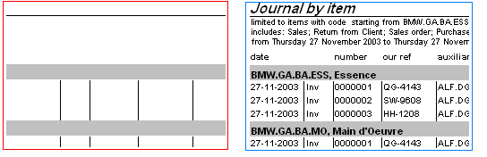
This option is usually found in your driver applet, by following: Printing Preferences button … Paper/Quality tabpage … Advanced button … Document Options:
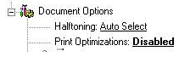

Epson dot-matrix printer printing too slow
It has been sometimes reported that some Epson or Epson-compatible dot-matrix printers were printing at a very slow speed. This was for instance reported with Epson LQ-300 printers.
Declare them in Windows as Epson LQ-2550, and printing speed will increase noticeably.

Recovering from BLOB errors
Should you ever get an error that says: "BLOB has been modified", this is the indication of a corrupted BLOB. A BLOB being a memo-field or an image-field (BLOB stands for Binary Large OBject).
When a file contains, in one of its records, a corrupted BLOB, this record may become non-accessible in the forms, as every attempt to access it generates an error.
The best recovery is often returning to your backups, prior to the last corruption.
But you may prefer to attempt a recovery without getting back to your backups. Such a recovery will make you lose the contents of the BLOB field, however.
Recovery means most often the loss of the data in the BLOB field.
To do so, perform a reindexing of your files, using the reindexing form at Tools … Technical Maintenance … Reindexing. Be sure to have checked the "rewrite files" options, as this is what may correct the situation. Any corrupted BLOB will then be replaced by an empty one.

Remote Assistance, using TeamViewer
With Remote Assistance using TeamViewer, Profiles is close to you, however far your may be. Using TeamViewer, the Profiles Support Team can access your PC(s) right from our offices
For this purpose, you must start TeamViewer.
- If you are inside PIMS2, you can simply click on the menu Tools … Technical Maintenance … Launch Remote Assistance. This will launch TeamViewer.
- If you are outside PIMS2, and cannot enter into PIMS2 for some reason, then locate and launch the program named TeamViewerQS.exe, which is located in the same folder as your PIMS2 program, typically C:\PIMS2.
- If you cannot locate your local copy of TeamViewerQS.exe, you can download it from the following link:
http://www.profiles-software.com/download/TeamViewerQS.exe
Once launched, TeamViewer generates a unique combination of an ID and a password. Of course, the computer where TeamViewer is launched must be connected to Internet.
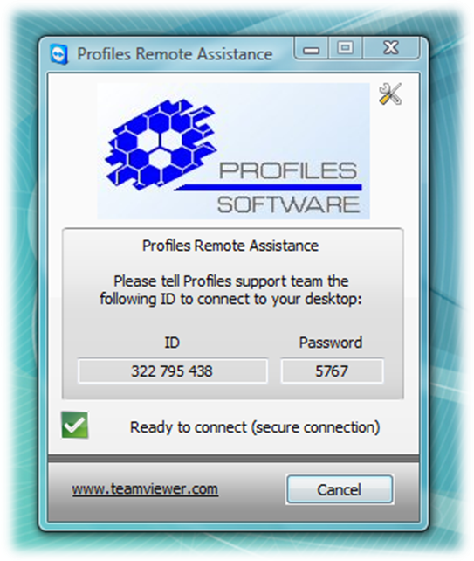
You need to let us know the ID and the password, so that we can access your computer.
Note that the generated combination of ID and password is only valid for the duration of the current session. As soon as you click the "Cancel" button on the TeamViewer panel, the session is closed, and the password expires. This way, the connecting party can only access your computer while authorized, as if this person was sitting next to you.

Firewall considerations:
TeamViewer uses the internet, and your local network if you have one.
Many companies are reluctant to hook their stations to internet, for a variety of reasons: fear of intrusions, staff abuse (Facebook, etc.), and this is understandable.
In order to allow TeamViewer operation without allowing any other activity, you need to open a single port on your firewall, port 5938 (both UDP and TCP). All TeamViewer traffic goes through this port, and other traffic does not need to be authorized through your network.

Sybase SAP Advantage database, server detection problems
The following applies to those using PIMS2 "Enterprise", i.e. under Sybase SAP Advantage Database Server. It does not apply to the BDE platform.
Upon starting PIMS2, a station on the network will first attempt to detect the "remote" database server. If PIMS2 fails to locate the remote server within a predefined delay, it assumes that no server is available, and operates on the data in what is known as "local server" mode, i.e. a file server mode actually. The result is a degraded performance, and a limited number of concurrent users, 5 maximum.
The failure to detect a remote server could of course be due to the fact that the service of the remote server is not running on the server itself. Correction consists into starting the service on the server machine.
The failure to detect a remote server could also be due to various combinations of hardware protocols and specifications, and this would happen even though the Sybase SAP Advantage service is running on the server machine.
If this is the case, you can direct Sybase SAP Advantage directly to the intended server, by explicitly indicating the IP of the server and the port of the Advantage Server service, therefore bypassing the discovery process.
You achieve this by adding a few lines to the ADS.INI configuration file. The ADS.INI configuration file is typically located in the same folder as the launched executable, most often C:\PIMS. If the ADS.INI configuration file does not exist, create one using Notepad or a similar editor, since ADS.INI is in fact a text file.
Edit or create the ADS.INI file, and add to it the following lines:
[MYSERVER]
LAN_IP=192.168.0.1
LAN_PORT=6262
Here is an explanation of each line:
[MYSERVER] this is the name of your server, assuming that you data is located in \\MYSERVER\MYDATA
LAN_IP=192.168.0.1 this is the network IP of server running Advantage Server service
LAN_PORT=6262 this is the port used to communicate with the Advantage Server service. 6262 is the default port. One must make sure that no firewall or anti-trojan blocks the port used.
Note that for the above changes to take effect without leaving anything to chance, it is strongly recommended to perform the following:
- Delete all index-files (*.ADI), all catalog-files (*.ADD)
- You may also delete leftover data backup files (*.BAK)
- Restart all of the server and every station involved.
- Start PIMS2 on one station, and launch the tables reindex process.

Sybase SAP Advantage database, error 5185 when using in remote session
When using PIMS2 in a remote session, such as Remote Desktop, Terminal Services, Citrix, 2X, TeamViewer, PC-Anywhere or similar, you may face an error 5185, which mentions a license breach.
If this happens, it indicates that you are using Sybase SAP Advantage Local Server, and it detected the situation, a situation which is not covered by the license for local server.
You may be facing this even if you are not using Sybase SAP Advantage as your main data engine, since PIMS2 uses it anyway for support files, such as help file and language translation.
You circumvent this message by adding a few lines to the ADS.INI configuration file. The ADS.INI configuration file is typically located in the same folder as the launched executable, most often C:\PIMS. If the ADS.INI configuration file does not exist, create one using Notepad or a similar editor, since ADS.INI is in fact a text file.
Edit or create the ADS.INI file, and add to it the following lines:
[SETTINGS]
MTIER_LOCAL_CONNECTIONS = 1

Sybase SAP Advantage database, degraded performance
The following applies to those using PIMS2 "Enterprise", i.e. under Sybase SAP Advantage Database Server. It does not apply to the BDE platform.
When a record is deleted, some database systems would remove it immediately from the database and update all indexes immediately, some other database systems would mark the record as deleted and filtered out, but would only discard it when the table is "packed".
Sybase SAP Advantage opted for the 2nd strategy: instant performance is preserved, but when the proportion of deleted records grows comparatively large, too many deleted records have to be filtered out, and performance degradation is perceptible. This is typically the case after major rebuild operations involving massive delete operations, such as for instance when vouchers regeneration is requested.
Solution: do run a "reindexing of tables", where the "tables rewrite" option is enabled. This will not only create index-files afresh, but will also rewrite the table altogether, therefore "packing" it and discarding all deleted records. The initial performance should be recovered after this.

Network interference, unusual problems
It has been reported to us that some long-range wireless handy telephones have such a strong signal that, if the base is placed near the server or the networking equipment, the interference may disrupt network communication, resulting into data corruption in PIMS2, in particular when phone calls are placed or received. Should you be facing unusual data corruption problems, you may want to check for such equipment in your environment.
____________

