VCC=4,5V tPHL=9.43 ns tpd=8.63 ns

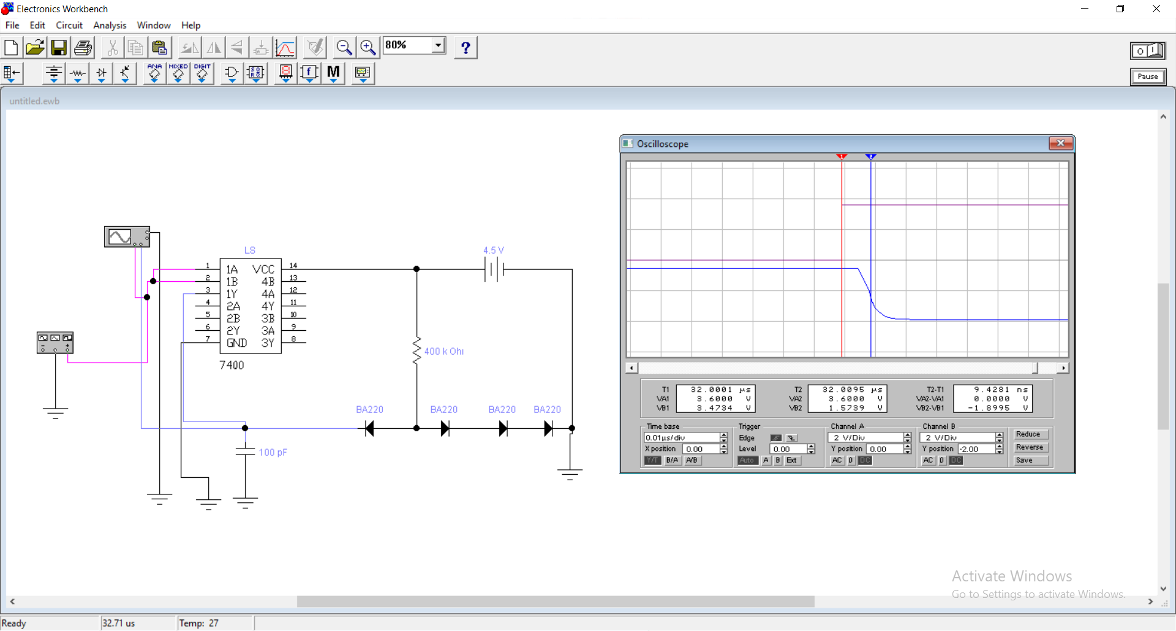CL=100pF tPLH=7.83 ns

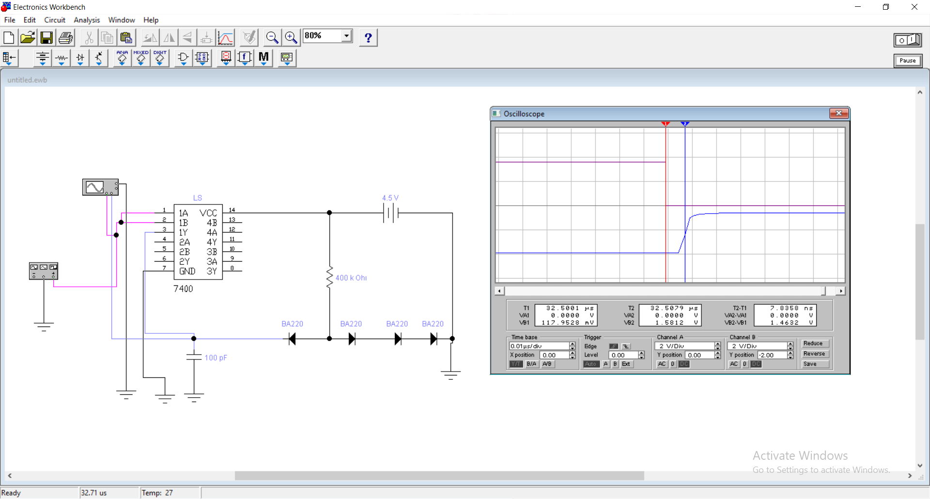

VCC=4,5V tPHL=22.6 ns tpd=17.67ns

CL=680pF tPLH=12.75 ns

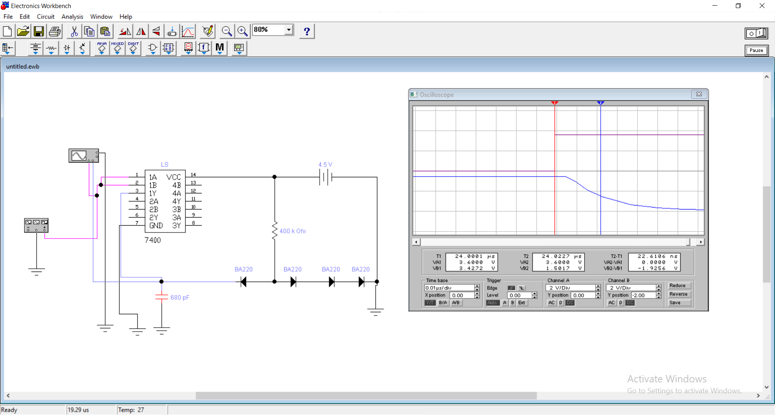

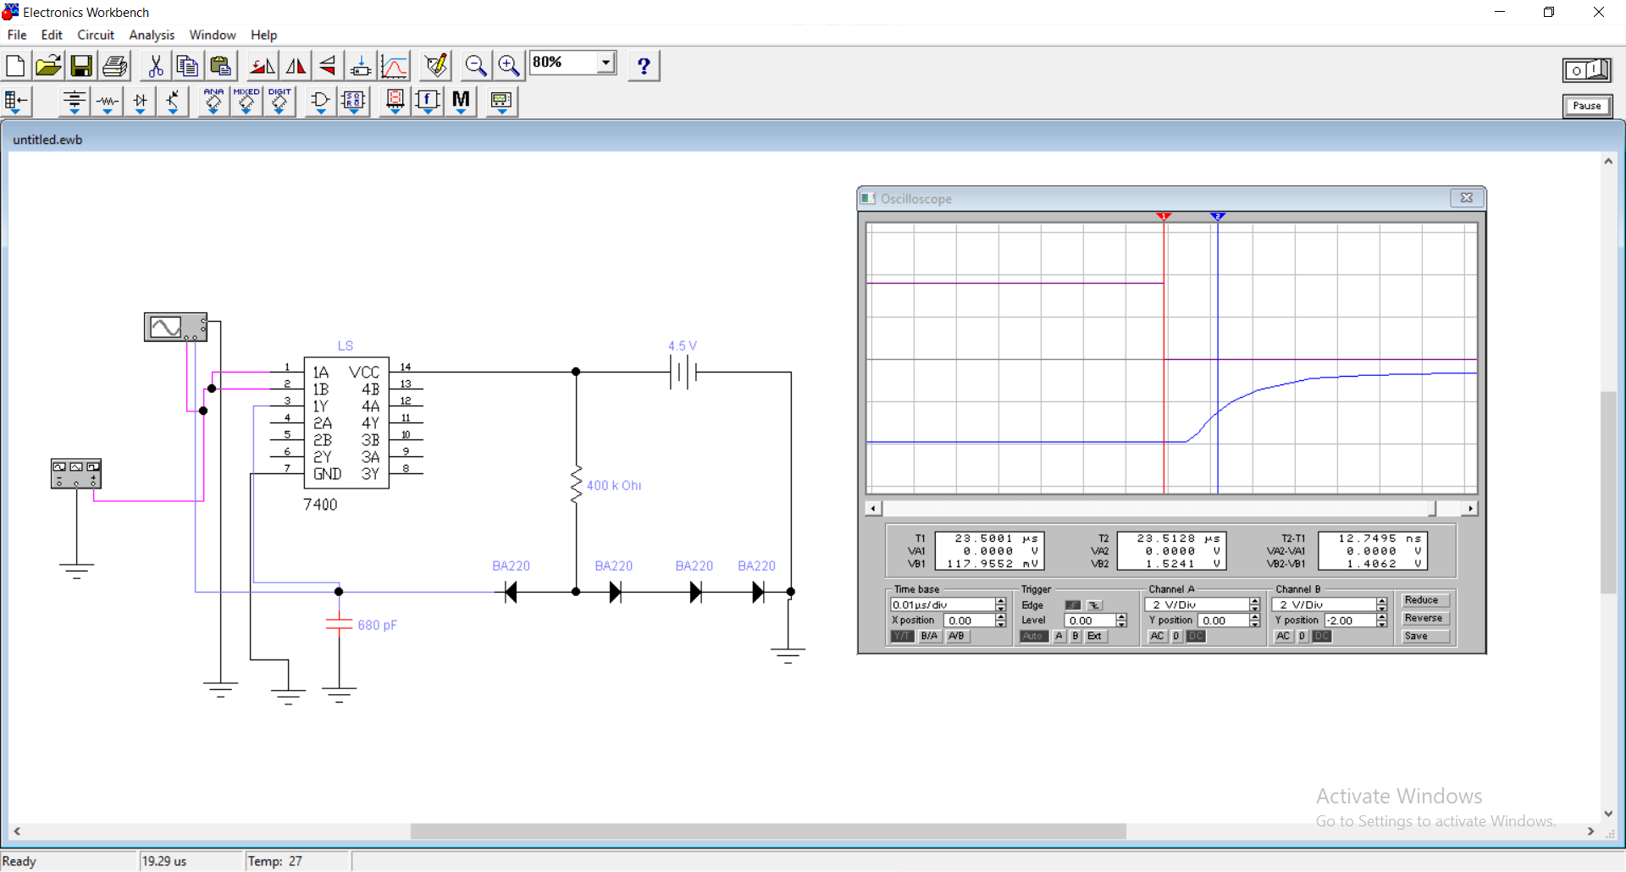

VCC=4,5V tPHL=41.36 ns tpd=30.9ns

CL=1.5nF tPLH=20.44ns

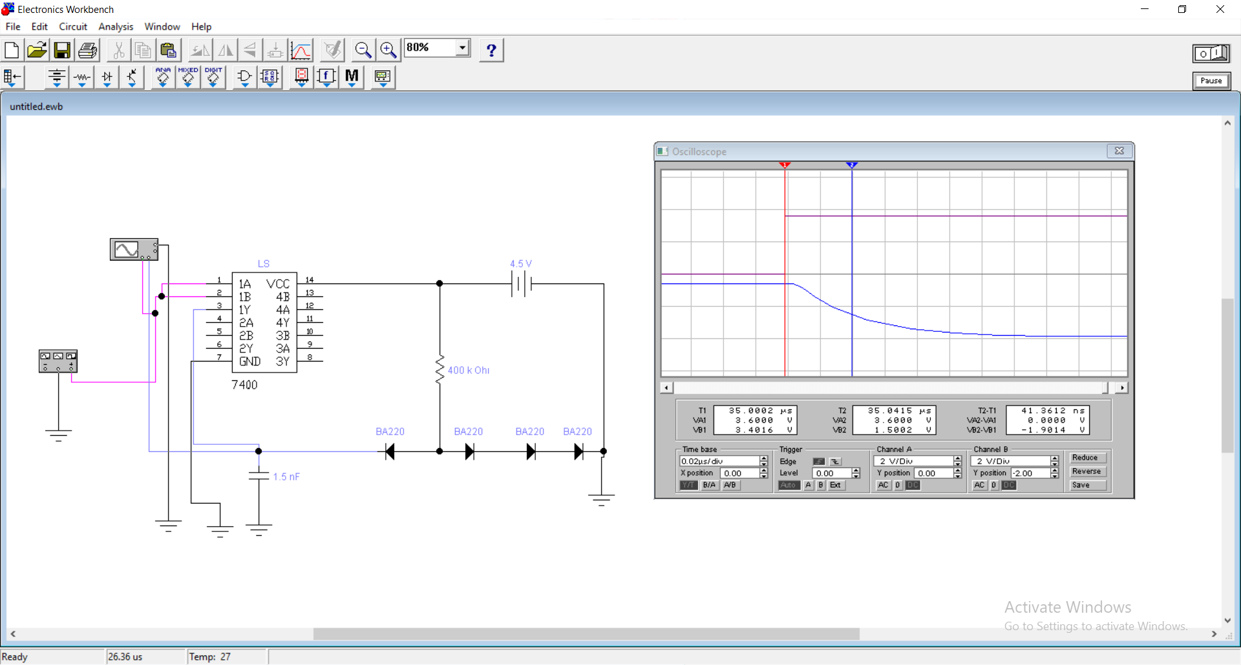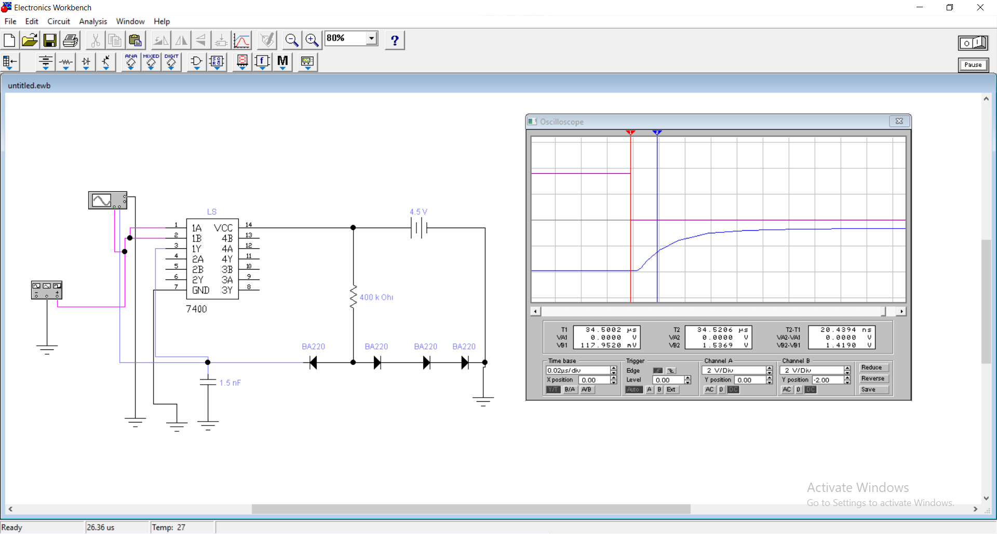

VCC=4,5V tPHL=214.74 ns tpd=145.86 ns

CL=10nF tPLH=76.98 ns

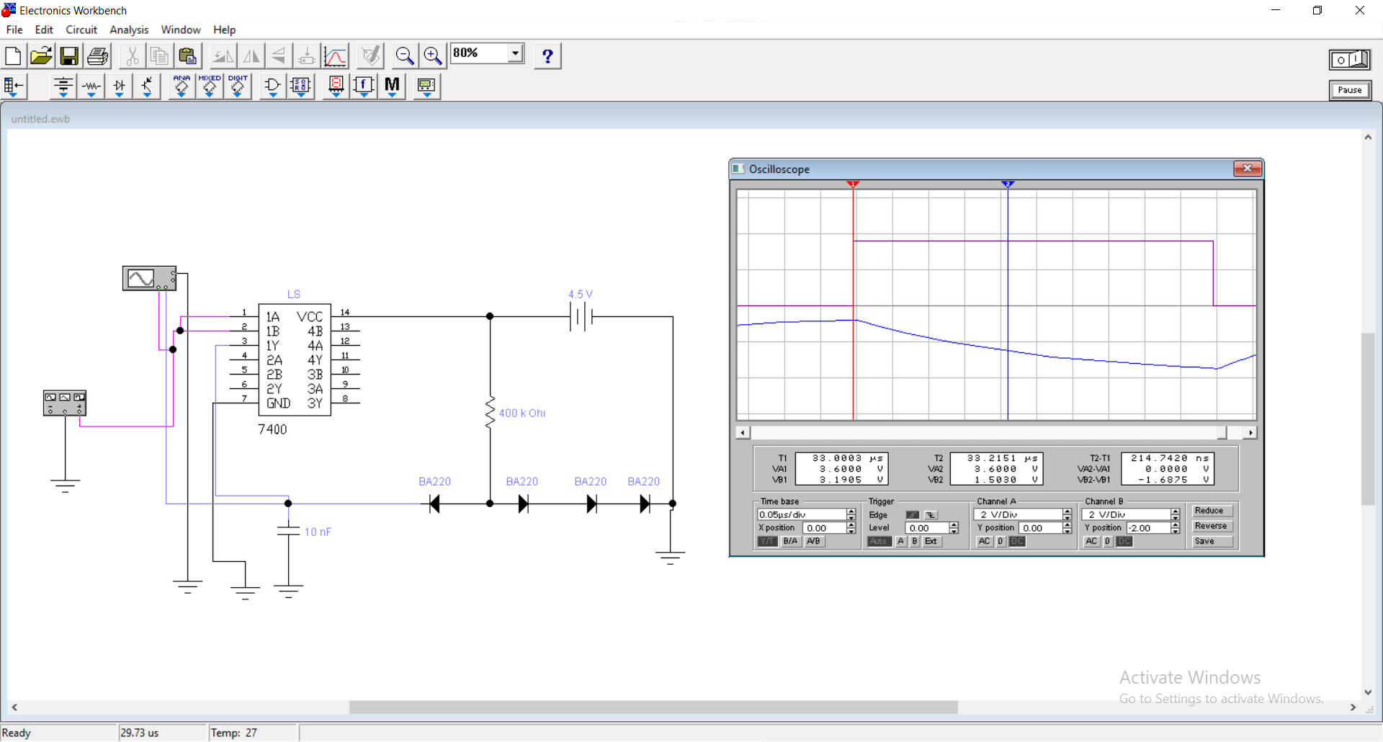

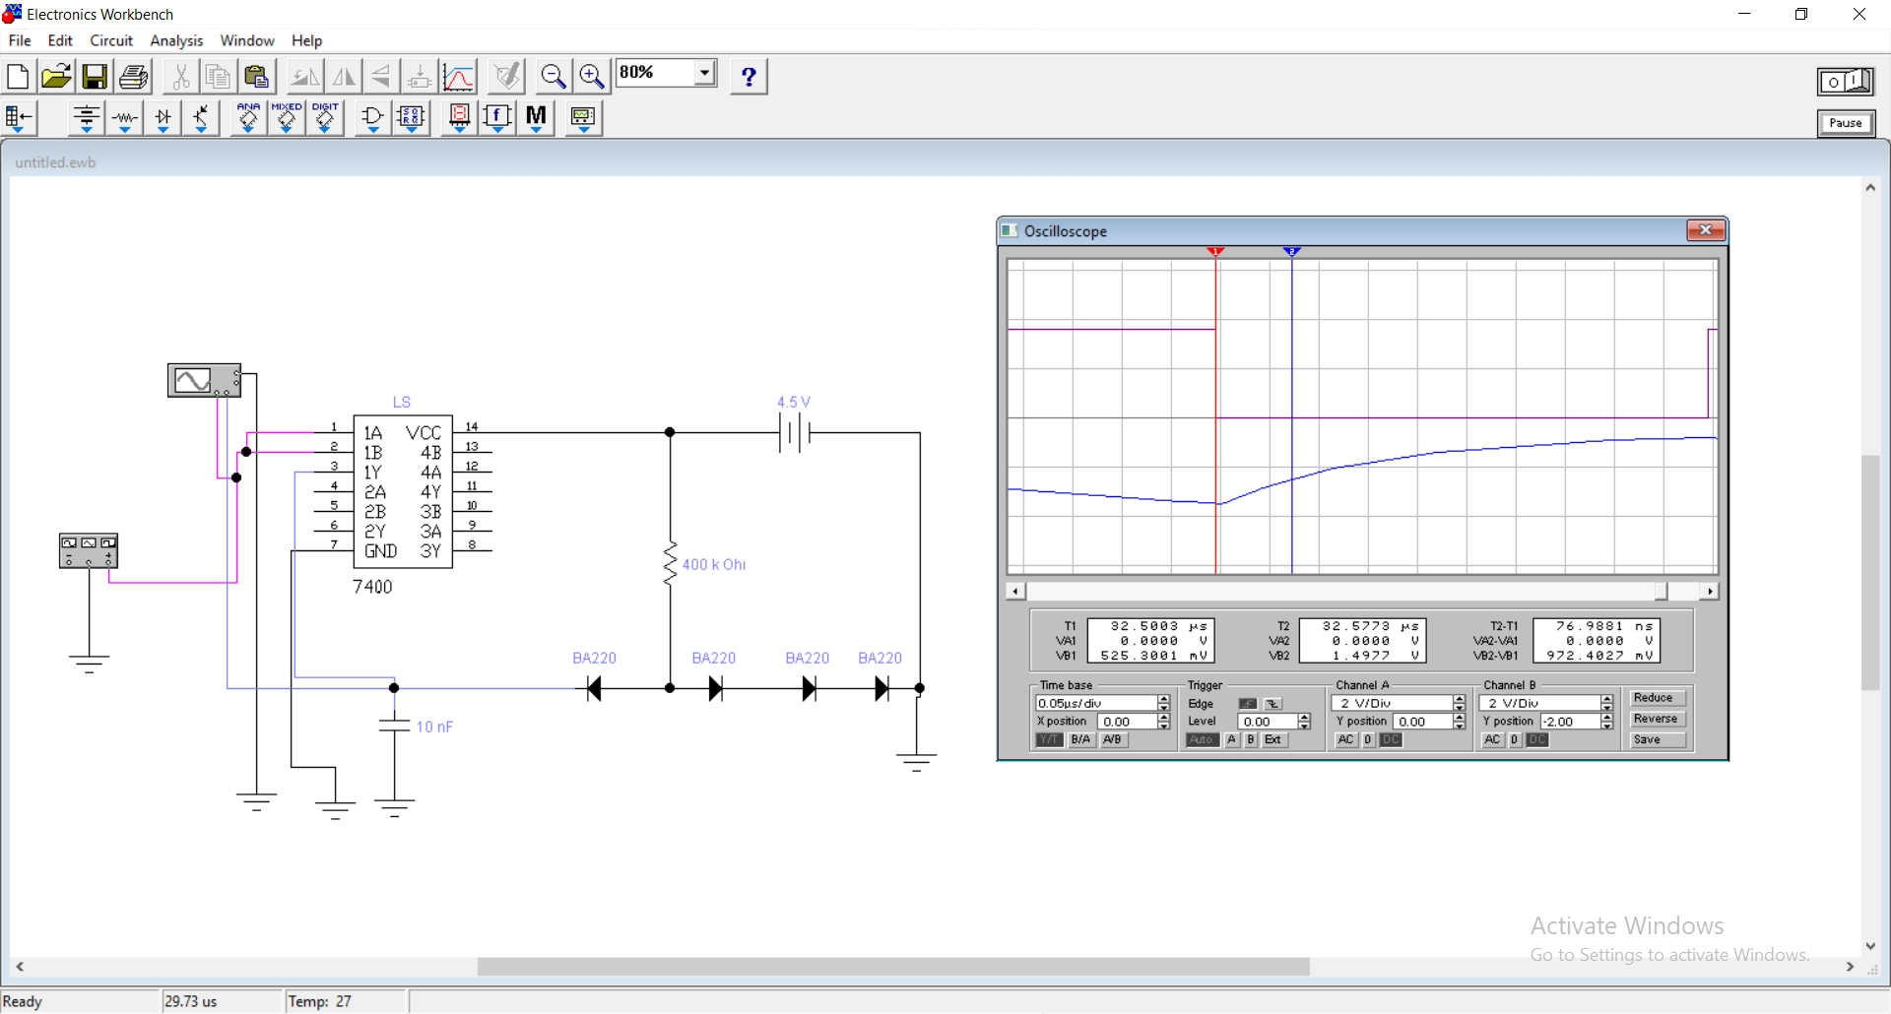

VCC=5V tPHL=9.56 ns tpd=8.65 ns

CL=100pF tPLH=7.75 ns

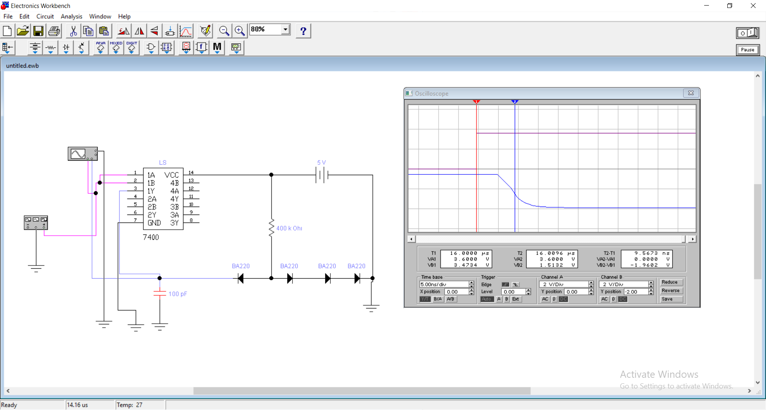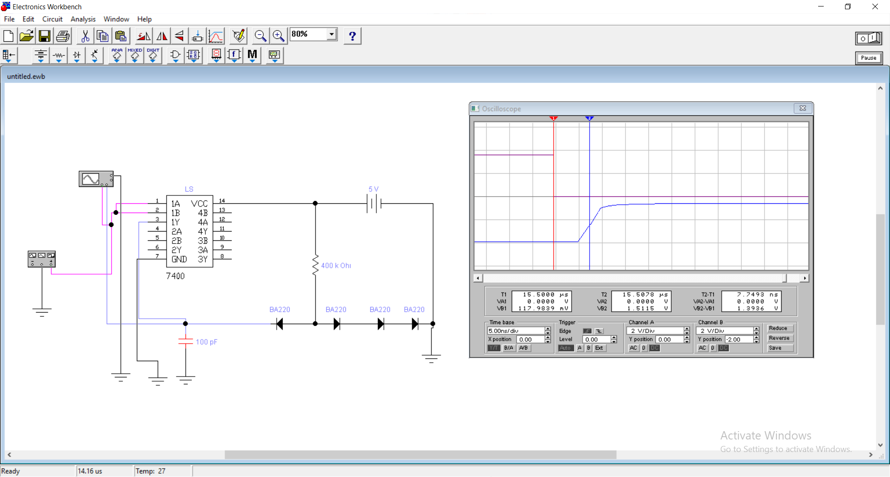

VCC=5V tPHL=22.61 ns tpd=17.64 ns

CL=680pF tPLH=12.67 ns

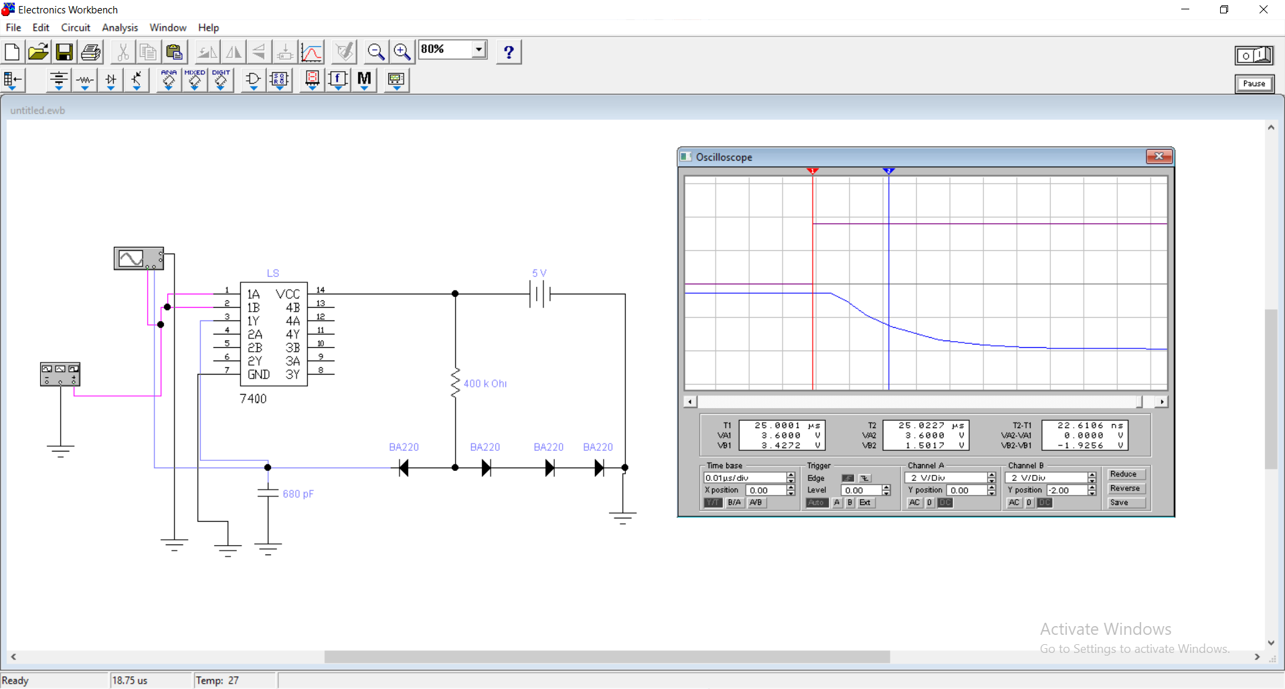

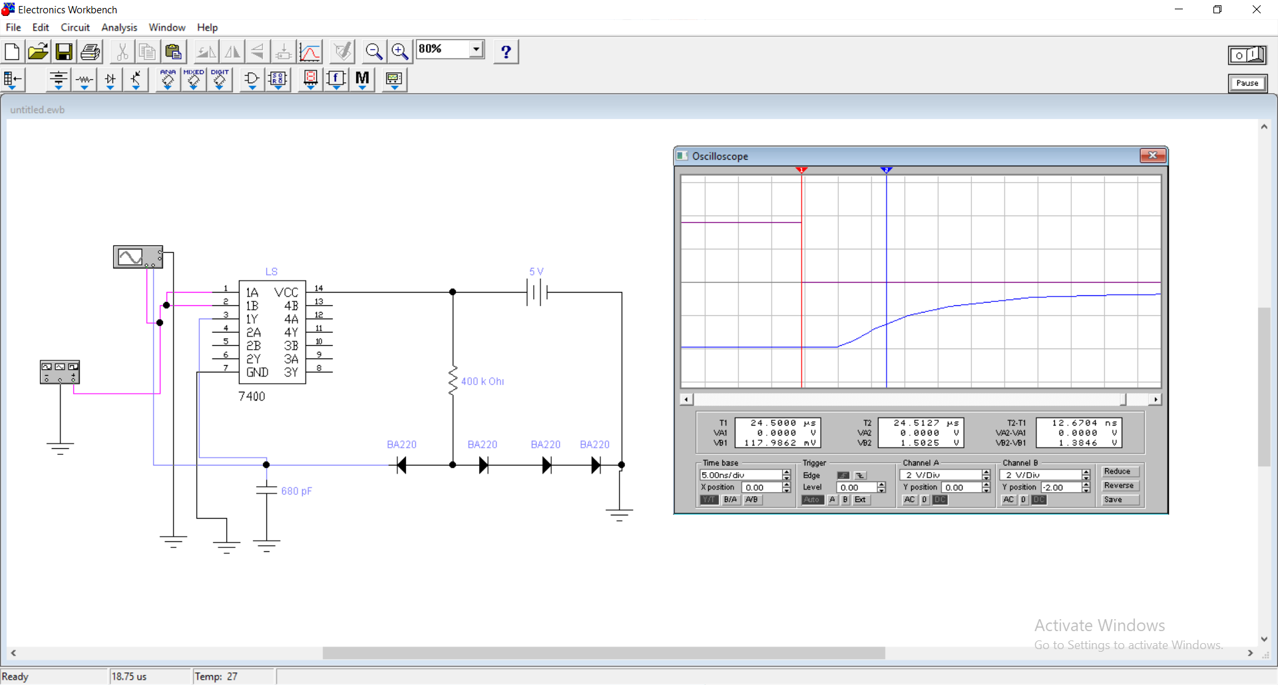

VCC=5V tPHL=41.14 ns tpd=30.62 ns

CL=1.5nF tPLH=20.1 ns

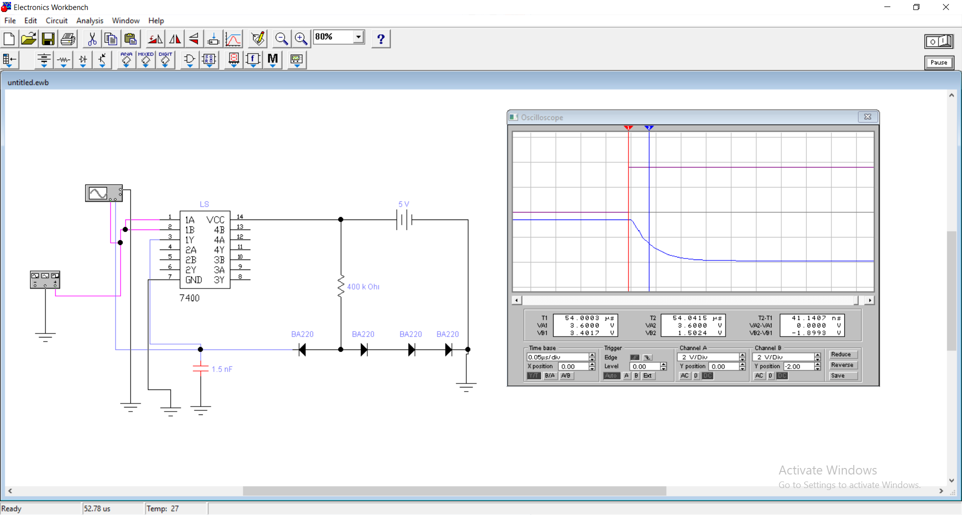

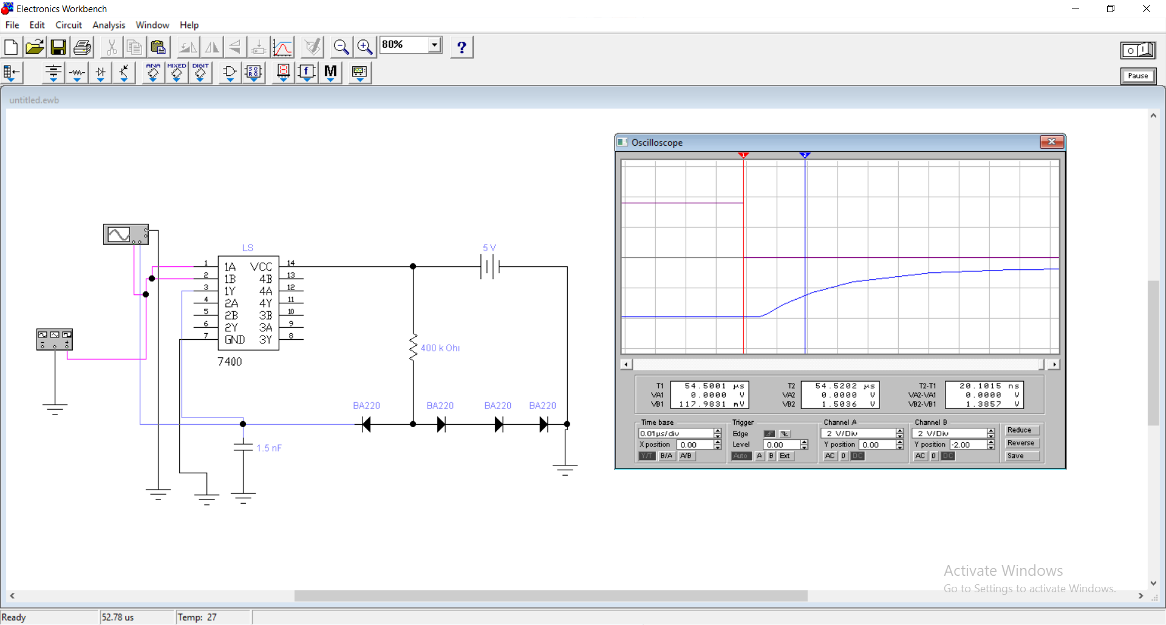

VCC=5V tPHL=214.74 ns tpd=145.92 ns

CL=10nF tPLH=77.1 ns

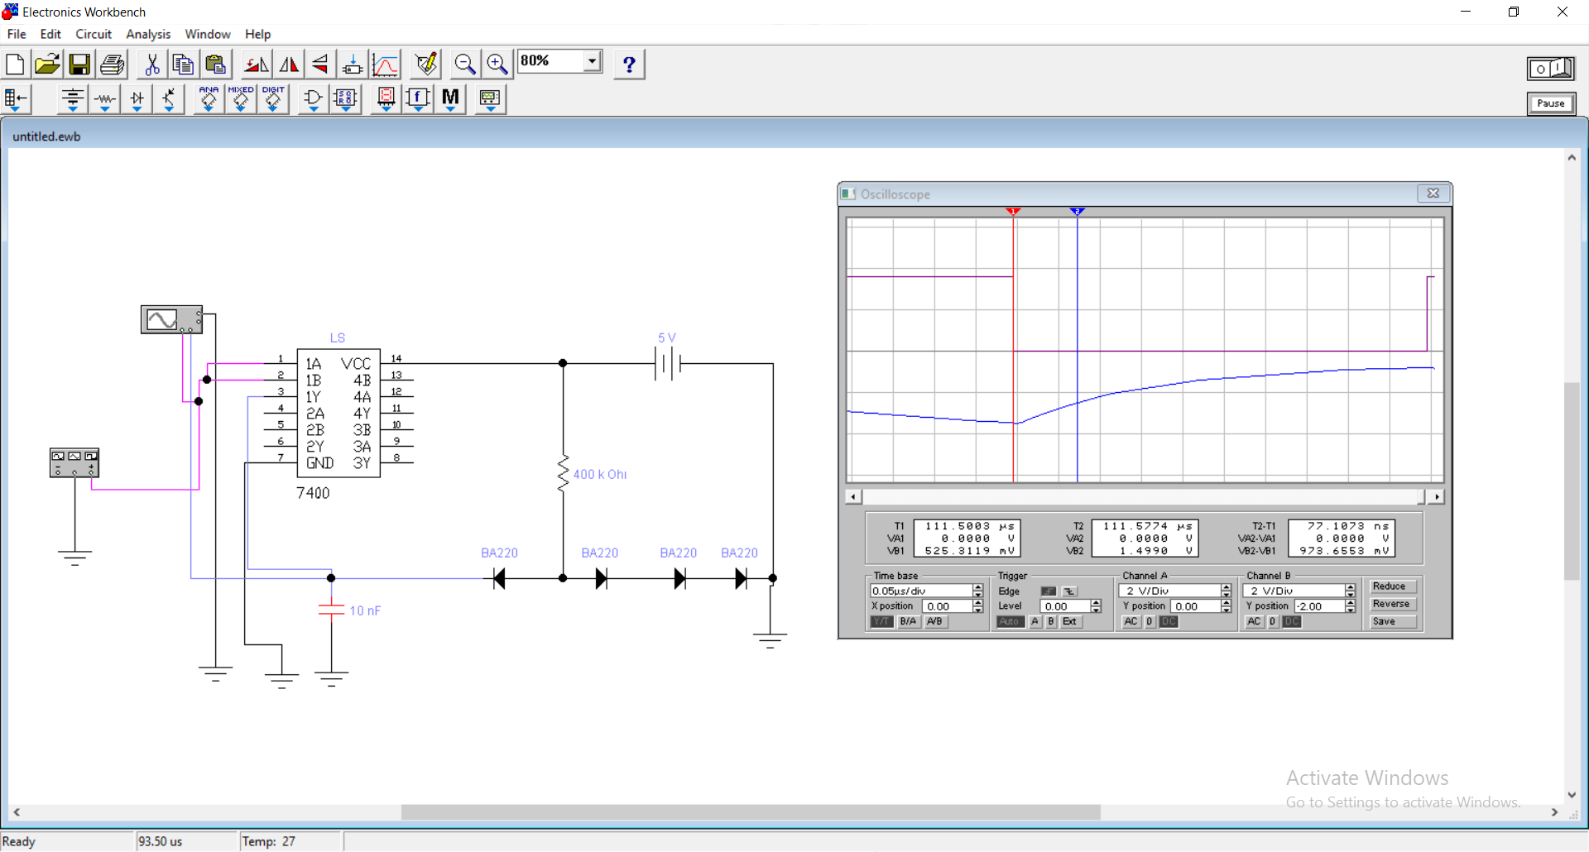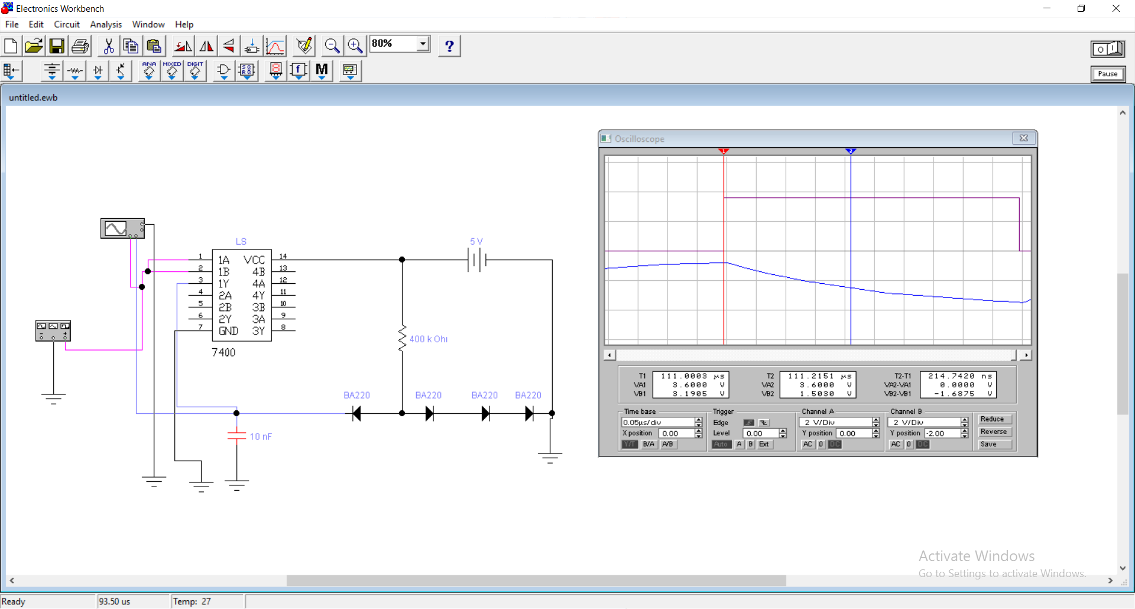

VCC=5.5V tPHL=9.56 ns tpd=8.65 ns

CL=100pF tPLH=7.74 ns

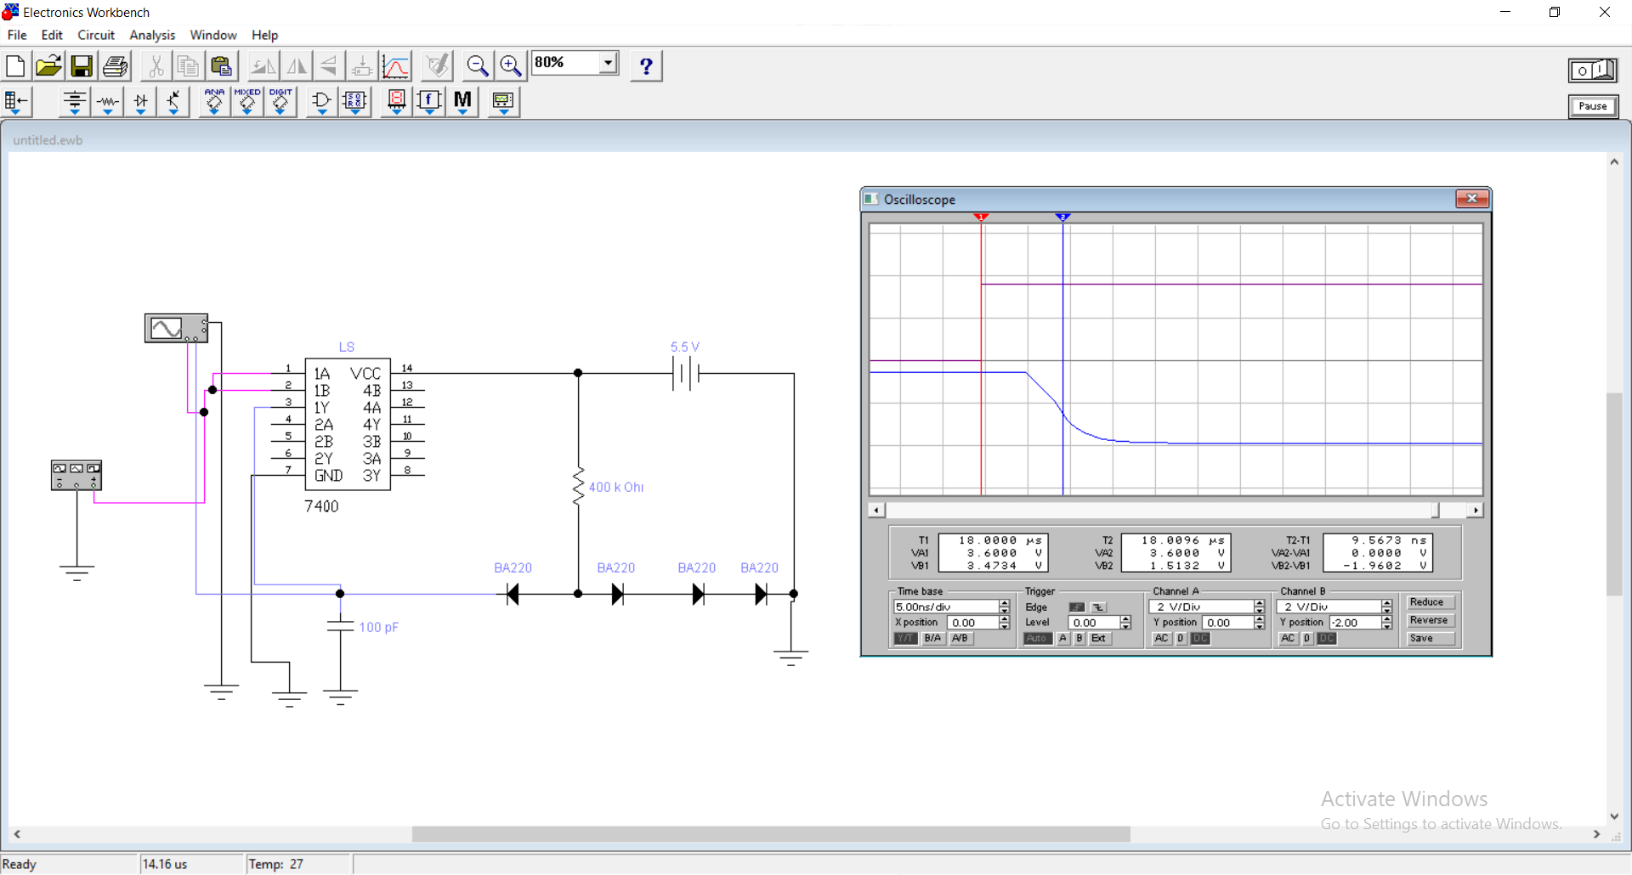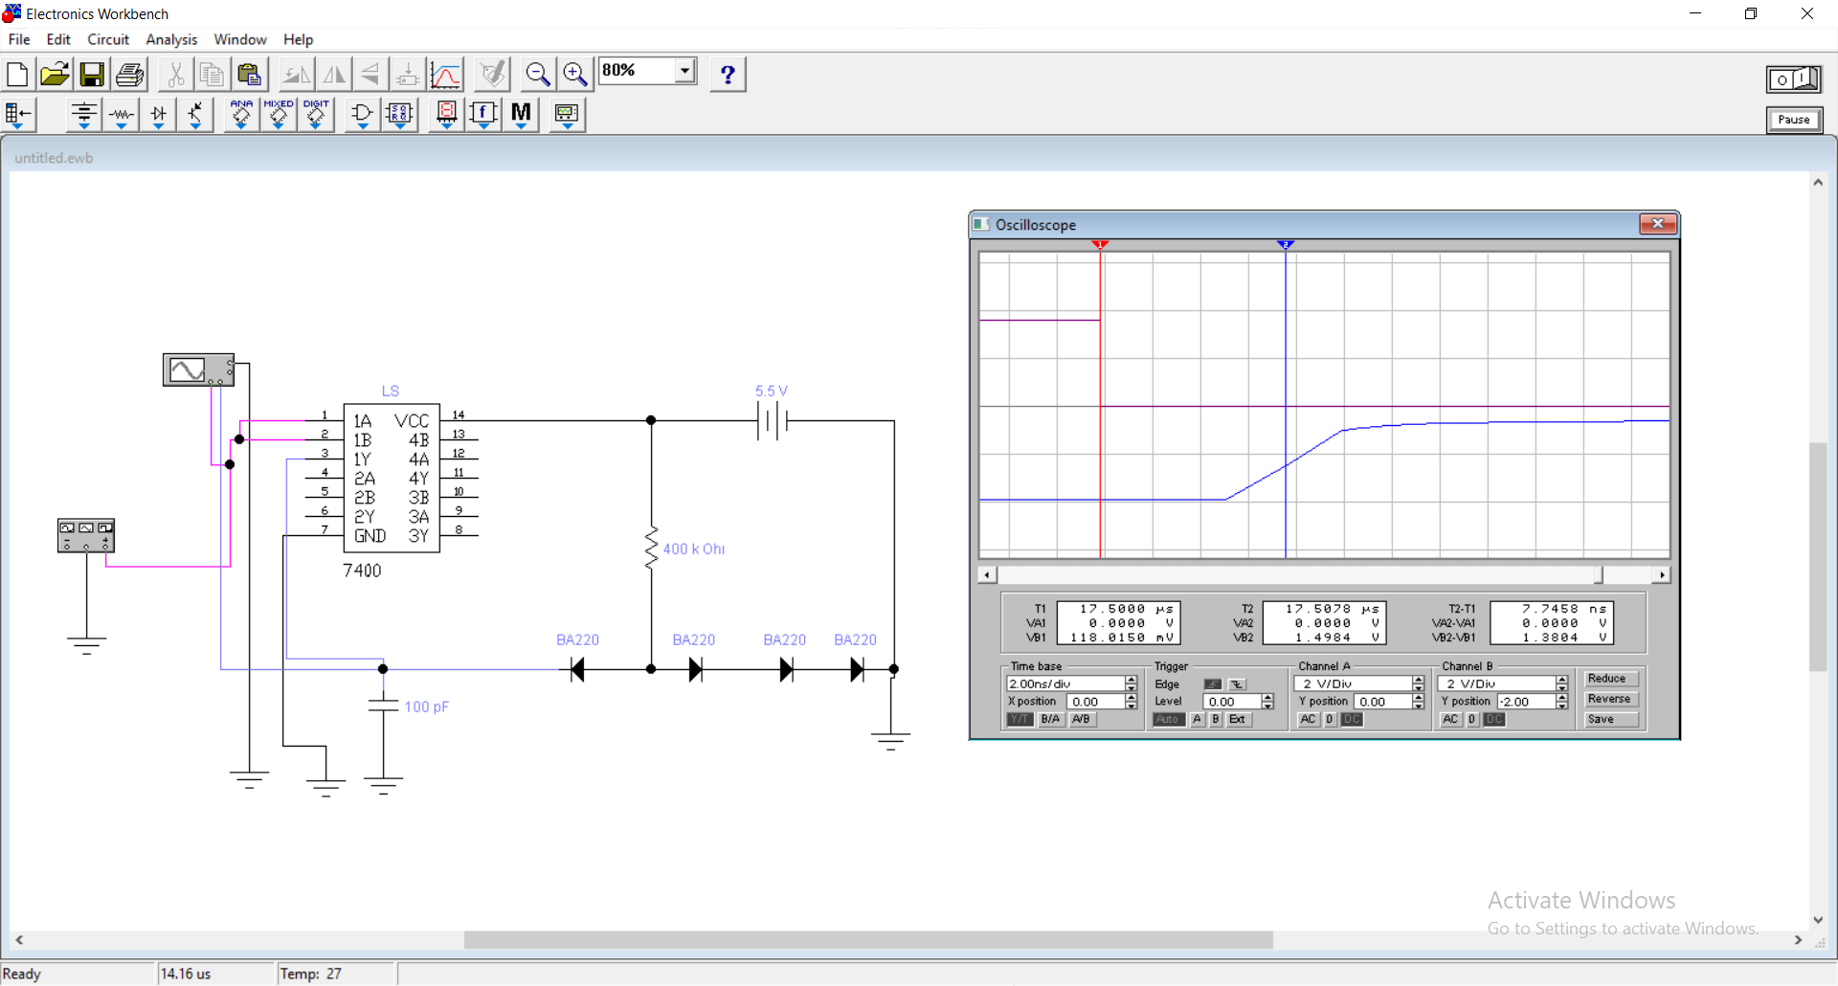

VCC=5.5V tPHL=22.62 ns tpd=17.64ns

CL=680pF tPLH=12.67 ns

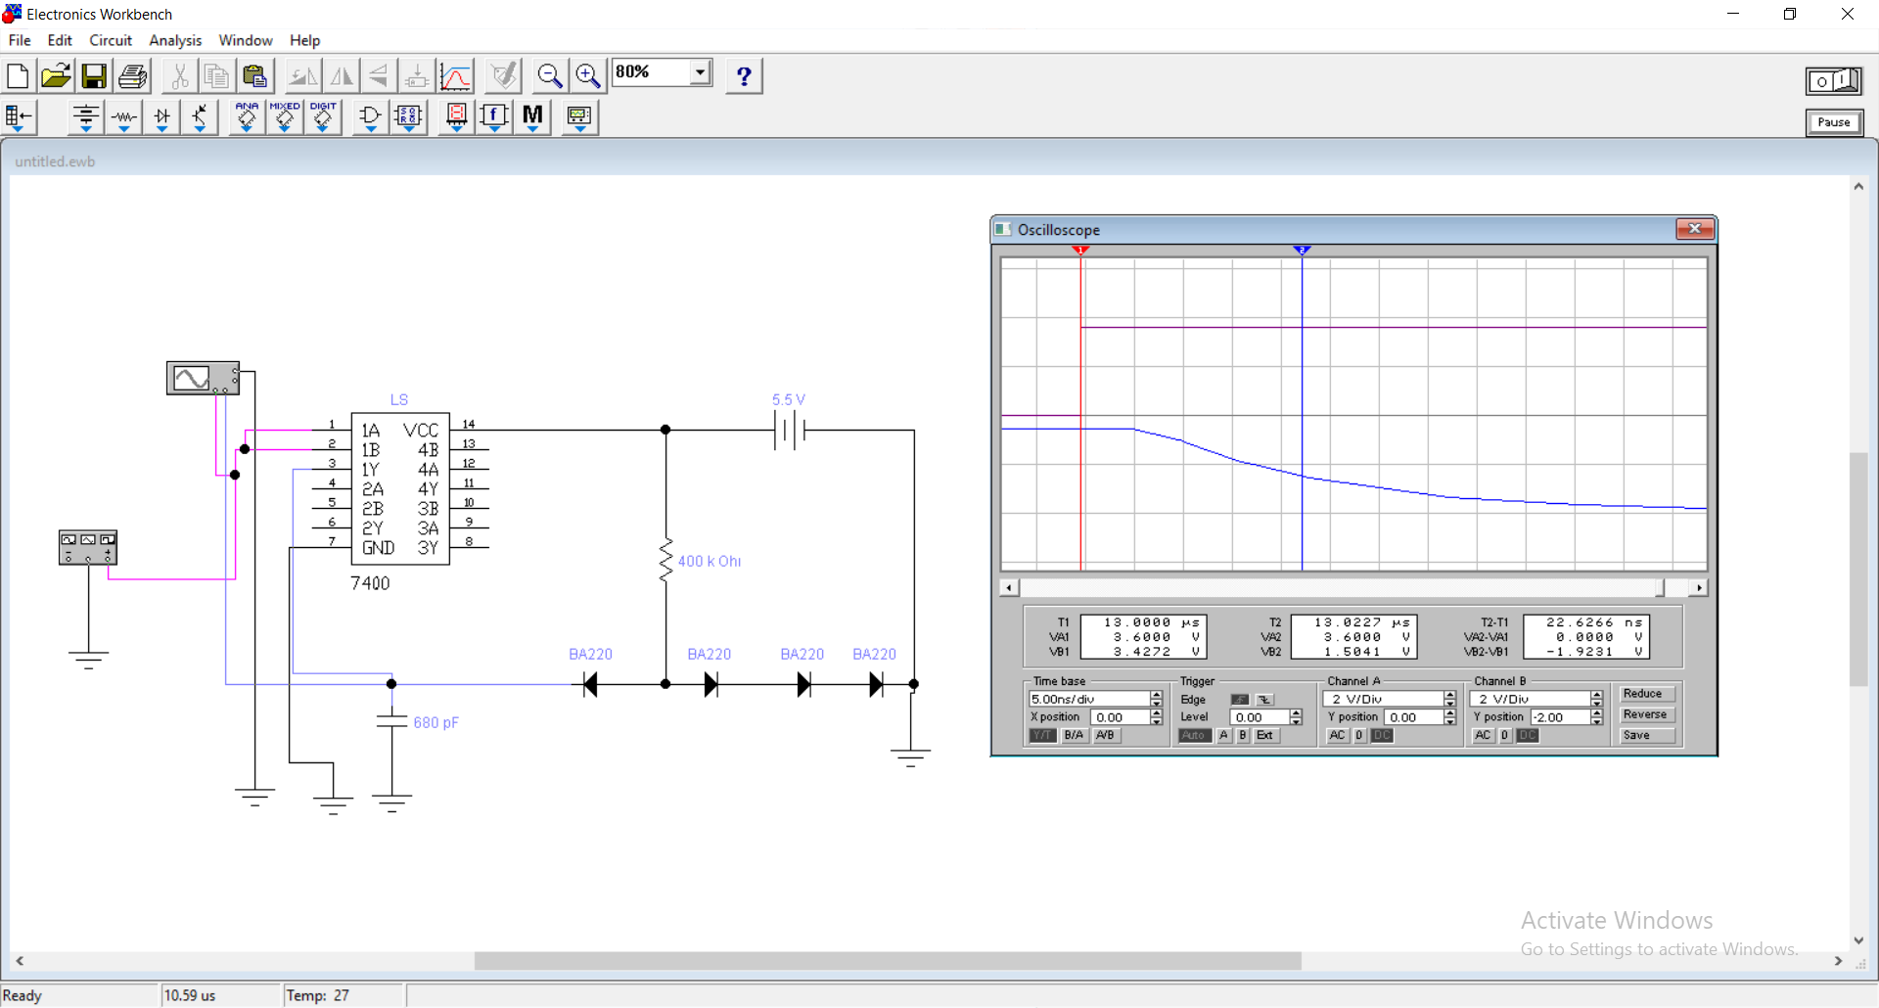

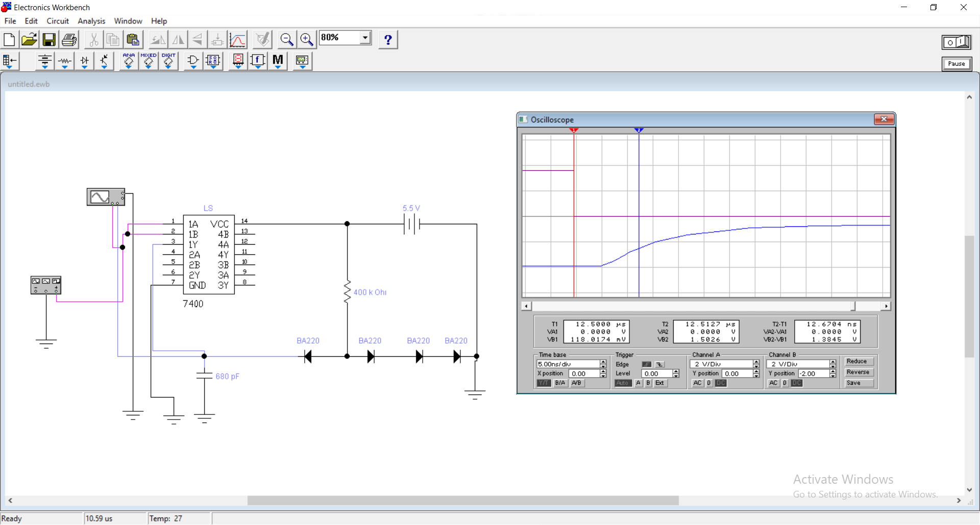

VCC=5.5V tPHL=41.41 ns tpd=30.75 ns

CL=1.5nF tPLH=20.1 ns

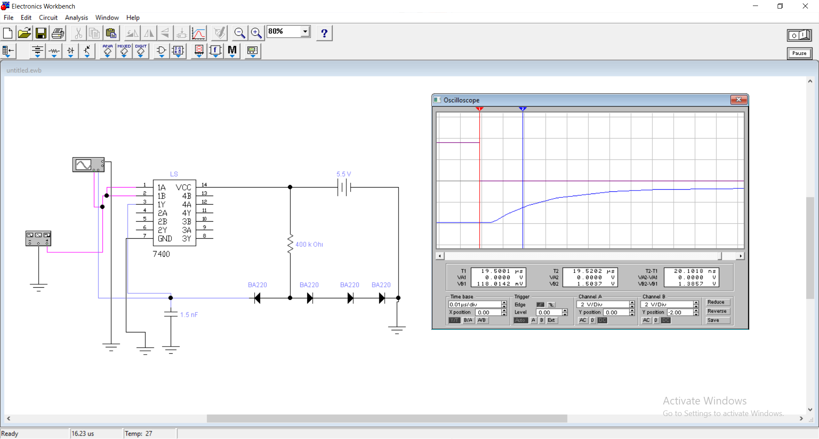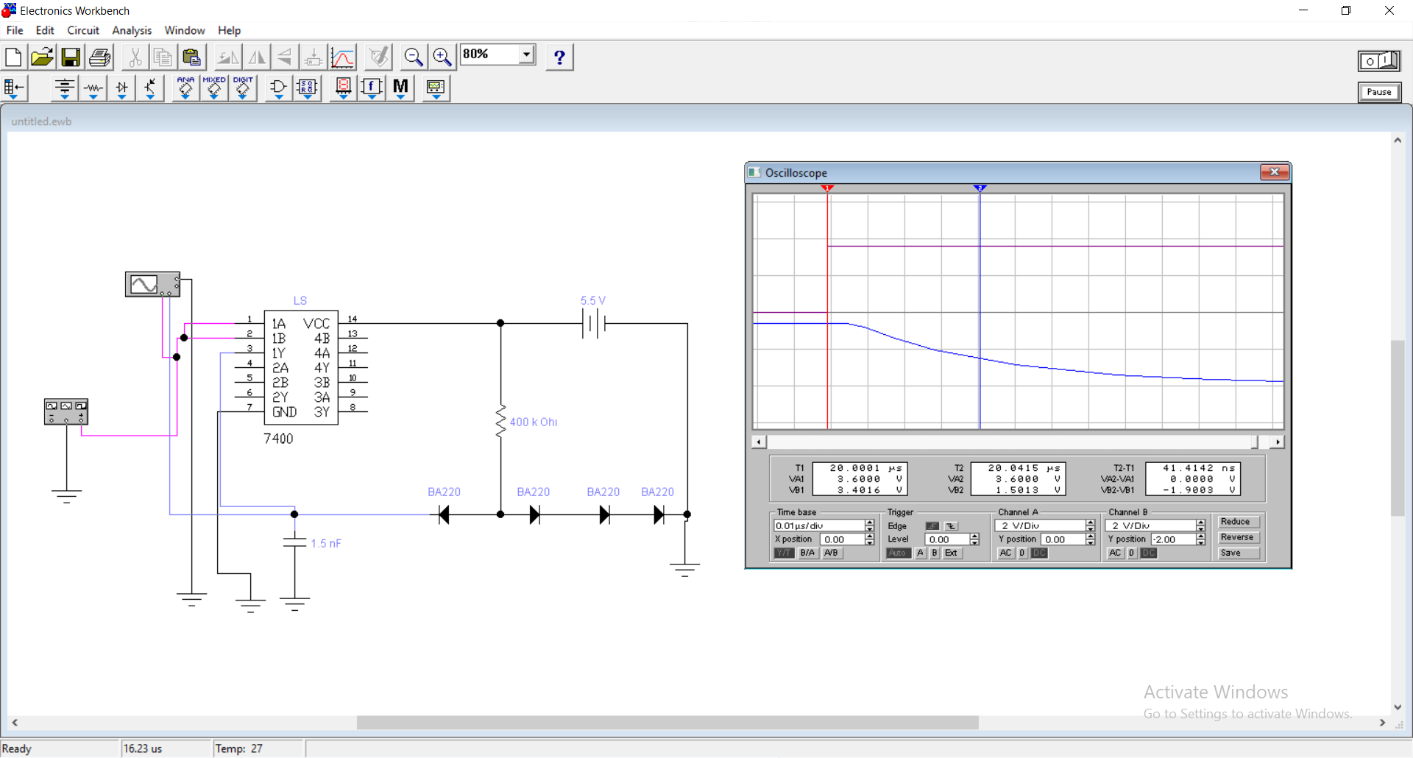

VCC=5.5V tPHL=214.05 ns tpd=145.51 ns

CL=10nF tPLH=76.98 ns

